Cold-Chain Logistics FDE Agent: Complete Project Guide
This guide explains the whole project from start to finish. You don't need any prior context. Read it top to bottom once, and you will know what the project does, why it exists, how every piece works, and where to look in the code.
For the hands-on setup commands, see instrutions.md. This guide explains the thinking; that file lists the steps.

Table of contents
- The problem
- The solution in one paragraph
- Who uses it and what they can ask
- Architecture at a glance
- The data: where it comes from and how it moves
- Live telemetry with Kafka
- The SOP knowledge base (RAG with pgvector)
- The AI agent (LangGraph)
- Security model
- The web app (Streamlit)
- Running everything (Docker)
- Configuration reference
- Repository map
- Design decisions and trade-offs
- How the project evolved
- Known limitations
- Ideas for the future
- Troubleshooting
- Glossary

1. The problem
A logistics company moves refrigerated cargo (fresh food, medicine) in trucks. Every truck has IoT sensors that report GPS position, cargo temperature, risk scores, delay probability and port congestion.
When something goes wrong (a truck's cargo warms up, a port gets congested), a night-shift dispatcher has to react fast. Today that means:
Pain point | Why it hurts
Data is locked in a legacy database with cryptic column names like iot_temp_val_c, prt_cng_lvl, risk_cls_txt | Dispatchers can't write SQL, and even analysts have to decode the schema first.
Rules live in a separate SOP document (Standard Operating Procedure) | The dispatcher has to remember or look up thresholds ("fresh perishables must stay 0–4 °C") under time pressure.
External conditions (weather) are in yet another place | Deciding whether the truck or the environment is the problem means checking a third source.
No audit trail of what was looked at and why | After an incident, nobody can show how a decision was reached.
Giving an AI database access is dangerous | A model that writes SQL could, in theory, read sensitive tables or delete data.

The core question: How can a non-technical person safely "chat with" live fleet data, the company's rules and the outside world, and get a clear, rule-backed action plan in seconds?
This is a typical Forward Deployed Engineer (FDE) problem: take messy enterprise data and systems as they are, and put a safe, useful AI layer on top without rewriting the legacy systems.

2. The solution in one paragraph
A dispatcher types a question in plain English into a web app. An AI agent (an LLM in a LangGraph loop) decides which of three tools it needs: (1) run a read-only SQL query on a clean view of the fleet database, (2) fetch live weather for a GPS location, (3) search the SOP documents by meaning (vector search). It combines the results and answers in a fixed business format: summary, data table, and an action plan that cites the SOP rule. Meanwhile Kafka streams simulated live sensor readings into the database, so the data keeps changing like a real fleet. Every agent step is written to an audit log, and every component uses a separate database login with the least privileges it needs.

3. Who uses it and what they can ask
Primary user: a dispatcher or operations manager. They don't need SQL or any technical knowledge.
Example questions
Question | What the agent does
"Find active shipments near Los Angeles (~33.8, -118.1). Check the weather and tell me if the cargo temperature violates the SOP for fresh perishables." | Uses all three tools: SQL for nearby readings, weather for that point, SOP search for the temperature rule. Then it gives an action plan.
"Explain the difference between a Tier 1 and Tier 2 escalation." | Uses only the SOP search. No data needed, so it doesn't query telemetry (the "restraint" test).
"What are the 5 most recent readings, and are any above 8 °C?" | Uses SQL on the live data that Kafka is streaming in.

Answer format (enforced by the system prompt in src/prompts/system_prompt.txt):
- Executive Summary: 1–2 sentences plus the immediate risk
- Telemetry & Environment Analysis: a table with location, temperature, risk and weather
- Required Action Plan: numbered steps taken from the SOP, plus a citation of the exact SOP rule

4. Architecture at a glance
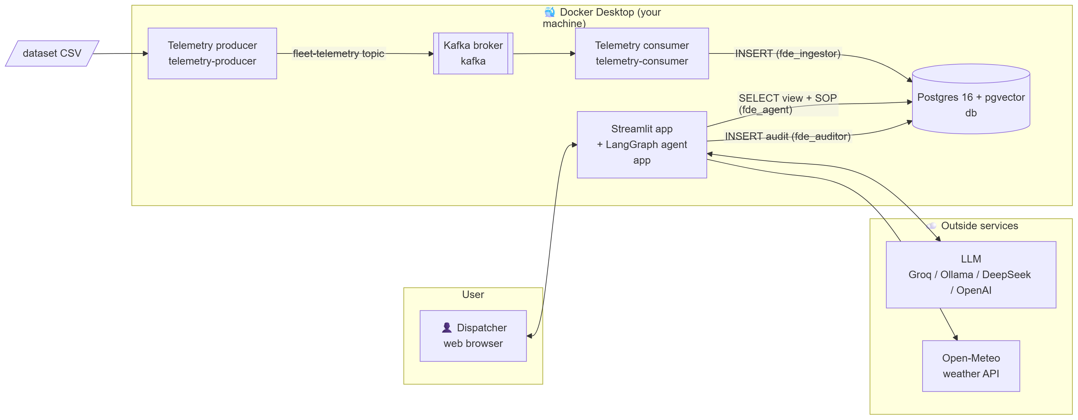
Figure 1
Component | Technology | Job
db | Postgres 16 with the pgvector extension | Stores fleet readings, SOP text and vectors, and the audit log in one database
app | Streamlit (UI) + LangGraph (agent) | Chat console, live dashboard, historic browser, audit viewer
kafka | Apache Kafka 3.9 (KRaft mode, single node) | Message broker for the live sensor stream
telemetry-producer | Python + confluent-kafka | Pretends to be the trucks' IoT gateway: sends one reading per second
telemetry-consumer | Python + confluent-kafka | Reads the stream and writes each reading into Postgres
LLM | Groq (free tier, recommended), Ollama (local), DeepSeek or OpenAI | The "brain" that decides which tools to call and writes the answer
Weather | Open-Meteo (free, no key) | Live temperature and wind for a GPS point

5. The data: where it comes from and how it moves

5.1 The dataset
- Source: the Kaggle "Logistics and Supply Chain Dataset" (link in data/source/data.txt)
- File: data/raw/dynamic_supply_chain_logistics_dataset.csv
- Size: 32,065 hourly readings from 2021-01-01 to 2024-08-29, with about 26 columns
- We use 9 columns: timestamp, GPS latitude/longitude, IoT temperature, cargo condition, risk classification, delay probability, port congestion, route risk
⚠️ The dataset is synthetic: temperatures range roughly from -10 °C to 40 °C at random, so many readings "breach" the SOP. That is fine for a demo, because it gives the agent plenty of incidents to find.

5.2 Simulating a legacy system
Real enterprises have old databases with ugly names. To make the project realistic, the CSV is loaded into a table with cryptic 2000s-style column names, and then a clean view is put on top. This is the "semantic layer" pattern.
Figure 2
CSV column | Raw table column (legacy) | View column (what the agent sees)
timestamp | ts_utc | event_time
vehicle_gps_latitude | v_lat | latitude
vehicle_gps_longitude | v_lon | longitude
iot_temperature | iot_temp_val_c | current_temperature_c
cargo_condition_status | cgo_cond_cd | cargo_condition_score
risk_classification | risk_cls_txt | risk_classification
delay_probability | delay_prob_dec | delay_probability
port_congestion_level | prt_cng_lvl | port_congestion_level
route_risk_level | rt_rsk_idx | route_risk_index
(added) | sys_ingest_flag | (hidden): Y = batch load, K = arrived live via Kafka

The mapping lives in one place, LEGACY_MAPPING in src/db.py, and both the batch loader and the Kafka consumer use it.
Why a view? The LLM gets readable column names, so it writes correct SQL more often. The raw table stays hidden, and the view is the only fleet object the agent is allowed to read.

5.3 Two ways data enters the database
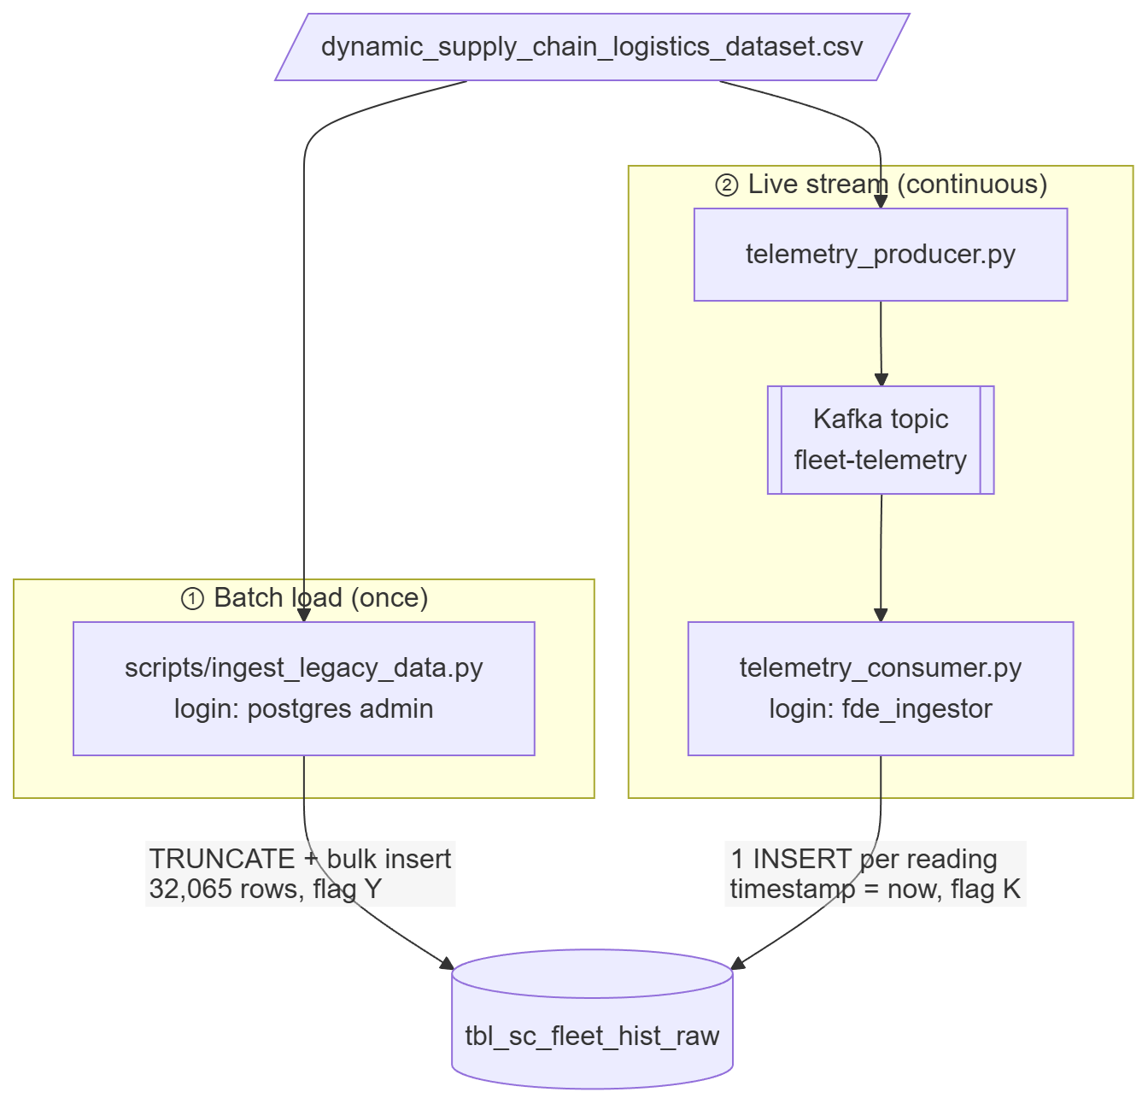
Figure 3
- Batch (history): ingest_legacy_data.py empties the raw table and reloads the whole CSV. It uses TRUNCATE + append instead of "replace", because "replace" would drop the table and break the view that depends on it.
- Stream (live): described in the next section.

6. Live telemetry with Kafka

6.1 Why Kafka?
Real trucks don't send a CSV once. They send a continuous stream of readings. Kafka is the industry-standard way to carry such streams: producers write messages to a topic, consumers read them at their own pace, and the broker holds messages in between, so neither side has to wait for the other.

6.2 How it works
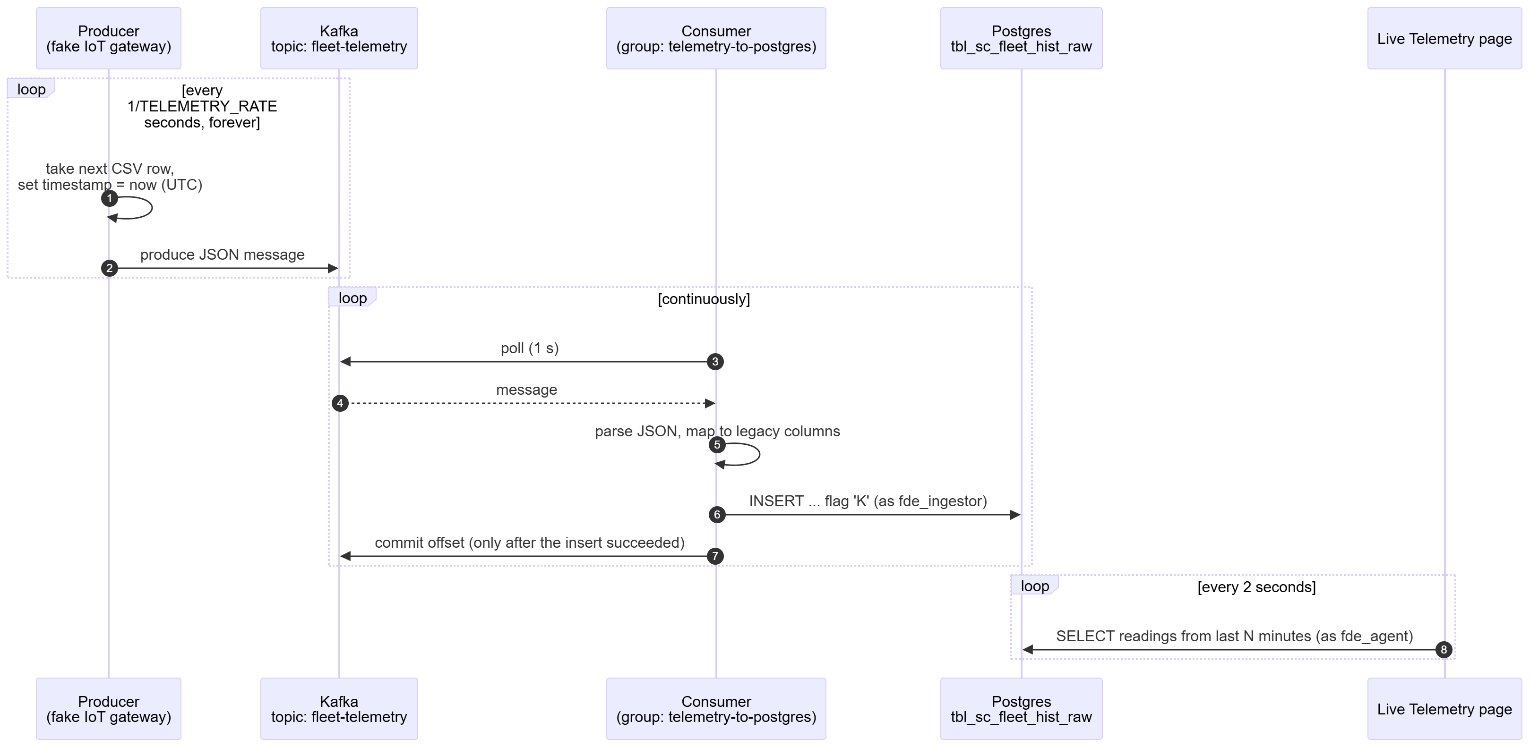
Figure 4
Important details
Detail | Choice | Why
Timestamp | Replaced with current UTC time | Readings look live, so "latest readings" questions work
Rate | TELEMETRY_RATE (default 1/second) | About 86,000 rows per day; easy to change
Looping | Restarts at row 1 after the last row | The demo never runs out of data
Delivery guarantee | At-least-once: the offset is committed after the DB insert | If the consumer crashes mid-way, the message is re-read, not lost
Bad messages | Logged and skipped (offset committed) | One malformed message can't block the whole pipeline
DB login | fde_ingestor, INSERT-only on the raw table | Even a malicious message can't read or delete anything
Broker mode | KRaft (no ZooKeeper), single node, replication factor 1 | Smallest setup that works on a laptop
Listeners | kafka:9092 inside Docker, 127.0.0.1:29092 from your PC | Containers and host scripts both connect. 127.0.0.1 rather than localhost, because Windows may try IPv6 first and fail

The code is in scripts/telemetry_producer.py and scripts/telemetry_consumer.py.
The agent needed no changes for live data. It reads the same view, which simply keeps growing.

7. The SOP knowledge base (RAG with pgvector)

7.1 The SOP
data/policy/Cold_Chain_Incident_SOP_v2.md contains three rule sections:
Section | Rule | Action
1. Temperature | Fresh perishables must stay 0.0–4.0 °C; above 4.0 °C is a critical breach | Contact the driver to restart the cooling unit; if the delay is over 1 h, divert to emergency cold storage
2. Port congestion | Long Beach / LA congestion > 7.0 suspends standard routing | Divert to the Inland Empire Overflow Depot (San Bernardino)
3. Risk escalation | High Risk and delay probability > 0.65 | Escalate to the Tier 2 Logistics Manager

7.2 What is RAG?
Retrieval-Augmented Generation: instead of hoping the LLM "knows" your company rules, you search your own documents for the relevant passages and hand them to the LLM along with the question. The search is by meaning (vectors), not keywords, so "how cold must lettuce be?" finds the "Fresh Perishables" rule.

7.3 Ingestion pipeline
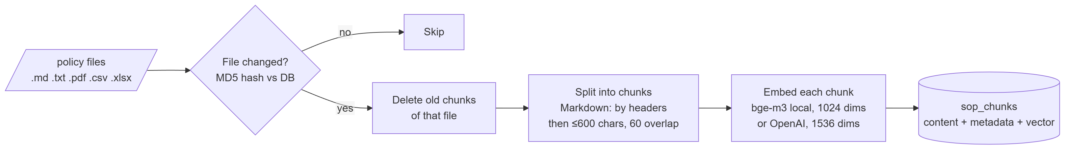
Figure 5
scripts/ingest_sop_pgvector.py handles this:
- Several formats: Markdown (split by headers first, so each chunk keeps its section title), plain text, PDF (page by page), and CSV/Excel (one chunk per row)
- Incremental: each chunk stores its file's MD5 hash, and unchanged files are skipped. Chunks of deleted files are purged. The database itself is the cache, so no separate cache file can drift out of sync.
- Same model at query time: the agent must embed questions with the same model used for ingestion, otherwise the vectors aren't comparable

7.4 Retrieval at question time
SELECT source_file, metadata->>'file_format', content
FROM sop_chunks
ORDER BY embedding <=> CAST(:q AS VECTOR) -- <=> is cosine distance: smaller = more similar
LIMIT 2
The two closest chunks go back to the LLM along with their source file name, which is how the answer can cite the SOP.

8. The AI agent (LangGraph)

8.1 The loop
The agent is a small state machine built with LangGraph (src/orchestrator.py). It is a "ReAct" style loop: reason → act (call a tool) → observe → reason again, until the LLM decides it has enough to answer.
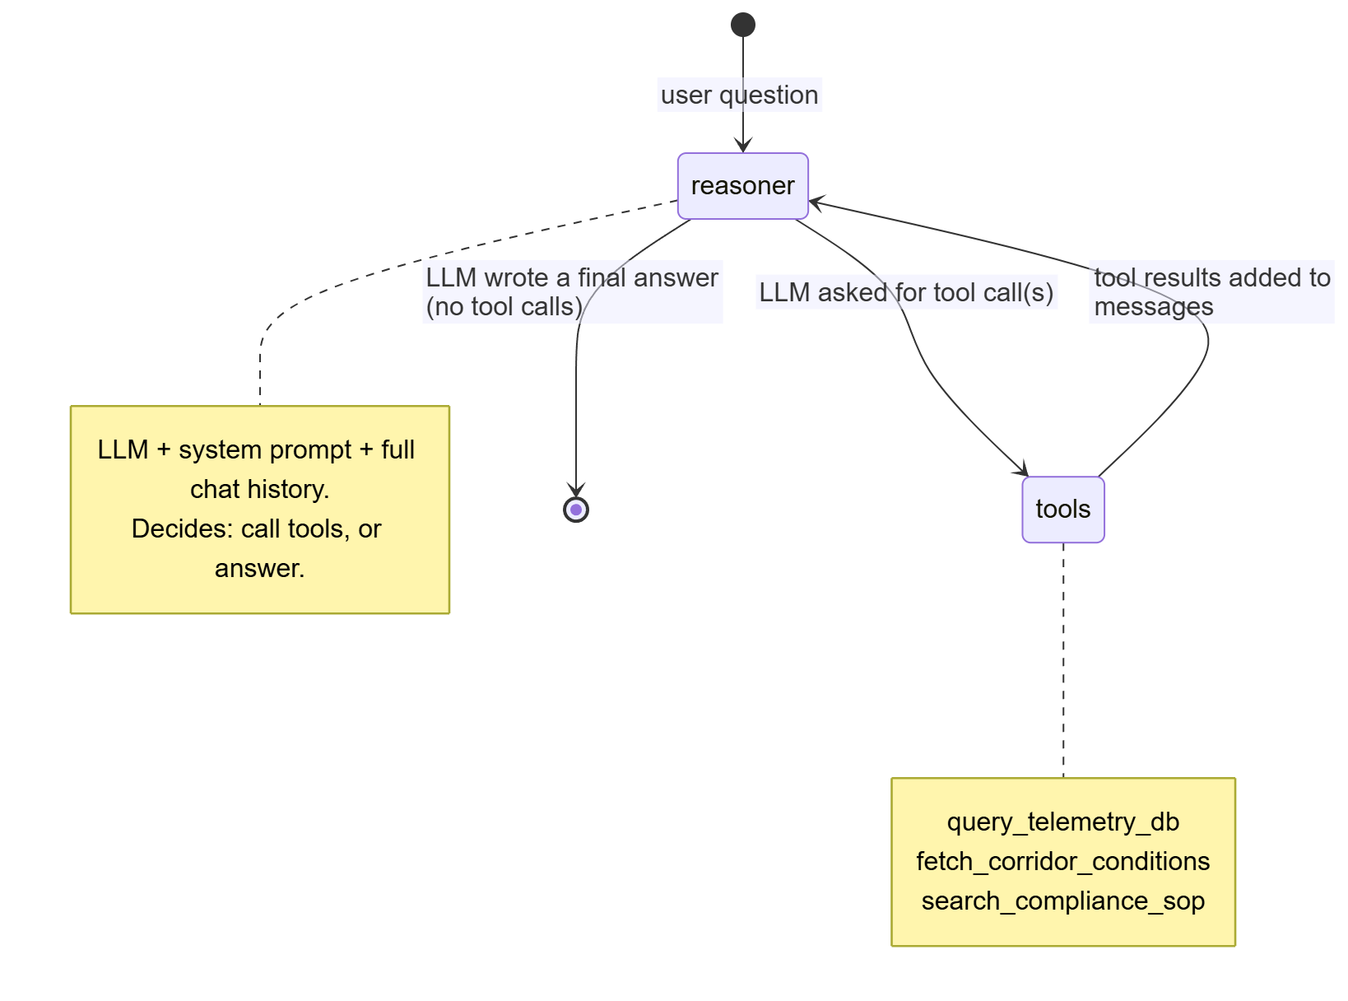
Figure 6
- State: a list of messages (user, AI, tool results). add_messages appends rather than overwrites.
- System prompt: added to every LLM call (not stored in the chat history), so it can't be lost or diluted.
- Memory: MemorySaver keeps each browser session's conversation by thread_id, so follow-up questions work. It is in memory only and resets when the app restarts.

8.2 The three tools
Defined in src/agent_tools.py. The docstring of each tool is what the LLM reads to decide when and how to use it.
Tool | Input | What it does | Safety
query_telemetry_db | SQL string | Runs a query on fde_views.vw_fleet_history, returns up to 10 rows | Must start with SELECT; runs as read-only fde_agent; the DB rejects anything else anyway
fetch_corridor_conditions | latitude, longitude | Calls Open-Meteo for current temperature and wind; wind > 10 km/h means "High Transit Disruption" | 6 s timeout; errors return as text instead of crashing
search_compliance_sop | question text | Vector search in sop_chunks, top 2 chunks with source | Read-only

Every tool returns errors as text instead of raising them, so the LLM can see what went wrong and try again (for example, fix its SQL).

8.3 One question, end to end
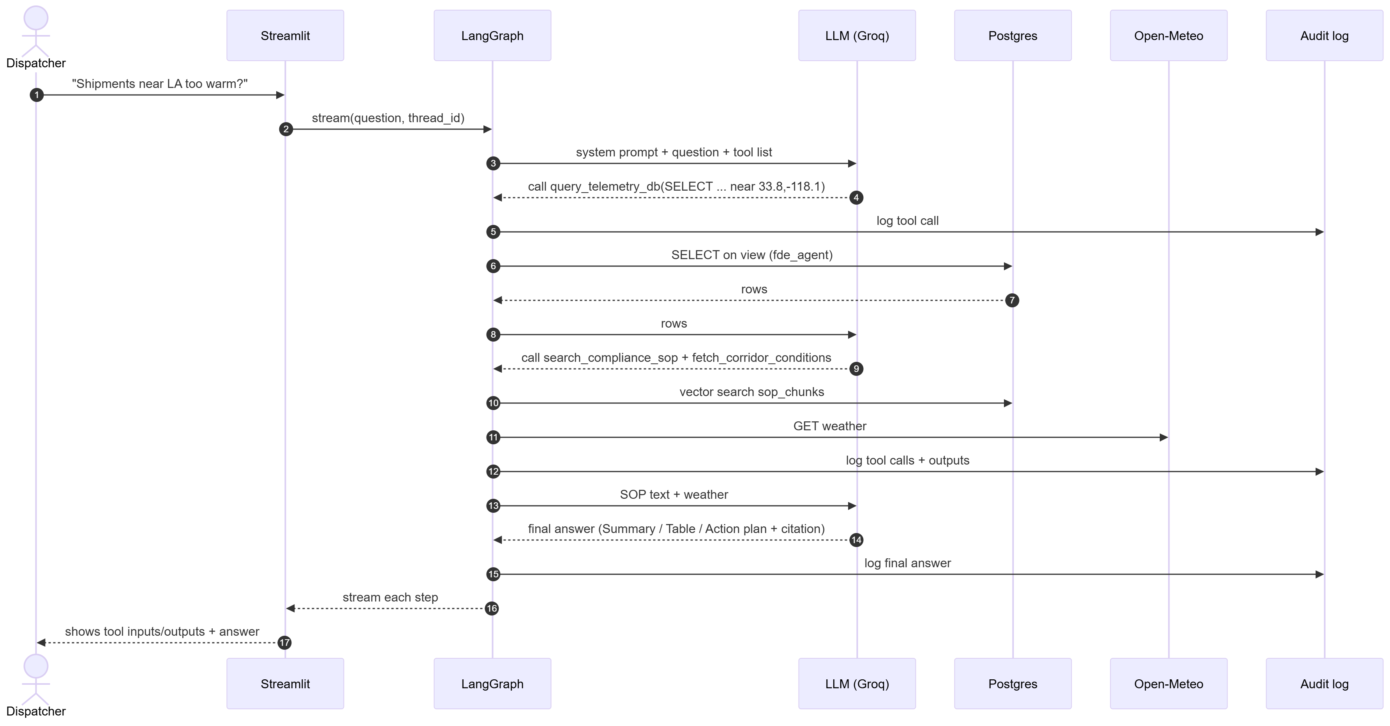
Figure 7
The UI shows each step as it happens: which tool was chosen, its input, and its raw output (in expandable boxes). The user can therefore check why the agent concluded what it did.

8.4 Choosing the LLM
Set Agent_llm in .env:
Value | Model | Cost | Notes
GROQ | openai/gpt-oss-120b (change with GROQ_MODEL) | Free tier | Recommended: no install, fast; free keys are rate-limited
OLLAMA | qwen2.5:7b on your PC | Free | The code's fallback default. Needs Ollama installed and the model pulled (~4.7 GB)
DEEPSEEK | deepseek-v4-flash | Paid, cheap | Needs DEEPSEEK_API_KEY
OPENAI | gpt-4o | Paid | Needs OPENAI_API_KEY

Groq, DeepSeek and OpenAI all speak the OpenAI API, so they share one client class (ChatOpenAI) with a different base_url. The model must support tool calling.

9. Security model
The guiding principle is least privilege: every component gets its own database login that can do only its job. The real security boundary is the database permissions, not the Python code.
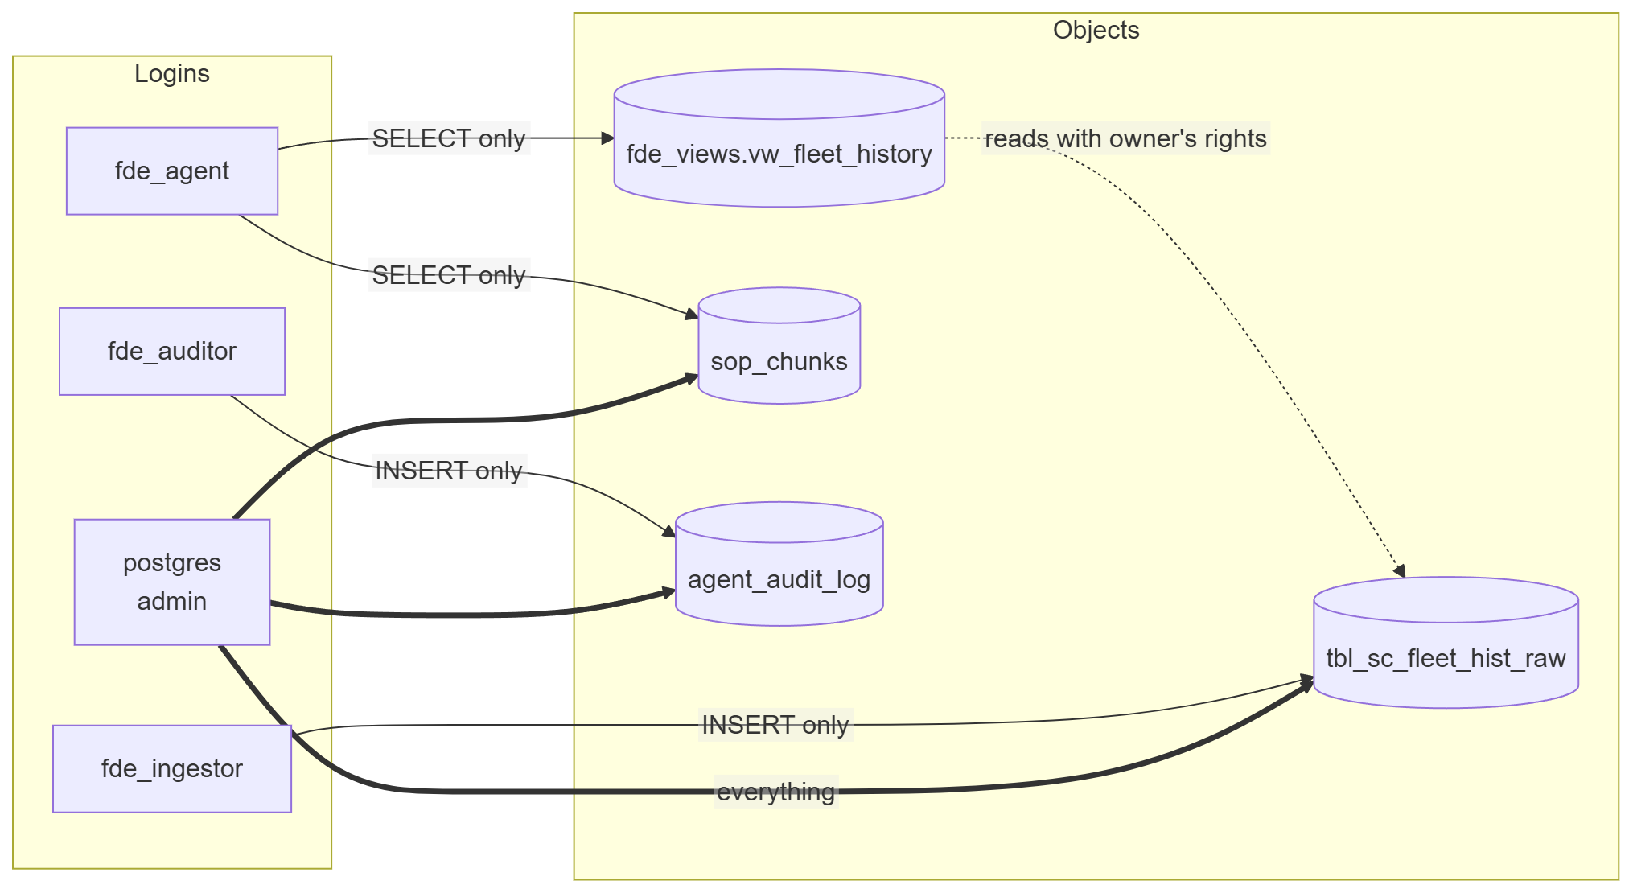
Figure 8
Login | Used by | Can | Cannot
postgres (admin) | Batch ingest scripts, audit-log viewer page | Everything | – (only used by trusted scripts and behind the admin password)
fde_agent | The AI agent and the dashboards | SELECT the view and sop_chunks | Read the raw table or the audit log, or write anything. Its sessions are also forced read-only (default_transaction_read_only)
fde_auditor | Audit-log writer | INSERT into agent_audit_log | Read, change or delete audit rows, so the log is tamper-resistant
fde_ingestor | Kafka consumer | INSERT into the raw table | Read, update or delete anything

Layers of defense against a misbehaving LLM
- The tool rejects queries that don't start with SELECT (a first filter only)
- fde_agent has no write grants at all
- The session is read-only even if a grant slipped through
- The agent sees only the view, never the raw table
- The tool returns at most 10 rows, which limits how much data can leave
Other measures
- Passwords come from .env (git-ignored); .env.example holds only placeholders
- The init scripts are .sh (not .sql), so passwords are read from the environment instead of being written in the repo
- Docker ports bind to 127.0.0.1 only, so other machines on your network can't reach the DB, Kafka or the app
- Audit trail: every tool call, tool output and final answer is stored with the session ID and a timestamp
You can verify the model yourself (Phase 3 in instrutions.md): as fde_agent, selecting from the view works, while selecting from the raw table or deleting anything fails.

10. The web app (Streamlit)
src/ui.py, at http://localhost:8501. The sidebar switches between four pages:
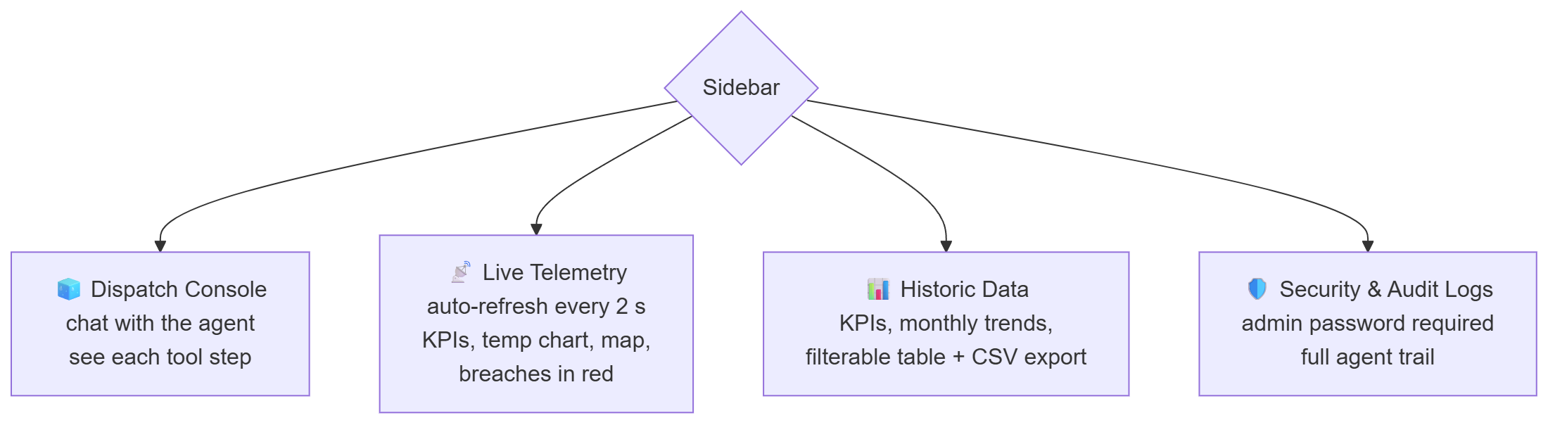
Figure 9
Page | Data source & login | Highlights
Dispatch Console | Agent (fde_agent), writes audit (fde_auditor) | Streams each graph step: "Intent Recognized", tool input JSON, raw tool output, final answer
Live Telemetry | View, last 5/15/30/60 min (fde_agent) | st.fragment(run_every="2s") re-runs only this panel; adjustable alert temperature; "last reading N s ago" shows the stream is alive
Historic Data | View (fde_agent) | Aggregations run in Postgres (only a few rows reach the app) and are cached for 60 s; browser filters by date, risk class and row cap
Security & Audit Logs | agent_audit_log (admin) | Asks for the Postgres admin user and password from .env

The Purge button in the sidebar starts a new session (new thread_id), so the agent forgets the conversation.

11. Running everything (Docker)
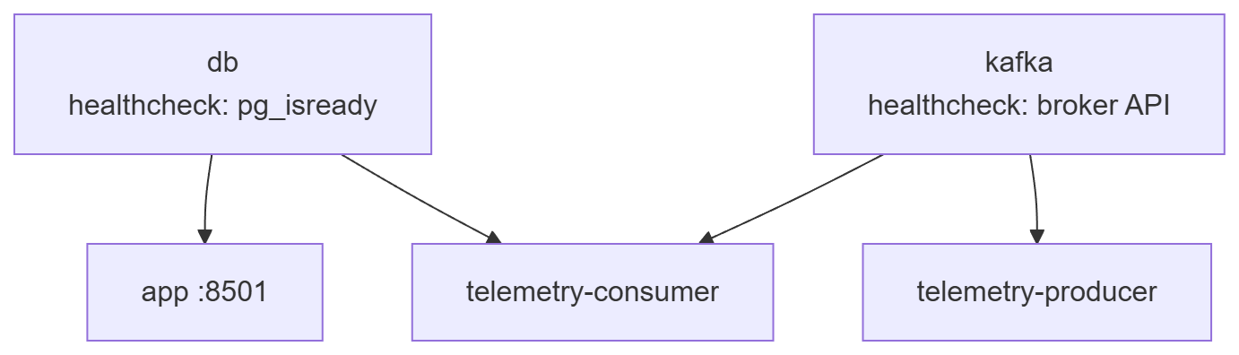
Figure 10
docker compose up -d --build starts all five containers in the right order: each waits for the healthchecks of the services it depends on.
First-time order of operations (details in instrutions.md):
- copy .env.example .env and set passwords and the LLM key
- docker compose up -d db. On the very first start, db/init/01_init.sh and 02_ingestor.sh create tables, the view and the logins
- python scripts\ingest_legacy_data.py loads history
- python scripts\ingest_sop_pgvector.py loads SOP vectors (downloads bge-m3, about 2 GB, once)
- docker compose up -d --build starts the app and the Kafka stream
- Open http://localhost:8501
Volumes (data that survives restarts): pg_data (the database) and hf_cache (the downloaded embedding model). docker compose down -v deletes them and starts from zero.

12. Configuration reference
All settings live in .env (template: .env.example).
Variable | Default | Meaning
POSTGRES_USER / POSTGRES_PASSWORD / POSTGRES_DB | postgres / – / fde | Admin login and database name
PG_HOST / PG_PORT | 127.0.0.1 / 5432 | Where host scripts find Postgres (Docker services override these)
AGENT_DB_PASSWORD | – | Password for fde_agent
AUDIT_DB_PASSWORD | – | Password for fde_auditor
INGEST_DB_PASSWORD | – | Password for fde_ingestor
Agent_llm | OLLAMA | GROQ, OLLAMA, DEEPSEEK or OPENAI
GROQ_API_KEY / GROQ_MODEL | – / openai/gpt-oss-120b | Groq credentials and model
DEEPSEEK_API_KEY, OPENAI_API_KEY | – | Other LLM keys
Embeddings_model | LOCAL | LOCAL (bge-m3) or OPENAI. Must match what the SOPs were ingested with
Local_Embedding_Model | BAAI/bge-m3 | Hugging Face model name
KAFKA_BOOTSTRAP | 127.0.0.1:29092 | Kafka address for host scripts (containers use kafka:9092)
TELEMETRY_RATE | 1 | Readings per second from the producer

13. Repository map
cold-chain-logistics-FDE-Project/
├── data/
│ ├── raw/dynamic_supply_chain_logistics_dataset.csv # the fleet dataset
│ ├── policy/Cold_Chain_Incident_SOP_v2.md # the rules (RAG source)
│ └── source/data.txt # where the dataset came from
├── db/init/
│ ├── 01_init.sh # tables, view, sop_chunks, audit log, agent + auditor logins
│ └── 02_ingestor.sh # insert-only login for the Kafka consumer
├── scripts/
│ ├── ingest_legacy_data.py # batch: CSV -> legacy raw table
│ ├── ingest_sop_pgvector.py # SOP files -> chunks -> embeddings -> sop_chunks
│ ├── telemetry_producer.py # CSV -> Kafka (fake live IoT)
│ └── telemetry_consumer.py # Kafka -> raw table
├── src/
│ ├── db.py # one helper to connect + LEGACY_MAPPING
│ ├── agent_tools.py # the three tools + embeddings setup
│ ├── orchestrator.py # LLM choice + LangGraph loop (+ terminal chat)
│ ├── prompts/system_prompt.txt # agent behaviour and answer format
│ └── ui.py # Streamlit app (4 pages)
├── docs/
│ ├── instrutions.md # step-by-step setup commands
│ └── PROJECT_GUIDE.md # this file
├── Dockerfile # app image (CPU-only torch to keep it smaller)
├── docker-compose.yml # db, app, kafka, producer, consumer
├── requirements.txt # pinned Python packages
├── .env.example # config template (copy to .env)
└── .gitattributes # keeps *.sh files LF so they run in Linux containers

14. Design decisions and trade-offs
Decision | Alternatives considered | Why this one
Postgres + pgvector for both data and vectors | MSSQL + Pinecone (the original design) | One database, one backup, one permission system; runs locally for free; SQL joins are possible between data and SOPs
Clean view over a legacy table | Rename the table, or let the LLM read raw columns | Mirrors real enterprises (you can't rename legacy systems); readable names make the LLM's SQL more reliable; the view doubles as the security boundary
Agent loop with tools (LangGraph) | One big prompt with all the data, or a fixed pipeline | The LLM fetches only what it needs and can skip tools (the "restraint" test); every step is visible and auditable
Separate login per component | One shared app login | A bug or a prompt injection in one part can't affect the others
Kafka for live data | Polling the CSV, or direct inserts on a timer | Matches how real IoT streams work; decouples producer and consumer; shows a real streaming pattern
At-least-once delivery | Exactly-once (transactions) | Much simpler; a rare duplicate reading is harmless for monitoring
KRaft single-node Kafka | ZooKeeper cluster, Redpanda | Fewest containers and settings; the official Apache image
Groq as the recommended free LLM | Ollama (local), paid APIs | No install or GPU needed, free, fast; easy to switch with one setting
Local bge-m3 embeddings | OpenAI embeddings | Free and private; good multilingual quality
Streamlit | React + an API server | One Python file for the whole UI; fast to build and change
Docker Compose on localhost | EC2 / cloud deploy (the original design) | Zero cloud cost; anyone can run it with one command

15. How the project evolved
Stage | What existed
Phase 0 | MSSQL "legacy" database in Docker on an AWS EC2 instance; CSV ingestion
Phase 1 | SOP ingestion into Pinecone (cloud vector DB)
Phase 2 | Data security: SQL view plus a read-only login (USR_FDE_RO)
Phase 3–4 | LangGraph agent with three tools; audit log; Streamlit UI; GitHub Actions deploy to EC2
Current | Everything moved to local Docker: Postgres + pgvector replaces MSSQL + Pinecone; init scripts create the security model automatically; Kafka live stream added; Groq added as a free LLM; Live and Historic pages added; the EC2 CI/CD workflow was removed

16. Known limitations
- Synthetic data: temperatures jump randomly, so most "breaches" are noise, not real equipment trends. There are also no truck or shipment IDs, so the agent identifies trucks by location.
- No vehicle ID: you can't follow one specific truck over time.
- SOP coverage: the SOP defines only Tier 2 escalation. If you ask about Tier 1, the agent may search repeatedly and then guess. Add the missing rules to the SOP (or tell the prompt to say "not covered") to fix this.
- Chat memory is in RAM: conversations are lost when the app restarts.
- Free LLM limits: Groq rate-limits free keys, and models get retired (that's why the model is configurable).
- Live alert default: the Live page's alert defaults to 8 °C, while the SOP limit for fresh perishables is 4 °C. Adjust it on the page.
- Mixed charts: the historic monthly charts include live rows, so the current month appears after 2024.
- Single-node Kafka: fine for a demo, with no fault tolerance.
- No user login on the app: anyone who can reach localhost:8501 can use the console. The audit page is protected by the DB admin password.

17. Ideas for the future
- Proactive alerts: a second consumer on the Kafka topic that checks each reading against the SOP and pushes alerts (Slack or email) without anyone asking
- Vehicle IDs: add a vehicle_id to the producer so trucks can be tracked over time
- Persistent chat memory: use LangGraph's Postgres checkpointer instead of MemorySaver
- Evaluation set: a list of questions with expected tools and answers, run automatically after every change
- App login: Streamlit authentication or a reverse proxy with SSO
- CI: a GitHub Actions job that builds the image and runs the tool tests
- Separate live and historic data in the dashboards using sys_ingest_flag

18. Troubleshooting
Symptom | Cause | Fix
failed to connect to the docker API ... dockerDesktopLinuxEngine | Docker Desktop isn't running (or is still starting) | Start Docker Desktop, wait until it says "running", retry
Chat shows model_not_found (404) | The LLM provider retired the model | Set a current model, e.g. GROQ_MODEL=..., then docker compose up -d app
Chat shows Invalid API Key (401) | Key missing or wrong in .env | Fix GROQ_API_KEY= (no #, quotes or spaces), restart the app
Chat shows connection refused to 11434 | Agent_llm=OLLAMA but Ollama isn't installed or running | Install Ollama and ollama pull qwen2.5:7b, or switch to GROQ
Live page: "No live readings in this window" | Producer or consumer not running | docker compose up -d telemetry-producer telemetry-consumer
Consumer log: password authentication failed for user "fde_ingestor" | DB volume was created before 02_ingestor.sh existed | docker compose exec db bash /docker-entrypoint-initdb.d/02_ingestor.sh
Host script hangs connecting to Postgres or Kafka | localhost resolved to IPv6 on Windows | Use 127.0.0.1 in .env
Code change doesn't show up in the app | The app runs from the built image | docker compose up -d --build app
Init scripts fail with \r: command not found | .sh files got Windows line endings | .gitattributes forces LF; re-checkout the files
UnicodeEncodeError when piping script output on Windows | Emoji in prints with a non-UTF-8 console | set PYTHONIOENCODING=utf-8

19. Glossary
Term | Meaning
FDE | Forward Deployed Engineer: an engineer who builds solutions directly on a customer's real systems and data
Cold chain | A temperature-controlled supply chain (refrigerated transport and storage)
SOP | Standard Operating Procedure: the company's written rules for handling situations
IoT telemetry | Sensor readings sent automatically by devices (here: trucks)
LLM | Large Language Model, e.g. GPT, Llama, Qwen
Agent | An LLM that can decide to call tools (functions) and use their results
Tool calling | The LLM's ability to output a structured request like query_telemetry_db(sql=...) instead of plain text
LangGraph | A library for building agents as graphs of steps (nodes) and transitions (edges)
RAG | Retrieval-Augmented Generation: search your documents, then give the matches to the LLM
Embedding / vector | A list of numbers that represents the meaning of a text; similar meanings give nearby vectors
pgvector | A Postgres extension that stores vectors and finds the nearest ones
Cosine distance (<=>) | How different two vectors' directions are; 0 = same meaning
Chunk | A small piece of a document (here ≤600 characters) that is embedded and searched separately
View | A saved SQL query that looks like a table; here it renames and hides the raw table
Least privilege | Give each component only the permissions it strictly needs
Kafka topic | A named stream of messages (here fleet-telemetry)
Producer / consumer | A program that writes to / reads from a Kafka topic
Consumer group / offset | Kafka tracks, per group, how far it has read (the offset), so it can resume after a restart
KRaft | Kafka's built-in coordination mode, which no longer needs ZooKeeper
At-least-once | Every message is processed at least once; duplicates are possible, losses are not
Streamlit fragment | A part of a Streamlit page that re-runs on its own (here every 2 s)
Docker Compose | A tool that starts several containers together from one YAML file

