BRAC UNIVERSITY
Department of Computer Science and Engineering

Examination: Semester Final  Duration: 2 hours | Semester: Spring 2026  Full Marks: 50
CSE 320/EEE361/ECE361: Data Communications

Answer the following questions.
Figures in the right margin indicate marks.

SET A

Name: | ID: | Section:

1.  [CO2] | a) | The following signal was obtained through Binary Amplitude Shift Keying (BASK):  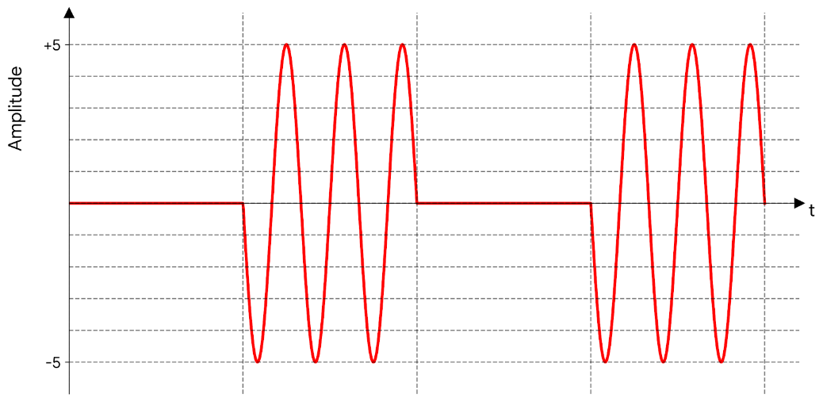  - Decode the bit stream from the signal.  - Identify the carrier signal’s amplitude, frequency and phase. Then, draw a Binary Frequency Shift Keying (BFSK) modulated signal for the same bit stream in (a), with Δf=2 Hz.  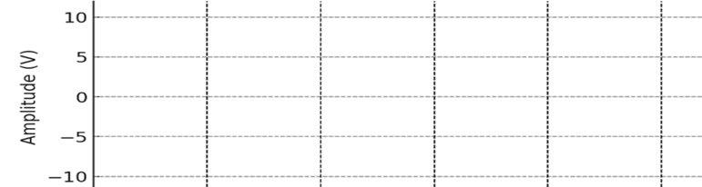 | [1+1+3]
1.  [CO2] | b) | What is the role of a carrier signal in the modulation process? | [2]
1.  [CO2] | c) | Kevin wants to create an analog signal from the bit stream 101110110001. Two bits are used to create each signal element. The phase of the carrier signal for the left bit is 180 degrees, and 270 degrees for the right bit. The carrier signal has two complete waves in a signal element with an amplitude of 5V.  Create a constellation diagram for QPSK showing all the possible bit stream combinations (00, 01, and so on). State the resultant amplitude and phase of all the bit stream combinations. | [4+1]
2.  [CO3] | a) | Assume a telephone company wants to multiplex 10 voice channels (each with 5 kHz bandwidth without any guard band) onto a higher bandwidth line to create a "group". In the next level, 5 groups are multiplexed—requiring a 3 kHz guard band between them—to create a composite signal called a "super group."  At the next level, 6 super groups are multiplexed with a 4 kHz guard band between them to create a "master group" using the FDM technique.  - How many voice channels can be multiplexed together in the master group?  - What is the total required bandwidth for the master group? | [1+2]
2.  [CO3] | b) | Discuss the disadvantages of Statistical TDM with an example. | [2]
2.  [CO3] | c) | A TDM system multiplexes four input channels of 100 kbps each, using 8 interleaved bits. If the output bit rate of the TDM is 425 kbps, find out the number of synchronizing bits used in each frame. | [2]
2.  [CO3] | d) | Consider 5 channels, each having a different input data rate. The data rate of the first channel is 8 MBps. The next three channels each have half the data rate of the first channel, and the final channel has a data rate of 31.9 Mbps. You need to multiplex these channels in such a way that the total number of channels is reduced to two. If the interleaving unit is a character, plus 1 bit is used for synchronization. Answer the following:  - Draw the figure to visualize the multiplexing process with proper labels.  - Calculate the input data rate.  - Find the Frame duration.  - Determine the Frame rate.  - Identify the output data rate.  - Calculate the output bit duration. | [3+1+1+1+1+1]
3.  [CO4] | a) | A ground station receives data transmissions from a satellite using CRC error detection technique. The system uses the notation C (7,4). The satellite encodes messages using the following generator polynomial:  "The divisor has “1” as its left and right bit. The 2nd and 3rd bits from the left are 1 and 0 respectively. The Data word is 1010 and is encoded correctly at the sender side.  - From the description, determine the generator in binary. Write down the augmented Dataword.  - Due to cosmic interference, the receiver gets 1011011. Using CRC, determine whether the received codeword contains any error. Show full division steps. | [2+3]
3.  [CO4] | b) | A linear block coding scheme is used to encode Dataword into Codeword. The following table shows the encoding scheme:  Note: In a linear block coding scheme, XOR-ing two distinct valid codewords produces another distinct codeword.  - From the table above, find the missing codeword.  - Determine the number of valid and invalid codewords of the given scheme. | [1+2]
  Dataword | Codeword
  00 | 0000000
  01 | 0111100
  10 | 1000111
  11 | ?
3.  [CO4] | c) | A data packet is made of four 7-bit numbers (21)₁₀ , (x)₁₀ , (45)₁₀ , (33)₁₀ . The checksum on the sender side is (14)₁₀. The value of sum and wrapped sum are exactly the same.  - Find the value of the wrapped sum.  - Find the value of x.  - While transmission, the first number is changed to (15)₁₀ , the third number to (49)₁₀ and fourth number to (35)₁₀. Show with proper calculation if the error can be detected. | [1+2+2]
4.  [CO4] | a) | In a computer lab, many students are working at their computers and using a shared connection. Sometimes, multiple students want to send their work or open online resources simultaneously. Each student first checks if the network seems free or busy. If it looks busy, they keep waiting and checking until it becomes free. When it finally becomes free, no one jumps in instantly.  - Name the CSMA variant (1-persistent, non-persistent or p-persistent) used here.  - Mention one drawback of 1-persistent and non-persistent methods.  - Write the role of T_{B} (Back-off time) in CSMA/CD? | [1+2+1]
4.  [CO4] | b) | In a shared communication link, there are two stations on either side. They are using the CSMA/CD protocol to detect any collision occurring during transmission. The minimum frame size to detect collision is 700 bytes, the speed of propagation is 5 x 10⁷ m/s, and the bandwidth of the channel is 20 Mbps.  - Find out the vulnerable time of the system.  - Identify the distance between the two stations. | [2+1]
 | c) | A smart agriculture system uses a satellite uplink to send soil sensor readings. A single data frame from one node consists of 800 characters, each encoded using 7 bits per character. The satellite channel bandwidth is 1.4 Mbps.  - Determine the frame transmission time T_{fr.}  - Find the vulnerable time for both Pure ALOHA and Slotted ALOHA. | [1+2]

---END---

