BRAC UNIVERSITY
Department of Computer Science and Engineering

Examination: Semester Final Semester: Summer 2023
Duration: 1 hr. 45 min Full Marks: 40

CSE 320/EEE361/ECE361: Data Communications

Answer the following questions.
Figures in the right margin indicate marks.

SET A

Name: | ID: | Section:

1.  [CO2] | a) | Show the staircase in the following graph and generate the digital data from the given analog signal using the Delta Modulation (DM) technique.  You must answer this question in the question paper only.  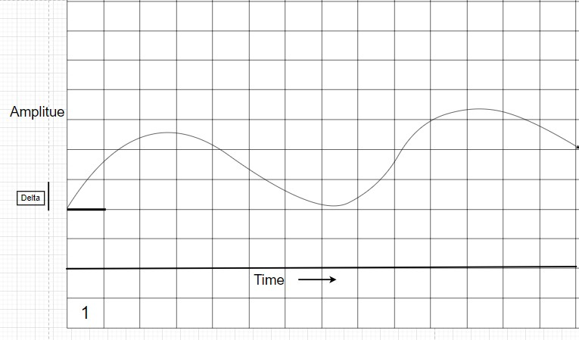 | 5
[CO4] | b) | What is the function of the twisting in twisted-pair cable? | 2
[CO4] | c) | What is the purpose of cladding in an optical fiber? Which type of optical fiber cable is recommended for long haul communication and why it is so? | 3

2.  [CO3] | a) | Consider, you have 4 sources, each creating 250 characters per second. If the interleaved unit is two characters long and 1 synchronous bit is added to each frame, find the followings:  - What is the size of a frame (in bits)?  - What is the frame rate (fps)? iii. What is the input bit rate (in bps)? iv. What is the output data rate (in bps)?  v. What is the output bit duration (in sec)? | 5
[CO3] | b) | Suppose you have three channels among which two channels have a bandwidth of 1600 kbps and one with 1200 kbps. How would you multiplex this without using any extra pulses? Draw and validate with visual representation. | 3
[CO3] | c) | Differentiate between Multiple slot multiplexing and Multilevel multiplexing. | 2
3.  [CO3] | a) | Assume we want to send the following signal using DSSS technique. For ensuring higher security, we have invented a 5-bit spreading code “10110”. Draw the corresponding spread signal on the question paper. You can use bipolar NRZ encoding (0 = negative voltage, 1 = positive voltage) for signal drawing. Comment on the bandwidth of the spread signal in brief.  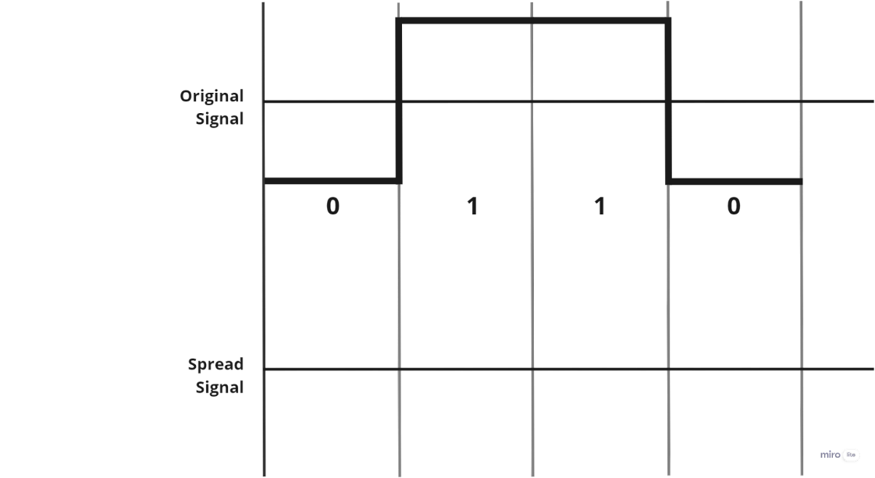 | 5
[CO5] | b) | Suppose, all the stations are transmitting following CSMA/CD protocol. Station 1 and Station 3 are at opposite ends of the common multipoint link that 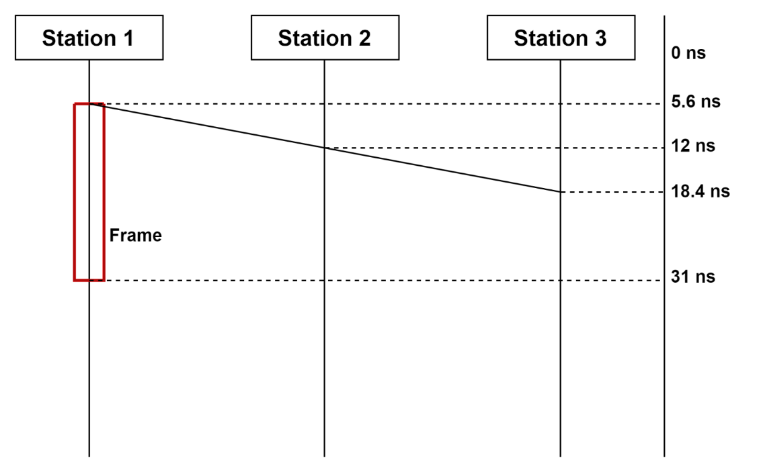all the stations share. The bandwidth of the link is 10 Gbps.  - Find out the transmission time and maximum propagation time from the given diagram.  - If collision detection methods are introduced, what should be the minimum size of the frame in bytes? Does the frame in the given diagram meet the minimum size requirement? | 5
4.  [CO5] | a) | Consider an environment where usually most stations remain idle (no data to send), which multiple access protocol is suitable in such a scenario? Justify. | 2
 | b) | As a network administrator, you want to provide a fair bit rate or data rate (R/N) in respect to the time to each of the stations. Mention the name of the MAC protocol that satisfies the condition. What is the drawback of this protocol in terms of bandwidth utilization of a common channel, validate with a diagram. [You can imagine any number of stations that transmit data.] | 3
 | c) | Let us assume a packet is made only of four 16-bit words (450F)₁₆, (1A4)₁₆, (A309)₁₆, and (B00)₁₆. (Hint: The given words are in hexa-decimal value, that means, each digit can be represented by 4 bits. Remember hexadecimal values range from 0000 – FFFF).  - Show the checksum at the sender.  - Synthesize a case where checksum method will fail to detect error and show how the checksum method will fail. Explain the reason of failure. | 5

---END---

