BRAC UNIVERSITY
Department of Computer Science and Engineering

Examination: Semester Final  Duration: 1 hour 45 min | Semester: Spring 2025  Full Marks: 45
CSE 320/EEE361/ECE361: Data Communications

Answer the following questions.
Figures in the right margin indicate marks.

SET B

Name: | ID: | Section:

1.  [CO2] | a) | In a QPSK, the amplitudes and the phases are as follows for pairs of bits.  The carrier frequency contains 2.5 cycles for each signal element. Given the bit sequence 1011000110, Draw the analog signal.  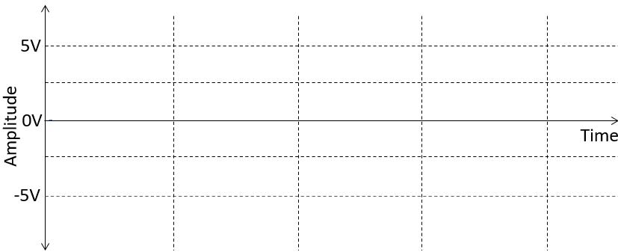 | [5]
  Bits | Amplitude | Phase
  00 | 5 | 315
  01 | 5 | 225
  10 | 5 | 45
  11 | 5 | 135
2.  [CO3] | a) | A control system has 4 devices. In the first time slot, only devices 1, 3 and 4 have data. In the second time slot, devices 1, 2 and 4 have data.  - What TDM technique should be used here?  - Sketch a figure of the TDM process and show the frames.  - If two bits are used for addressing, determine the frame size.  - Does this scheme have any drawbacks? Justify. | [1+2+1+1]
 | b) | In this hierarchical TDM, calculate the frame rate and output rate for DS-3.  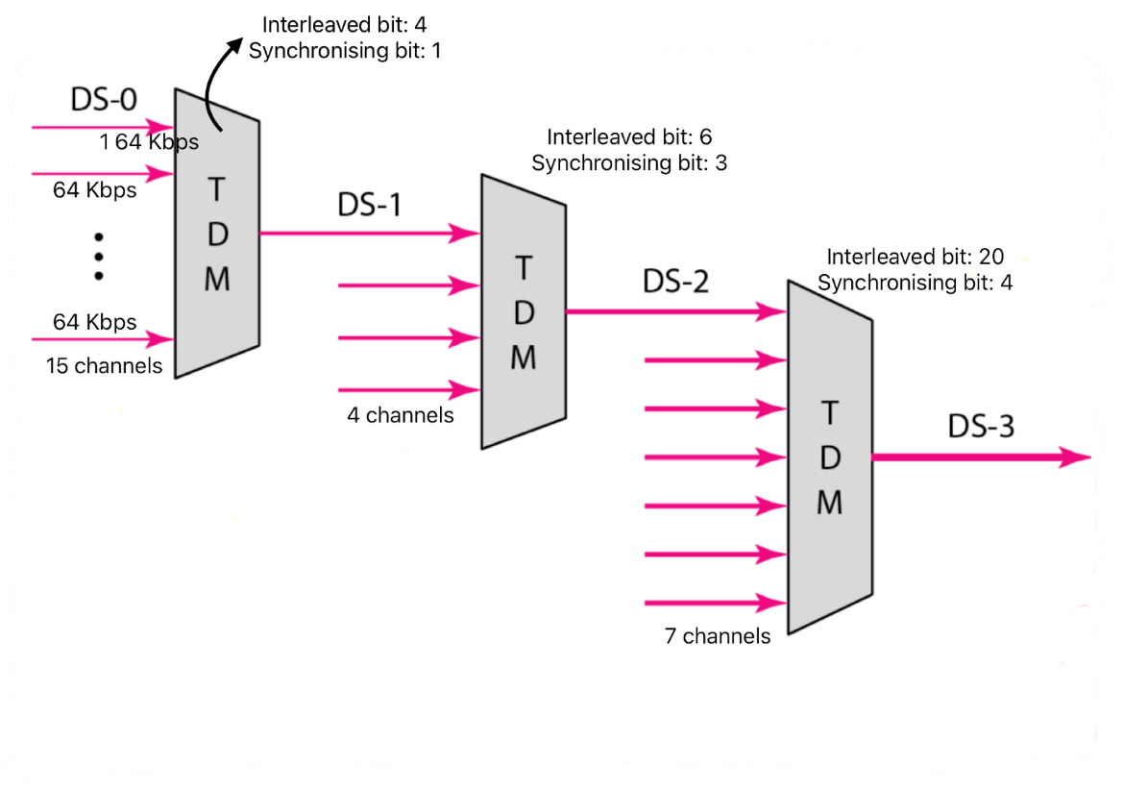 | [7]
 | c) | In a FDM, 4 input channels are multiplexed together. The size of the assigned bandwidth for each channel are 3 KHz, 7 KHz, 11 KHz and 15 KHz respectively. If the guard band is 4 KHz. What is the overall required bandwidth of the output channel? | [3]
3.  [CO4] | a) | Suppose a sender is sending a message consisting of five 5-bit numbers to the receiver. In both ends, traditional checksum is being used to detect errors.  - Is the actual checksum from the sender equal to the checksum received by the receiver?  - Are there any errors in the data received? Explain if the errors are detectable using checksum or not. | [4]
  Sender |  | Receiver
  Data | 8  12  14  0  9 | Data | 9  12  13  0  9
  Actual Checksum | ? | Received Checksum | 19
3.  [CO4] | b) | Observe the Block Coding scheme below.  - Calculate the minimum hamming distance.  - How many errors can this scheme detect and how many can it correct?  - Receiver receives the two codewords 1101000 1110011. Identify if there were any errors in the received codewords. For each codeword, find the original data after error correction? | [6]
  Dataword | Codeword
  00 | 0001111
  01 | 0110011
  10 | 1000110
  11 | 1111000
3.  [CO4] | c) | Suppose you want to crack promo codes for your favorite “PAAPJI” games. You know that the game publishers are using CRC to verify the legitimacy of an entered code. Upon some research, you partially cracked the following info for one of your entries.  - Codeword: x⁷ + x⁴ +x³ + x +1  - Quotient: x⁴ + x³+x²+x +1  - C (8,5)  However, sigh! No mention of the divisor. But a genius like you would never stop to crack your favorite game! So, you combined your current Data Comm. lesson and your high school math formula –  Dividend = Divisor* Quotient ⊕ Remainder  Now show us how you did it by answering the following questions.  - From the given Codeword and C(n,k), find out what the remainder was? Why so?  - What was the dividend? Why so?  - From (i), (ii), and the formula, find out the correct divisor. Show full steps.  Hint: Binary and Polynomial CRC are interchangeable. You may use any of them, whichever feels suitable for a question. All operations are in modulo-2 arithmetic. | [1+1+3]
4.  [CO4] | a) | Four devices are sharing a single communication channel using the CSMA/CD protocol as shown in the figure below. Propagation speed of the medium is  2.5*10⁶ m/s.  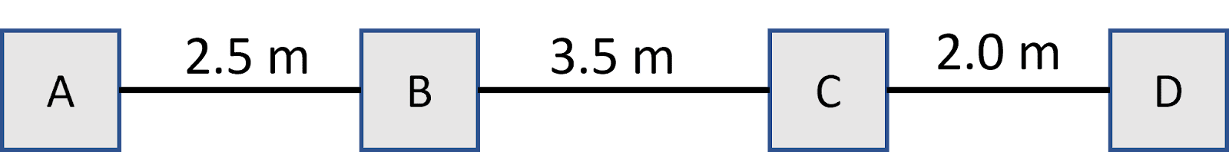  - Suppose, device A wants to send a frame to another device. If the channel bandwidth is 5 Mbps (megabits per sec), what will be the minimum frame size required? What if the frame size is smaller than that?  - Suppose, device B starts sending a frame at time 2.0 μs (microsecond). Device D starts sending a frame at 4.5 μs. Find out whether this will lead to a collision. | [3+3]
4.  [CO4] | b) | Suppose, you are developing a wired LAN in a small office where multiple computers frequently share a common Ethernet channel. Which multiple access protocol should be used here? Explain. | [2]
4.  [CO4] | c) | Three devices are sharing a common channel using slotted ALOHA protocol. Frame transmission time is 10 μs (each frame takes 10 μs to transmit). Each slot is 10 μs.  - Device A generates ONE frame at times 15 μs.  - Device B generates ONE frame at times 22 μs.  - Device C generates TWO frames at times 8 μs and 27 μs.  Using a figure, find out how many frames will be successfully transmitted. | [2]

---END---

