BRAC UNIVERSITY
Department of Computer Science and Engineering

Examination: Semester Final  Duration: 2 hours | Semester: Spring 2023  Full Marks: 50
CSE 320/EEE361/ECE361: Data Communications

Answer the following questions.
Figures in the right margin indicate marks.

SET B

Name: | ID: | Section:

1. [CO5] | a) | Suppose you want to transmit the message 1011101000 and protect it from errors using the CRC generator polynomial x⁴+ x³ + x+ 1. Use polynomial long division to determine the message that should be transmitted.  Later, at the receiving end codeword x¹³+ x¹² + x¹⁰ + x⁵+ x³ + x+ 1 is received. Is it valid or not? Show the calculation. | 6
 | b) | How frame transmission time is calculated in CSMA/CD? Token passing is better than CSMA/CD, state three points, how. | 4
2. [CO3] | a) | Four channels, two with a bit rate of 200 kbps and two with a bit rate of 150 kbps, are to be multiplexed without adding extra pulse in the input channel. If there are two synchronization bits in the output frame. Write the following answers:  - What is the size of a frame in bits?  - What is the frame rate?  - What is the duration of a frame?  - What is the data rate?  - What is the input bit duration?  - How many input channels are there after doing multiplexing? | 6
 | b) | The Following FDM hierarchy has been used by a telephone company. How many voice channels can be multiplexed together in the master group? What is the required bandwidth for the multiplexing?  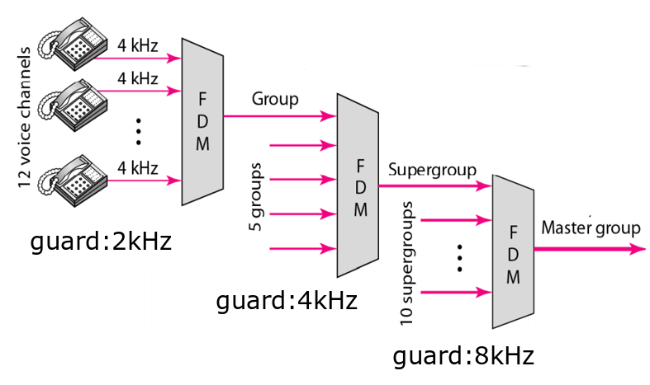 | 4
3. [CO2] | a) | Show the staircase in the following graph and generate the digital data from the given analog signal using the Delta Modulation (DM) technique.  Answer this question in the question paper only.  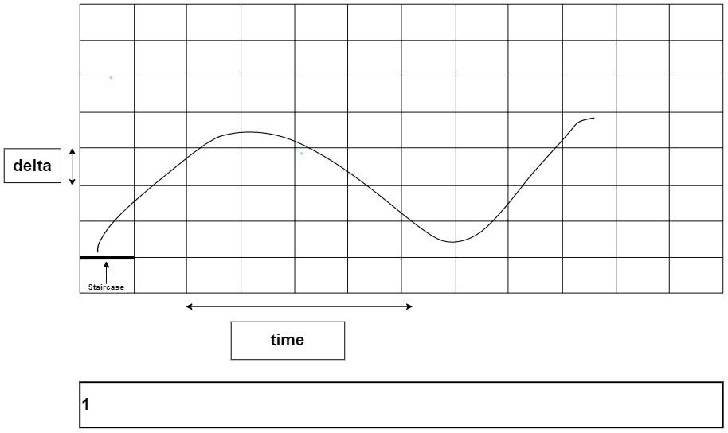 | 6
[CO4] | b) | Suppose, you are using fiber optic cable and you want the density of the core to vary gradually such that it is maximum at the center of the core. Illustrate the diagram. What will the figure look like if you keep the densities constant? | 4
4. [CO5] | a) | What are the major drawbacks of controlled-access protocols for a large network? Why can the CSMA/CD multiple access protocol not be used in wireless networks? | 3
 | b) | In CSMA/CD, how does a node detect that collision is happening? And what does the node do when it detects a collision? | 3
 | c) | The 2 bit datawords are converted to the following 5 bit codewords. For how many bits can we successfully detect and correct errors using this scheme? | 4
  Dataword | Codeword
  00 | 00000
  01 | 10101
  10 | 01011
  11 | 11110
5. [CO3] | a) | We have a digital medium with a data rate of 20 Mbps. How many 32-kbps  voice channels can be carried by this medium if we use DSSS with the Barker  sequence? | 3
 | b) | Suppose, you are given with the k-bit pattern and Carrier Frequency as follows:  k-bit pattern  Draw FHSS cycle 2 times using the above pseudo random generated k-bit pattern and given frequency table. (** Hint: Draw the Carrier frequency graph against hop period) | 4
  10 01 11 00
  k-bit | Carrier Frequency
  00 | 150 kHz
  01 | 250 kHz
  10 | 350 kHz
  11 | 450 kHz
 | c) | Suppose you have five channels among which three channels have a bandwidth of 1200 kbps and two with 1170 kbps. What is the smartest way to multiplex these channels without involving too many sub channels? Draw and validate with visual representation to aid your reasoning. | 3

---END---

