BRAC UNIVERSITY
Department of Computer Science and Engineering

Examination: Semester Final Semester: Summer 2023
Duration: 1 hr. 45 min Full Marks: 40

CSE 320/EEE361/ECE361: Data Communications

Answer the following questions.
Figures in the right margin indicate marks.

SET B

Name: | ID: | Section:

1.  [CO2] | a) | Show the staircase in the following graph and generate the digital data from the given analog signal using the Delta Modulation (DM) technique.  You must answer this question in the question paper only.  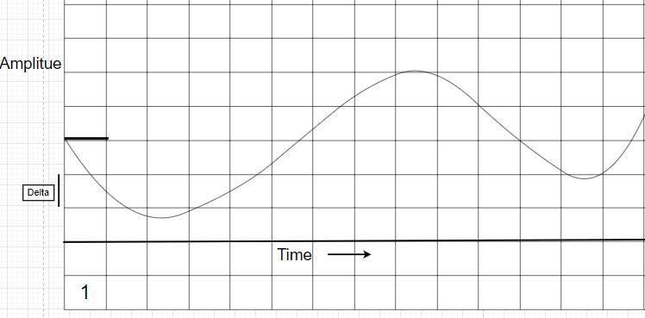 | 5
[CO4] | b) | How does sky propagation differ from line-of-sight propagation? Give an example. | 2
[CO4] | c) | Explain the step index and graded index mode in fiber optic cable with diagram. | 3
2.  [CO3] | a) | Consider, a synchronous TDM which combines 12 digital sources, each of 300 Kbps. Each output slot carries 4 bits from each digital source, but one extra bit is added to each frame for synchronization. Answer the following questions:  i. What is the frame rate (in fps)? ii. What is the input bit rate (in bps)? | 5

- What is the output data rate (in bps)?
- What is the output bit duration (in sec)?
- What is the frame size (in bit)?
[CO3] | b) | Suppose you have three channels among which two channels have a bandwidth of 1200 kbps and one with 1400 kbps. How would you multiplex this without using any extra pulses? Draw and validate with visual representation. | 3
[CO3] | c) | Differentiate between synchronous TDM and statistical TDM. | 2
3.  [CO3] | a) | Assume we want to send the following signal using DSSS technique. For ensuring higher security, we have invented a 5-bit spreading code “01011”. Draw the corresponding spread signal on the question paper. You can use bipolar NRZ encoding (0 = negative voltage, 1 = positive voltage) scheme for signal drawing. Comment on the bandwidth of the spread signal in brief.  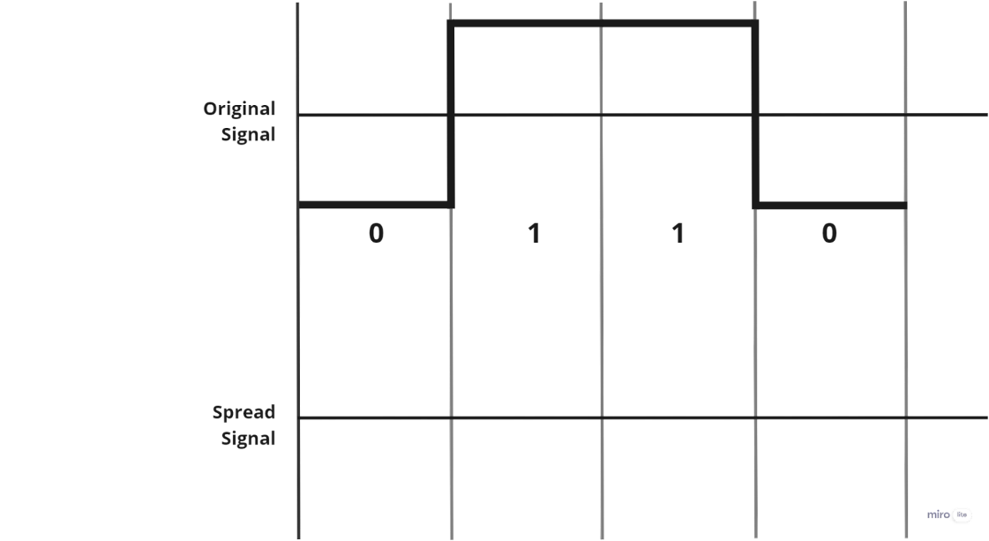 | 5
[CO5] | b) | Suppose, all the stations are transmitting following CSMA protocol. Station 1 and Station 3 are at opposite ends of the common multipoint link that all the 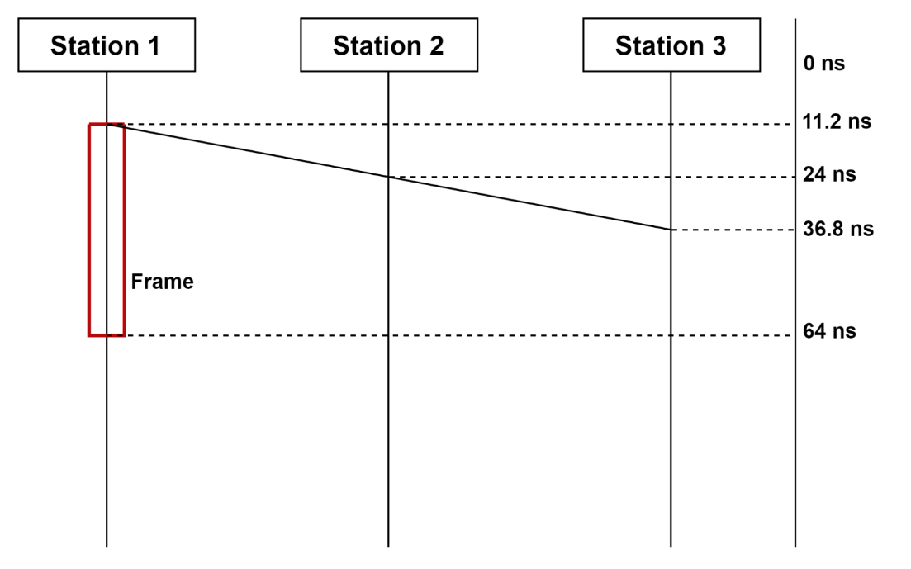stations share. The bandwidth of the link is 15 Gbps.  - Find out the transmission time and maximum propagation time from the given diagram.  - If collision detection methods are introduced, what should be the minimum size of the frame in bytes? Does the frame in the given diagram meet the minimum size requirement? | 5
4.  [CO5] | a) | Consider an environment where usually most stations remain active, which multiple access protocol is suitable in such a scenario? Justify. | 2
[CO5] | b) | Among the 1-persistent and p-persistent methods, which one is more likely to result in more collisions? Explain your answer briefly. | 3
[CO5] | c) | Let us assume a packet is made only of four 16-bit words (703D)₁₆, (2E6)₁₆, (B308)₁₆, and (C00)₁₆. (Hint: The given words are in hexa-decimal value, that means, each digit can be represented by 4 bits. Remember hexadecimal values range from 0000 – FFFF).  - Show the checksum at the sender.  - Synthesize a case where checksum method will fail to detect error and show how the checksum method will fail. Explain the reason of failure. | 5

---END---

