BRAC UNIVERSITY
Department of Computer Science and Engineering

Examination: Semester Midterm  Duration: 1 hour 10 min | Semester: Spring 2023  Full Marks: 30
CSE 320: Data Communications

Answer the following questions.
Figures in the right margin indicate marks.

SET A

Name: | ID: | Section:

1.  [CO1] | a) | Label the frames (1 and 2) shown below with appropriate Port, IP and MAC addresses. The sender A is requesting for a web page to the Web server by sending frame 1. The web server is sending frame 2 to Host S. Assume the numbers mentioned in the figure represent IP addresses and the alphabets are MAC addresses. While mentioning the port addresses, you can use any value from the appropriate ranges.  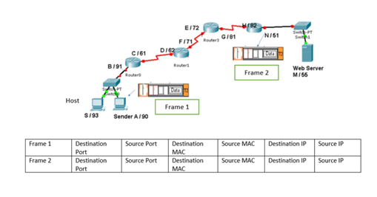 | [4]
1.  [CO1] | b) | Illustrate diagrammatically a hybrid topology with a ring backbone and three star networks consisting of 4 nodes at each hub. In the topology drawn, identify one possible problem or failure that could bring the whole network down and justify your answer. | [2]
 | c) | Identify the name of the TCP/IP model layers based on the following functionalities:  - The layer processes information which helps us identify a network.  - The layer responsible for transmitting data over fiber-optic.  - This layer translates messages from one language to another.  - This layer uses sequence numbers to sort segments. | [4]
2. [CO2] | a) | A non-periodic composite signal contains frequencies from 25 to 60 KHz. The peak amplitude is 30 V for the lowest and the highest signals and is 10 V for the 45-KHz signal.  What is a non-periodic composite signal?  What is the bandwidth of this signal?  Assuming that the amplitudes change gradually from the maximum to the minimum and then minimum to the maximum , draw the frequency spectrum. | [1+1+1]
2. [CO2] | b) | Suppose AB = 0.5km, BC = 0.6km and CD= 0.5km. The signal has a power of 3mW at the beginning of the cable (point A). Predict if the signal has gained or lost in power at point D? (measure in dB)  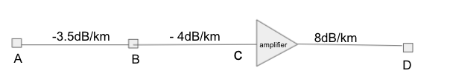 | [2]
 | c) | Consider a channel with a bandwidth of 2 MHz. The strength of the intended signal is 40mW and 60 times stronger than the noises present in the channel.  i) Interpret the upper limit of the data rate that the channel can carry?  ii) In practice, better error performance can be achieved if we use a lower data rate. Assume we choose a data rate ⅔ of the maximum upper limit. How many signal levels are needed to achieve this data rate?  iii) If we change the bandwidth to 4 MHz. How changes in signal levels should be made to maintain the same data rate? | [1+2+2]
3.  [ CO2] | a) | Convert the following bit stream to digital signal using an appropriate encoding scheme that matches the requirements given below. Write which signal encoding scheme you are using.  Given Data: 1 0 1 1 0 0 0 0 0 0 0 0 0  Given Requirement 1 : The encoding scheme does not support self-synchronization for long 0’s.  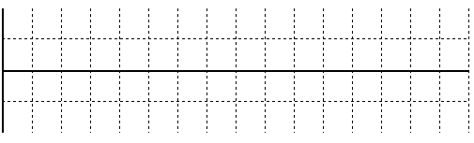  Given Requirement 2 : Now apply a North American technique to prevent long sequences of 0’s without increasing signals. | [2.5+2.5]
 | b) | The following table depicts a sampled analog signal for digital signal representation. By applying the concept of Pulse Code Modulation, assume there will be 3-bit code words for each sampled amplitude. Show the normalized PAM value and quantization code for the given analog signal value at different time stamps. Assume that the sampling amplitudes are between -32V to +32V. | [5]
  Time | Analog Signal Value (V)
  0 | 4.7
  1 | 12.3
  2 | -6.8
  3 | -28.3
  4 | 20.3

---END---

