BRAC UNIVERSITY
Department of Computer Science and Engineering

Examination: Semester Midterm  Duration: 1 hour 30 min | Semester: Spring 2024  Full Marks: 30
CSE 320: Data Communications

Answer the following questions.
Figures in the right margin indicate marks.

SET A

Name: | ID: | Section:

1.  [CO1] | a) | You have been tasked to work with the network topology shown below. Assume the physical addresses to be the uppercase letters and the logical addresses to be the lowercase letters. For the Devices, use a Port number from the dynamic range (49152 - 65535).  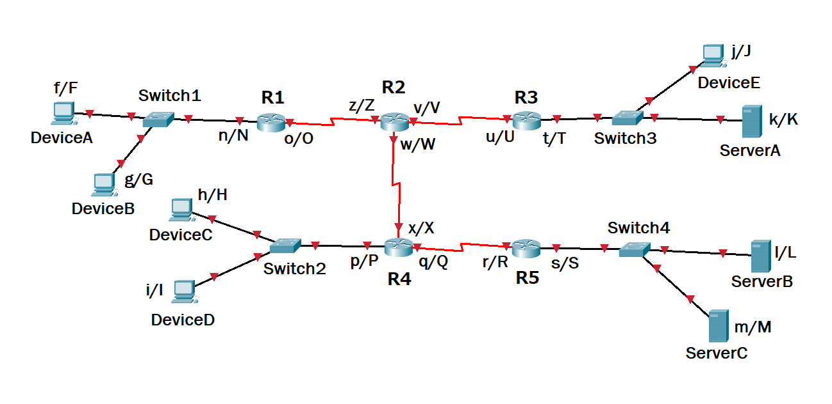  - How many networks are there in total? What is a hop-to-hop delivery and which layer of the OSI model is responsible for maintaining this?  - Device E has a process running which is trying to receive a data frame from Server A, which is a Web Server using Port 80.  How many hops will there be? Complete Frame 1 below by writing the Destination and Source physical, logical and appropriate port addresses if the data frame is in its second hop. | [2+4]
  Frame1 | D. Mac | S. Mac | D. IP | S. IP | D. Port | S. Port | Data | Trailer
1.  [CO1] | b) | Suppose, a hospital has four buildings. Each building has an administration ward and a patient care ward. There are 3 nodes in each ward. Identify the topologies and draw the hybrid network that satisfy the following criteria:  - Each ward can communicate with each other as they are connected centrally. If one ward gets disconnected, the other ward remains active.  - The devices in both wards use a central backbone line and are connected using multipoint connections only.  - Dedicated point to point connection is used to connect buildings with each other. | [4]
2.  [CO2] | a) | A document takes 0.5 minutes to download over a communication channel, assuming the channel is completely noiseless. The data rate of the channel is 10 Mbps and the bandwidth is 1.5 MHz, analyze the following aspects  - Calculate the number of characters present in the document.  - Determine the value of the signal Level. | [2+2]
 | b) | Alice is calling Bob through a hybrid communication system as shown in the following figure. Suppose the signal power is 801 mW at Alice's phone. The power loss rate from Alice to Tower 1 is 2.14 mW/km. The final attenuation from Alice to Bob is -0.9745 dB.  - Calculate the attenuation for the signal transmitted from SAT to Tower 2.  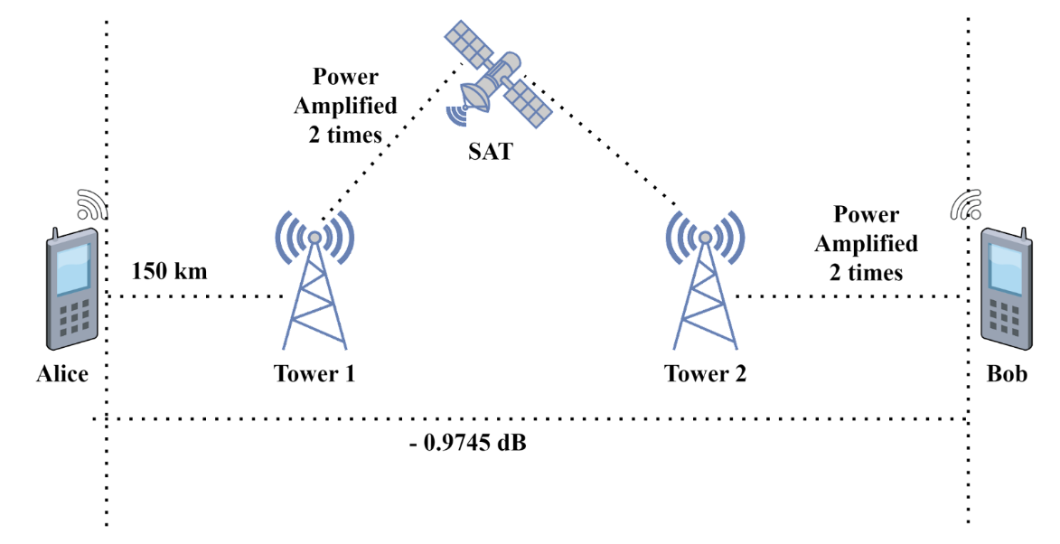 | [3]
 | c) | A periodic composite signal is characterized by a bandwidth of 20 kHz and a starting (minimum) frequency of 25 kHz. The signal exhibits peak amplitudes of 12 V, 18 V, and 24 V corresponding to the lowest, highest, and midpoint frequencies within its range, respectively. Calculate the maximum frequency. Draw the frequency domain plot. | [3]
3.  [CO2] | a) | If the number of levels is increased in PCM, will the system perform better or not? Justify your answer. | [2]
3.  [CO2] | b) | Show the staircase in the following graph and generate the digital data from the given analog signal using the Delta Modulation (DM) technique.  You must answer this question in the question paper only.  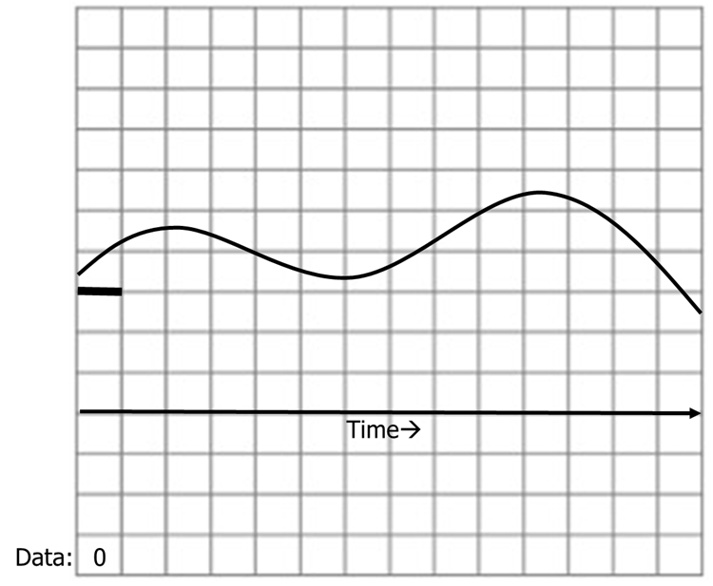 | [3]
 | c) | Baseline wandering is a common problem in both NRZ-I and NRZ-L, however, it is twice in NRZ-L scheme. Explain why. Hint: Inspect the nature of the encoding scheme and what happens for 0s and 1s. | [2]
 | d) | 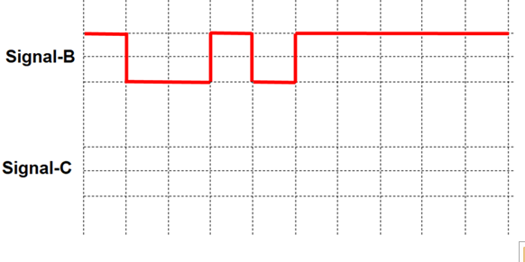  - Decode the Signal B and generate the binary bit stream using appropriate line coding scheme.  - Now from the extracted binary bits, draw the Signal-C where there is no synchronization problem. | [3]

