BRAC UNIVERSITY
Department of Computer Science and Engineering

Examination: Semester Midterm  Duration: 1 hour 10 min | Semester: Spring 2023  Full Marks: 30
CSE 320: Data Communications

Answer the following questions.
Figures in the right margin indicate marks.

SET B

Name: | ID: | Section:

1.  [CO1] | a) | Label the frames (1 and 2) shown below with appropriate Port, IP and MAC addresses. The sender A is requesting for a web page to the Web server by sending frame 1. On the other hand, the web server is sending frame 2 which is intended for device A. Assume the numbers mentioned in the figure represent IP addresses and the alphabets are MAC addresses. While mentioning the port addresses, you can use any value from the appropriate ranges.  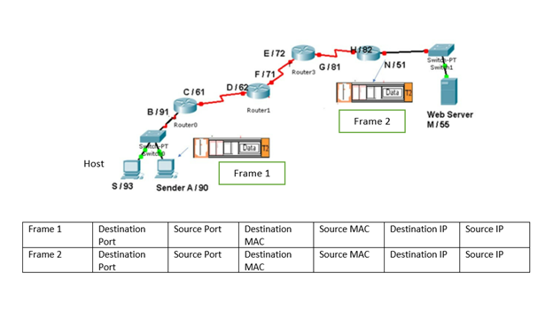 | [4]
1.  [CO1] | b) | Illustrate diagrammatically a hybrid topology with a bus backbone and three-star networks consisting of 4 nodes at each hub. In the topology drawn, identify at least one possible problem or failure that could bring the whole network down and justify your answer. | [2]
 | c) | Identify the name of the TCP/IP model layers based on the following functionalities.  - The layer responsible for node to node error control.  - The layer responsible for route determination.  - The layer responsible for restarting browsers which was idle for a long time.  - The layer identifies different application processes. | [4]
2. [CO2] | a) | Write the definition of a periodic composite signal. If a periodic signal has a bandwidth of 60 KHz and the highest frequency is 95-KHz.  What is the lowest frequency of this periodic signal?  Draw the spectrum if the signal contains all frequencies of the same amplitude. | [1+1+1]
2. [CO2] | b) | Suppose AB = 0.3km, BC = 0.5km and CD= 0.3km. The signal has a power of 4mW at the beginning of the cable (point A). Predict if the signal has gained or lost at point D? (measure in dB)  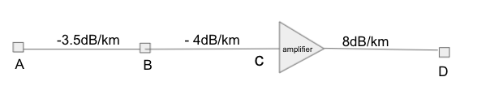 | [2]
 | c) | Consider a channel with a bandwidth of 1 MHz. The strength of the intended signal is 20mW and 40 times stronger than the noises present in the channel.  i) Interpret the upper limit of the data rate that the channel can carry?  ii) In practice, better error performance can be achieved if we use a lower data rate. Assume we choose a data rate ⅔ of the maximum upper limit. How many signal levels are needed to achieve this data rate?  iii) If we change the bandwidth to 2 MHz. How changes in signal levels should be made to maintain the same data rate? | [1+2+2]
3.  [CO2] | a) | Convert the following bit stream to digital signal using an appropriate encoding scheme that matches the requirements given below. Write which signal encoding scheme you are using.  Given Data: 1 0 0 1 0 0 0 0 0 0 0 0  Given Requirement 1 : The encoding scheme must occupy a low bandwidth. Any self-synchronization and DC component problem may be ignored.  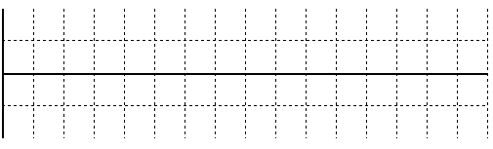  Given Requirement 2 : The encoding scheme must be self-synchronizing and should not have a DC component problem. High signal rate is not acceptable. | [2.5+2.5]
 | b) | The following table depicts a sampled analog signal for digital signal representation. By applying the concept of Pulse Code Modulation, assume there will be 3-bit code words for each sampled amplitude. Show the normalized quantized value and quantization code for the given analog signal value at different time stamps. Assume that the sampling amplitudes are between -16V to +16V. | [5]
  Time | Analog Signal Value (V)
  0 | 2.3
  1 | -12.7
  2 | 6.8
  3 | -9.4
  4 | -14.8

---END---

