Name – Nishad Dineshkumar Purohit

Email – [Nishad.purohit20@gmail.com](mailto:Nishad.purohit20@gmail.com)

Among Us Assignment

**Task 1: Read the data.**

1. **Read in the data using the mongoimport command.**



1. **Display data for the match with “game” = “3”**

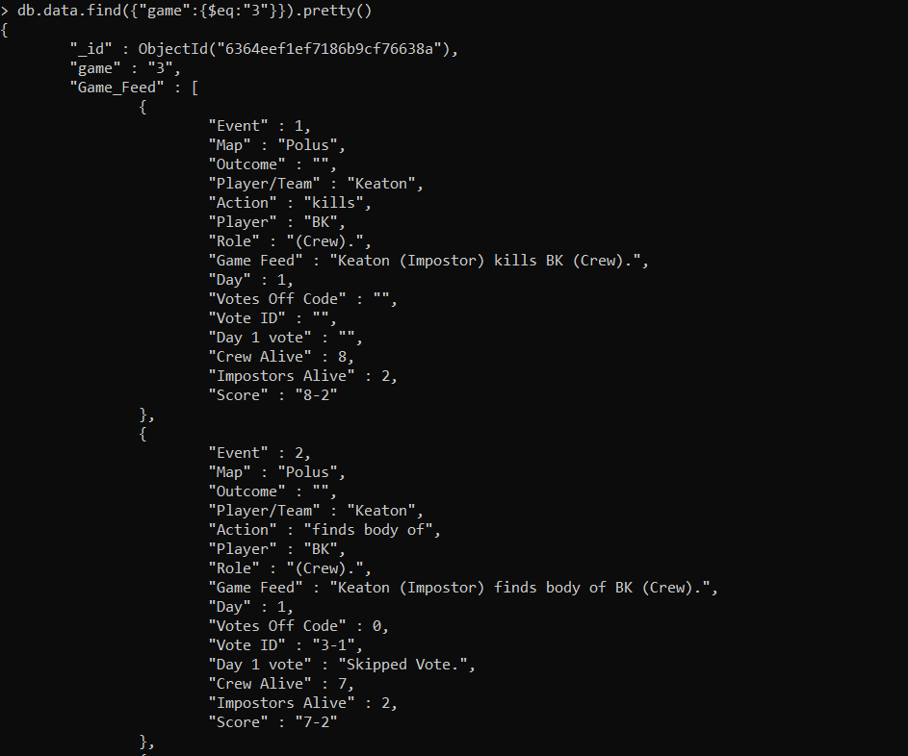

**Task 2: Explore the data for game 3.**

1. **Display the Game Feed data for the game in the new collection.**

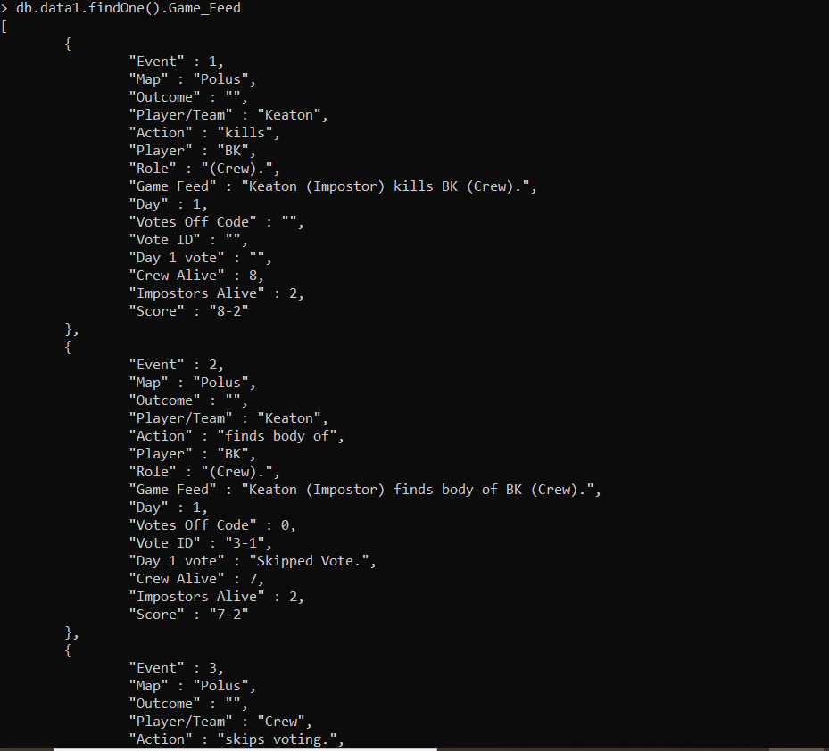

1. **Display the last event in game 3.**

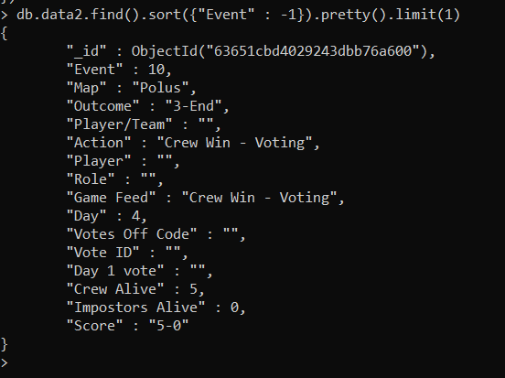

1. **Who won game 3, imposters or crew?**

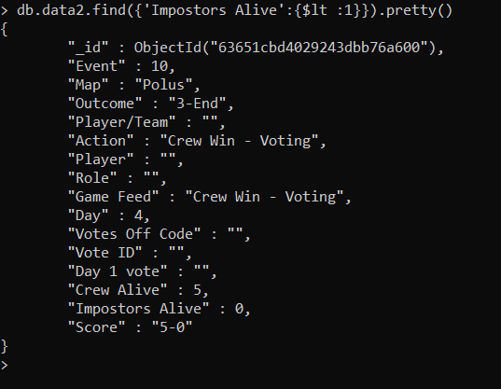

**As the score was 5-0, we can conclude that the crew won.**

1. **Who picked the black color in game 3? Was that player crew or imposter?**

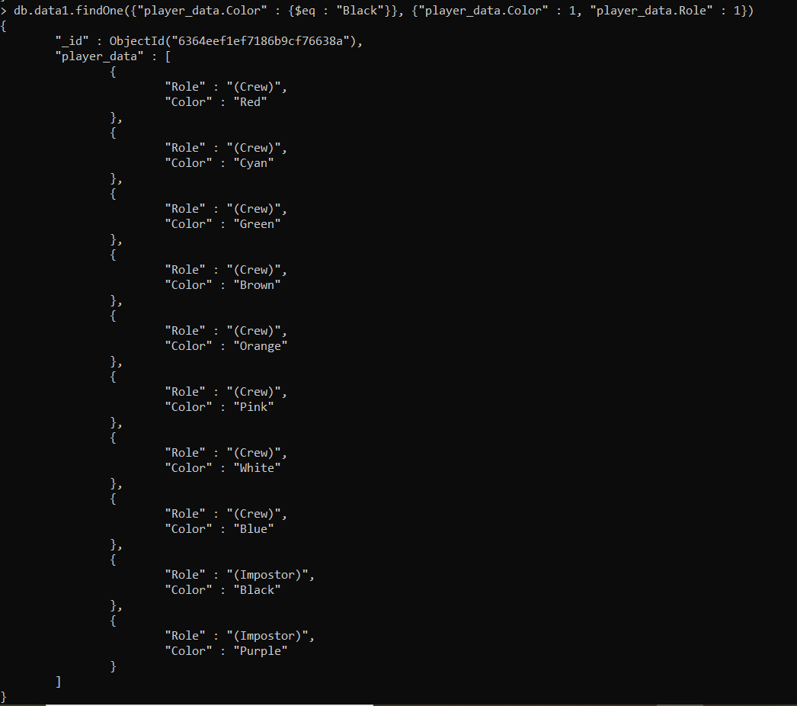

**As we can see here Black color was selected by impostor.**

1. **How many voting events happened in game 3?**



**There were total three distinct voting events.**

1. **This task was focused on exploring a single document. As explained earlier the document is made of 4 main fields and three of those are nested and hold a lot of data.  
   If you were to redesign this database to make it easier to query what changes would you make to the structure? Explain your design decisions. Do not modify the structure, simply explain the changes you want to make and justify them.**

**There were some significant changes that could have been made in the database to make it simpler to fire queries on. Some of them are listed below.**

* **We can split the data into different collections for easy access.**
* **There are some numeric values that are declared string datatype.**
* **Is_alive can be Boolean or simply one and zero**
* **The column role can be one and zero as well**

**These are some changes that I would make to this data.**

**Task 3: Overall aggregation.**

1. **How many events in total do you have data for, in this collection?**

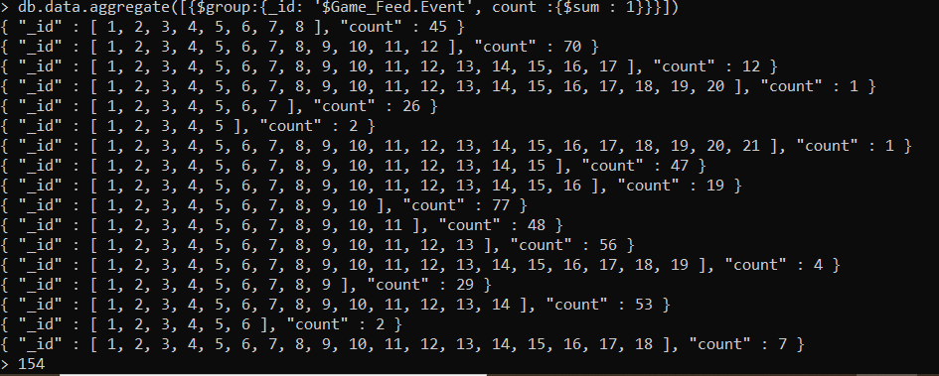

**There are total 154 events in the collection.**

1. **How many matches did the crew win versus how many matches did the impostors win?**



**Crew Win 323 times**



**Impostors win 176 times**

1. **Find out how many matches were played on each map. Your output should contain the names of maps and the number of games played on each map.**

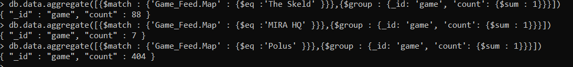

**There were 88 in The Skeld, 7 in MIRA HQ and 404 in Polus**

1. **How many times in total across all games did the crew skip a vote?**



**The crew skipped vote 385 times**

1. **How many times in total across all matches does the crew vote against imposters?**



**The crew voted off against impostors 368 times**

1. **The questions you answered in this task were all related to high-level aggregations across the entire collection. In your opinion, is the game more or less hard for impostors? Justify your answer with suitable insights from the data.**

**The game is harder for impostors as the data shows that the crew is winning more times however it is also a fact that the number of crew members is more than that is of the impostors. The impostors were voted off 385 times thus it is likeable that among these matches the probability of winning as a crew member is more than it is of the impostor.**