WEEK 5 INTERNSHIP REPORT | EVALUATION AND REFLECTION
GERMAN LANGUAGE A1 · CULTURAL INTEGRATION

Kultur im A1-Unterricht
Evaluating Cultural Integration in German A1 Courses: Framework, Case Studies and Recommendations
At a glance
Evidence base | Published research on textbooks, CEFR and intercultural competence; public data from the Goethe-Institut; course descriptions (Menschen, Nicos Weg, Goethe-Zertifikat A1)
Original frameworks | CCIA – a 15-criterion audit rubric · CII – a Culture Integration Index with four learner-outcome components
Analysis | Self-audit of the Week 3 and Week 4 modules · SWOT · catalogue of 12 interactive elements · differentiation playbook
Case studies | Three hypothetical cases built on public data (adult online class, mixed-ability school class, self-learner)
Recommendations | 12 prioritised recommendations · 3 redesigned micro-modules with new objectives and narrative scripts · 12-week roadmap

Submitted by Nishadevi M
Programme Biomedical Engineering
Institution Sri Ramakrishna Engineering College
Internship YuvaIntern – Online Internship
Task Week 5 – Evaluation of Cultural Integration in Language Learning
Submission type Evaluation report with framework, case studies and recommendations

INHALT · TABLE OF CONTENTS
Section | Content
Summary | Executive summary and how this report responds to earlier feedback
1 Introduction | Context, problem statement, research questions, method and limitations
2 Conceptual background | Byram's model for A1, the CEFR and its Companion Volume, D-A-CH, “binding and connecting”, evidence on motivation
3 Review of strategies | Eight integration strategies, textbook research, course profiles, comparison and the Integration Depth Scale
4 Evaluation framework | Criteria (CCIA), quantitative and qualitative metrics, the Culture Integration Index, data plan, validity and ethics
5 Detailed analysis | Self-audit of the Week 3 and Week 4 modules, strengths, weaknesses, SWOT, interactive-element catalogue, differentiation playbook
6 Case studies | Case 1 adult online class · Case 2 mixed-ability school class · Case 3 self-learner
7 Recommendations | Twelve recommendations, priority matrix, redesigned micro-modules with new scripts, narrative formats, roadmap
8 Conclusion | Synthesis, limitations, future work, reflection
Appendices | A instruments · B CII worksheet · C response to feedback · D glossary · E references

EXECUTIVE SUMMARY · ZUSAMMENFASSUNG

What this report asks
German A1 courses almost always claim to teach “language and culture”. This report asks a harder question: how well is culture actually integrated, how could we tell, and what should be improved? It reviews published research and course descriptions, builds an evaluation framework with qualitative and quantitative metrics, applies it to the author's own Week 3 (German traditions) and Week 4 (virtual field trip) modules, illustrates its use in three hypothetical case studies and ends with twelve prioritised, practical recommendations.

Key findings
- Culture is present but often not “binding”. In an analysis of the Dutch secondary-school course Neue Kontakte (A1–A2) cultural tasks were labelled “extra”, cultural goals were absent from unit objectives and tests, and most topics were introduced once and dropped (Tammenga-Helmantel, 2019). In two Finnish beginner textbooks only 9.7 % and 4.2 % of numbered exercises were DACH-related, Germany dominated, the perspective was “rather touristic” and history was largely missing (Vidgren, 2026).
- Assessment can undermine culture. The Goethe-Zertifikat A1 tests listening, reading, writing and speaking through everyday tasks; the test description does not state that cultural knowledge is assessed. Where an exam is the goal, culture can become optional.
- The evidence is mixed and must be handled with humility. Intercultural sensitivity is related to foreign-language motivation, but a four-week intervention in one quasi-experimental study did not produce a significant change in sensitivity (Niu, 2022). Claims about culture “improving” learning should therefore be tested, not assumed.
- A measurable framework is feasible at A1. The report proposes the CCIA audit (5 dimensions, 15 criteria, scored 0–4) for materials and the CII (Culture Integration Index) for learners, combining engagement, retention, appreciation and language transfer.
- The author's own modules show clear strengths and gaps. Interactivity and structure score well (D4: 2.3–2.7 of 4), but intercultural/critical work (D3: 1.7–2.0) and assessment/piloting (D5: 1.3–2.3) are weak; all 28 learning objectives in Weeks 3–4 are form-, production- or interaction-oriented – none is receptive-cultural, intercultural or mediation; and every unit uses the same guide-narrates script.
- In the hypothetical cases the integrated approach does not cost language gains (language-test effect small and uncertain, d = 0.25) while culture retention, engagement and appreciation are clearly higher; the data are simulated and are used to show how the framework works, not as proof.

Top recommendations
# | Recommendation | Effort | Impact
4 | Add a structured Notice–Compare–Question routine for intercultural comparison, with sentence frames and home-language use | low–mid | very high
1 | Write explicit, assessable cultural can-do objectives for every unit | low | high
3 | Move from “sights” to everyday life (bakery, Pfand, du/Sie, Sonntagsruhe) | mid | high
9 | Assess culture formatively and retest after 2 and 6 weeks (retrieval practice) | mid | high
2 | Represent D-A-CH – at least one Austrian or Swiss element per module | mid | high
8 | Use tiered tasks and participation tools so quiet learners speak | low | high

Reading guide
Sections 4 and 7 are the practical core (framework and recommendations). Section 6 uses hypothetical data – every such table and chart is labelled. Appendix C shows where each point of the earlier feedback (depth and originality, varied objectives and narrative scripts, specific differentiation and interactive examples, complete deliverables) is addressed.

1 · EINLEITUNG · INTRODUCTION

1.1 Context: who learns German, and where?
According to the Goethe-Institut's 2020 survey more than 15.4 million people learn German worldwide. About 106,000 schools offer German (up from about 95,000 in 2015), around 474,000 adults learn German (up from 433,000) and about 309,000 people take Goethe-Institut language courses. Europe has about 11.2 million learners; Africa grew by almost 50 % (for example Egypt, Algeria and Côte d'Ivoire) and Asia is described as a major growth market. Online learning rose sharply: visits to the Goethe-Institut's learning platform grew from about 326,000 (May 2019) to over 1.2 million (May 2020), and Deutsche Welle's online courses reached 4.2 million visits (Goethe-Institut, 2020).
Three consequences matter for this report. First, most A1 learners are far from German-speaking countries, so culture cannot be “absorbed” from the environment – it must be designed into the course. Second, the learner group is diverse (adults, schoolchildren, migrants, students), so cultural content must not assume one background. Third, much A1 learning now happens online, which makes interaction, visual material and participation tools central to cultural integration.

1.2 Problem statement
Earlier weeks of this internship produced a module on German traditions (Week 3) and a virtual field-trip plan (Week 4). Reviewer feedback on previous work noted that reports were comprehensive but lacked depth and originality, that language objectives and narrative scripts were not varied enough, and that differentiation strategies and interactive elements needed more specific examples. The same questions apply to the field as a whole: cultural integration is widely promised in A1 courses, but rarely evaluated with clear criteria.

1.3 Research questions
RQ | Question | Answered in
RQ1 | Which strategies for integrating culture are used in A1 German courses, and what does published research say about their strengths and weaknesses? | Sections 2–3
RQ2 | Which criteria and metrics can capture successful integration of language and culture (engagement, retention, cultural appreciation, language transfer)? | Section 4
RQ3 | How well do two concrete A1 modules (Weeks 3–4) perform against these criteria, and what does that reveal? | Section 5
RQ4 | How do the strategies and metrics work in practice in realistic scenarios, and what concrete improvements follow? | Sections 6–7

1.4 Method
- Document analysis of publicly available sources: the Goethe-Institut survey and exam description, the CEFR Companion Volume overview, research on intercultural competence (Byram; Chen & Starosta; the Intercultural Development Inventory), two textbook studies (Tammenga-Helmantel, 2019; Vidgren, 2026), a quasi-experimental study (Niu, 2022), and publisher/broadcaster descriptions of Menschen and Nicos Weg.
- Framework development: the CCIA and CII were designed by the author, building on Byram's components, the “binding/connecting” lens and the measures found in the literature.
- Self-audit: the Week 3 and Week 4 deliverables were scored with the CCIA, including a count of their learning-objective types.
- Case studies: three hypothetical scenarios, with simulated data where numbers are needed, grounded in public statistics.
- Synthesis: recommendations ranked by estimated effort and impact.

1.5 Limitations
- Secondary sources. Full textbooks were not available; course descriptions come from publisher or broadcaster pages and published studies. Findings about a book are therefore reported as findings of the cited study.
- Hypothetical data. Case-study numbers are constructed for demonstration and carry no empirical weight.
- Interpretive scoring. CCIA scores, depth ratings and effort/impact estimates are the author's judgements; they should be repeated by a second rater.
- Evidence base. Research on the effect of cultural integration on A1 outcomes is limited and mixed; this report treats its framework as a measurement tool, not as proof of any effect.

2 · KONZEPTE · CONCEPTUAL BACKGROUND

2.1 Three meanings of “cultural integration”
Level | Culture is … | Typical A1 form | Risk
1 Content | a set of facts about a country | info box about Oktoberfest | facts remembered briefly, stereotypes
2 Context | the setting for language use | ordering at a bakery in Berlin | culture is decoration
3 Competence | a skill: noticing, comparing, interpreting, mediating | comparing how people greet in Hamburg, Munich and Zürich and explaining it to a friend | needs time, careful tasks and assessment

Most A1 materials operate at levels 1–2. The aim of a strong course is to include level 3 in simple form – not as long discussions (impossible at A1 vocabulary) but as short, structured routines with sentence frames and, where useful, the learners' own language.

2.2 Byram's model of intercultural communicative competence, translated to A1
Byram (1997) describes five components of intercultural communicative competence: knowledge, attitudes, skills of interpreting and relating, skills of discovery and interaction, and critical cultural awareness. The table shows what each can mean for a complete beginner and where the author's earlier modules touched it.
Component (Byram, 1997) | In plain terms | What it can look like at A1 | Example from Weeks 3–4
Knowledge | awareness of social groups, products and practices – own and other | name three Pfand items; say what Rosenmontag is | fact files, vocabulary, quizzes
Attitudes | curiosity, openness, readiness to suspend judgement | ask Warum? before saying komisch (odd) | “Did you know?” boxes (weak)
Interpreting and relating | comparing and connecting perspectives | fill a 3-column table: Bei uns / In Deutschland / Warum? | Bei uns gibt es … frames
Discovery and interaction | engaging with unfamiliar contexts as they happen | role-play, virtual walk, chat with a guest speaker | role-plays, Street View walks
Critical cultural awareness | assessing practices and values with explicit criteria | spot a stereotype in an advert and say why | not yet addressed

2.3 The CEFR and its Companion Volume
The CEFR describes language learning through can-do statements. Its Companion Volume adds descriptor scales for mediation (mediating a text, concepts and communication) and links cross-linguistic mediation to plurilingual competence, with descriptors from Pre-A1 to C2 (ECML overview). For A1 this suggests a modest but useful idea: learners can relay simple information (a sign, a price, a greeting) to another person, in the target language or their own. This is a form of cultural mediation that the author's earlier modules did not exploit and that Section 7 introduces.

2.4 D-A-CH and the question of representation
Textbook research in German as a foreign language often uses the D-A-CH lens: do materials present Germany, Austria and Switzerland (the “CH” in D-A-CH stands for Confoederatio Helvetica) – and, ideally, Liechtenstein and other German-speaking regions – or only Germany? Vidgren (2026) found that Germany dominated both Finnish beginner books analysed, and that Liechtenstein and Luxembourg were barely covered.

2.5 “Binding” and “connecting”
Tammenga-Helmantel (2019) evaluates culture teaching with two questions that are adopted in this report as a central lens. Culture is binding when it is part of required learning – goals, tasks, tests and repeated across units. It is connecting when it is linked to the learners' own world and encourages comparison. Her study of Neue Kontakte found good connection to learners' lives but weak binding: culture had “extra” status, topics were rarely repeated and critical reflection was rare.

2.6 What does the evidence say about motivation and outcomes?
Niu (2022) reports a quasi-experimental study with U.S. foreign-language learners based on intergroup contact theory. Intercultural sensitivity was significantly related to language-learning motivation after controlling for background factors, but a four-week intervention did not produce a statistically significant increase in intercultural sensitivity. Parental encouragement and exposure to the target culture were related to learners' openness to innovative culture learning. The practical message for A1 course designers is twofold: cultural attitudes and motivation are connected, but short, ad-hoc interventions may not shift attitudes, so integration must be sustained and measured.

3 · ÜBERBLICK · REVIEW OF STRATEGIES IN EXISTING A1 COURSES

3.1 Eight strategies for integrating culture
# | Strategy | How it appears in A1 materials | Examples
S1 | Culture info box / Landeskunde page | a separate page or box with facts and photos | info boxes on greetings and gastronomy in beginner textbooks (Vidgren, 2026)
S2 | Culture inside language texts | reading and listening texts set in German-speaking places | culture tied mainly to reading tasks (Tammenga-Helmantel, 2019)
S3 | Story-driven video or serial | a continuing story provides contexts and characters | Menschen lesson stories; Nicos Weg (A1–B1 video course)
S4 | Project task | learners research or produce something about D-A-CH | “Projekt Landeskunde” with recipes from D-A-CH (Menschen)
S5 | Festival / tradition module | a cultural event is the unit's theme | Week 3 module of this internship
S6 | Virtual field trip | guided virtual visit to places with narrative and tasks | Week 4 plan of this internship
S7 | Structured comparison and reflection | explicit tasks that compare home and target cultures | comparison tasks (often open and shallow – Tammenga-Helmantel, 2019)
S8 | Real contact | exchange, pen-pals, guest speakers, tandem | school and online exchanges (not covered by the sources reviewed)

3.2 Evidence from two textbook studies
 | Tammenga-Helmantel (2019) | Vidgren (2026)
Material | Neue Kontakte 1–3 (Netherlands, secondary school, A1–B1) | Freut mich 1 and Hallo! 1 (Finland, adult beginners)
Method | content analysis of position, content and tasks for culture | content analysis of DACH maps, cities, exercises, info boxes
Main numbers | – | DACH-related exercises: 9.7 % of numbered exercises (Freut mich 1), 4.2 % (Hallo! 1)
Positives | culture integrated with reading, listening and grammar; linked to teenagers' lives | Freut mich 1: detailed map, varied themes (greetings and forms of address, gastronomy)
Weaknesses | culture seen as “extra”; no cultural goals in objectives or tests; topics rarely repeated; critical comparison rare | Germany dominates; Liechtenstein and Luxembourg barely covered; “rather touristic” perspective; history largely absent
Recommendations | more demanding reflective tasks; give culture prominence in structure and goals; adapt creatively; cooperate with history, music and art teachers | (analysis of printed books only; use in the classroom not studied)

Key finding
Across the two studies culture is integrated at the level of content and context (levels 1–2), but weakly binding (not in objectives or assessment) and rarely critical (shallow comparison). Representation is Germany-centred and tourist-oriented.

3.3 Three course profiles

Menschen A1 (Hueber) – coursebook with story and project pages
According to the publisher's concept overview, each sub-volume (for example A1/1) has 12 short lessons of 4 pages, three lessons forming a module. Every lesson opens with a small story meant to trigger emotions and lead into the learning content; presentation, practice and application follow, with grammar boxes, phrase boxes, a picture dictionary and action pages. Culture enters through the page “Projekt Landeskunde” (for example recipes from D-A-CH with a background text), “Film-Stationen” with film sequences on everyday life and culture in Germany, Austria and Switzerland, a reading magazine, a song and additional pages after each module; the teacher DVD contains further cultural topics such as a city portrait of Bern. A learner DVD-ROM offers interactive exercises (including “Landeskunde”) so that learners can choose topics themselves.
- Strengths: D-A-CH is explicit; project and film formats; learner choice; story as hook.
- Weaknesses (as far as the description shows): culture sits on dedicated pages; no mention of cultural learning goals or tests in the overview; the description does not mention the CEFR or Goethe exams.

Nicos Weg (Deutsche Welle) – free story-based video course
Nicos Weg is a free online course by Deutsche Welle, produced with Germany's Federal Employment Agency, covering A1, A2 and B1. Each level has about two hours of video in 76 short episodes of roughly two minutes, each with interactive exercises; a final test per level leads to a DW certificate. The story follows Nico's adventures in Germany and covers “various topics and everyday situations”. A1 and A2 are available with English and other language versions, and subtitles exist in more than 15 languages. DW's online courses reached 4.2 million visits in the period reported by the Goethe-Institut (2020).
- Strengths: free, scalable, authentic everyday situations, short episodes suited to micro-learning, multilingual support.
- Weaknesses: the sources reviewed do not describe explicit cultural learning goals, comparison tasks or assessment of cultural knowledge; learning is individual, with limited interaction (an inference from the format).

Goethe-Zertifikat A1: Start Deutsch 1 – the exam that shapes teaching
Module | Time | Content (per the test description)
Hören | about 20 min | 3 parts, 15 tasks: short everyday conversations, announcements, phone messages
Lesen | about 25 min | 3 parts, 15 tasks: short notes and e-mails, classified ads, signs
Schreiben | about 20 min | 2 tasks: complete a form; write a short message of about 30 words on three points
Sprechen | about 15 min | Group exam of up to 4 candidates: introduce yourself; ask and answer questions; make requests and react

The test description does not state that cultural knowledge is tested; it is task-based and focuses on everyday communication, with some German contexts (for example a visit to Dresden). Passing requires at least 60 of 100 points. The implication is a washback risk: in exam-oriented classes, culture can be dropped because it is not on the test. A good integration strategy therefore embeds culture in the same tasks the exam uses (forms, short messages, requests, questions) instead of competing with them for time.

3.4 Comparison of the strategies
The ratings are the author's synthesis of the sources above, plus experience from Weeks 3–4 (H = high, M = medium, L = low). They indicate potential, not measured effects.
Strategy | Engagement | Retention | Cultural appreciation | A1 feasibility | Cost / effort | Main caveat
S1 Info box | L | L | L–M | H | L | passive, one-off
S2 Culture in texts | M | M | M | H | L | culture serves language, rarely goal
S3 Story / video | H | M | M | H | M–H | depends on how story is exploited
S4 Project task | M–H | H | M–H | M | M | needs time and support at A1
S5 Festival module | H | M–H | M | H | M | risk of “tourist lens”
S6 Virtual field trip | H | M–H | M | M–H | M–H | tech dependence; sights, not everyday life
S7 Comparison and reflection | M | H | H | M | L–M | needs scaffolds and home-language use
S8 Real contact | H | M | H | L–M | H | organisation, safety, scheduling

3.5 The Integration Depth Scale
To compare strategies and materials the author defines a five-point Integration Depth Scale (IDS):
Score | Label | Description
0 | absent | no cultural content
1 | decorative | culture appears as information or images; no task depends on it
2 | contextual | culture provides the setting for language tasks; learners need not engage with it
3 | communicative | tasks cannot be completed without cultural knowledge; learners use culture in interaction
4 | critical-intercultural | learners compare, interpret, mediate and question assumptions, ideally with real contact
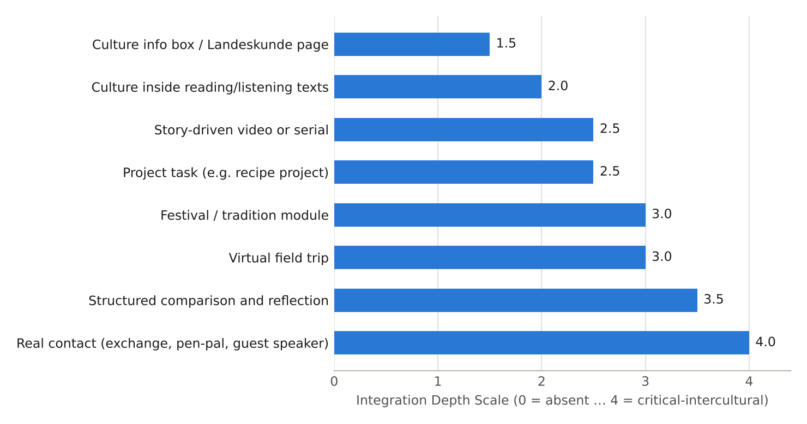
Figure 1. Typical integration depth of eight strategies (author's interpretive ratings on the IDS; not measured data).

3.6 Synthesis: six findings
- F1 – Depth rises with structure, not with quantity. More culture pages do not raise depth; structured comparison and real contact do.
- F2 – Binding beats extra. Culture that appears in objectives, tasks and assessment survives; “extra” culture is dropped under time pressure.
- F3 – Representation is narrow. Germany dominates, sights and food dominate, history and everyday social practice are thin.
- F4 – A1 can be critical, in small steps. Comparison with sentence frames and home-language support is feasible at A1.
- F5 – Exams steer content. Embed culture in the task types that exams use.
- F6 – Evidence is thin; measure locally. Because research effects are mixed, each course should collect its own simple data – the purpose of Section 4.

4 · BEWERTUNGSRAHMEN · EVALUATION FRAMEWORK

4.1 Design principles
- Two lenses. Audit the materials (what the course offers) and measure the learners (what happens).
- Mixed methods. Every quantitative metric has a qualitative partner that explains it.
- A1-appropriate. Instruments use pictures, short answers, sentence frames and home-language responses.
- Cheap enough to use. A teacher can run the whole cycle in about two hours per unit.

4.2 CCIA: the Cultural Content and Integration Audit (materials)
The CCIA has five dimensions with three criteria each (15 in total). Every criterion is scored 0–4 using the anchors below; the dimension mean is reported.
Dim. | Criterion | 0 (absent) | 2 (partly) | 4 (strong)
D1 Binding | 1.1 Cultural objectives | none stated | implied in activities | explicit, assessable can-do per unit
 | 1.2 Repetition | topic appears once | revisited once | revisited across ≥ 3 units
 | 1.3 Assessment | culture never assessed | ungraded quiz | formative and summative, with rubric
D2 Representation | 2.1 D-A-CH | one country only | two countries, tokenistic | D, A, CH (and FL) in each unit
 | 2.2 Everyday life | only sights/festivals | some daily life | daily life is the main setting
 | 2.3 Diversity | single stereotype | some variety | regions, ages, migration backgrounds shown
D3 Intercultural | 3.1 Comparison | none | open “compare” prompts | structured routine with frames
 | 3.2 Critical reflection | none | one question | stereotype and perspective tasks
 | 3.3 Mediation | none | incidental | dedicated relay/explain tasks
D4 Interactivity | 4.1 Task variety | one task type | 3–4 types | ≥ 6 types incl. role-play and project
 | 4.2 Learner voice | none | choice of topic | learners create and share
 | 4.3 Technology | none | viewing only | participation tools and virtual contact
D5 Evidence | 5.1 Pilot | never used | teacher check | piloted with learner data
 | 5.2 Learner feedback | none | informal | survey and interviews each unit
 | 5.3 Revision | none | ad hoc | documented revision cycle

4.3 Quantitative learner metrics
Metric | Definition | Instrument | Target (A1)
Engagement (E) | mean of: attendance %, task completion %, voluntary contributions per session (scaled) | register, platform logs, observation tally | ≥ 75 %
Cultural retention (R) | score on a delayed culture quiz as % of immediate score, after 2 and 6 weeks | 10-item picture quiz | ≥ 80 %
Cultural appreciation (A) | mean score on a 5-point scale, 8 short items, converted to % of maximum | appreciation survey with emoji anchors | ≥ 75 %
Language transfer (L) | score on a language task that uses cultural content (message, form, role-play) | rubric 0–4 on 3 criteria | ≥ 70 %
Comparison quality | share of learner comparisons that are explained (“weil / denn”) and not just listed | coding of the Bei uns / In Deutschland / Warum? sheet | ≥ 40 %
Stereotype index | number of stereotype statements per 10 learners before vs after | coded open answers | decrease

4.4 Qualitative methods
Method | What it captures | A1 adaptation | Frequency
Learner reflection journal | noticing, attitudes | 3 prompts, answers in any language, 5 min | weekly
Focus group | reasons behind scores | 5–6 learners, home-language moderator | once per module
Observation checklist | participation, risk-taking, who speaks | tally by two observers | two sessions per unit
Artefact analysis | depth of products (posters, role-plays) | CCIA D3 rubric applied to artefacts | each project
Teacher log | feasibility, time costs | 5 lines after each lesson | each lesson

4.5 The Culture Integration Index (CII)
The CII combines four outcome components, each scaled to 0–100, into one number: CII = 0.20 E + 0.25 R + 0.25 A + 0.30 L. Language transfer receives the highest weight (0.30) because the aim is integration, not a trade-off between language and culture. The weights are the author's judgement and should be adapted to local priorities. Reading bands: ≥ 80 strong; 65–79 developing; < 65 weak.
Worked example
E = 80, R = 90, A = 70, L = 78 → CII = 0.20×80 + 0.25×90 + 0.25×70 + 0.30×78 = 16 + 22.5 + 17.5 + 23.4 = 79.4 (developing, close to strong).

4.6 Data-collection plan
When | What | Who | Time
Week 0 | pre-survey (appreciation, stereotype statements); baseline language task | teacher | 20 min
During unit | observation tally, task completion, teacher log | teacher + observer | 5 min per lesson
End of unit | post-survey, immediate quiz, language transfer task | teacher | 25 min
Week +2 | delayed culture quiz (retention) | teacher | 10 min
Week +6 | second delayed quiz; reflection journal; focus group | teacher / facilitator | 30 min
After module | CCIA of materials; CII; revisions logged | author + second rater | 2 h

4.7 Validity, reliability and ethics
- Second rater: two people score the CCIA independently; disagreements above one point are discussed. Report simple agreement.
- Triangulation: a rise in appreciation scores is trusted only if journals or observation point the same way.
- Confounds: novelty effect, teacher enthusiasm and test familiarity; use a comparison group where possible.
- Small samples: report effect sizes with confidence intervals and avoid p-value claims in groups under 30.
- Ethics: informed consent, anonymised data, no pressure to disclose personal or religious background, opt-out for any activity touching identity.
- Known weakness: Niu (2022) found no significant attitude shift after a four-week intervention, so a short unit should not be expected to move attitudes; track change across several units.

5 · ANALYSE · DETAILED ANALYSIS OF THE WEEK 3 AND WEEK 4 MODULES

5.1 Self-audit with the CCIA
The author's Week 3 module (German traditions, 34 pages) and Week 4 plan (virtual field trip, 52 pages) were scored by the author using the CCIA. This is a self-assessment and therefore likely generous; a second rater is recommended.
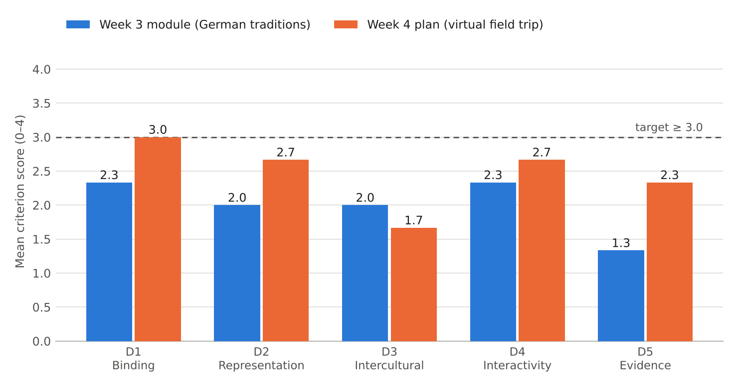
Figure 2. CCIA dimension means for Week 3 and Week 4 (scale 0–4; dashed line = target 3.0).
Dimension | Week 3 | Week 4 | Reading
D1 Binding | 2.3 | 3.0 | objectives present per unit but cultural can-dos are implicit; quizzes exist; no retest
D2 Representation | 2.0 | 2.7 | Germany-heavy; Week 4 adds Vienna and Zürich; sights dominate over everyday life
D3 Intercultural | 2.0 | 1.7 | “Bei uns …” frames exist; no critical or mediation tasks
D4 Interactivity | 2.3 | 2.7 | stations, role-plays, quizzes; few learner-created products
D5 Evidence | 1.3 | 2.3 | no pilot with real learners; Week 4 includes an evaluation plan only

5.2 Objective-type audit
All 28 learning objectives across the two modules were classified by type. Every one is form-oriented (recognise, name, list), production-oriented (say, write) or interaction-oriented (ask, answer, role-play). None is receptive-cultural (interpret a cultural text), intercultural (compare and explain) or mediating (relay information). This is the main depth gap and explains the earlier feedback about varying objectives.

5.3 Narrative-script audit
Every unit uses the same script type: a guide narrates, the learner answers. There is no learner-as-character, no mystery, no dialogue between two cultures, no unreliable-guide or problem-solving frame. The result is predictability, which lowers engagement across a 12-unit programme. Section 7.4 offers six alternative narrative formats.

5.4 Strengths and weaknesses
Strengths | Weaknesses
clear A1 vocabulary and structure | culture is mostly facts and sights
varied activity types in Week 4 | objective types uniform
quizzes with answer keys | no pilot data; no retention measure
links to real places (Street View, official sites) | limited representation of Austria and Switzerland in Week 3

5.5 SWOT of cultural integration at A1
Strengths (internal) | Weaknesses (internal)
short units, concrete topics, visual material | limited vocabulary, so discussion is hard; reliance on facts
Opportunities (external) | Threats (external)
free tools (DW, Street View, Padlet-type walls), online contact, tandem partners | exam washback, time pressure, stereotypes in media, uneven internet access

5.6 Catalogue of twelve interactive elements
The feedback asked for specific examples of interactive elements. Each entry gives the steps, tools, time and the evidence of success.
# | Element | Steps (A1) | Tool | Time | Evidence of success
1 | Notice–Compare–Question | notice a photo → fill Bei uns / In Deutschland / Warum? → share one | paper / shared sheet | 15 min | ≥ 40 % of comparisons explained
2 | Bakery role-play | order with ich möchte → pay → ask Haben Sie …? | pairs, props | 15 min | completion without L1
3 | Pfand scavenger hunt | find 3 items with Pfand symbols in photos → note price | slides | 10 min | 3 items correct
4 | Du/Sie sorting | sort 8 situations into du or Sie → say why in L1 | cards | 10 min | ≥ 6 of 8 correct
5 | Mystery postcard | read short card → infer city → verify on map | print / slide | 15 min | correct inference with reason
6 | Dialogue relay | A reads German sign → B tells C in L1 | groups of 3 | 10 min | message conveyed
7 | Quiet-learner wall | everyone adds one emoji + one word to a wall | padlet-type tool | 5 min | 100 % participation
8 | Stereotype detective | find one stereotype in an advert → say Das stimmt nicht immer. | images | 15 min | stereotype identified
9 | Postcard to a partner | write 30 words to a tandem partner on three points | paper / e-mail | 20 min | 3 points covered
10 | Festival calendar | each learner adds one date to a class D-A-CH calendar | wall chart | 10 min | ≥ 12 distinct entries
11 | Retrieval flash | 5-item quiz at start of next unit | slides | 5 min | ≥ 80 % correct after 2 weeks
12 | Guest question | prepare three questions for a German speaker | video call | 20 min | 3 well-formed questions

5.7 Differentiation playbook: specific examples
Differentiation is shown for one task, the bakery role-play (element 2), at three levels, and then as a general toolkit.
Level | Learner profile | Task | Support | Output
Support | needs more time | order one item using a menu with pictures | sentence frame: Ich möchte ___, bitte. + audio model | 1 sentence
Core | typical A1 | order two items, ask the price, pay | phrase box; partner feedback | 3–4 sentences
Extension | fast learner | order, ask about ingredients, complain politely about a wrong item | no frame; role cards with a surprise | short dialogue + 1 self-correction

Need | Specific strategy
Quiet or anxious learners | think-pair-share; wall posting; written answer before speaking; no cold-calling
Different home languages | allow L1 for the “Warum?” column; bilingual glossary; learners translate for each other
Visual impairment | audio description of images; high-contrast slides; tactile cards
Hearing impairment | captions; written scripts; visual turn-taking
Low-bandwidth learners | downloadable PDF stations; text-only version of virtual walks
Different cultural backgrounds | opt-out for identity topics; choose festivals from learners' own backgrounds to compare

6 · FALLSTUDIEN · CASE STUDIES (HYPOTHETICAL)
HYPOTHETICAL DATA · illustrative simulation
All three cases are theoretical. They are built to show how the CCIA, CII and the interactive elements work in realistic settings. Numbers in Case 1 and Case 2 are simulated with plausible values; they are not empirical findings and must not be quoted as evidence.

6.1 Case 1: an adult online A1 class, eight weeks
Setting | Detail
Learners | 18 adults (aged 19–52), four home languages, evening online class, 2 × 90 min per week
Design | two groups of 9 taught by the same teacher with the same language syllabus
Group A (integrated) | cultural can-do per unit; Notice–Compare–Question routine; one D-A-CH element per unit; retrieval flash at the start of each lesson; participation wall
Group B (standard) | same language syllabus; optional culture boxes as homework; no routine, no retrieval
Measures | language test (/50), culture quiz (/20, immediate and week 10), ISS-short (1–5), speaking task (/15), talk time per session, voluntary extension tasks, CII

Measure | Group A mean (SD) | Group B mean (SD) | Cohen's d [95 % CI]
Language test, post (/50) | 41.6 (4.6) | 40.4 (5.0) | 0.25 [−0.68, 1.18]
Speaking task (/15) | 10.8 (1.9) | 10.1 (2.1) | 0.35 [−0.58, 1.28]
Culture quiz, post (/20) | 14.4 (2.4) | 9.6 (2.8) | 1.84 [0.74, 2.94]
Culture quiz, delayed wk 10 (/20) | 12.9 (2.6) | 7.1 (2.9) | 2.11 [0.95, 3.26]
ISS-short, post (1–5) | 3.86 (0.38) | 3.55 (0.41) | 0.78 [−0.17, 1.74]
Talk time per session (min) | 8.4 (2.0) | 5.6 (1.9) | 1.44 [0.40, 2.47]

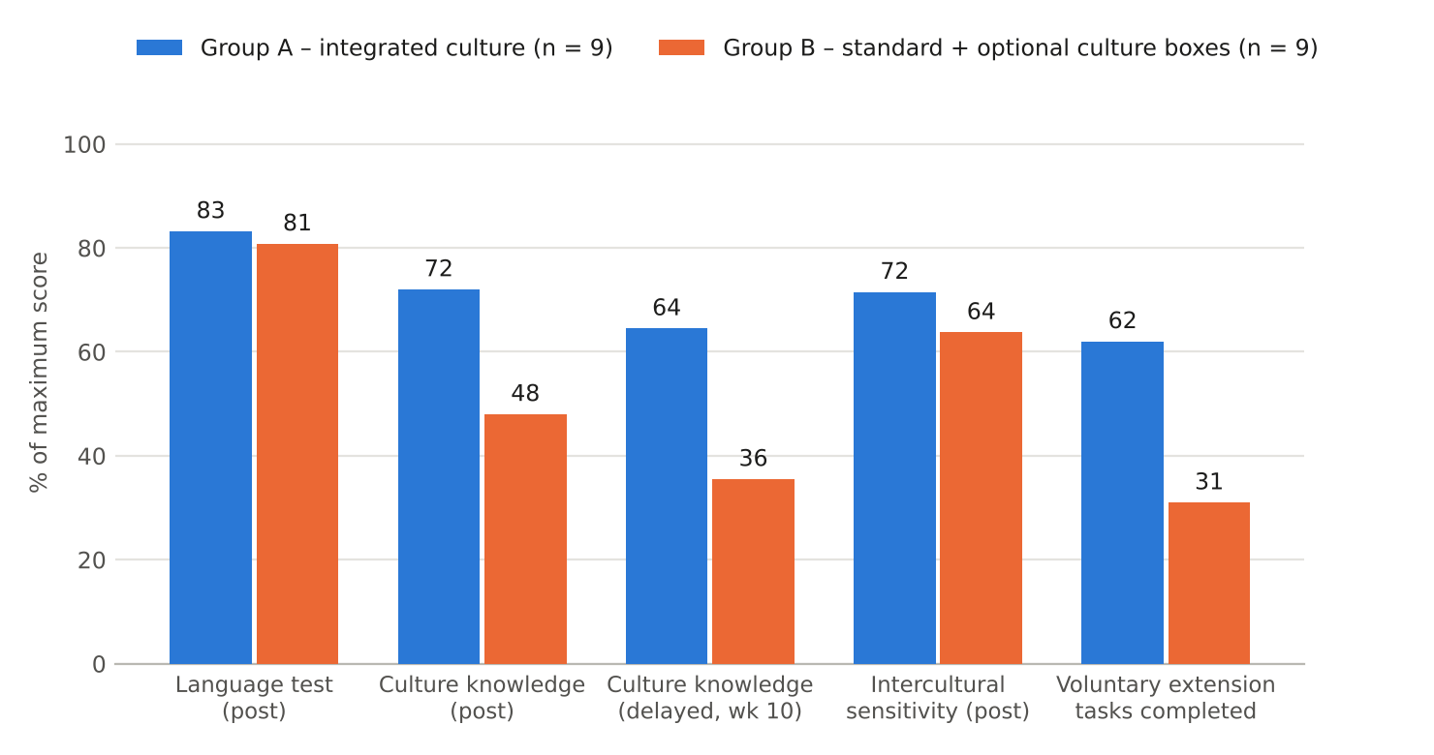
Figure 3. Case 1 (hypothetical data): outcomes after eight weeks as % of maximum score.
Reading. The language difference is small and its interval spans zero in both directions, so the data suggest integration did not harm language progress, but cannot show that it helped. Cultural knowledge, its retention and talk time show large differences with intervals above zero. Attitude (ISS-short) moves in the expected direction but is uncertain with n = 9 per group. Language gains (11.2 vs 9.5 points; d = 0.45) and ISS gains (0.48 vs 0.14; d = 1.10) point the same way.
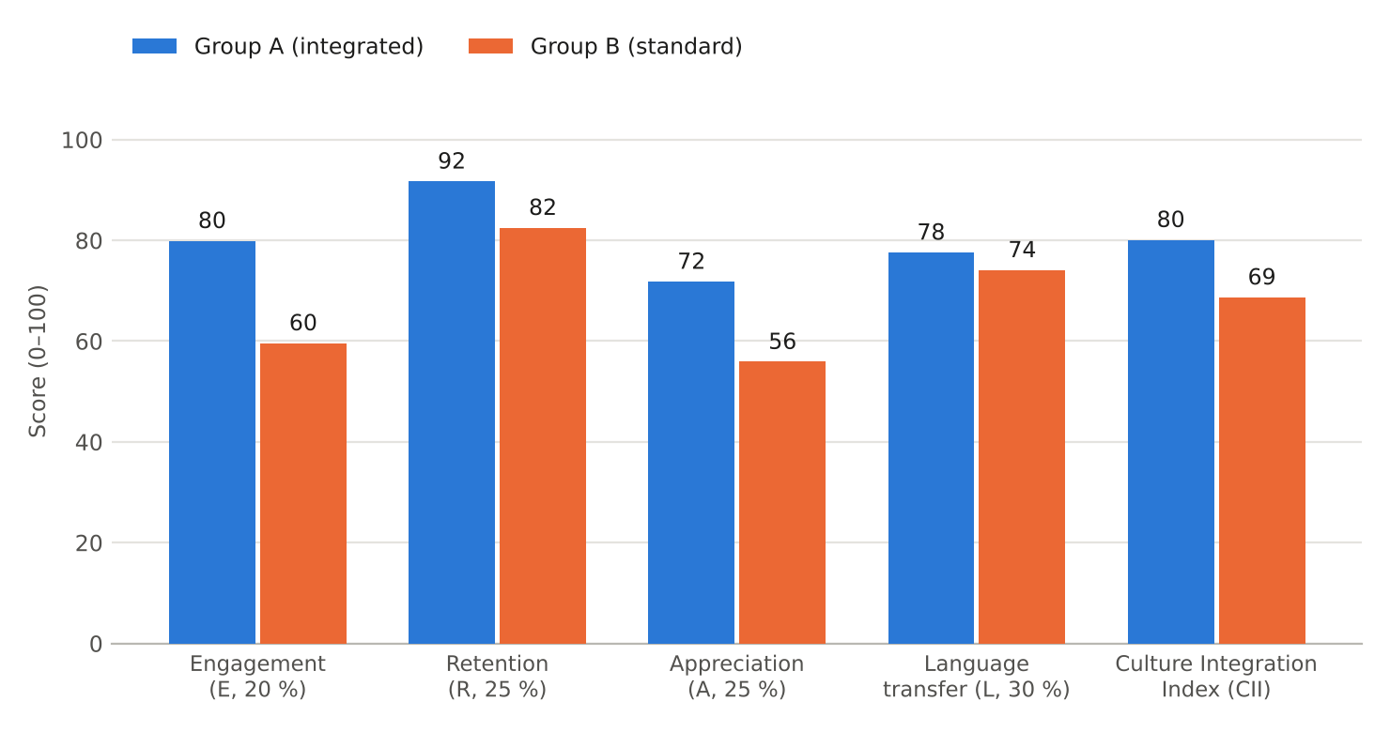
Figure 4. Case 1 (hypothetical data): Culture Integration Index and its components.
Component | Group A | Group B | Note
E Engagement | 79.9 | 59.6 | attendance, extension tasks, talk, self-rated engagement
R Retention | 91.7 | 82.5 | culture retention 89.6 % vs 74.0 %; language retention 93.8 % vs 91.1 %
A Appreciation | 71.8 | 55.9 | ISS-short plus appreciation rubric
L Language transfer | 77.6 | 74.1 | language test and speaking
CII | 80.1 (strong) | 68.7 (developing) | bands: ≥ 80 strong; 65–79 developing

Qualitative findings (illustrative)
- Journal (Group A): “I thought bread was just bread. Now I know why the baker asks if I want it sliced.” – noticing everyday practices.
- Focus group (Group A): two learners said the Warum? column was “hard in German, easy in Tamil”, confirming the value of L1 for explanation.
- Observation (Group B): the same three learners answered 70 % of the questions; others waited to be called.
- Teacher log: the routine took 12 minutes at first, 7 minutes by week 4; the retrieval flash took 5 minutes.

Threats to validity
Two small groups, one teacher, a novelty effect, and a possible “teaching to the test” effect because Group A practised culture questions. A real study would randomise, add a second teacher and pre-register the measures.

6.2 Case 2: a mixed-ability school class, eight weeks
Setting. A class of 30 Class-9 students (age 14–15) in India, A1 German as a third language, 3 lessons a week. Reading and speaking levels vary widely; six students dominate the talk time. The teacher keeps the language syllabus and adds two interventions, using the elements from Section 5.6.
- Week 4: tiered tasks (support / core / extension, Section 5.7) and talk tokens (each student has two tokens per lesson; spend one before anyone spends a second).
- Week 6: pair-first routine (think–pair–share) and a voice-note option on the class platform for students too shy to speak live.
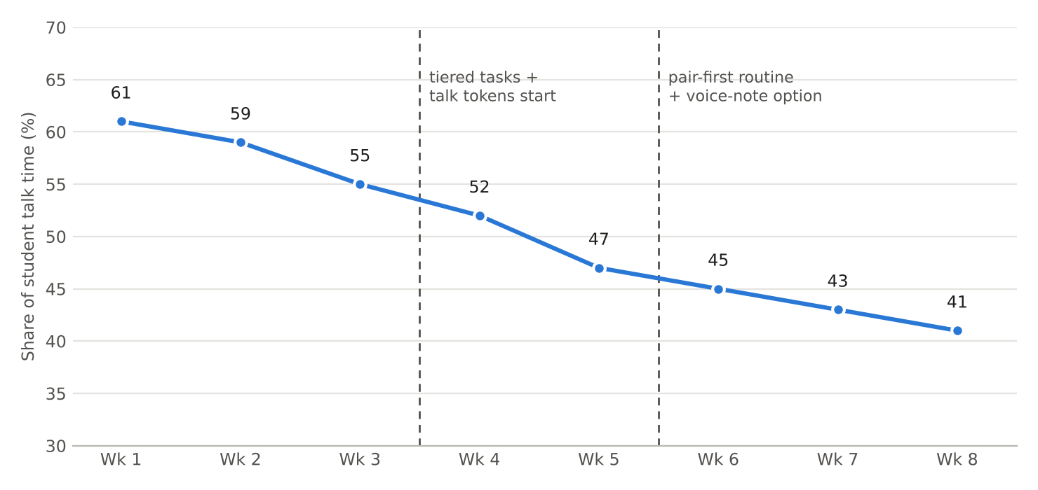
Figure 5. Case 2 (hypothetical data): share of student talk time taken by the six most talkative students.
Reading. In the simulation the top-six share falls from 61 % to 41 % over eight weeks, with visible steps after each intervention. The case illustrates a process metric (who speaks) that the CCIA criteria 4.1 and 4.2 can use without any test. Risks: tokens can feel artificial, and quieter students may still avoid the voice-note option; the teacher should check quality of talk, not only quantity.

6.3 Case 3: a self-learner with a video course
Setting. A 24-year-old working student studies alone with a free video course (Nicos Weg style, 76 episodes of about 2 minutes) for 20 minutes a day. There is no teacher and no classmates.
Need | Gap in a typical video course | Low-cost addition | Metric
Comparison | episodes show Germany, but no prompt to compare | after each episode write one line: Bei uns …, in Deutschland … | lines written per week; explained share
Retention | exercises follow the episode only | two-day and one-week delayed flash-quiz in an app | delayed score ≥ 80 % of immediate
Contact | no interaction | weekly 15-minute tandem call; three prepared questions | calls completed; questions asked
Representation | Germany-centred | one Austrian and one Swiss video per week from public broadcasters | D-A-CH share of viewed items
Motivation | long path A1–B1 | monthly “culture mission” (cook a recipe, find a Pfand machine) | missions completed

The case shows that the framework scales down to one person: the same four CII components can be tracked in a simple notebook, with the learner as both subject and rater.

6.4 What the cases teach
- Integration works when it is routinised (a short, repeated activity), not when it is occasional.
- Process metrics (talk share, completion) give early feedback; outcome metrics (retention, CII) confirm later.
- L1 support for explanation is a resource, not a failure.
- Small samples require interval reporting and careful claims.

7 · EMPFEHLUNGEN · RECOMMENDATIONS

7.1 Twelve recommendations
Each recommendation gives a concrete example and the metric by which success would be judged. Numbers refer to the priority matrix in Figure 6.
# | Recommendation | Concrete example (A1) | Metric
1 | Write explicit cultural can-do objectives for every unit | Ich kann sagen, wie man in Deutschland im Café bestellt, und mit meiner Kultur vergleichen. | CCIA 1.1 ≥ 3
2 | Represent D-A-CH in every module | greeting unit: Grüß Gott (Bavaria/Austria), Grüezi (Switzerland), Moin (north) | CCIA 2.1 ≥ 3
3 | Shift from sights to everyday life | Pfand, bakery, Sonntagsruhe, recycling bins, Du/Sie | CCIA 2.2 ≥ 3
4 | Teach a Notice–Compare–Question routine | three-column sheet with frames; L1 allowed for “Warum?” | explained comparisons ≥ 40 %
5 | Add mediation tasks | A reads a German sign; B tells C in L1 or simple German | relay success ≥ 80 %
6 | Organise real contact | tandem call or guest speaker with three prepared questions | contacts per learner
7 | Pilot and revise each module with CCIA and CII | run one unit with 8–10 learners, revise, re-run | CII ≥ 80
8 | Use tiered tasks and participation tools | three levels for the bakery role-play; emoji + word wall | top-six talk share ≤ 45 %
9 | Assess culture formatively and retest at 2 and 6 weeks | five-item retrieval flash at start of lessons | retention R ≥ 80 %
10 | Let learners create and share cultural products | class D-A-CH festival calendar; postcard to partner | artefact D3 rubric ≥ 2
11 | Vary narrative formats | mystery, role reversal, letter exchange (Section 7.4) | engagement E ≥ 75 %
12 | Embed culture in exam-type tasks | form completion with a German address and Pfand receipt; message to a friend | language transfer L ≥ 70 %

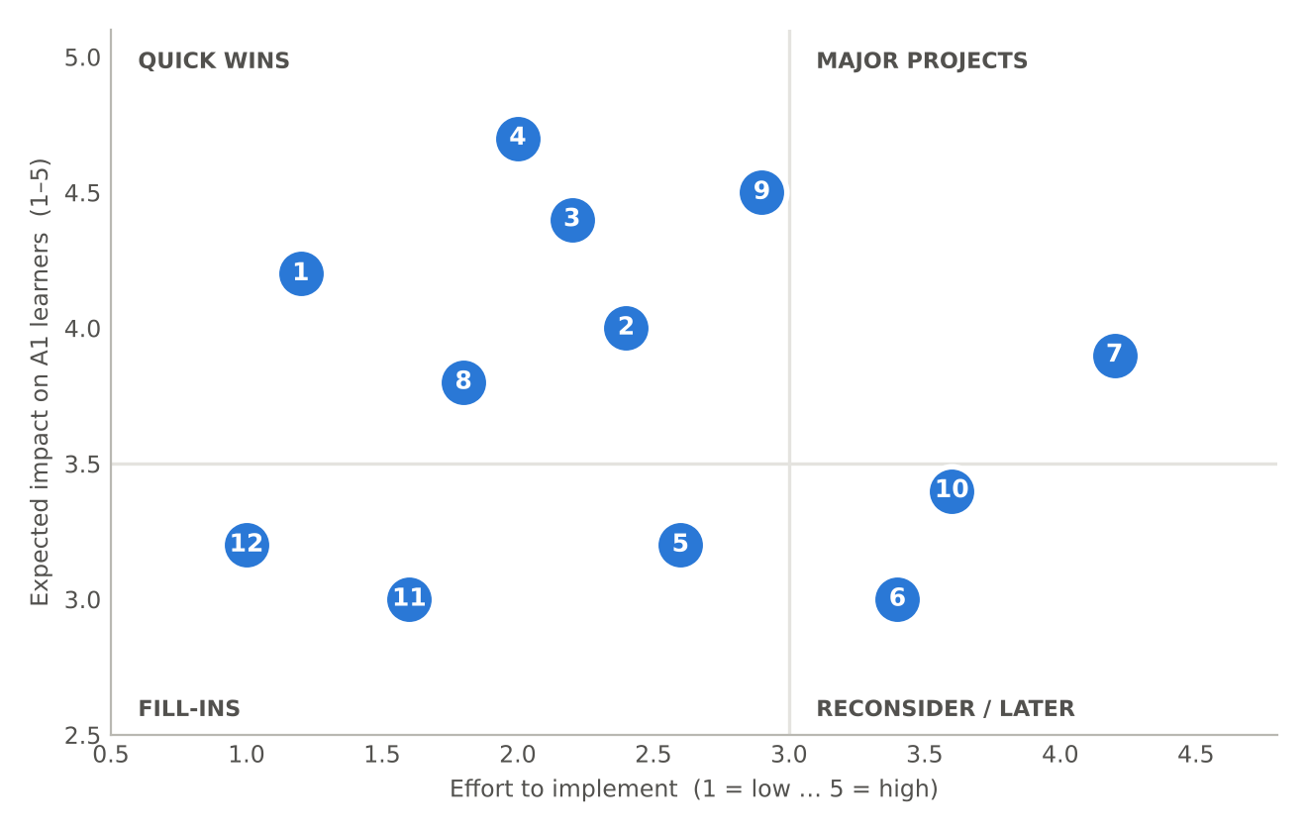
Figure 6. Priority matrix (author's estimates). Quick wins: 1, 4, 8, 11, 12; major projects: 3, 7, 9, 10.

7.2 Three redesigned micro-modules with new objectives
Each micro-module takes 45–60 minutes and has objectives of different types (the audit found only form and production objectives), a different narrative script, interactive steps, three-tier differentiation and an assessment.

MM1 · Beim Bäcker (everyday life; narrative: role reversal)
Objective type | Objective
Receptive-cultural | I can read a German bakery sign and say what is for sale and what it costs.
Production | I can order two items and ask the price: Ich möchte … Was kostet das?
Intercultural | I can name one difference from buying bread in my country and say why (Bei uns …, weil …).
Mediation | I can tell a friend in my own language what the baker said.

Narrative script · Rollentausch (the learner is the expert)
Erzähler/in: Ein Tourist aus Deutschland, Max, ist in Ihrer Stadt. Er möchte Brot kaufen, aber er versteht das System nicht. Sie erklären ihm alles!
English: A tourist from Germany, Max, is in your city. He wants to buy bread but does not understand the system. You explain it to him.
Max (teacher or audio): Entschuldigung, wo kaufe ich Brot? Muss ich warten? Was kostet das?
Lerner/in: Hier. Bitte warten. Das kostet … Rupien.
Wechsel / Switch: after two minutes the roles swap – now the learner is the tourist in a Berlin Bäckerei.

Step | Min | Interactive activity | Output
1 Notice | 8 | photo of a bakery counter: what do you see? list 5 words | word list
2 Role reversal | 10 | learner explains the bakery in their city to Max, using frames | spoken, 4 sentences
3 Role-play | 12 | learner orders in a Berlin bakery; partner is baker with surprise card (Ausverkauft!) | role-play
4 Compare | 8 | Bei uns / In Deutschland / Warum? sheet, L1 allowed | sheet
5 Relay | 7 | learner tells a partner in L1 what the baker said | relay

Support | Core | Extension
picture menu; frame Ich möchte ___, bitte.; audio model | phrase box; partner feedback | ask about ingredients; handle a wrong item politely; self-correct once

Assessment. Role-play rubric (0–4) on task completion, politeness (bitte/danke), accuracy; comparison sheet coded for explained comparisons. Success: 80 % of learners complete the order; at least 40 % explain a difference.

MM2 · Pfand: Flaschen, Geld und Umwelt (everyday life; narrative: mystery)
Objective type | Objective
Receptive-cultural | I can understand the Pfand symbol and a price on a drinks label.
Interaction | I can ask where to return bottles: Wo kann ich die Flasche zurückgeben?
Intercultural/critical | I can say one reason why Germany has Pfand (Das ist gut für die Umwelt.) and compare it with my country.
Mediation | I can explain Pfand to a new visitor in simple language.

Narrative script · Das Rätsel der Flasche (mystery)
Erzähler/in: Im Park liegt eine Flasche. Auf der Flasche steht: „0,25 € Pfand“. Was ist Pfand? Wir sind Detektive!
English: In the park there is a bottle. On it: “0.25 € deposit”. What is Pfand? We are detectives!
Hinweis 1: Man kauft die Flasche für 1,20 €. Dann kostet sie 1,45 €. (Clue 1: price goes up)
Hinweis 2: Man bringt die Flasche zurück. Man bekommt 0,25 €. (Clue 2: money comes back)
Lösung: Pfand ist Geld für die Flasche. Das ist gut für die Umwelt.

Step | Min | Interactive activity | Output
1 Mystery | 8 | show bottle picture; predict “Was ist das?” | predictions
2 Clues | 10 | groups read three clue cards; calculate 1,20 + 0,25 | solution
3 Hunt | 10 | find three Pfand items in drink photos and note price | hunt sheet
4 Compare | 10 | does your country have a deposit system? Warum / warum nicht? | comparison
5 Explain | 7 | explain Pfand to a visitor (pairs) | spoken

Support | Core | Extension
pictures with prices; numbers card | clue cards in German with glossary | write a 30-word message to a friend about the system

Assessment. Hunt sheet (3 items correct), explanation rubric, delayed retrieval flash after two weeks (“Wie viel Pfand?”). Success: retrieval ≥ 80 %.

MM3 · Grüß Gott, Grüezi, Moin (D-A-CH greetings; narrative: letter exchange)
Objective type | Objective
Receptive-cultural | I can recognise three regional greetings and where they are used.
Interaction | I can greet people with du/Sie and a time-of-day expression.
Critical | I can say Das stimmt nicht immer. when a greeting map oversimplifies, and give an example.
Mediation | I can tell a friend which greeting to use in a given situation.

Narrative script · Briefwechsel (letter exchange)
Brief von Lena (Hamburg): Moin! Ich bin Lena. Ich wohne in Hamburg. Bei uns sagt man „Moin“. Wie sagt man bei dir?
Brief von Anna (Wien): Servus! Ich bin Anna aus Wien. Bei uns sagt man „Servus“ oder „Grüß Gott“.
Brief von Luca (Zürich): Grüezi! Ich bin Luca. In Zürich sagt man „Grüezi“. Und du?
Ihre Antwort: Hallo! Ich bin … Ich komme aus … Bei uns sagt man „…“.
English: Three young people from Hamburg, Vienna and Zurich write; learners reply with their own greeting.

Step | Min | Interactive activity | Output
1 Read | 10 | three letters; learners underline the greeting and the city | table
2 Map | 8 | place letters on a D-A-CH map | map
3 Du/Sie | 10 | sort 8 situations into du or Sie | sorted cards
4 Stereotype check | 7 | map oversimplifies: find one counter-example (Servus also in Bavaria) | critical sentence
5 Reply | 15 | write a short reply of 30 words | reply letter

Support | Core | Extension
frame letter with blanks; word bank | free reply with 3 points | reply plus a question about the sender's town

Assessment. Reply letter on a 0–4 rubric (3 points covered, greeting correct, comparison given); coded for stereotype statements before and after. Success: at least 60 % of learners identify a counter-example.

7.3 Varying learning objectives: a menu
To avoid uniform objectives (Section 5.2) each unit should draw from at least three of five types.
Type | Verb examples | A1 example
Receptive-cultural | read, recognise, match | I can read a sign and say what it means.
Production | say, write, ask | I can write a 30-word message.
Interaction | order, answer, react | I can order a drink and pay.
Intercultural | compare, explain, notice | I can say one difference and why.
Mediation | relay, translate, explain | I can tell a friend what the sign says.

7.4 Varying narrative scripts: six formats
Format | Learner role | Example opening line (A1) | Suitable for
Guide narrates | passenger | Willkommen in Köln! | sights, history
Role reversal | expert | Max kennt Ihre Stadt nicht. Sie erklären. | everyday life
Mystery | detective | Was ist Pfand? Wir sind Detektive. | objects, systems
Letter exchange | pen-pal | Liebe Lena, bei uns sagt man … | greetings, comparison
Problem-solving | traveller with a problem | Der Zug ist weg! Was machen wir? | transport, directions
Debate / opinion | participant | Ich finde … gut, weil … | festivals, food

7.5 Twelve-week roadmap
Weeks | Action | Recommendation | Output
1–2 | audit existing units with CCIA (two raters) | 7 | baseline scores
2–3 | write cultural can-dos and vary objective types | 1 | revised objectives
3–5 | add D-A-CH elements and everyday-life content | 2, 3 | revised units
4–6 | introduce Notice–Compare–Question routine; tiered tasks | 4, 8 | routines in use
6–8 | pilot MM1–MM3 with 8–10 learners | 7, 11 | pilot data
8–10 | add retrieval flash and delayed retests | 9 | retention data
9–11 | tandem call or guest session; learner products | 6, 10 | contacts, artefacts
12 | compute CII, revise, report | 7 | evaluation report

8 · SCHLUSS · CONCLUSION

8.1 Synthesis
Existing A1 materials include culture, but mostly as information and context and rarely as assessed competence. Textbook studies show Germany-centred, tourist-oriented content and “extra” status for culture; the exam rewards everyday language, not cultural knowledge. The report proposed a measurable response: the CCIA to audit materials, the CII to track learners, and a set of specific interactive, differentiated and narrative formats to improve integration.
Applied to the author's own modules, the framework showed that interactivity and structure are strengths, whereas intercultural work, evidence and variety of objectives and scripts are weaknesses. The three micro-modules and twelve recommendations are the direct response.

8.2 Limitations and future work
- Replace hypothetical data with a pilot of at least 30 learners and a second rater.
- Validate and adapt the CII weights; test whether language transfer should weigh more or less.
- Extend the corpus: audit full textbooks and the Goethe sample papers.
- Study learners with different home languages to see how L1 use affects comparison quality.

8.3 Reflection
The most important lesson of this week is that good intentions need criteria. A module that “includes culture” can still be shallow; writing the rubric made the gaps visible, and the gaps pointed directly to practical fixes. For an engineering student the exercise is familiar: define the specification, measure against it, iterate.

ANHANG · APPENDICES

Appendix A · Instruments

A1 Appreciation survey (8 items, 1 = strongly disagree … 5 = strongly agree; emoji anchors for A1)
# | Item (English; translate for learners)
1 | I like learning about life in German-speaking countries.
2 | I am curious about how people live in Germany, Austria and Switzerland.
3 | I enjoy comparing German customs with customs in my country.
4 | Customs that are different from mine are interesting, not strange.
5 | I feel confident talking about culture in simple German.
6 | I think culture helps me remember German words.
7 | I would like to talk to someone from a German-speaking country.
8 | Learning culture makes German lessons more interesting.

A2 Notice–Compare–Question sheet
Bei uns … | In Deutschland / Österreich / der Schweiz … | Warum? (any language)

A3 Observation tally (per lesson)
Learner | Turns in German | Turns in L1 | Asked a question | Helped a peer
A
B
C

A4 Reflection journal prompts
- Today I noticed …
- One thing that surprised me …
- One thing I would like to ask a German speaker …

Appendix B · CII worksheet
Step | Calculation
1 | E = mean of attendance %, extension-task completion %, talk-time index (min/10), self-rated engagement scaled to 0–100
2 | R = mean of culture retention % and language retention % (delayed score ÷ immediate score × 100)
3 | A = mean of ISS-short scaled to 0–100 and the appreciation rubric %
4 | L = mean of language test % and speaking task %
5 | CII = 0.20 E + 0.25 R + 0.25 A + 0.30 L; read against bands

Appendix C · Response to earlier feedback
Feedback | How it is addressed | Where
Lacks depth | original frameworks (CCIA, CII, IDS); self-audit; effect sizes with intervals; validity and ethics | 4, 5, 6
Lacks originality | own rubric, index and depth scale; role reversal, mystery and letter-exchange scripts; talk-token routine | 4, 7
Vary language-learning objectives | five objective types; audit of 28 objectives; menu of objective types | 5.2, 7.2, 7.3
Vary narrative scripts | audit of script uniformity; six formats; three full scripts with English | 5.3, 7.2, 7.4
More specific differentiation examples | three-tier bakery role-play; need-based strategies; tier tables in each micro-module | 5.7, 7.2
More specific interactive elements | catalogue of twelve with steps, tools, time and success evidence | 5.6
All required deliverables | review of strategies, key metrics, framework, case studies, sections, recommendations | 3–7

Appendix D · Glossary
Term | Meaning
A1 | CEFR level for beginners
D-A-CH | Deutschland, Österreich, Schweiz (Confoederatio Helvetica)
Binding / connecting | culture required by the course vs linked to learners' lives (Tammenga-Helmantel, 2019)
CCIA | Cultural Content and Integration Audit (author's rubric)
CII | Culture Integration Index (author's index)
IDS | Integration Depth Scale 0–4
ISS | Intercultural Sensitivity Scale (24 items, five factors; short form used here)
L1 | the learner's first or home language
Mediation | relaying meaning between people or languages (CEFR Companion Volume)
Pfand | bottle deposit

Appendix E · References
- Byram, M. (1997). Teaching and Assessing Intercultural Communicative Competence. Multilingual Matters.
- Chen, G.-M., & Starosta, W. J. (2000). The development and validation of the Intercultural Sensitivity Scale. Human Communication, 3, 1–15.
- Council of Europe (2020). Common European Framework of Reference for Languages: Companion Volume. (Overview via the ECML.)
- Deutsche Welle. Nicos Weg course description (dw.com).
- Goethe-Institut (2020). Deutsch als Fremdsprache weltweit: survey of learner numbers. Goethe-Institut e.V.
- Goethe-Institut. Goethe-Zertifikat A1: Start Deutsch 1 test description.
- Hueber Verlag. Menschen A1 concept overview and teaching materials description.
- Niu, R. (2022). Intercultural sensitivity and foreign language learning motivation: a quasi-experimental study. (Journal article as read for this report.)
- Tammenga-Helmantel, M. (2019). Culture in a Dutch German-as-a-foreign-language textbook: binding and connecting. (Journal article as read for this report.)
- Vidgren, S. (2026). D-A-CH content in two Finnish beginner German textbooks, Freut mich 1 and Hallo! 1. (Study as read for this report.)
Note on accuracy
Source descriptions reflect the pages and abstracts available to the author. Details of full textbooks were not verified, and bibliographic details for the journal studies should be checked against the originals before formal citation. All case-study figures are hypothetical.

