Introduction

Purpose and Scope
Purpose of this document is to describe the software requirements for “Raspberry Pi demonstration Project”.

Scope of software implementation work includes:
- Raspberry pi 2b+ v1.2
- Driver customization activities for the following modules:
- Multicore programming using quad core processor
- A complex Pico project, compiled under the Arduino IDE
- Multi-core programming using the Pico C/C++SDK
- SG90 miniature servo position control using PWM
- DC motor direction control using GPIO
- switch of DPST mechanical relay using a MOSFET
- PWM DC motor speed control using GPIO to switch a MOSFET
- Interrupt driven measurement from ultrasound sensors

- Basic functionality and implementation of the following activities:
- Application of Raspberry PI libraries
- Implimenting Devices and peripherals with their drivers
- interfacing components with raspberry PI.
- Troubleshooting and customising peripherals.
- Integration and Testing with Simulated Data

The scope contains Board bring up, device driver customization and basic test application development of Automated car system functionality.

Acronyms | Description
4G | Fourth Generation Network
SATA | Serial Advanced Technology Attachment
SPI | Serial Peripheral Interface
USB | Universal Serial Bus
Wi-Fi | Wireless Fidelity
GPS | Global Positioning System
LowPAN | IPv6 over Low-Power Wireless Personal Area Networks

Requirement Specification Overview

Raspberry Pi 2 Model B v1.2
- BCM2837 SoC
- quad-core 900 MHz ARM Cortex-A53 processor.
- 1 GB RAM
- 4 x USB 2.0 sockets
- 10/100 BaseT Ethernet socket
- HDMI video socket
- RCA composite video socket
- microSD card socket
- Powered from microUSB socket
- 3.5 mm audio out jack
- Header for GPIO and serial buses
- Display Serial Interface (DSI) 15 way flat flex cable connector with two data lanes and a clock lane
- Camera connector 15-pin MIPI Camera Serial Interface (CSI-2)

Development Environment
Enviornment statistics for host machine:
Host PC | Ubuntu 20.04.05 LTS
Cross Compiler | Gcc-arm-none-eabi-4_9-2015q3
Linux Kernel | 5.15.0-60-generic
System clock cycle | 32-bit
Debian version | 11 (bullseye)
Debug port/Console | UART
Board Support Package | Raspberry PI Support SDK
Debugging Tools | PI In system debugger

Table 1 : Development Environment Details for mesh platform

Software Overview
There are 2 major phases in software implementation:

Overall Linux software consists of boot loader (i.e. U-boot) which is used for board initialization and loading the OS, OS/kernel, which contains the OS as well as drivers and kernel configurations and file system. It includes the entire user level utilities and applications along with system libraries. Raspberry Pi has its own proprietary bootloader, which is loaded by the ROM code and is capable of loading the kernel

Testing Overview
- The Visual indicators will work while demonstrating the signal transfer between the board and the peripherals.
- The Ultrasound feature can be used for detecting impending objects, we can use light indicators to warn about distance.
- The Ultra sound sensor will be the trigger to the warnings, so it will be used as the interrupt caller for an unexpected situation that may arise. Motors will have visual indication that will be the movement as a response to the input. We are using DC motors and servo motors for each purpose of their own.
- Pulse width Modulation (PWM) pins will be used for modulation or sensitive control of our motors asPulse width modulation or PWM is a commonly used control technique that generates analog signals from digital devices such as microcontrollers. In PWM technique, the signal's energy is distributed through a series of pulses rather than a continuously varying (analog) signal.

Layered Architecture

System Booting process for Raspberry Pi

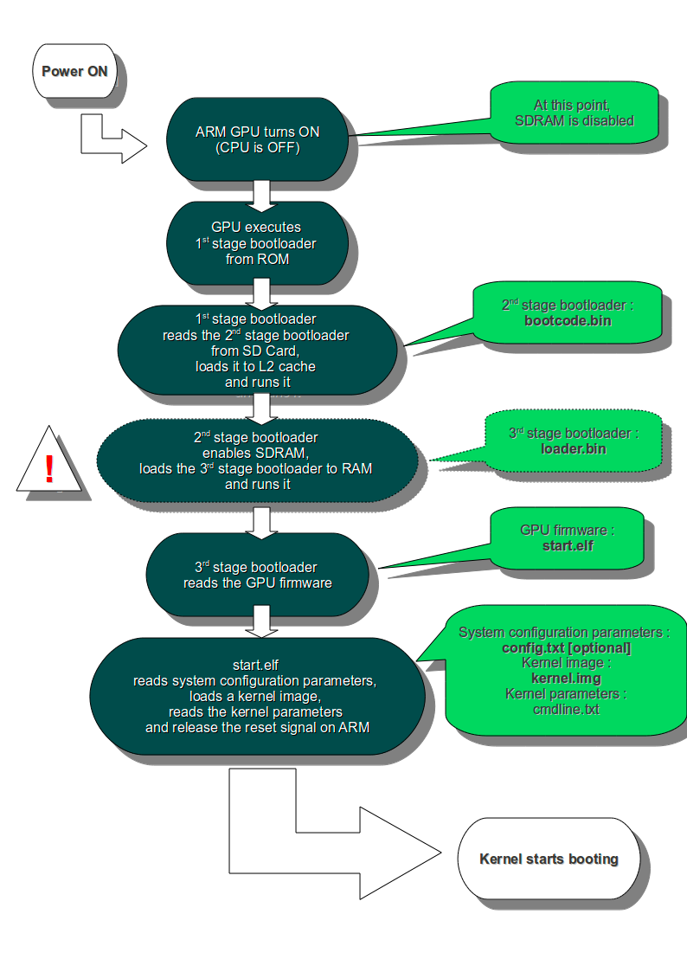

Software Requirement

Linux Driver and Hardware Interface Requirements:

Requirement  ID | Requirement | Description | Customer Requirement | Hardware Interface, Dependencies,  Remarks (if any)
1 | Wi-Fi Driver | Wi-Fi Communication | Data transfer | This module can use interface type Wi-Fi.
2 | Ethernet streaming Module | Data Transmitted via Ethernet. | Data transfer between peripherals | This module can use interface Ethernet
3 | Ultra sound Sensor | UART | Data from sensor to serial display | To detect impending objects
4 | DC motor | GPIO interface | Polar terminals | Steering wheel and wheels of car
5 | Servo motor | GPIO interface | Polar terminals | Steering wheel
6 | CLCD screen | I2C protocol | Display Data from peripherals | Analysis and Diagnostics
7 | Raspberry PI 2B v1.2 | USB protocol | Single board Computing of peripherals | Main processor

Requirement Specification Details

Booting Requirements

Micro SD Card with Processor Specific Tool chain
Purpose
Raspberry PI Bullseye has its OWN BIOS, so OS will be configured and booted from SD card.

Communication & Interface Requirements
Latest stable Linux Kernel which is 5.15. is used.
Src: https://www.raspberrypi.com/software/operating-systems/

Wi-Fi Mesh Driver
Purpose
This driver is used to support the Ethernet protocol with Gigabit speed. The Ethernet MAC driver support data transfer to fixed IP address in mesh module.

Discrete I/O Interface
Purpose
This contains 2 to 3 Discrete I/O pins. Here for example application to read ADC output using the interface.

SPI
Purpose
This interface is required to support WAIC. SPI Driver should be made available.

Linux application Requirements

Wi-Fi transfer
Purpose
Data transfer among multiple modules. It can be used with sensors connectivity as well as Data transfer application.

GPIO transfer
A basic component of interface for modern microcontrollers with 2 voltage settings (High-Low)

