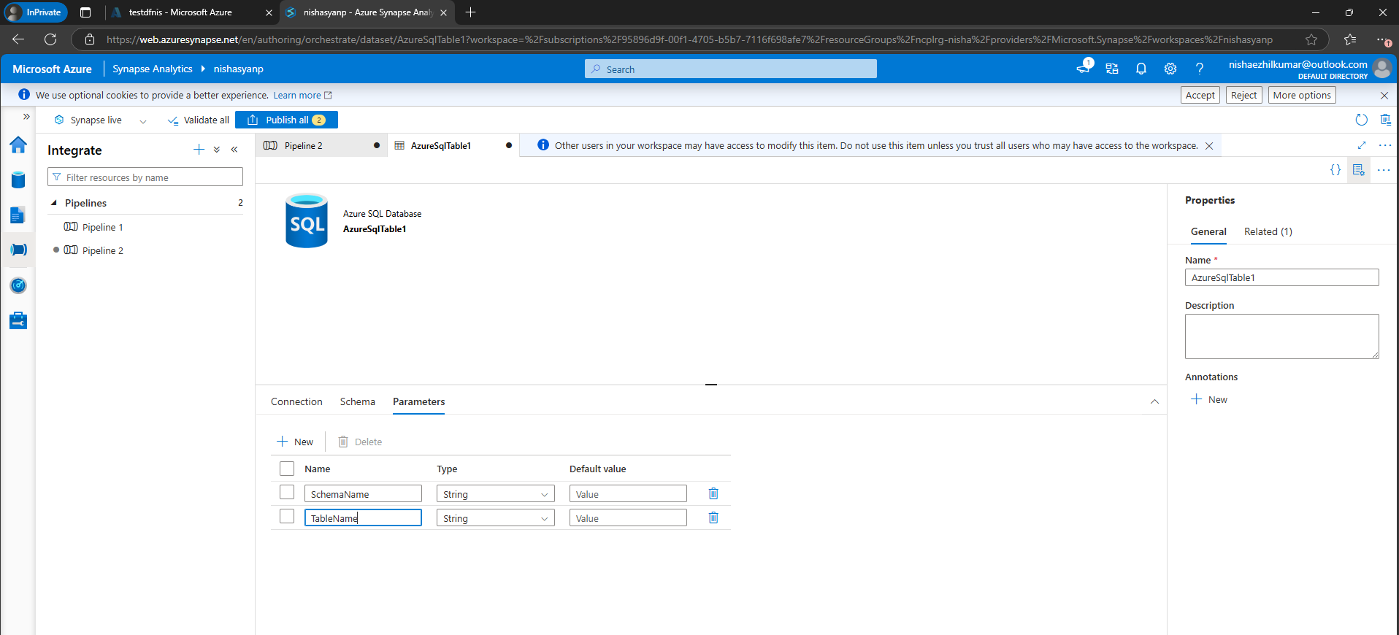

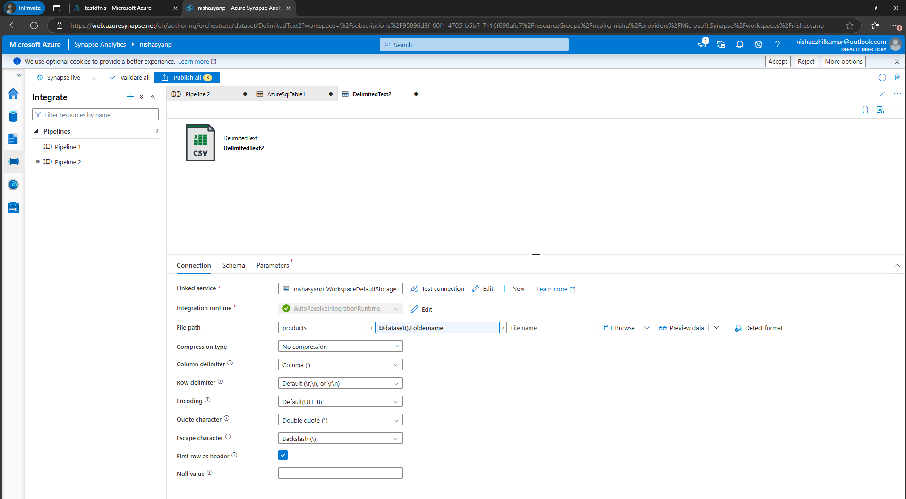

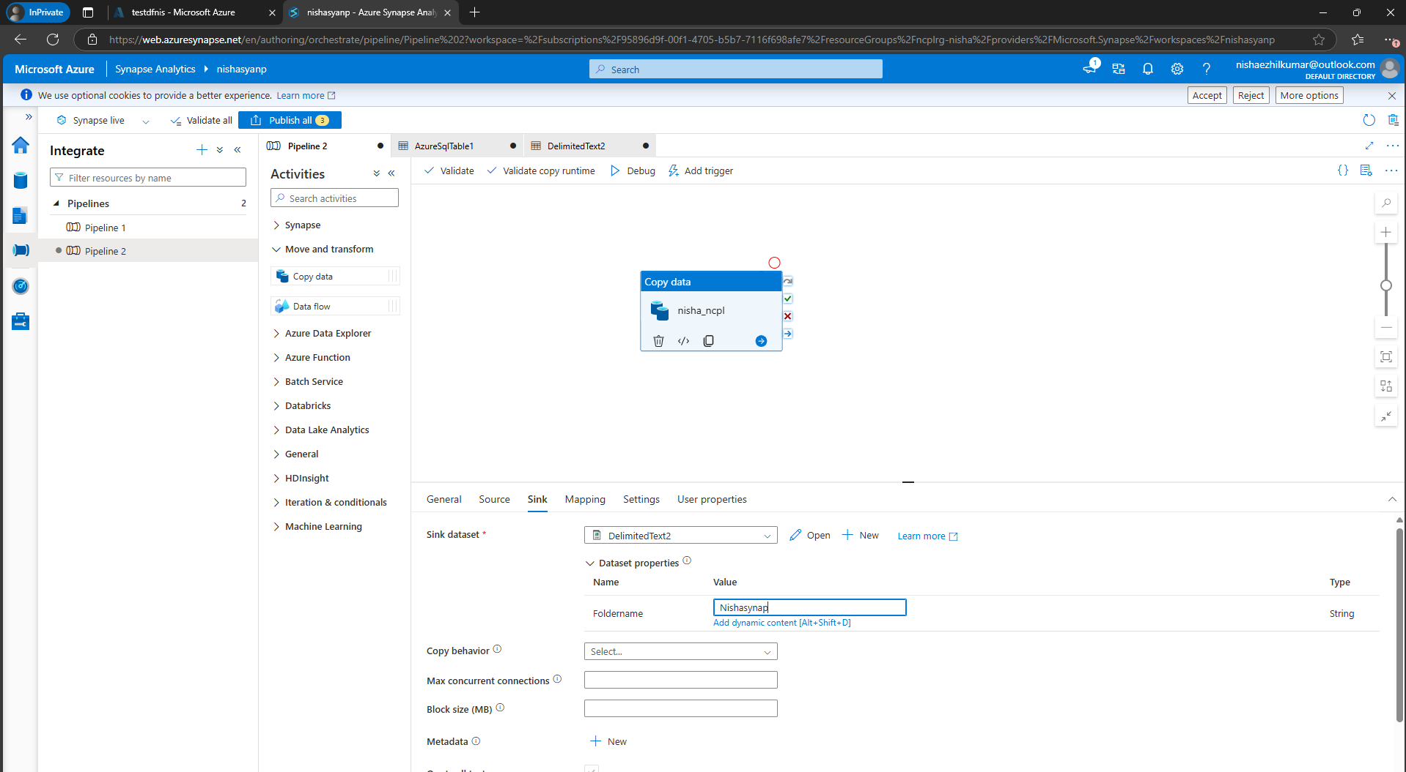

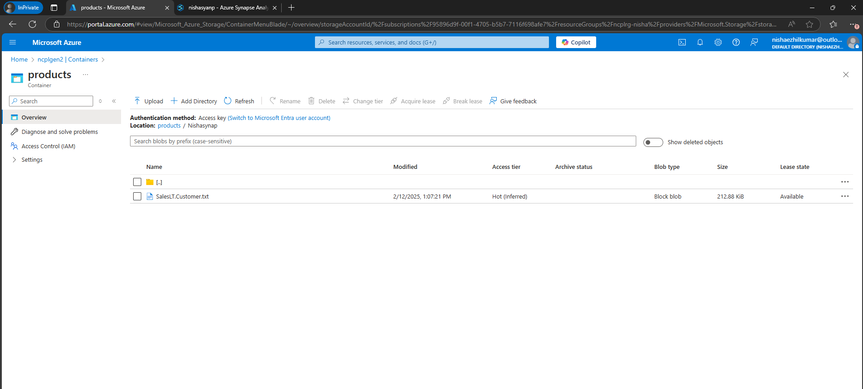

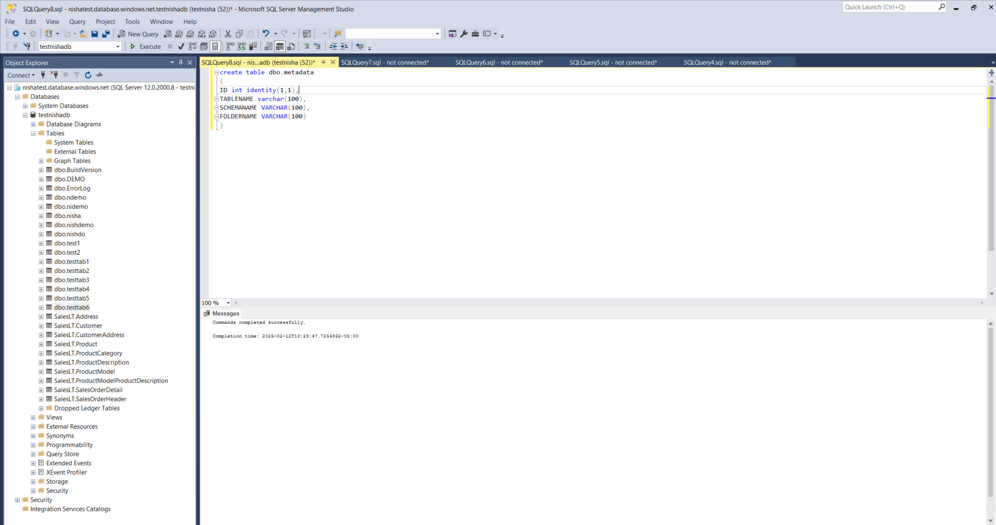

create table dbo.metadata

(

ID int identity(1,1),

TABLENAME varchar(100),

SCHEMANAME VARCHAR(100),

FOLDERNAME VARCHAR(100)

)

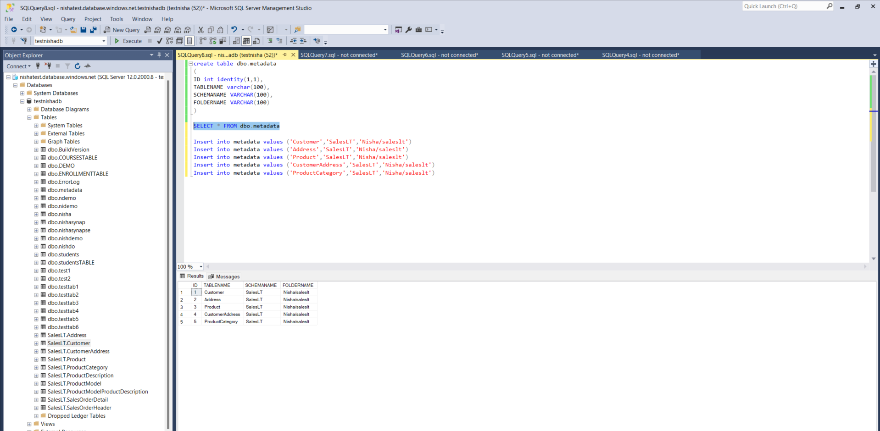

Insert into metadata values ('Customer','SalesLT','Nisha/saleslt')

Insert into metadata values ('Address','SalesLT','Nisha/saleslt')

Insert into metadata values ('Product','SalesLT','Nisha/saleslt')

Insert into metadata values ('CustomerAddress','SalesLT','Nisha/saleslt')

Insert into metadata values ('ProductCategory','SalesLT','Nisha/saleslt')

