\* Create 5 tables with primary keys and foreign keys relationship

\* Insert Data Into those Tables

1st table

Create table testtab1(ID INT PRIMARY KEY, Nam Varchar(100), Designation varchar(50))

Insert Into testtab1 values

('12','Ajaey','Designer'),

('23','Nisha','Developer'),

('34','XYS','Tester'),

('22','AJ','Ios'),

('3','XYS','Dev'),

('20','AJ','Ios')

2nd table

Create table testtab4(EMPLOYID INT

--FOREIGN KEY (EMPLOYID) REFERENCES testtab1(ID), Nam Varchar(100), Designation varchar(50), ID INT PRIMARY KEY)

Insert Into testtab4 values

('12','Ajaey','Designer','1'),

('23','Nisha','Developer','2'),

('34','XYS','Tester','3'),

('22','AJ','Ios','4'),

('3','XYS','Dev','5'),

('20','AJ','Ios','6')

3rd table

Create table testtab6(EMPLOID INT

FOREIGN KEY (EMPLOID) REFERENCES testtab1(ID), Nam Varchar(100), Designation varchar(50), ID INT FOREIGN KEY (ID) REFERENCES testtab4(ID), CUSID INT PRIMARY KEY)

Insert Into testtab6 values

('12','Ajaey','Designer','1','600'),

('23','Nisha','Developer','2','900'),

('34','XYS','Tester','3','809'),

('22','AJ','Ios','4','607'),

('3','XYS','Dev','5','918'),

('20','AJ','Ios','6','540')

\* Explore Indexes Section and check for keys in the created tables.

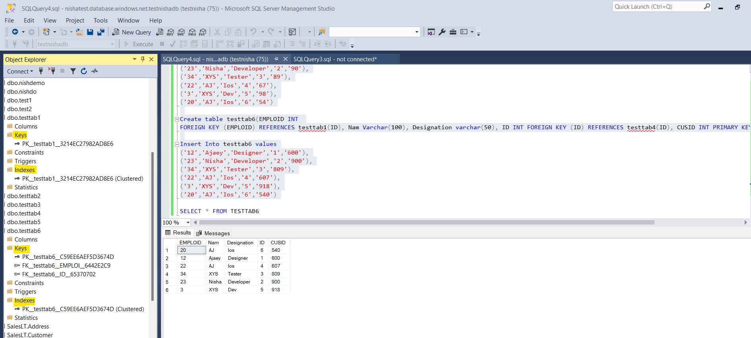

\* Document Explanation of why understanding table relationships and indexing is crucial for query performance.

Table relationship will keep data structured and speed up Joins using Primary key, Foreign key which is useful to connect the table

Indexing is used to filtering and searching fast

Two types of indexes are Clustered and Non clustered

Clustered points to Primary key and Non clustered refers to Foreign key

In a real-time scenario Clustered refers to a Phonebook where contacts are saved based on alphabetical order, and non-clustered refers to index in a notebook pointing to where the data is stored.

Problems I faced during creating Primary and foreign keys:

1. While creating the second table I created less number of rows than the first table so it was throwing an error
2. While creating the third table I got confused with table names so it threw another error
3. While checking keys and indexes I forgot to save the file so it was not displaying the keys in it, after saving and refreshing the error was resolved.