1. Practice creating and debugging pipelines in Azure Data Factory to understand the Copy Data Activity process.

2. Use a sample CSV file to create a pipeline and successfully copy data between containers.

———————————

1. Create an ADF Pipeline:

* Set up a Copy Data Activity in Azure Data Factory.

* Use Azure Data Lake Storage Gen2 as both the source and destination containers.

* Select a sample CSV file as the source dataset.

2. Configure and Test:

* Define the file format and configure linked services for both source and destination.

* Test connections to ensure proper setup.

3. Debug and Publish:

* Run the pipeline in debug mode and fix any errors.

* Publish the pipeline after successful execution.

4. Submit & Review:

* Take a screenshot of the successful pipeline run.

* Document any errors encountered and how they were resolved.

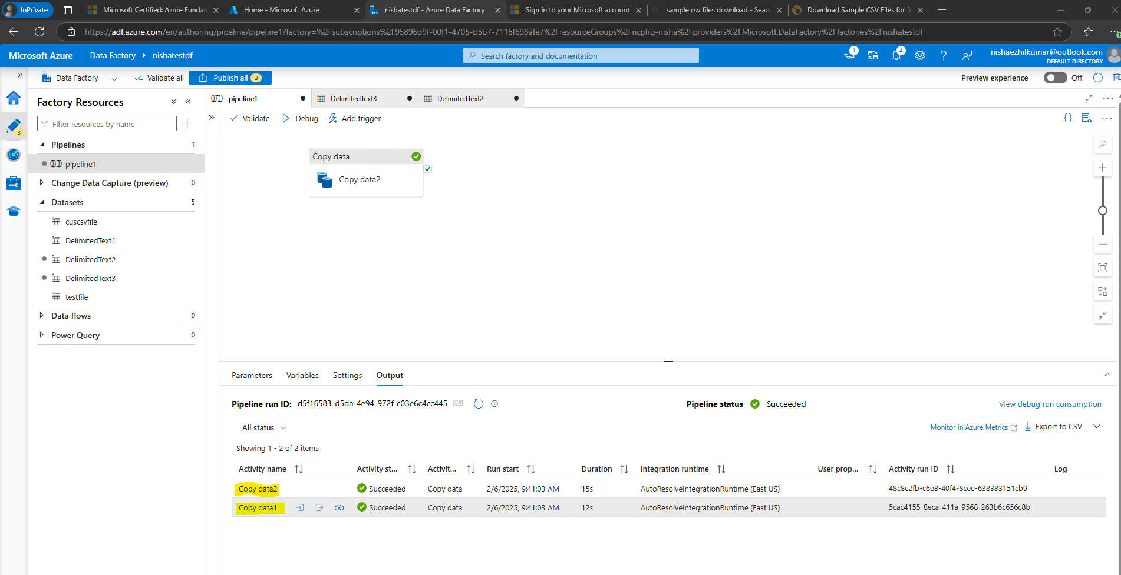

**SOURCE PATH OF THE CSV FILE**

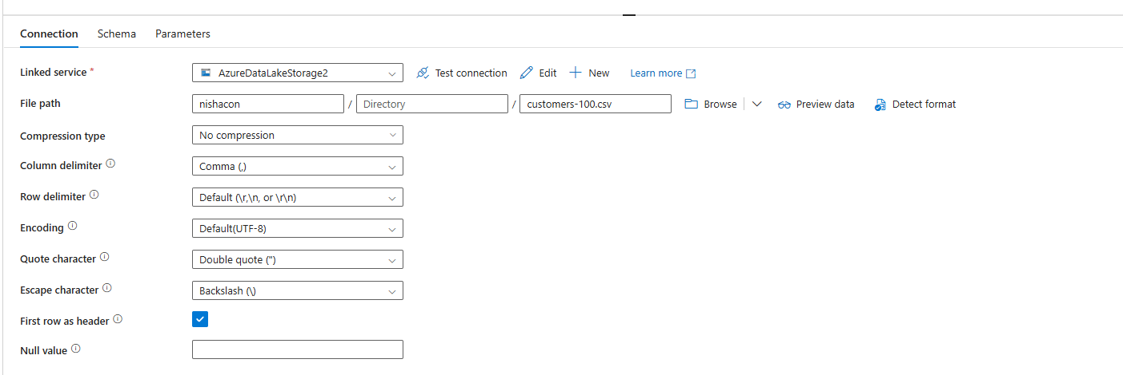

**SINK PATH OF THE CSV FILE**

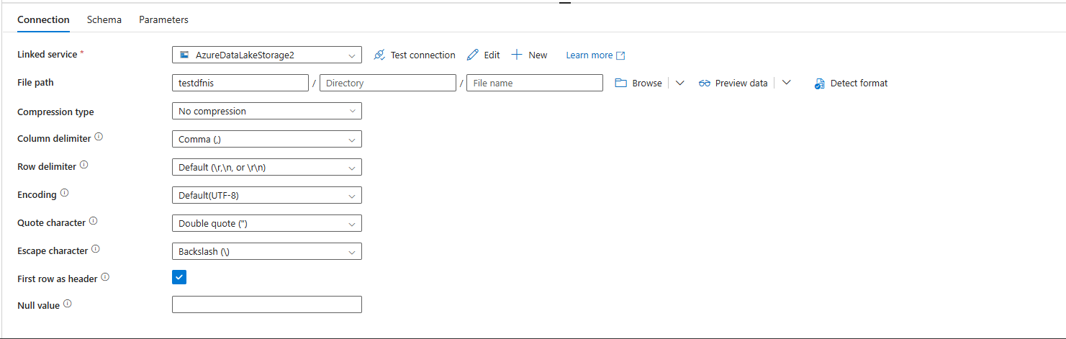

The second container is the new container created to store the copied file

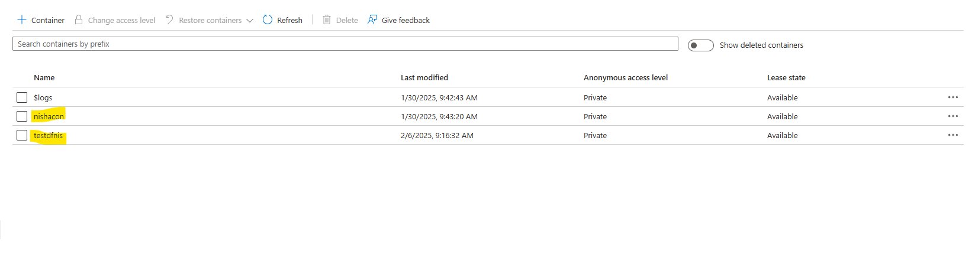

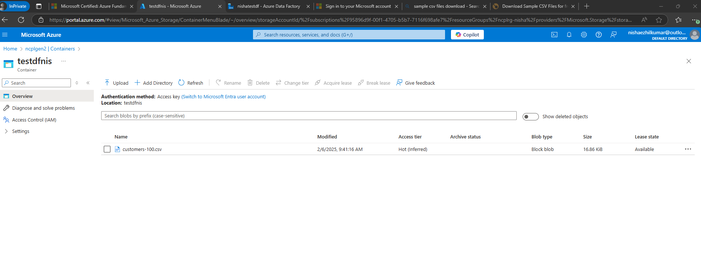

**Understanding the Error:** Error **2108** happens when ADF **can’t find or connect** to the Linked Service needed for the pipeline to work.

**Linked Service Validation:**

|  |  |  |  |  |
| --- | --- | --- | --- | --- |
| Step | What to Check? | |  | | --- | |  |  |  | | --- | | How to Fix? | |
| Open Linked Services | Find the Linked Service for Source & Destination | Go to **Manage > Linked Services** in ADF |
| Test Connection | Check if the connection is successful | Click **"Test Connection"** and review errors |
| Check Credentials | Verify passwords, keys, or Managed Identity | Update credentials if incorrect |
| Check Firewall | Ensure ADF is allowed in storage/database settings | Update firewall rules in **Networking** |
| Verify Dataset | Ensure datasets use the correct Linked Service | Open **Author > Datasets** and check settings |
| Publish & Debug | |  | | --- | |  |  |  | | --- | | Save and test changes | | Click **"Publish All"** and **Debug the pipeline** |

**Testing Connections:**

1️.**Go to** [ADF Studio](https://adf.azure.com/)  
2️.Click **Manage (⚙️) > Linked Services**  
3️.Find your **Source** and **Destination** Linked Services  
4️.Click **"Test Connection"**

✅ **If successful** → The connection is working.  
❌ **If it fails** → Check the error message.

Debugging the Pipeline: Explain how you will debug the pipeline to identify the issue with the linked service.

**Configuration Check:** Describe how to ensure the linked service is properly configured with the correct authentication details, storage account names, and container paths.

✔ **Correct Authentication** → Check passwords, keys, or Managed Identity permissions.  
✔ **Correct Storage Name** → Ensure the storage account name is accurate.  
✔ **Correct Container Path** → Verify the folder or table name in the dataset.

Fixing the Issue: Provide steps for how to fix the configuration and re-test the pipeline.

Best Practices: Share any tips to avoid such errors in the future.