1. ADLS TO BLOB STORAGE HAVING SAME FILE FORMAT

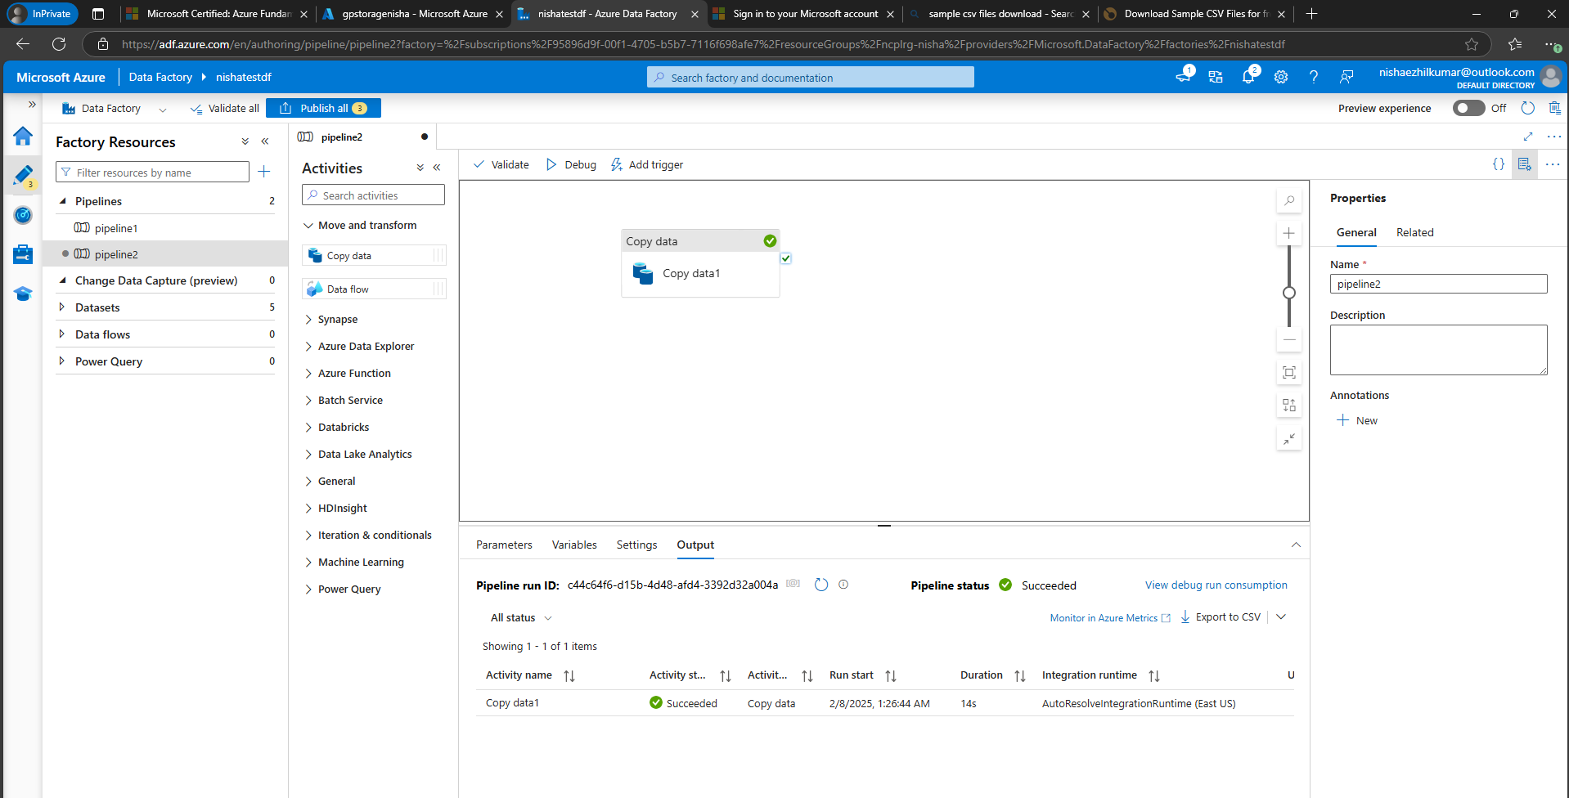

Data to be copied from GEN2 ACC to Blob storage account

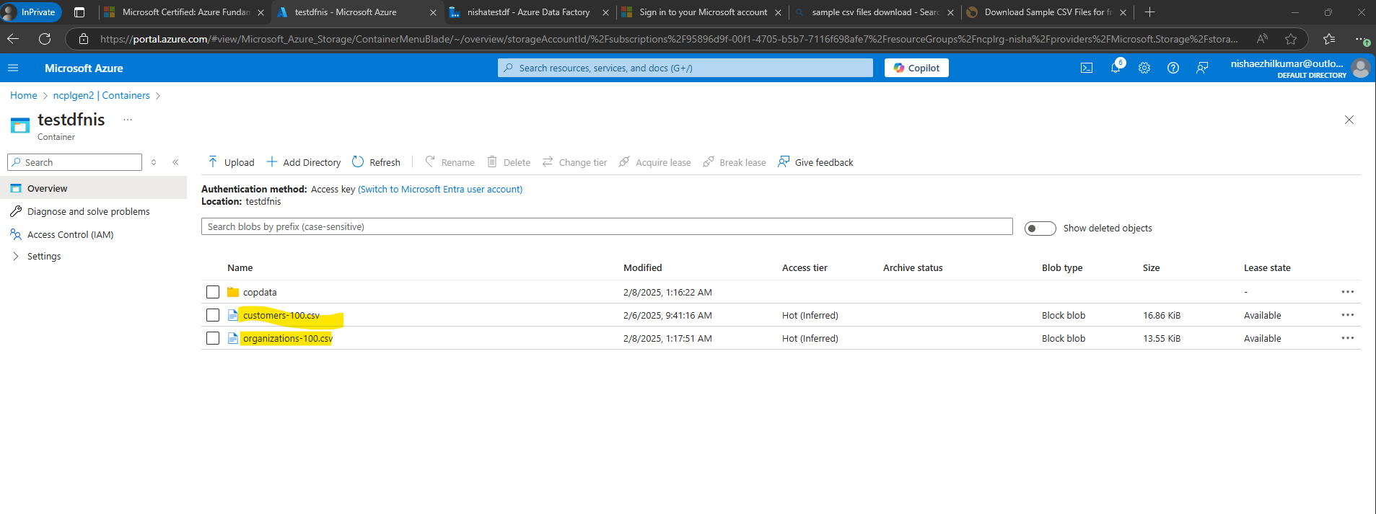

Data successfully copied to Blob storage account

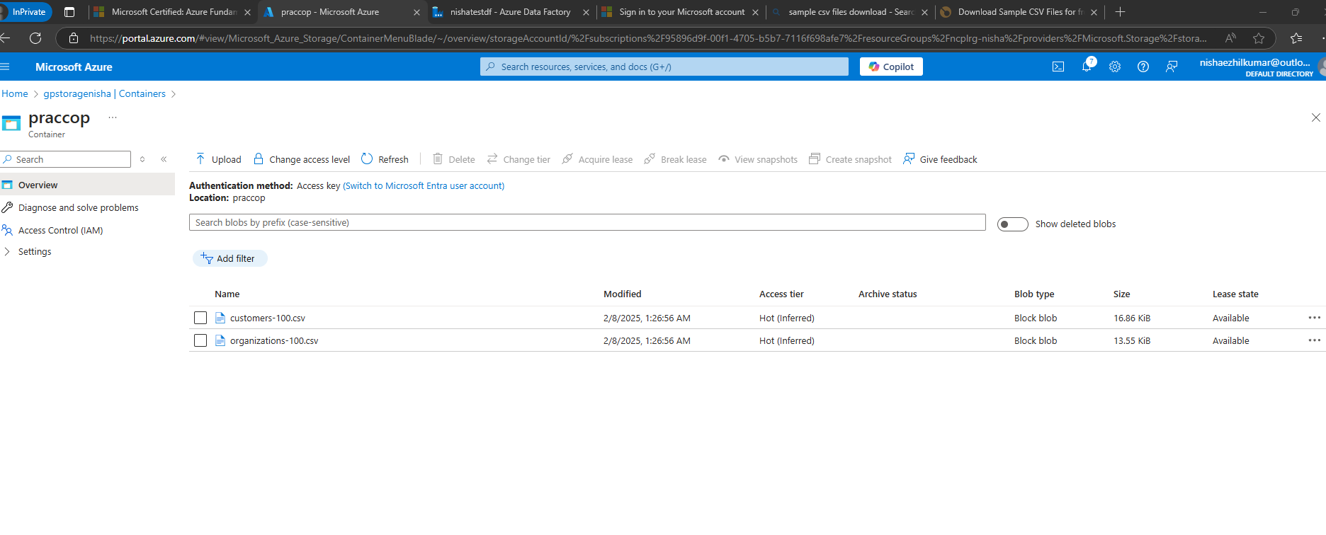

1. MOVING FEW FILES AND CHANGING THE FORMAT

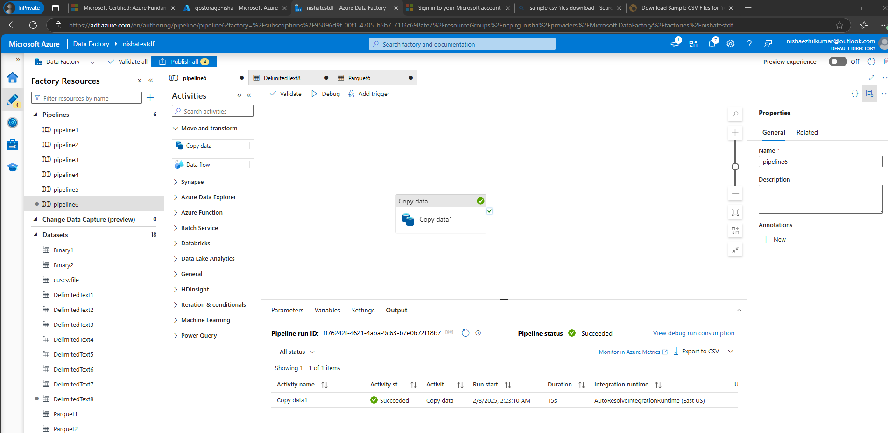

To Move all the files starting with people to blob storage account

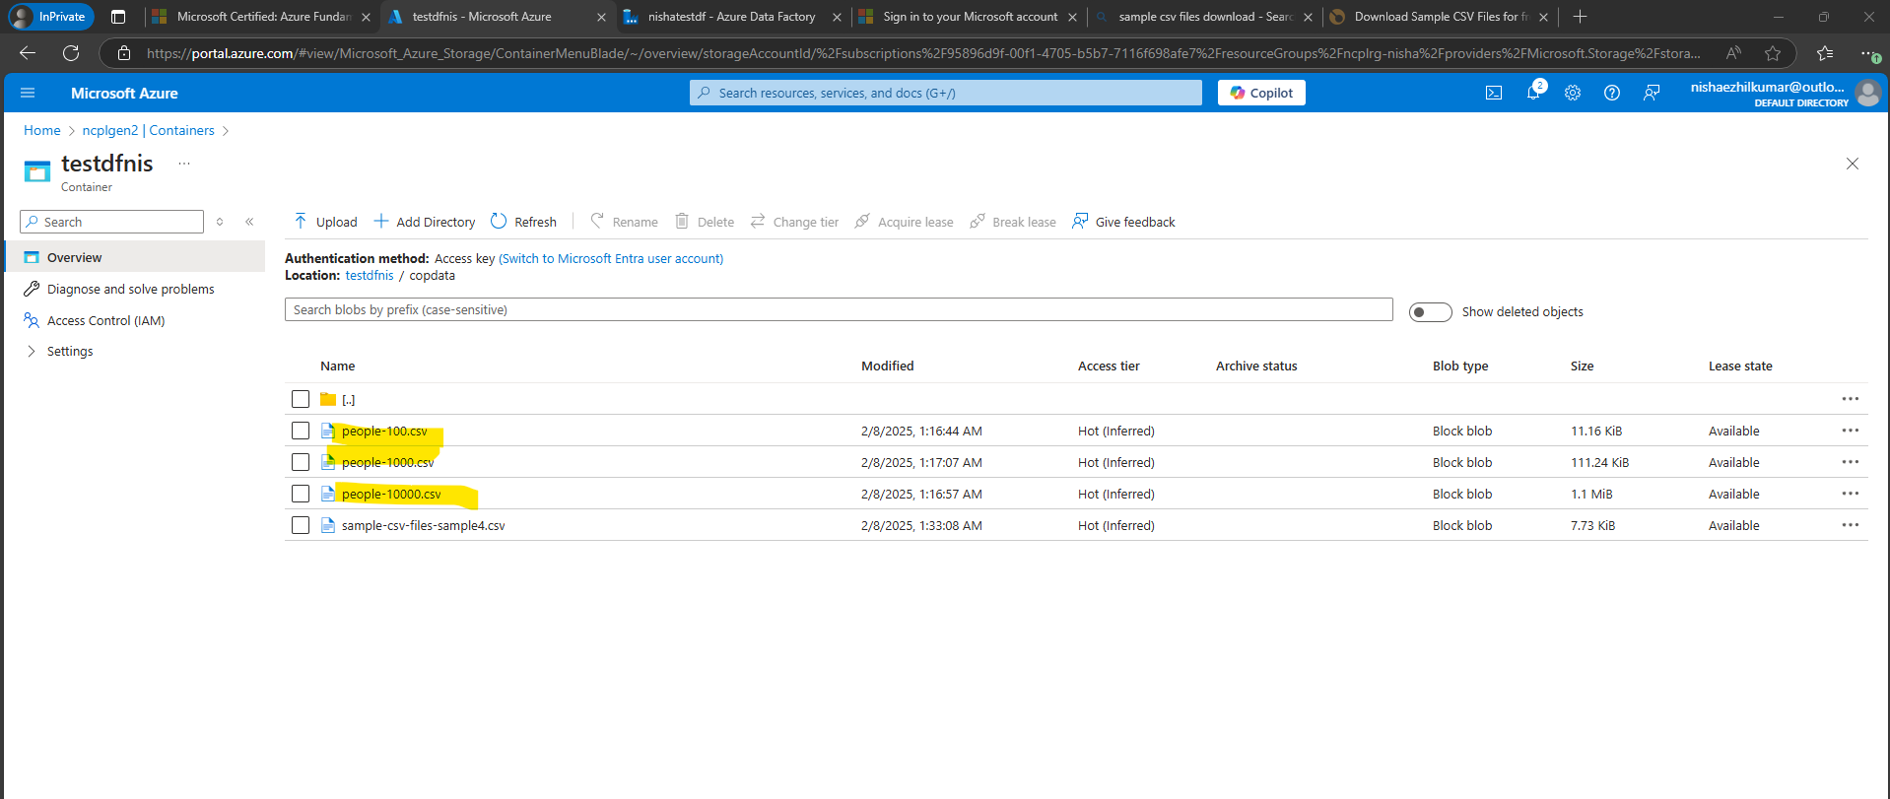

Successfully moved

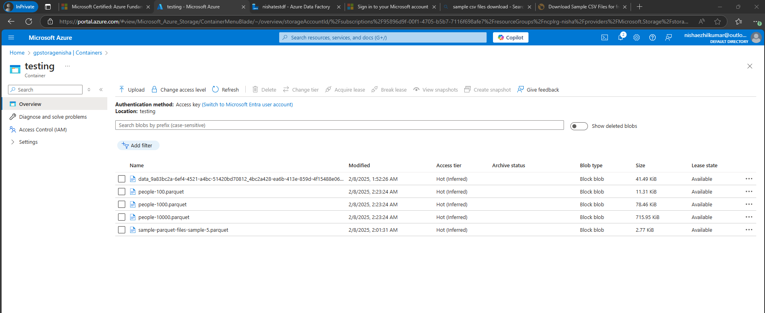

1. MERGE 2 FILES INTO ONE

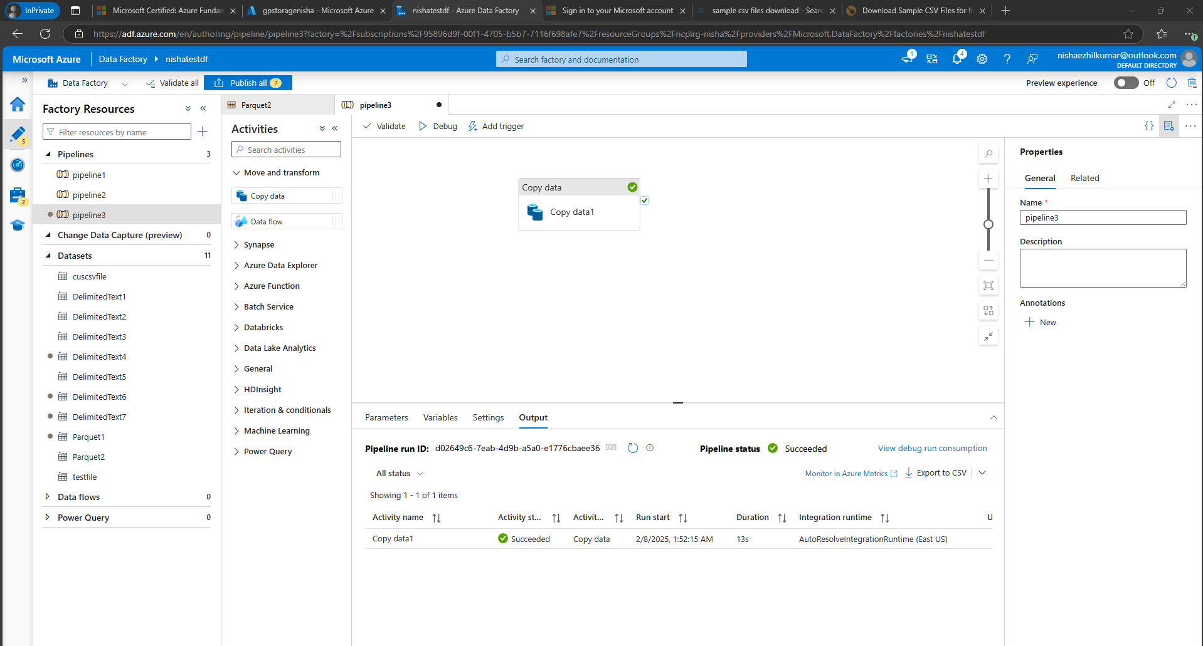

Files to be merged and copied to blob

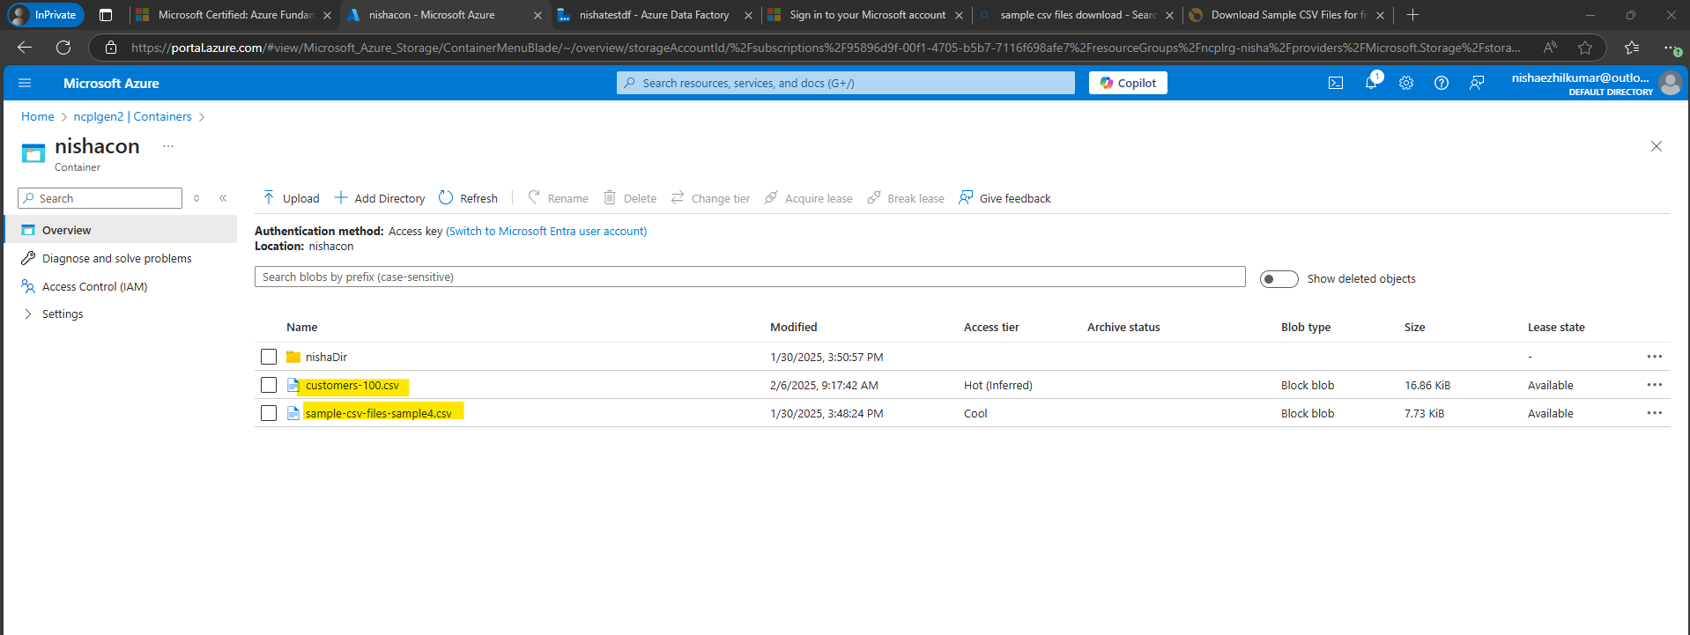

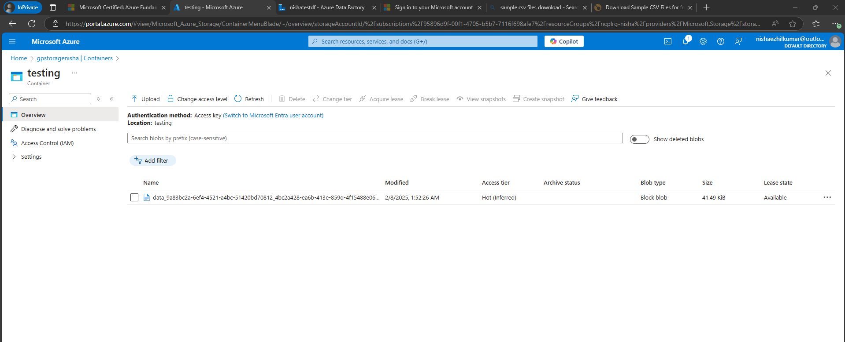

1. TO BRING ONLY PARQUET FILE

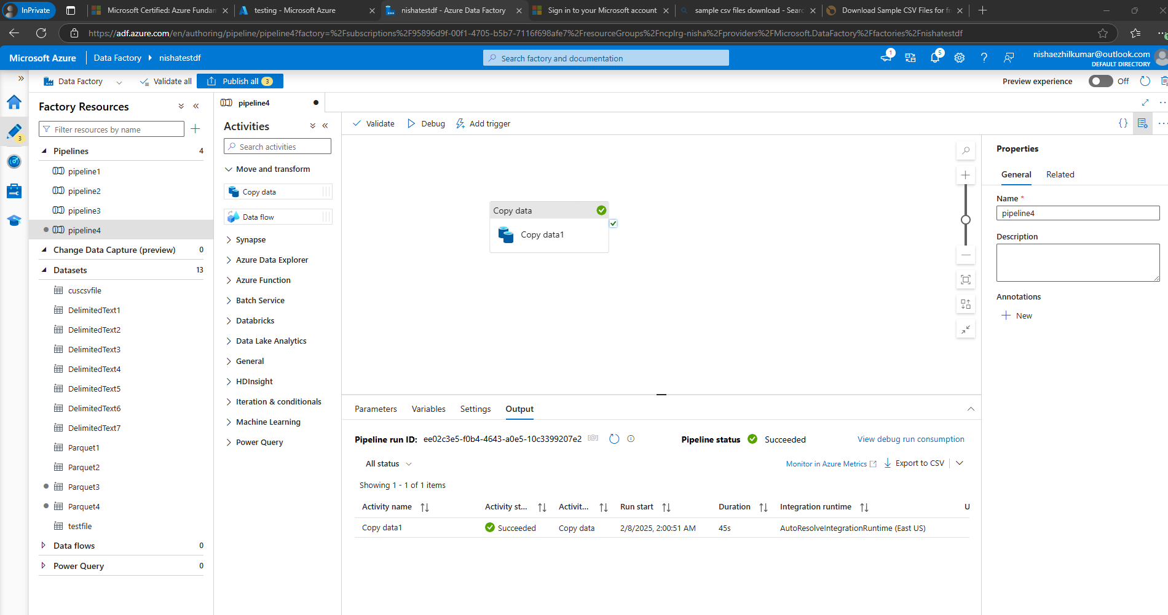

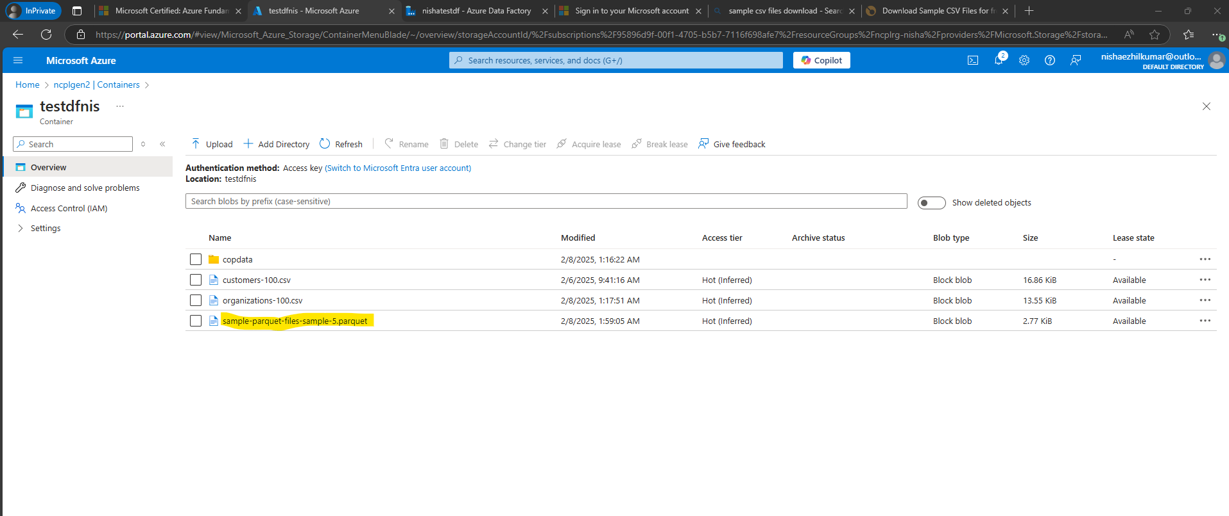

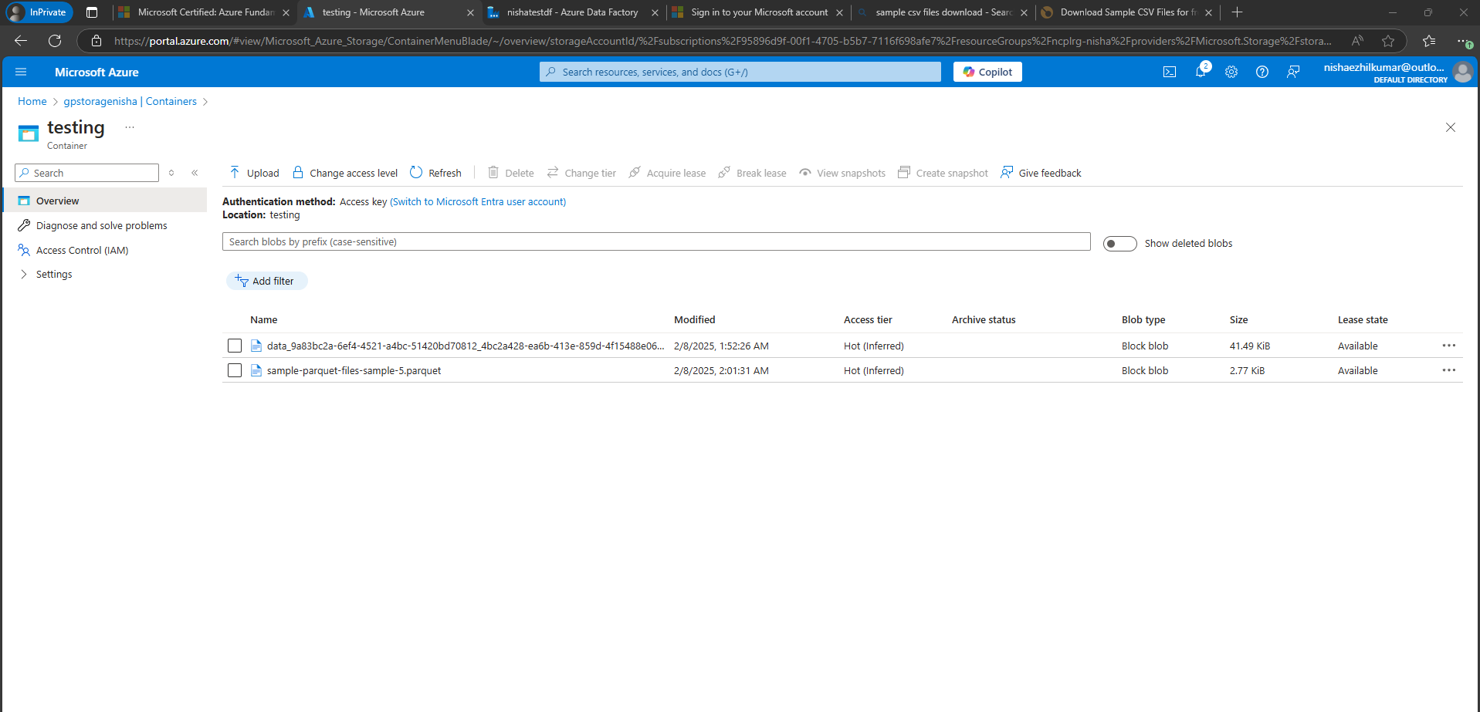

1. COPY ALL FOLDERS AND FILES TO BLOB

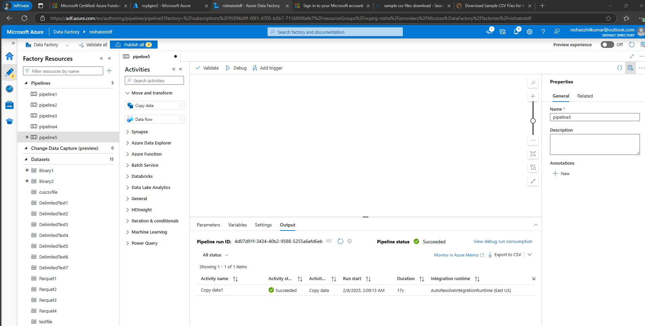

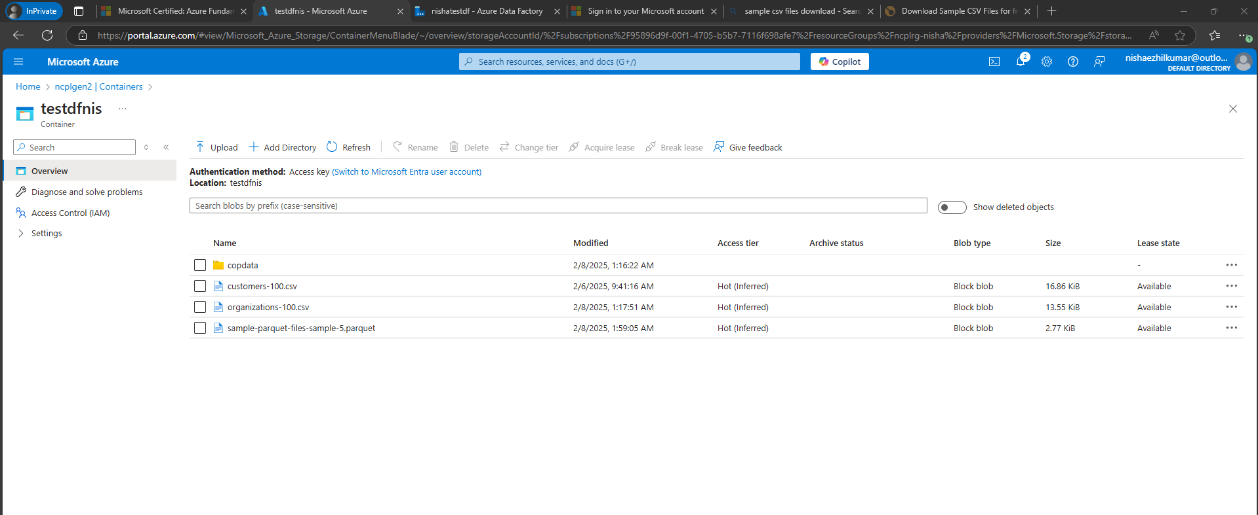

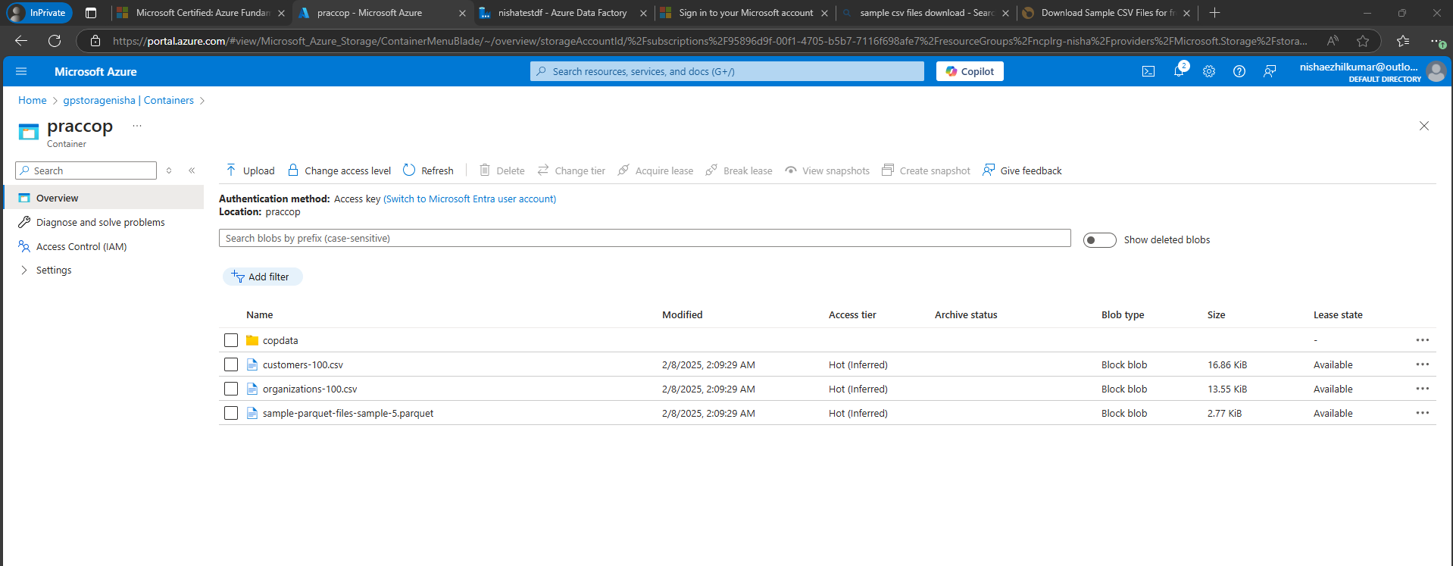

1. Create Tables

\* Create a Students table.

\* Create a Courses table.

2. Insert Sample Data

\* Insert sample records into Students and Courses tables.

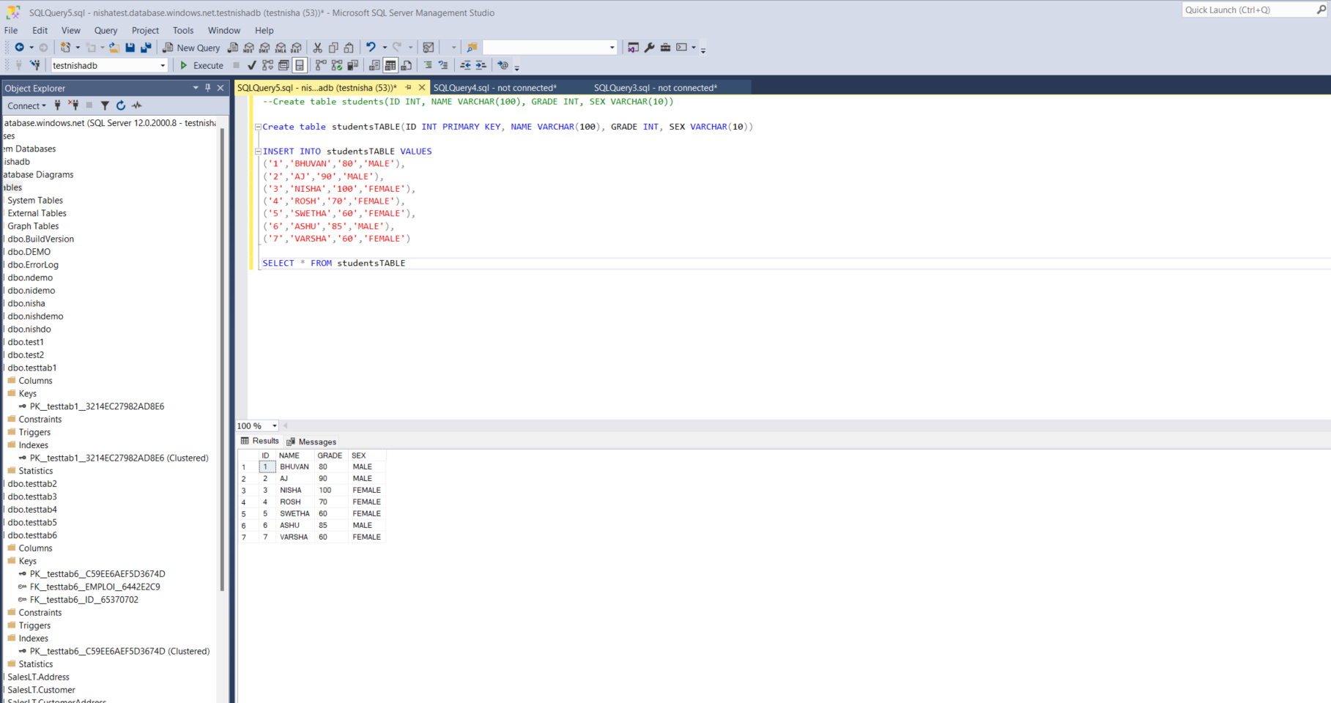

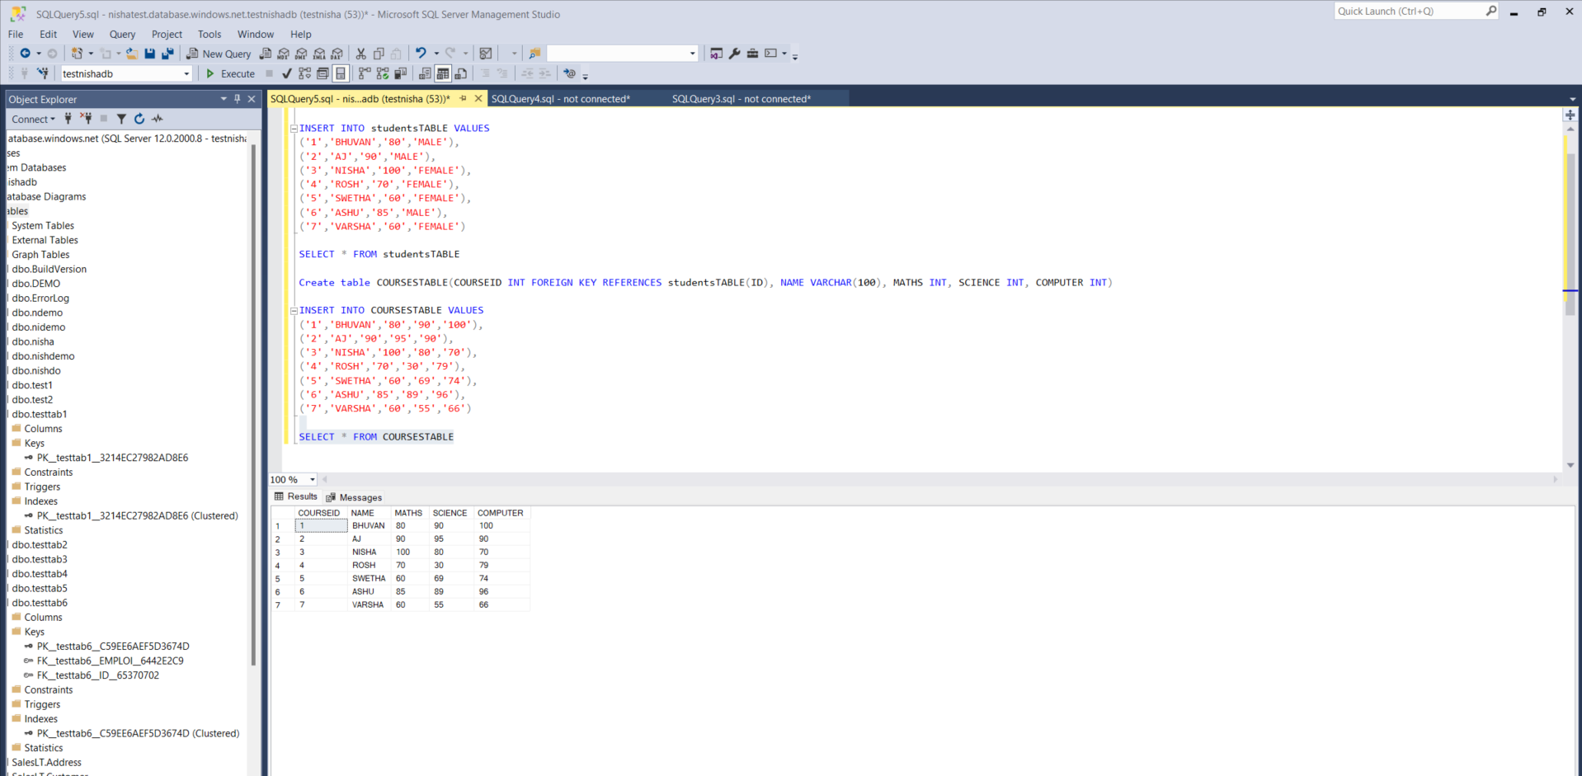

3. Update Data

\* Update the grade for one student.

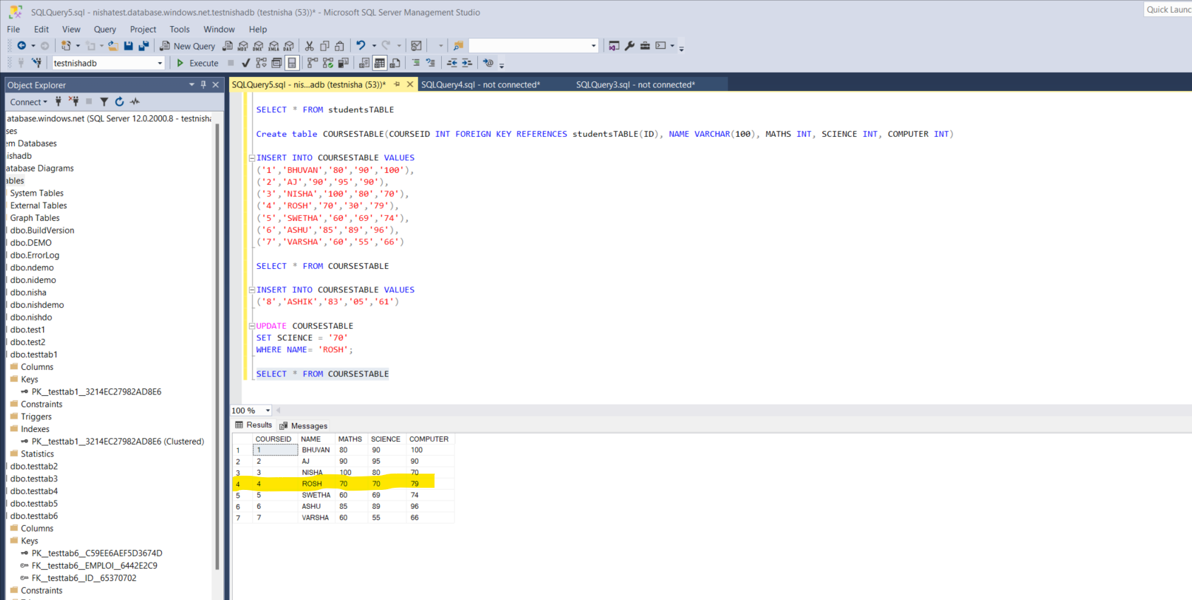

4. Perform a Conceptual Join

\* Create an Enrollment table.

\* Insert sample enrollment records.

\* Perform a JOIN query to retrieve student-course information.

