Tasks:

1. Create a Synapse Workspace

\* Set up an Azure Synapse Analytics workspace as the foundation for this activity.

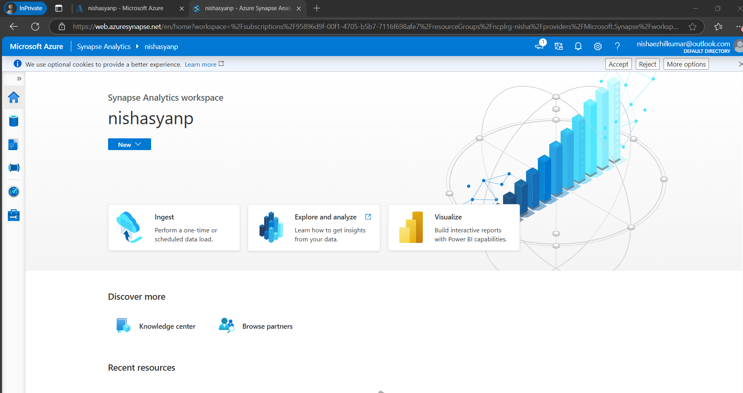

2. Load Data from ADLS Gen2 to Blob Storage

\* Transfer data from Azure Data Lake Storage Gen2 (ADLS Gen2) to Azure Blob Storage.

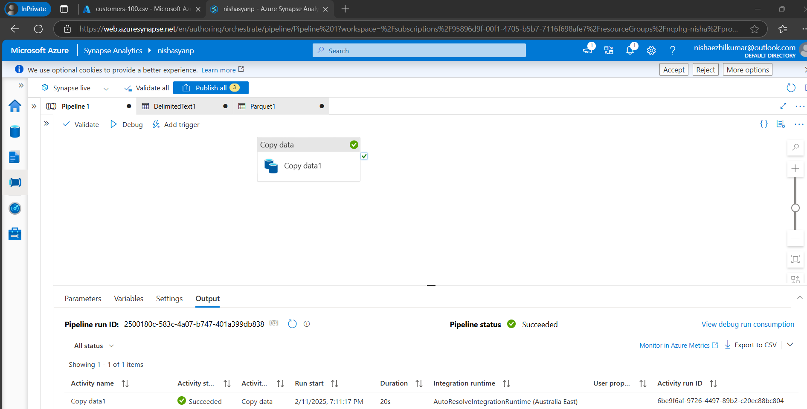

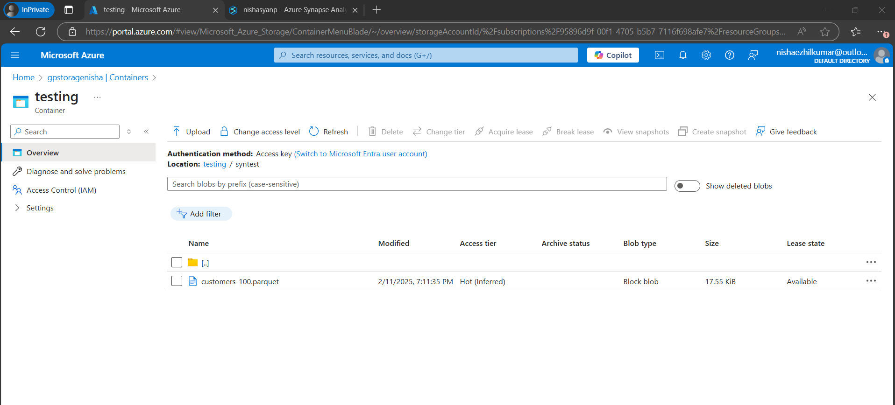

3. Load Data from ADLS Gen2 to SQL Database

\* Transfer data from ADLS Gen2 to an SQL database.

\* If column names are different between the source and the target, manually map the columns in the Import Schema section.

\* Ensure the target table in the SQL database is created with the correct data types that match the source data.

