1. Set Up Tables in Azure SQL

\* Create the Watermark Table

\* Define a table to track the last processed ID or timestamp for incremental loads.

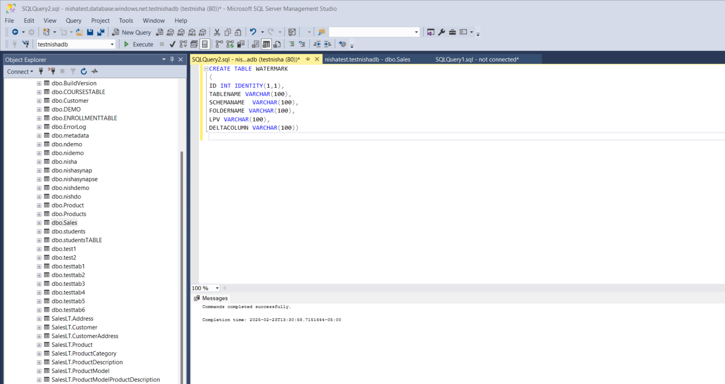

\* Create the Customer Table

\* Define a table to store customer data (ID, Name, Salary, City, etc.).

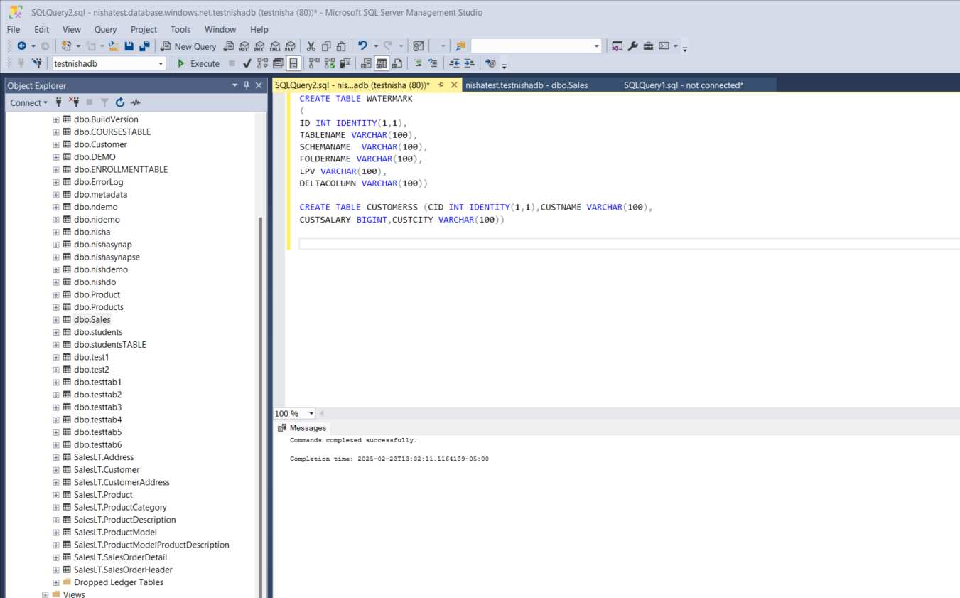

2. Write and Test Stored Procedure

\* Create a Stored Procedure to Update the Watermark Table

\* Write a procedure that updates the LastProcessedValue for the specified table.

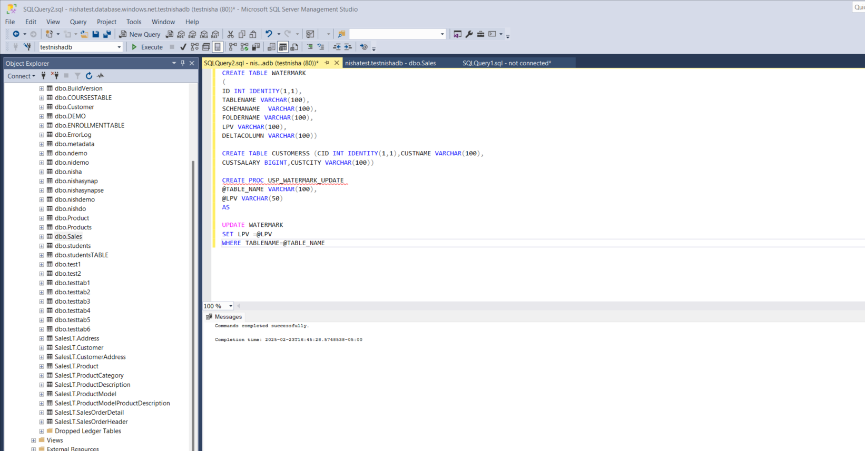

\* Test the Stored Procedure

\* Manually call the procedure with test values to ensure it updates correctly.

3. Insert Sample Data

\* Insert Initial Records into the Customer Table

\* Add a few records for testing the initial data load.

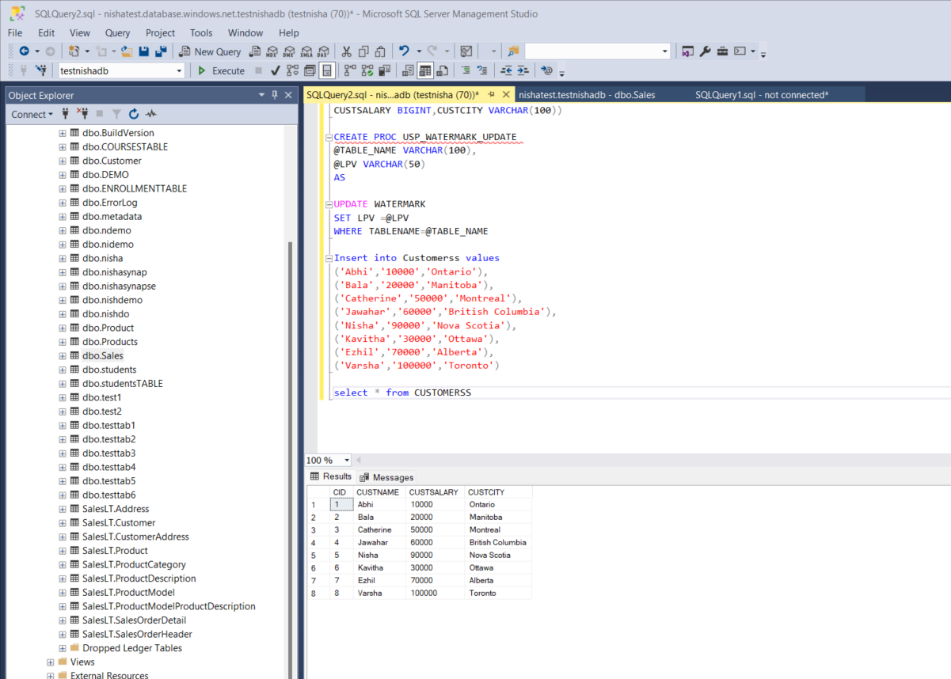

\* Insert New Records for Incremental Load Testing

\* Add more records to simulate new data for testing incremental loads.

4. Resolve Connection Issues

\* Set Up Firewall Rules in Azure SQL

\* Allow necessary IP addresses for connections (including SSMS or Azure Query Editor).

\* Verify Connection

\* Test connections using SSMS, Azure Data Studio, or Query Editor.

5. Prepare for Synapse Pipeline Implementation

\* Validate the Tables and Stored Procedure

\* Ensure tables and stored procedures are functioning correctly.

\* Plan Synapse Pipeline Activities

\* Outline Lookup, Copy Activity, and Stored Procedure tasks for incremental load.

\* Document Connection Strings and Credentials

\* Keep the Azure SQL connection details ready for pipeline setup.

6. Explore Lookup Activity Configuration

\* Test Lookup Activity with “First Row Only” Checked

\* Understand how only the first matching row is retrieved from the result set.

\* Test Lookup Activity with “First Row Only” Unchecked

\* Retrieve multiple rows and observe the output format (array of records).

\* Document Differences and Use Cases

\* Identify scenarios where each setting (checked vs. unchecked) is most applicable.

7. Explore Metadata Activity in Azure Synapse

\* Explore the Metadata Activity in Synapse

\* Understand how Metadata Activity fetches information about datasets, files, and folder properties.

\* Document Use Cases for Metadata Activity

\* Identify and write use cases such as reading file counts, last modified time, or dataset schema.

8. Build a Pipeline Using Metadata Activity

\* Create a Synapse Pipeline

\* Use Metadata Activity to read the number of files in a specified folder.

\* Add Logging and Output Activities

\* Store or display the file count retrieved by the Metadata Activity.

\* Test the Pipeline

\* Verify if the file count is correctly captured and logged.

\* Document the Pipeline Workflow

\* Write a brief explanation of how the pipeline works and its practical use cases.