***Developed a pipeline to dynamically retrieve data from a REST API source***

* Open a copy data activity and in source choose REST API in base URL provide the URL from which you are fetching the data and choose the authentication type as Anonymous

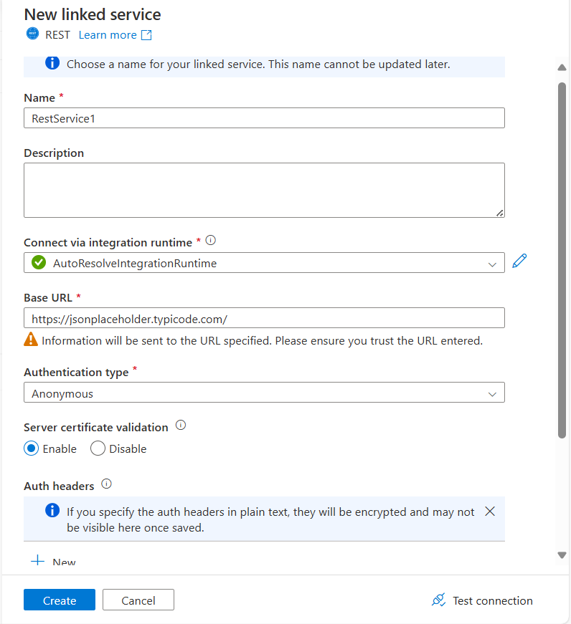

* In Sink choose ADLS GEN 2 and in that choose Delimited text format

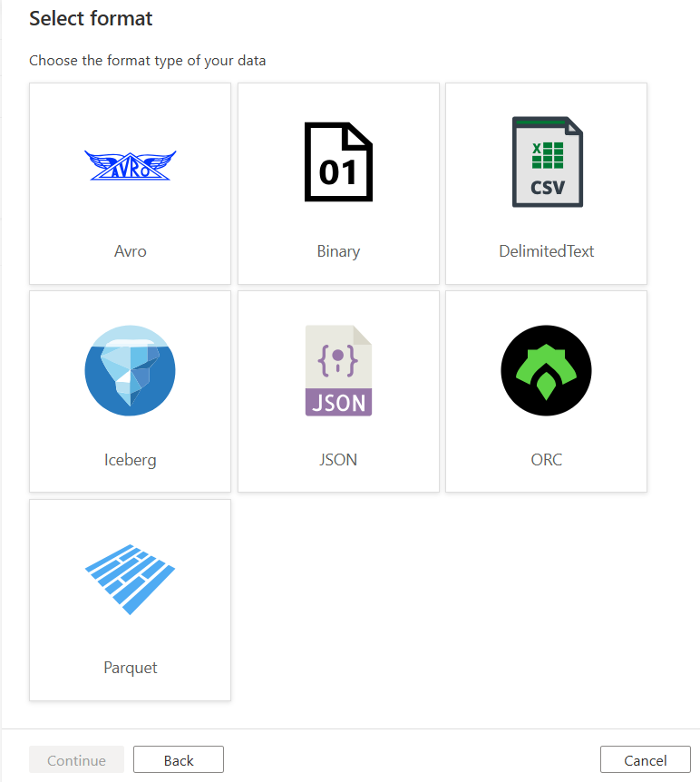

* Inside the connection for now give a Folder name

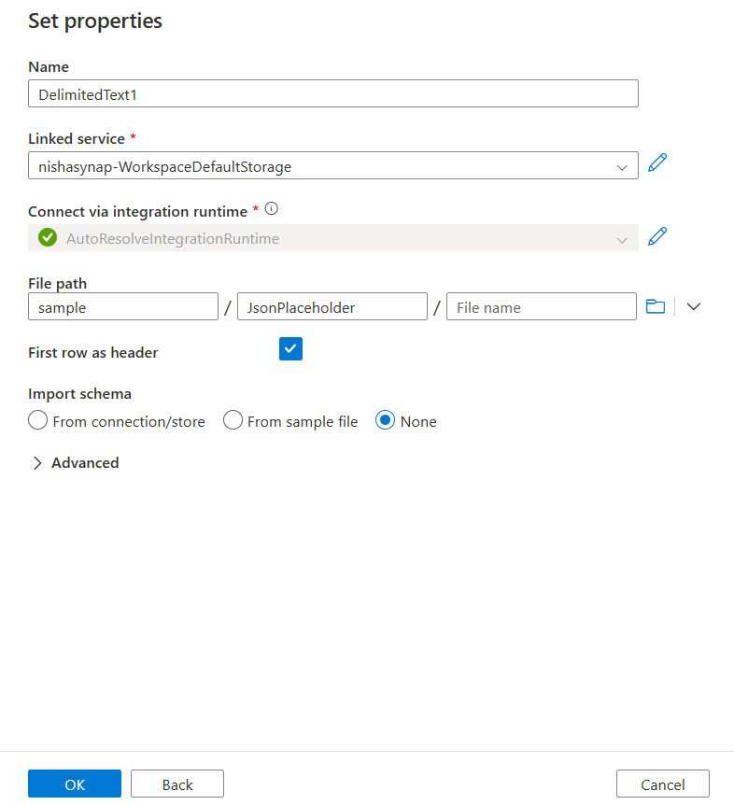

* Open a foreach activity and paste this copy function inside that to dynamically run all the links inside the URL

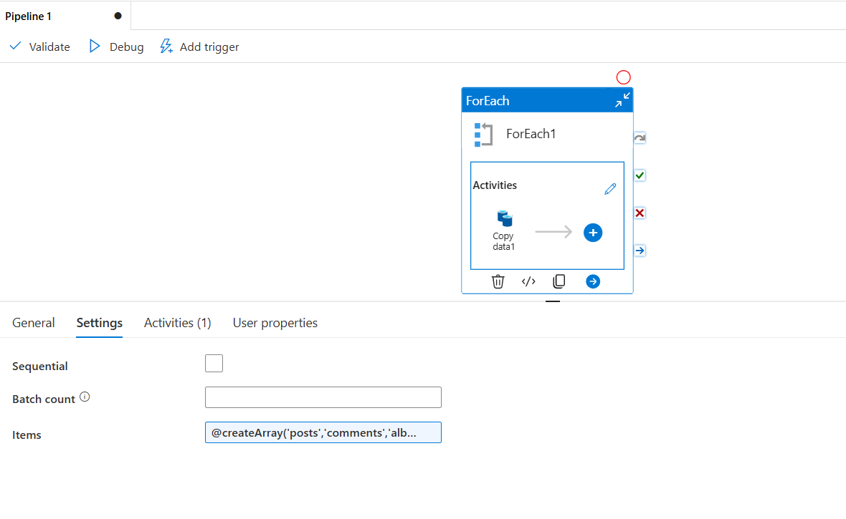

* Inside the Source in the relative URL dynamically pass the values as @dataset().Values

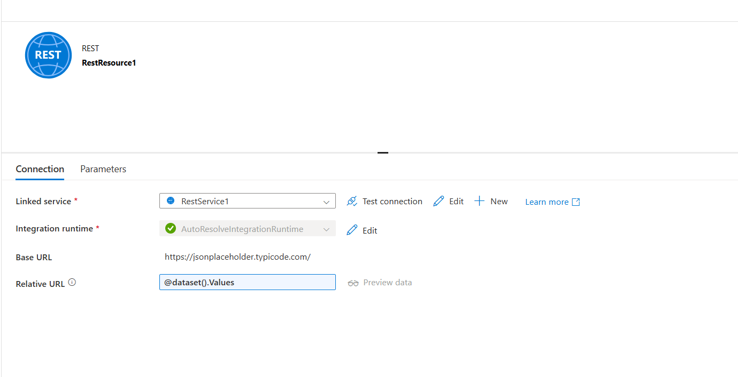

* In the sink pass the foldername as @item()

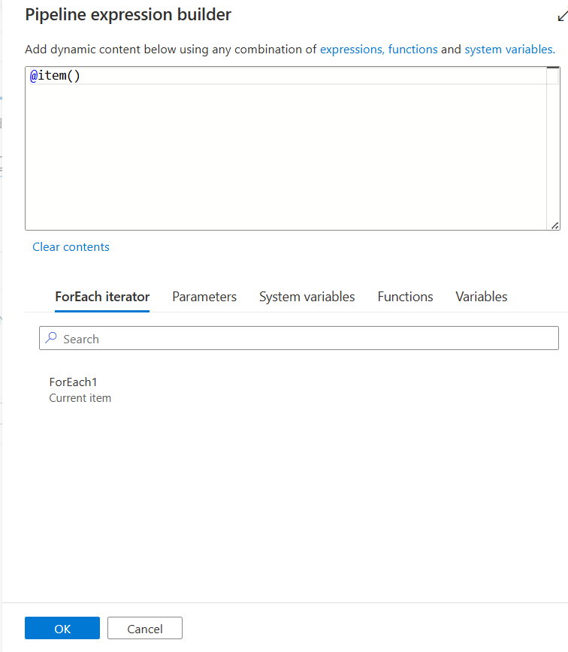

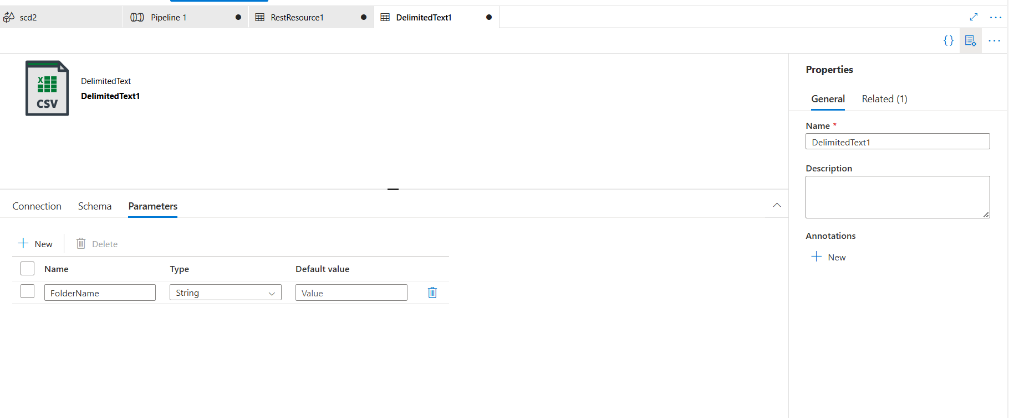

* Inside the sink now change the foldername as below

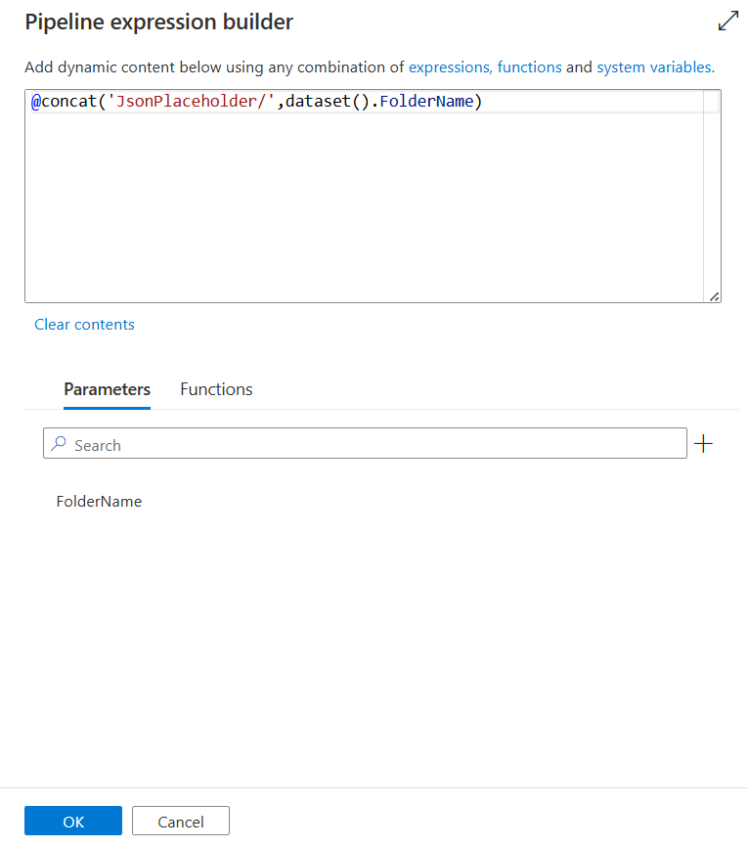

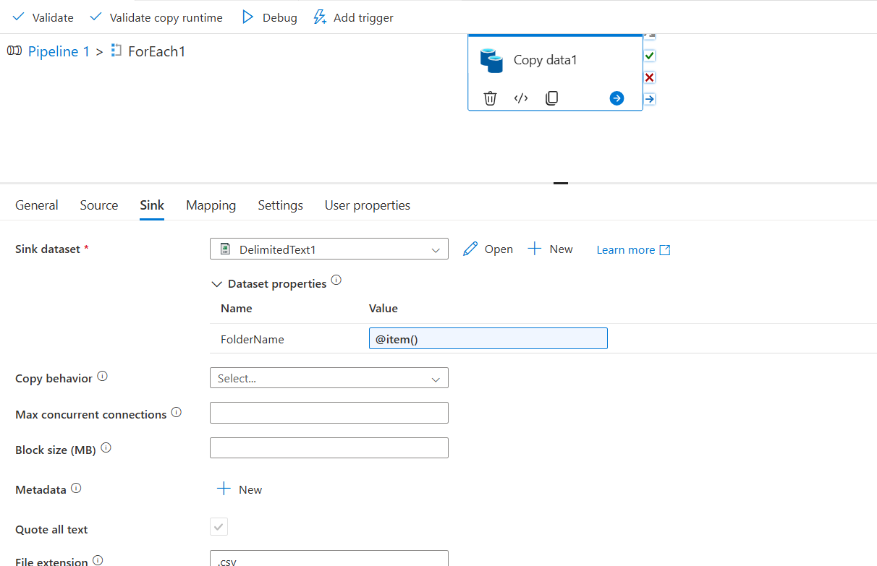

* In the Foreach pass the value like below

@createArray('posts','comments','albums','photos','todos','users')

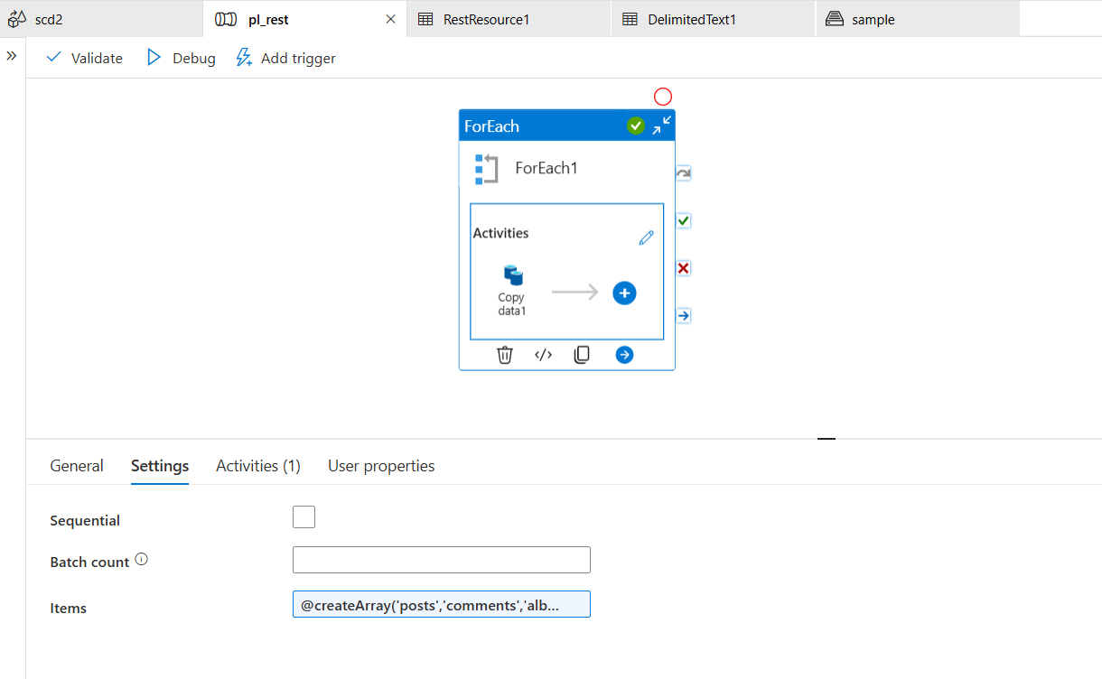

* The output looks like below

