Create a Databricks premium workspace

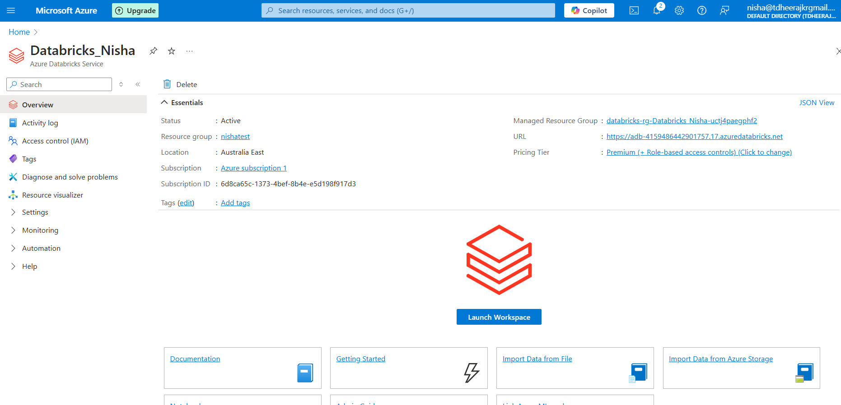

What is the difference between all purpose and job compute

**All-Purpose Compute (Interactive Clusters)**  
✅ Used for **exploratory analysis, debugging, and collaboration** in notebooks.  
✅ Supports **multiple users** and **auto-scaling**.  
✅ **Runs continuously**, making it **more expensive**.

**Job Compute (Job Clusters)**  
✅ Used for **scheduled ETL jobs and batch processing**.  
✅ **Dedicated per job**, auto-terminates after execution.  
✅ **More cost-efficient** since it runs only when needed.

**Use All-Purpose for development, Job Compute for production workloads.**

What is terminate the cluster when inactivity

**What It Means:**

* If a Databricks cluster is **idle (no activity)** for a specified time, it **automatically shuts down** to save costs.
* This is controlled by the **"Terminate after __ minutes of inactivity"** setting.

🔹 **How It Works:**

1. If no **notebook commands, jobs, or queries** run within the set time, the cluster **auto-terminates**.
2. When needed again, it must be **manually restarted** or **auto-restarted by a scheduled job**