Explore dbutil commands related to fs ( file system)

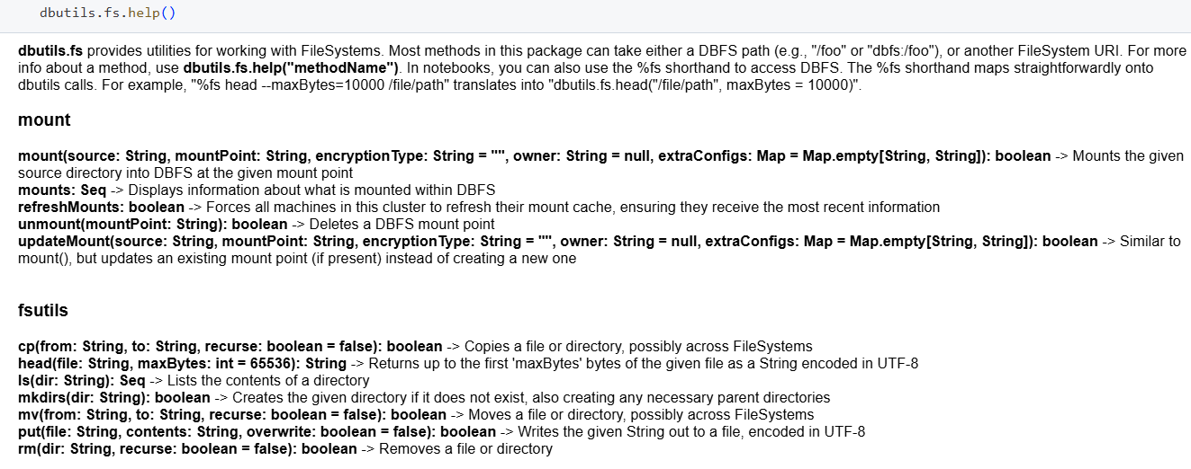

1. To check the existing mounts the following command is used – dbutils.fs.mounts()
2. To create a new mount use the following command

dbutils.fs.mount(

  source = "wasbs://dbnisha@nishablob.blob.core.windows.net",

  mount_point = "/mnt/dbnisha",

  extra_configs = {"fs.azure.account.key.nishablob.blob.core.windows.net":"0KKus4IpknAyP4PPrAN/+5eNWePTh+9sXBae+LOj1amuD6VA7ZLZdZtVl+NoEV6P1oRKqQ6+tSYZ+ASt4dWc1w=="})

For every different container we need to create separate mount points

1. To get the file and folder level details use the following command

dbutils.fs.ls("/mnt/dbnisha")

1. To get the data inside the file in a container use the following command

dbutils.fs.head("/mnt/dbnisha/Cus_Day1.csv")

1. To view the data in a proper format use the following code

print(dbutils.fs.head("/mnt/dbnisha/Cus_Day1.csv"))

1. To create a new directory use the following code

dbutils.fs.mkdirs("/mnt/dbnisha/testing")

1. To copy one file from one folder to another use the below code

dbutils.fs.cp("/mnt/dbnisha/Cus_Day1.csv", "/mnt/dbnisha/testing")

1. To remove any files use the below code

dbutils.fs.rm("/mnt/dbnisha/Products1_2025-03-10T20_24_21.3158235Z.csv",True)

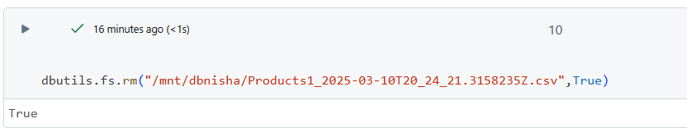

1. To unmount use the below code

dbutils.fs.unmount(“/mnt/dbnisha”)

1. To create a new text file inside a folder

dbutils.fs.put("/mnt/dbnisha/testing/Sample.txt", "Hello World  \By Nisha")

1. To print the data in a csv format use the below code

df= spark.read.format("csv").option("header", "true").option("inferSchema", "true").load("/mnt/dbnisha/testing/Cus_Day1.csv")

 display(df)

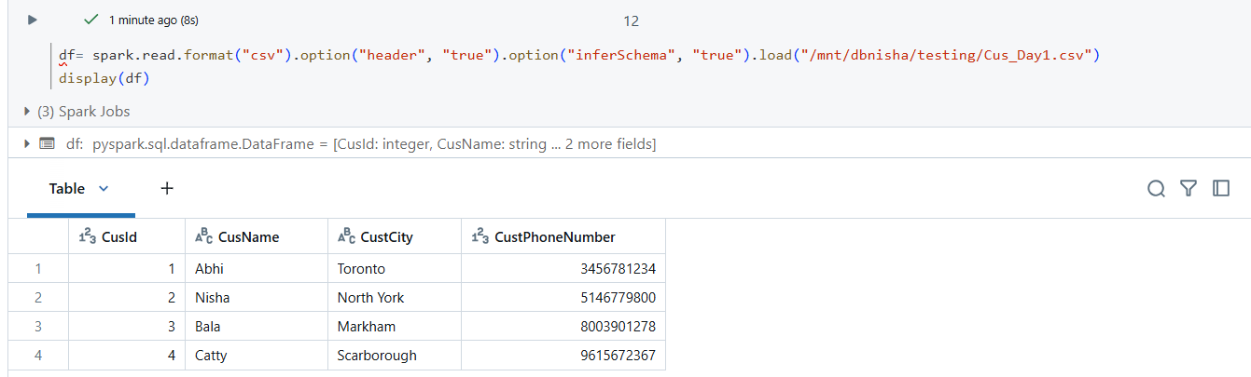

Df.show()

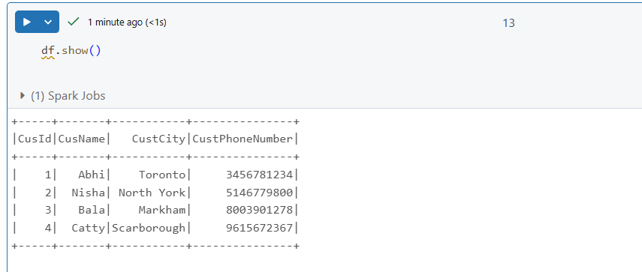

1. To create a parquet format file use the below command

df.write.format(“parquet”).mode(“overwrite”).save(“/mnt/dbnisha/testdata”)

1. If we are using new files will be created with the same data whereas with overwrite it will overwrite the data in same file

df.write.format(“parquet”).mode(“append”).save(“/mnt/dbnisha/testdata”)