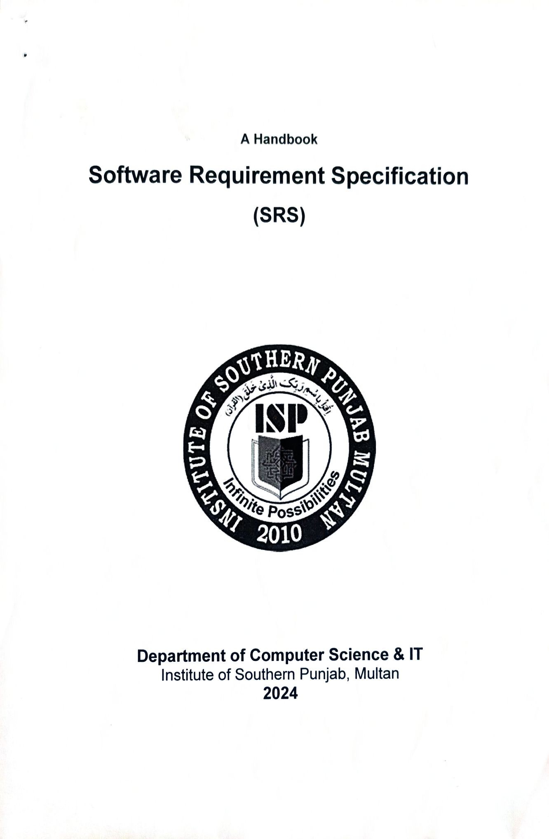

CHAPTER 1: INTRODUCTION

1.1 Overview of the Project
Office Hub is a cloud-based web application developed using React that aims to simplify and centralize office management activities. In modern organizations, daily operations such as employee coordination, task management, document handling, and communication are often scattered across different tools. Office Hub brings these functionalities together on a single platform that is accessible anytime and anywhere through the cloud.
By using React for the frontend, the system provides a fast, responsive, and user-friendly interface. Cloud integration ensures scalability, data availability, and secure access for users across different locations.

1.2 Background of the Study
With the rapid growth of digital workplaces and remote working culture, traditional office management systems are becoming inefficient. Manual processes and desktop-based software limit collaboration and real-time access to data. Cloud computing and modern JavaScript frameworks like React have transformed how web applications are built and used.
Office Hub is designed to take advantage of these technologies to support organizations in managing their operations efficiently while reducing paperwork, time consumption, and operational errors.

1.3 Problem Statement
Many offices face the following challenges:
- Lack of a centralized system for managing office tasks and resources
- Difficulty in accessing data remotely
- Poor collaboration between employees and departments
- Slow and outdated user interfaces in traditional systems

1.4 Objectives of the Project
The main objectives of the Office Hub project are:
- To develop a centralized office management system
- To provide a responsive and interactive user interface using React
- To enable cloud-based data storage and access
- To improve communication and collaboration within an organization
- To ensure secure and reliable access to office data

1.5 Scope of the Project
The scope of Office Hub includes:
- User authentication and role-based access
- Office task and workflow management
- Cloud data storage and real-time updates
- Responsive design for desktop and mobile devices

1.6 Technologies Used
The following technologies are used in the development of Office Hub:
- React.js – for building the frontend user interface
- Cloud Services – for data storage, hosting, and scalability
- REST APIs – for communication between frontend and backend
- Modern Web Technologies – HTML, CSS, JavaScript

1.7 Significance of the Project
Office Hub provides a modern solution to office management by combining the power of React and cloud computing. It improves productivity, enhances collaboration, and supports digital transformation in organizations. The project also serves as a practical implementation of modern web development concepts for academic and professional learning.

CHAPTER 2: LITERATURE REVIEW

2.1 Introduction
This chapter reviews existing studies, systems, and technologies related to office management applications, cloud computing, and React-based web development. The purpose of this literature review is to understand how similar systems work, identify their strengths and limitations, and justify the need for developing the proposed Office Hub system.

2.2 Existing Office Management Systems
Traditional office management systems are mostly desktop-based or partially web-enabled. These systems typically focus on basic functionalities such as employee records, attendance tracking, and document storage. However, many of them lack real-time collaboration, scalability, and remote accessibility.
Studies show that organizations using legacy systems face challenges in system maintenance, data synchronization, and user experience. These systems often require manual updates and are not suitable for modern, distributed work environments.

2.3 Cloud-Based Systems
Cloud computing has become a key technology for modern software systems. Cloud-based applications allow users to access data and services over the internet without depending on physical infrastructure.
Research highlights the following advantages of cloud-based systems:
- High availability and scalability
- Reduced hardware and maintenance costs
- Real-time data access from any location
- Automatic data backup and recovery
Despite these benefits, cloud systems also introduce concerns such as data security and privacy. Modern cloud platforms address these issues through encryption, authentication, and access control mechanisms.

2.4 Web Application Development Using React
React is a popular JavaScript library developed by Facebook for building user interfaces. It uses a component-based architecture that allows developers to create reusable and maintainable UI components.
According to recent studies, React improves application performance through its virtual DOM mechanism, which reduces unnecessary page reloads. React also supports state management, routing, and integration with APIs, making it suitable for large-scale applications like Office Hub.

2.5 Role of REST APIs in Cloud Applications
REST (Representational State Transfer) APIs are widely used for communication between frontend and backend systems. In cloud-based applications, REST APIs enable secure and efficient data exchange.
Literature suggests that REST APIs provide:
- Platform-independent communication
- Scalability and flexibility
- Easy integration with frontend frameworks like React
Office Hub uses REST APIs to connect the React frontend with cloud-hosted backend services.

2.6 Security in Cloud-Based Office Systems
Security is a critical concern in cloud-based office management systems. Research emphasizes the importance of:
- User authentication and authorization
- Secure data transmission using HTTPS
- Role-based access control
Modern cloud systems implement these security measures to protect sensitive organizational data and prevent unauthorized access.

2.7 Limitations of Existing Systems
Although many office management solutions exist, they have several limitations:
- Limited customization options
- Complex user interfaces
- Poor scalability for growing organizations
- High licensing and maintenance costs
These limitations highlight the need for a flexible, user-friendly, and cost-effective system like Office Hub.

2.8 Summary
This literature review examined existing office management systems, cloud computing technologies, React-based development, and security considerations. The analysis shows that while current systems provide basic functionality, they often fail to meet the requirements of modern organizations. The proposed Office Hub system aims to overcome these challenges by utilizing React and cloud technologies to deliver a scalable, secure, and efficient office management solution.

CHAPTER 3: SYSTEM METHODOLOGY

3.1 Introduction
This chapter describes the methodology and design of the proposed Office Hub system. It explains the development approach, system requirements, overall architecture, frontend and backend design, cloud integration, database structure, and security mechanisms. The system is developed using React for the frontend and cloud technologies for backend services and data storage.

3.2 Development Methodology
The development of Office Hub follows an Agile Software Development Methodology. Agile allows incremental development, continuous testing, and flexibility in handling changing requirements.
The reasons for choosing Agile include:
- Faster development cycles
- Continuous user feedback
- Early detection of errors
- Easy system enhancements
Each module of the system is designed, implemented, and tested independently.

3.3 System Overview
Office Hub is a cloud-based office management system that provides centralized access to office operations. Users can log in from any location using the internet. The React-based frontend interacts with cloud-hosted backend services through REST APIs.

3.4 Functional Requirements
Functional requirements define what the system should do.
The functional requirements of the Office Hub system are as follows:
- The system shall allow users to register and log in securely.
- The system shall support role-based access control (Admin, Employee).
- The system shall allow administrators to manage users and departments.
- The system shall allow users to create, update, and delete tasks.
- The system shall allow task assignment and status tracking.
- The system shall store office data on the cloud.
- The system shall allow document upload and management.
- The system shall provide real-time dashboard updates.
- The system shall allow users to access the system remotely.

3.5 Non-Functional Requirements
Non-functional requirements describe how the system should perform.
The non-functional requirements of the Office Hub system include:
- Performance:
The system shall provide fast response time and smooth interaction.
- Security:
The system shall ensure secure authentication and encrypted communication.
- Scalability:
The system shall support increasing numbers of users using cloud resources.
- Availability:
The system shall be accessible 24/7 through the internet.
- Usability:
The system shall be easy to use with a user-friendly interface.
- Reliability:
The system shall ensure data accuracy and fault tolerance.
- Maintainability:
The system shall allow easy updates and maintenance.

3.6 System Architecture
Office Hub follows a three-tier architecture:

1. Presentation Layer
- Developed using React.js
- Handles UI and user interaction
- Sends and receives data through REST APIs

2. Application Layer
- Cloud-hosted backend services
- Handles business logic and authentication

3. Data Layer
- Cloud database for data storage
- Stores user, task, and document information
This architecture ensures modularity and scalability.

3.7 Frontend Design Using React
The frontend of Office Hub is developed using React.js. React’s component-based architecture improves code reusability and performance.
Key frontend features:
- Single Page Application (SPA)
- Reusable components
- Virtual DOM for fast rendering
- Responsive design
State management is used to handle user sessions and application data.

3.8 Backend and Cloud Integration
Backend services are deployed on the cloud, enabling remote access and scalability. REST APIs handle communication between the frontend and backend.
Cloud integration provides:
- Real-time data synchronization
- Automatic scaling
- Secure data storage and backup

3.9 Database Design
The cloud database is structured to support efficient data management.
Main entities include:
- Users
- Roles
- Departments
- Tasks
- Documents
CRUD operations are performed through secure APIs.

3.10 Security Mechanisms
Office Hub implements the following security features:
- Secure login and authentication
- Role-based access control
- Encrypted data transmission
- Secure cloud storage
These measures protect sensitive office information.

3.11 System Workflow
The system workflow is as follows:
- User logs into the system
- Frontend sends request to backend via API
- Backend processes the request
- Data is stored or retrieved from the cloud database
- Response is sent back to the frontend
- Updated information is displayed to the user

3.12 Tools and Technologies
The tools and technologies used include:
- React.js
- Cloud Platform
- REST APIs
- HTML, CSS, JavaScript
- Git for version control

3.13 Summary
This chapter presented the complete methodology of the Office Hub system, including development approach, functional and non-functional requirements, system architecture, frontend and backend design, cloud integration, database structure, and security mechanisms. The proposed methodology ensures that the system is scalable, secure, and suitable for modern office environments.

