COIT20246 Networking and Cyber Security

Week 06 Tutorial Activities

Wireless Networks

Aim to have all tasks completed before your next tutorial.

# Task 1. View Wi-Fi Details

Explore the Wi-Fi details of your own device. If you have a laptop (or PC with Wi-Fi) try to use PowerShell with the WIFI Tools module (see lecture slides for commands). Otherwise, use your mobile phone to see nearby Access Points. Try to collect the following information about 2 or 3 different APs: SSID, BSSID, frequency band, channel, data rate you can connect with. While not required, the [WiFi Analyzer](https://vremsoftwaredevelopment.github.io/WiFiAnalyzer/) app on Android shows useful information. In your journal include a screenshot of details of at least one AP, as well as list of information you found.

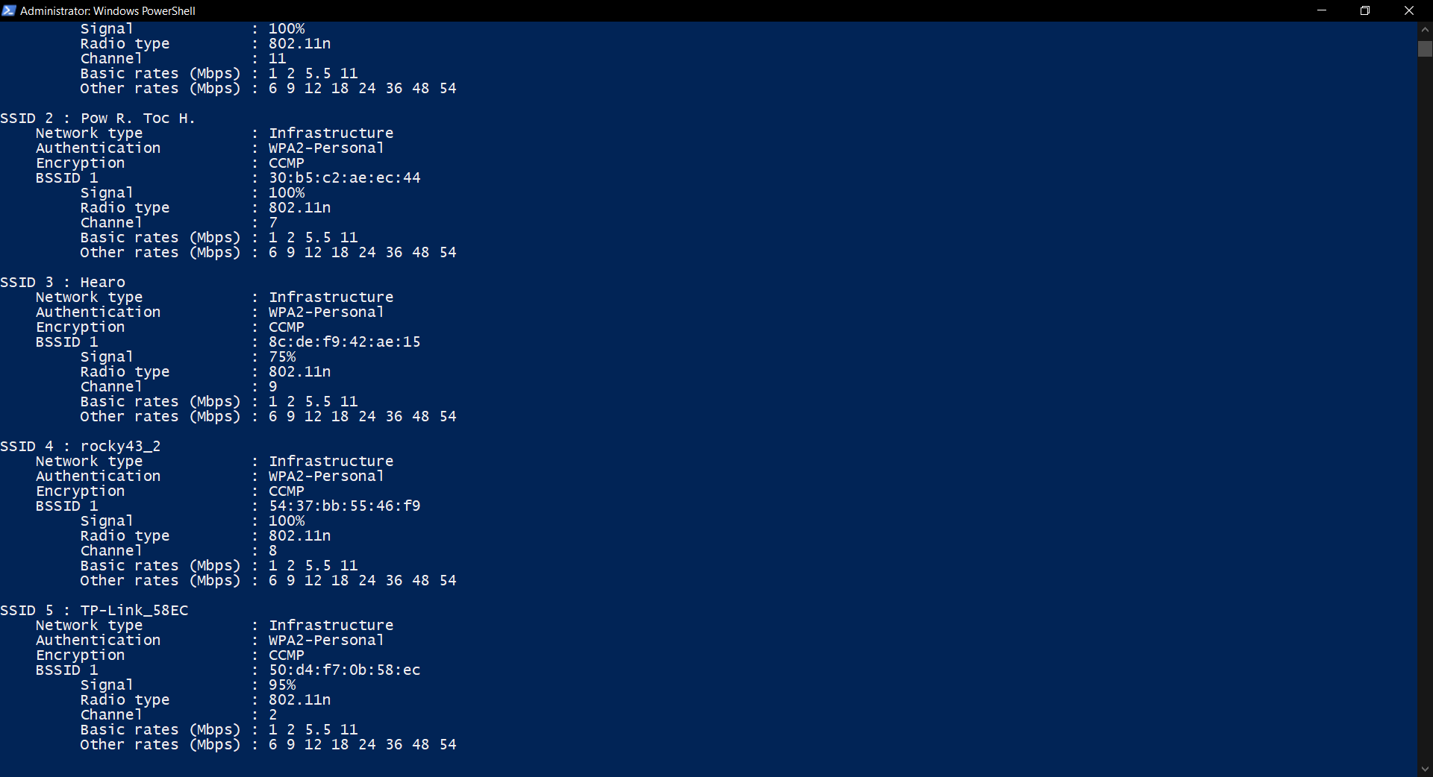

Figure Wi-Fi Analyser in PowerShell

# Task 2. Use Wi-Fi Access Point

Access the web management interface of a wireless AP or router, e.g., your home wireless router. Explore the settings. If you do not have access, then try an emulator: TP-Link has web emulators for many devices [(https://www.tp-link.com/au/support/emulator/)](https://www.tp-link.com/au/support/emulator/), e.g. under Home -> Routers -> Wireless Routers, try Archer C6 or TL-WR841N. What are the important settings that you should consider when designing a Wi-Fi network? (Do not simply list all settings; rather select some important settings and discuss what you would consider changing them to and why).

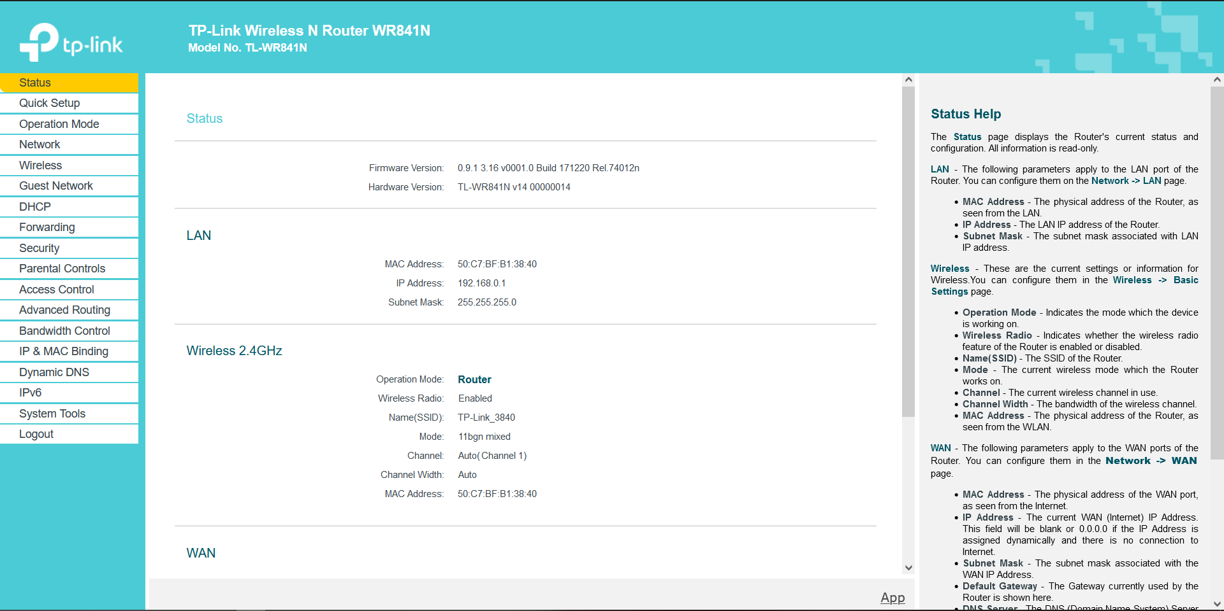

Figure : Wireless Router Emulator

The important settings that should be considered when designing the Wi-Fi network are as follow:

* Operation mode: This defines what the wireless router will act as such as Wireless Router, access point, WISP or range extender.
* Network: This will allow the user to define the WAN network and the LAN network that the router will be connected to. The WAN network is usually the internet service providers or other networks that allows internet access and the LAN defines the network for the wireless network hosted in the router.
* Wireless setting: This setting allows one to configure the wireless network settings such as SSID, security of the wireless network and view various statistics that enables real-time monitoring of the network.
* DHCP setting: This setting allows automatic configuration of the IP address on the end devices that connect to the wireless device and should be enabled at all times to ensure connectivity and easier management of the wireless end devices.

# Task 3. Continue Your Project

Use this tutorial to continue working on your project, in preparation for submitting the draft. Seek feedback from your tutor on any issues.

Wireless Networks 1