Dear parents

Greetings of the day

To help you and your child stay organized and prepared, we’ve sharing the **15 DAYS** planner of Strawbees classroom.

Please take a moment to review it with your child so you both are aware of class work.

**1. Biome Builders – Boreal Forest Biome**

The Boreal forest biome, also known as Taiga, is an expansive-forested region situated in the Northern Hemisphere. Distinguished by its coniferous pine and spruce trees, the Boreal forest experiences a prolonged period of cold temperatures lasting for several months.

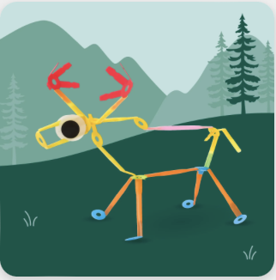

**2. Phenomenal Forces – Newton’s Three Laws of Motion**

Discover how to use Strawbees to model and test Isaac Newton’s three laws of motion. Construct a mini ramp to observe a ball traveling along a track through three experiments.

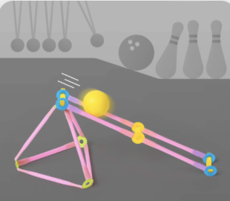

**3. Plant and Animal Behaviors - Bunny**

Explore with a curious woodland critter in a grass patch. Brighten up any space with this bunny companion for any spring celebration.

