**LIST OF EXPERIMENTS**

1. Installation of various hypervisors and instantiation of VMs with image file using open source hypervisors such as Virtual Box, VMWare Player, Xen and KVM.
2. Create and Launch Virtual Machines in Amazon Web Services and Google App Engine. Access Windows Server using RDP and Linux Instances using Putty/ssh.
3. Develop the Storage Services Using Buckets and EBS in Amazon Web Services.
4. Write a Google app engine program to generate n even numbers and deploy it to Google cloud.
5. Develop a Virtual Private Cloud using AWS/GCP Platform.
6. Demonstrate Cloud Database Services in AWS/GCP
7. Working in Codenvy to demonstrate Provisioning and Scaling of a website.

|  |  |  |  |  |  |  |
| --- | --- | --- | --- | --- | --- | --- |
| **TABLE OF CONTENTS** | | | | | | |
|  | **S.NO.** | **DATE** | **EXPERIMENT TITLE** | **MARKS**  **/10** | **SIGN.** |  |
| 1. |  |  |  |  |  |
| 2. |  |  |  |  |  |
| 3. |  |  |  |  |  |
| 4. |  |  |  |  |  |
| 5. |  |  |  |  |  |
| 6. |  |  |  |  |  |
| 7. |  |  |  |  |  |

|  |  |  |  |  |
| --- | --- | --- | --- | --- |
|  |  |  |  |  |

### EX NO. : 1

**DATE:**

# Installation of various hypervisors and instantiation of VMs with image fileusing open source hypervisors such as Virtual Box, VMWare Player, Xen and KVM.

**Aim:**

Installation of Virtual Box and instantiation of VMs with image file

# PROCEDURE:

**Steps to install Virtual Box:**

1. Download the Virtual box exe and click the exe file…and select next button..

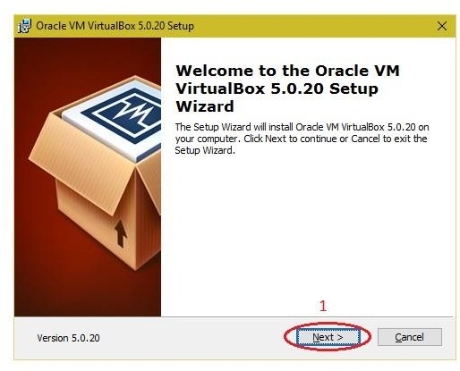

1. Click the next button..

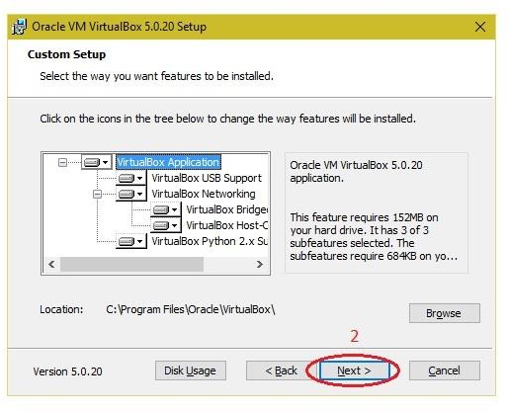

1. Click the next button

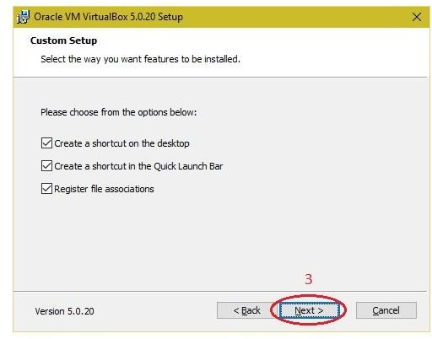

1. Click the YES button..

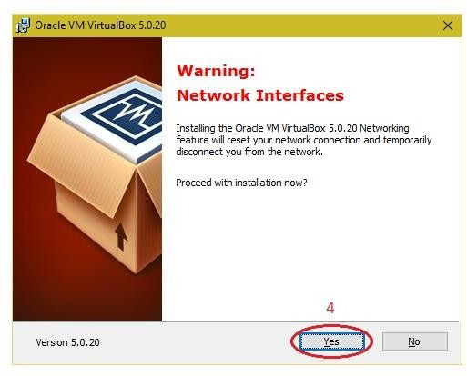

# Click the install button…

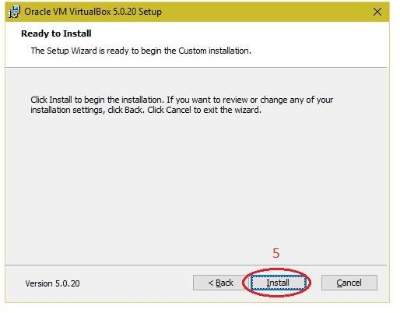

1. Then installation was completed..the show virtual box icon on desktop screen….

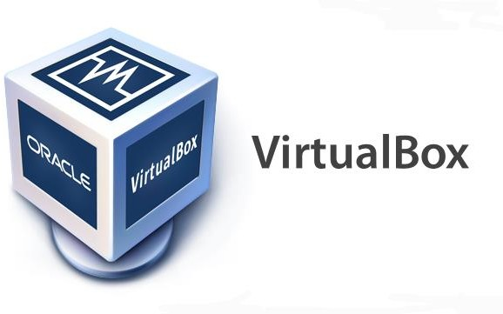

**Steps to create virtual machine:**

## 1.Downloading a Linux Image

1. Choose a Linux distribution:
   * [Ubuntu](https://ubuntu.com/download)
   * CentOS
2. Download the ISO file.

(Replace with screenshot)

## 2. Creating a New Virtual Machine

1. Open VirtualBox.
2. Click on the **New** button.

(Replace with screenshot)

1. Enter a name for your VM (e.g., "Ubuntu VM").
2. Select the type as **Linux** and version based on your ISO (e.g., "Ubuntu (64-bit)").
3. Click **Next**.

## 3. Configuring the Virtual Machine

1. **Memory Size**: Allocate RAM (e.g., 2048 MB).
   * Recommended: At least 2 GB for smooth operation.
2. **Hard Disk**: Choose to create a virtual hard disk now.

(Replace with screenshot)

1. Select **VDI (VirtualBox Disk Image)** and click **Next**.
2. Choose **Dynamically allocated** for disk space.
3. Set the disk size (e.g., 20 GB) and click **Create**.

## 4. Loading the Image File

1. Select your newly created VM and click on **Settings**.
2. Go to the **Storage** section.
3. Click on the **Empty** CD icon under the Controller: IDE.
4. On the right, click the CD icon and select **Choose a disk file**.

(Replace with screenshot)

1. Navigate to and select your downloaded ISO file.

## 5. Starting the Virtual Machine

1. Click **OK** to save your settings.
2. Select the VM and click **Start**.

(Replace with screenshot)

1. The VM will boot from the ISO. Follow the on-screen instructions to install Linux.

## 6. Initial Setup of Linux

1. Choose your language and keyboard layout.
2. Follow the installation steps:
   * Configure network settings.
   * Partition disks (default options are usually sufficient).
   * Create a user account.

(Replace with screenshot)

1. Once the installation is complete, reboot the VM.

## Result

You have successfully created and configured a Linux virtual machine using VirtualBox. You can now use this VM for various purposes, including testing, development, or learning.