Task 1: Opening Wireshark and Capturing Network Packets

Aim:
To open Wireshark Foundation tool and capture live network packets for analysis.

Software Requirement:
- Wireshark Tool
- Windows Operating System

Use Cases:
- To initialize network traffic monitoring before analysis.
- Used by network administrators to observe live packet flow.
- Helps cybersecurity analysts prepare for packet capture during investigations.
- Ensures the tool is ready before performing protocol filtering or troubleshooting .
Procedure:
- Wireshark tool was opened from the system.
- The active network interface (Wi-Fi/Ethernet) was selected.
- Packet capturing was started by double-clicking the interface.
- Network traffic was generated by accessing websites.
- The packet capture was stopped after sufficient packets were collected.
- The captured packets were displayed successfully.

Output:
The network packets were captured successfully and displayed with source, destination, protocol, and length details.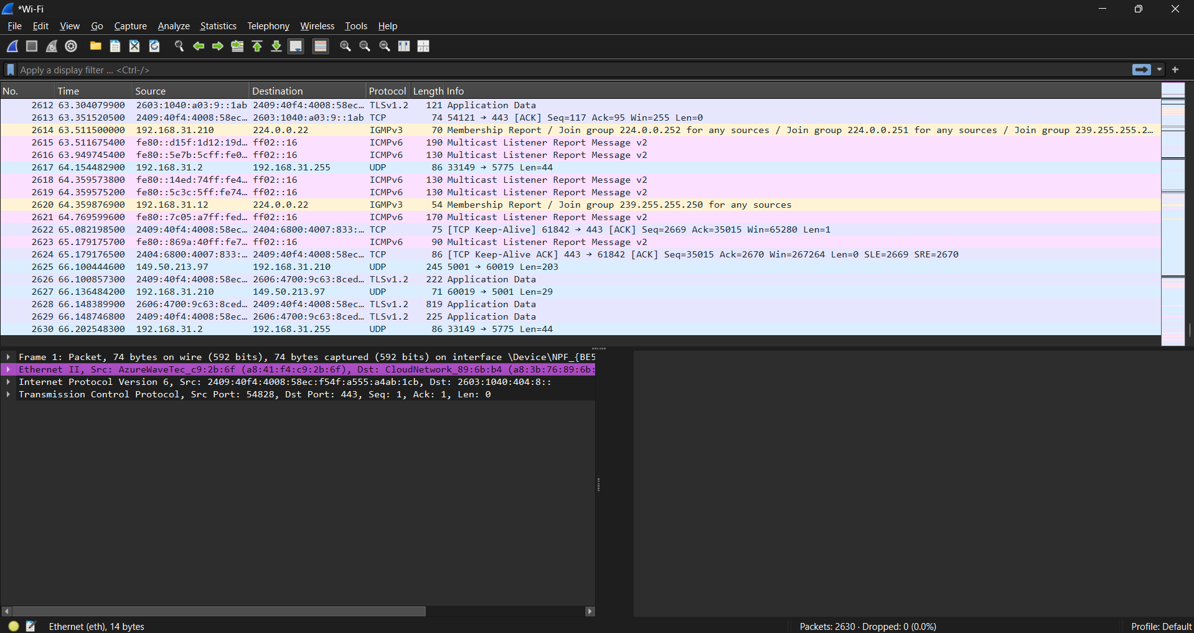

Result:
Thus, Wireshark was successfully opened and live packet capture was performed.
Task 2: Capturing Network Traffic Using Wireshark
Aim:
To capture live network traffic by selecting a network adapter and starting packet capture using Wireshark.

Software Requirement:
- Wireshark Foundation Tool
- Windows Operating System

Use Cases:
- To monitor real-time network communication.
- Used to identify abnormal or suspicious traffic.
- Helps in troubleshooting network connectivity issues.
- Allows organizations to analyze bandwidth usage.
- Used during penetration testing and security audits.
Procedure:
- Wireshark tool was opened on the system.
- The active network adapter (Wi-Fi) was selected.
- The packet capture was started by clicking the Start button.
- Network traffic was generated by accessing websites.
- Live packets were captured and displayed in the Wireshark window.
- The capture process was stopped after sufficient packets were collected.

Output:
Live network traffic was successfully captured and displayed with source address, destination address, protocol, and packet length.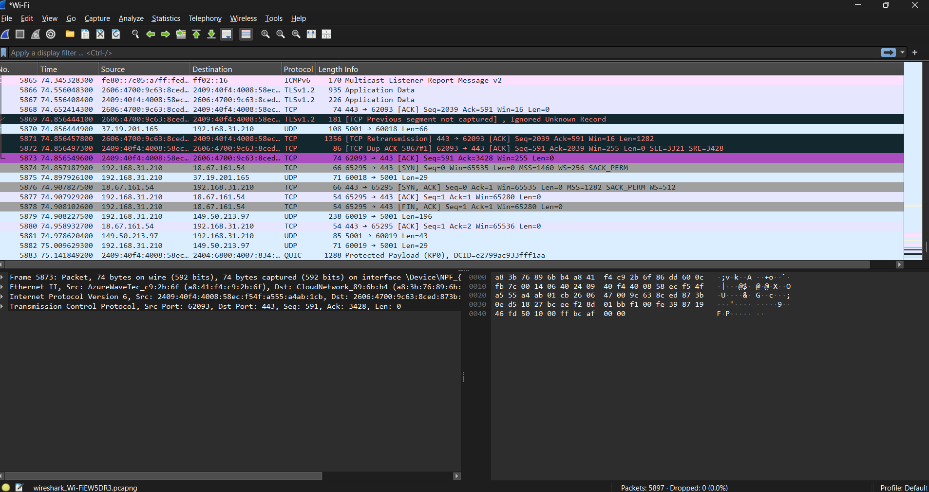

Result:
Thus, network traffic was successfully captured using Wireshark by selecting the network adapter and starting packet capture.
Task 3: Filtering Packets Using Wireshark
Aim:
To filter captured network packets using different display filters in Wireshark.

Software Requirement:
- Wireshark Foundation Tool
- Windows Operating System

Use cases:
DNS filter
- To monitor domain name resolution activities.
- Helps in detecting malicious or fake domain queries.
- Helps identify connection issues like retransmissions or delays.
UDP filter
- Used for analyzing real-time services like streaming, VoIP, and DNS.
- Helps detect packet loss or unusual UDP traffic.

Procedure:
- Wireshark tool was opened and packet capture was performed.
- The display filter bar was used to apply packet filters.
- The http filter was applied to view HTTP packets.
- The dns filter was applied to view DNS packets.
- The tcp filter was applied to view TCP packets.
- The udp filter was applied to view UDP packets.
- Filtered packets were displayed successfully.

Output:
The captured packets were successfully filtered using HTTP, DNS, TCP, and UDP display filters, and only the respective protocol packets were displayed.
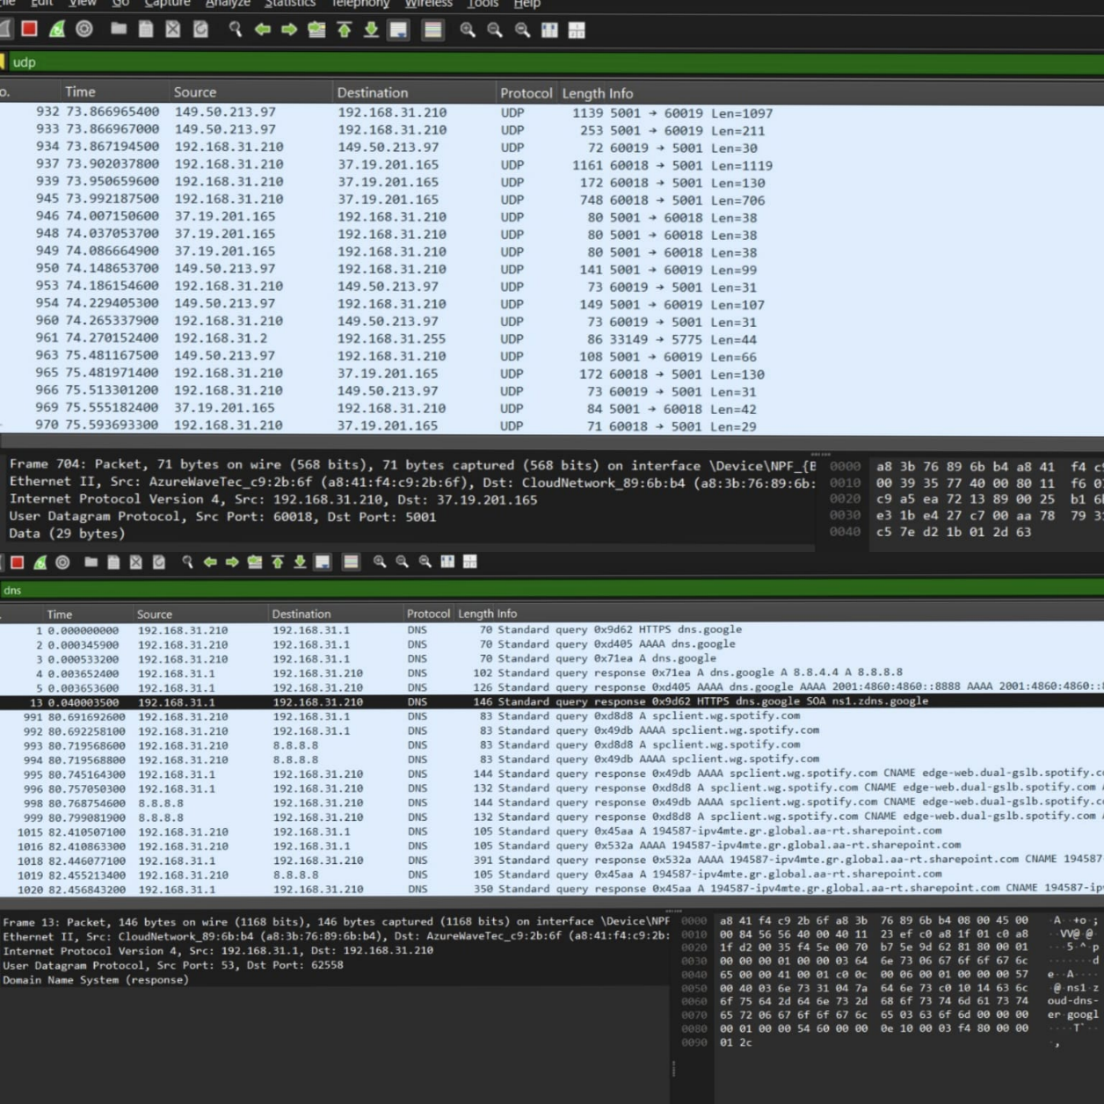

Result:
Thus, packet filtering was successfully performed using different display filters in Wireshark.

Task 4 – Check IP Address (Wireshark)
Aim:
To filter and analyze packets related to a specific IP address using Wireshark.

Tool Used:
- Wireshark

Filter Used:
ip.addr==192.168.31.210

Procedure:
- Open Wireshark.
- Start capturing packets from the active network interface (Wi-Fi/Ethernet).
- In the Display Filter bar, type
ip.addr == 192.168.1.10
- Press Enter.
- Wireshark displays only packets where 192.168.1.10 is either the source or destination IP.
Use Case:
- Network troubleshooting
- Identifying suspicious activity
- Monitoring a specific host

Observation:
- Only packets related to the IP address 192.168.1.10 are displayed.
- Other unrelated packets are hidden.
- The filtered packets include protocols such as TCP, UDP, DNS, or HTTP depending on traffic. 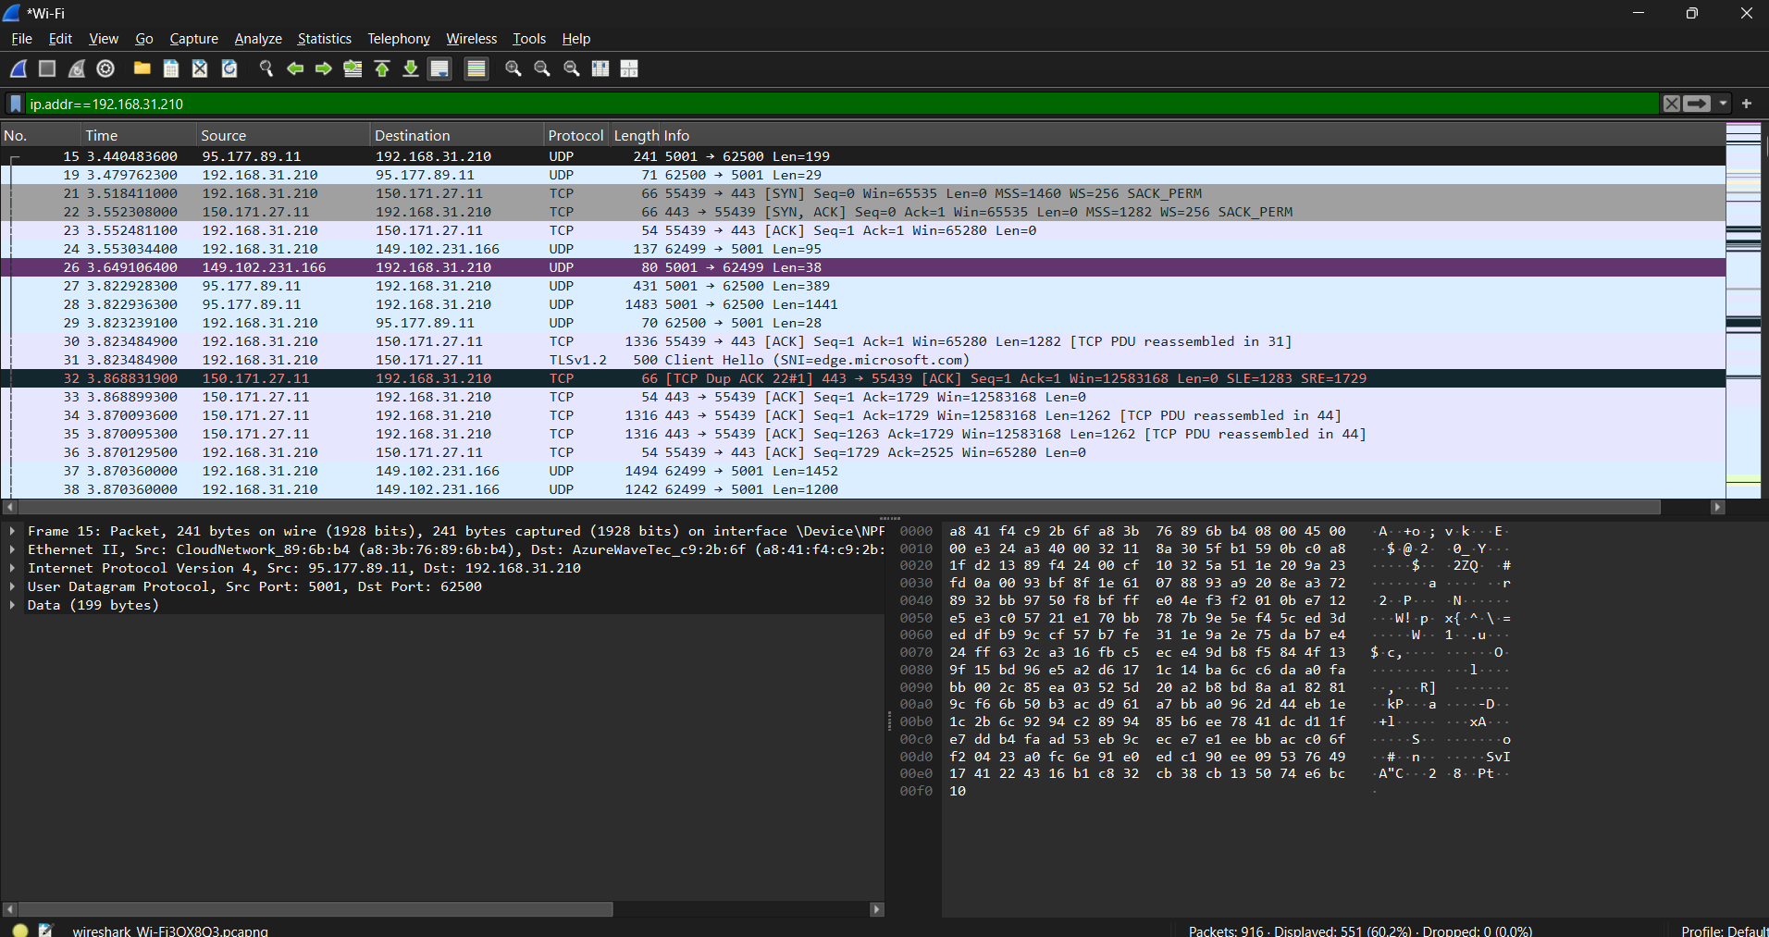

Result:
Successfully filtered and analyzed network traffic associated with the IP address 192.168.1.10 using Wireshark.

Task 5 – Analyze TCP Handshake
(SYN → SYN-ACK → ACK)

Step-by-Step Procedure (Wireshark)
Step 1: Start Capture
- Open Wireshark
- Select the active network adapter (Wi-Fi / Ethernet)
- Click Start (blue shark fin)

Step 2: Apply TCP Filter
In the display filter bar, type:
tcp
Press Enter
Now only TCP packets will be visible.

Step 3: Locate TCP Handshake Packets
Look at the Info column carefully.
You will see packets like:
- SYN
- SYN, ACK
- ACK
These three packets together form one TCP 3-way handshake. 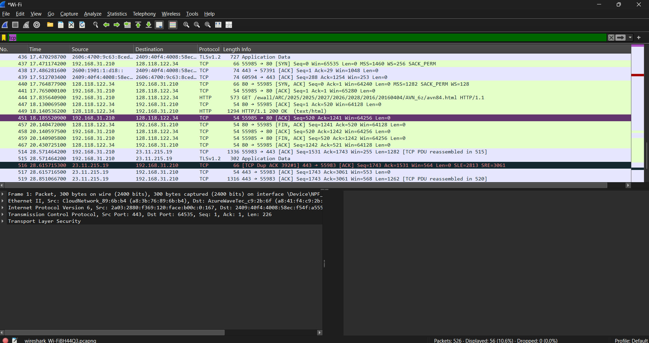
Use Cases –
- To verify successful TCP connection establishment
- Used in network troubleshooting
- Helps identify connection failures or delays
- Used by security analysts to detect:
  - SYN flood attacks
  - Abnormal connection attempts
- Useful in server performance and reliability analysis
- Helps understand client-server communication behavior
Observation / Result:
The TCP 3-way handshake was successfully observed using Wireshark by analyzing SYN, SYN-ACK, and ACK packets.
Task 6: Viewing DNS Traffic Using Wireshark
Aim:
To view and analyze DNS traffic using Wireshark.

Software Requirement:
- Wireshark Foundation Tool
- Windows Operating System

Use Case:
- Used to monitor domain name resolution.
- Helps detect malicious DNS queries.
- Useful in identifying DNS spoofing or tunneling attacks.
- Helps troubleshoot website access issues.
Procedure:
- Wireshark was opened on the system.
- Packet capture was started by selecting the active network adapter.
- The display filter dns was applied.
- Wireshark displayed only DNS query and response packets.
- The DNS traffic was successfully observed.

Output:
DNS traffic was displayed showing domain name queries and responses exchanged between client and DNS server.
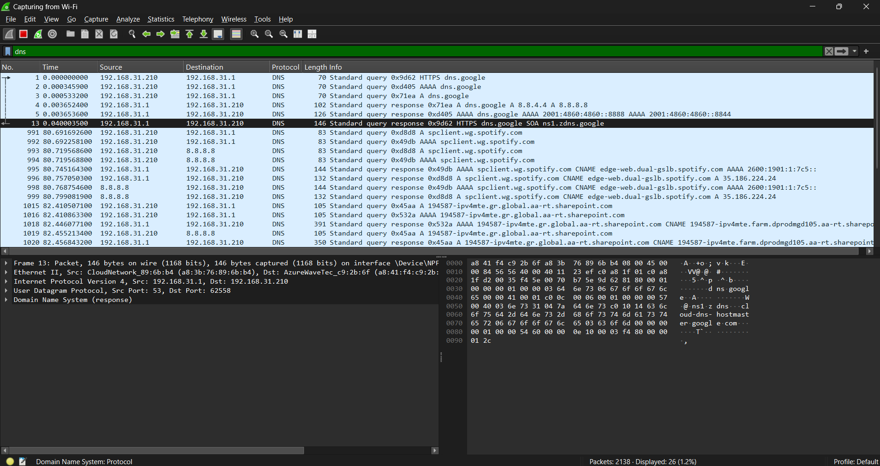

Result:
Thus, DNS traffic was successfully viewed and analyzed using Wireshark.

Task 7 – Export Capture
Aim:
To export and save the captured network traffic from Wireshark into a capture file for future analysis.

Procedure:
- Complete the packet capture in Wireshark.
- Click on the File menu.
- Select Export → Save As.
- Choose the file format as .pcap.
- Provide a suitable file name.
- Select the destination folder.
- Click Save to export the capture.

Observation:
The captured network packets were successfully saved in .pcap format, which preserves all packet details such as headers, payload, timestamps, and protocol information.

Result:
The network traffic capture was successfully exported and stored as a .pcap file for offline analysis.

Use Case:
- Used for sharing packet captures with team members.
- Helps in offline traffic analysis and troubleshooting.
- Useful in digital forensics and incident investigation.
- Allows replay and review of network activity at any time.

Conclusion:
Exporting packet captures in .pcap format ensures secure storage and easy analysis of network traffic, making it an essential step in network monitoring and security analysis.
Task 8 – Check Protocol Statistics
Aim:
To analyze the distribution of network protocols used in the captured traffic using the Protocol Hierarchy feature in Wireshark.

Procedure:
- Open the captured file in Wireshark.
- From the menu bar, click Statistics.
- Select Protocol Hierarchy.
- Observe the list of protocols along with packet count and percentage.
- Analyze the protocol usage in the network traffic.

Observation:
The Protocol Hierarchy window displays a hierarchical breakdown of all protocols involved in the capture such as:
- Ethernet
- Internet Protocol (IPv4 / IPv6)
- Transport layer protocols (TCP, UDP)
- Application layer protocols (DNS, HTTP, HTTPS, QUIC)
The window shows:
- Total number of packets
- Percentage of each protocol
- Protocol layering structure 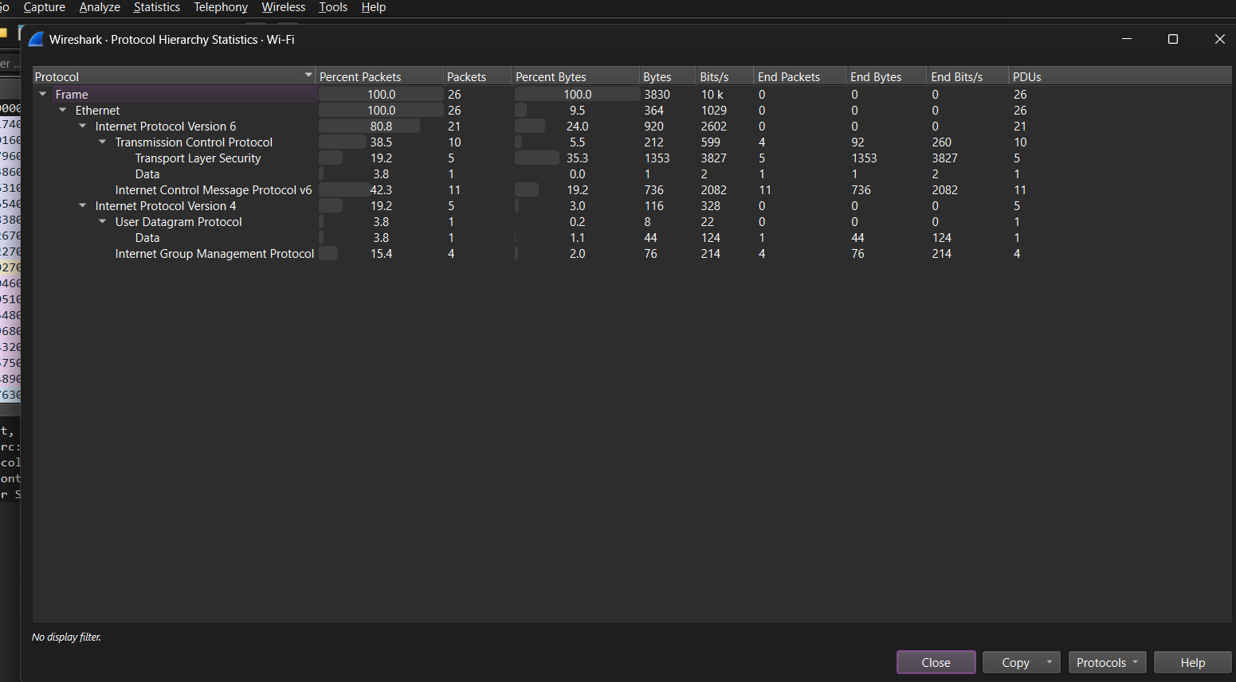

Result:
The protocol hierarchy was successfully analyzed and the distribution of protocols in the captured network traffic was observed.

Use Case:
- Helps identify dominant protocols in network traffic.
- Useful for network performance analysis.
- Assists in detecting abnormal or suspicious protocol usage.
- Used in network monitoring and security auditing.

Conclusion:
The Protocol Hierarchy feature in Wireshark provides a clear overview of protocol distribution, enabling effective analysis of network behavior and traffic patterns.
Task 9 – Follow TCP Stream
Procedure:
- Applied tcp display filter.
- Selected a TCP packet from the capture.
- Right-clicked on the packet.
- Chose Follow → TCP Stream.
- Observed the complete TCP conversation between client and server.
Use Case:
- Used to analyze client–server communication.
- Helps detect suspicious or malicious data transfer.
- Useful for troubleshooting application issues.
- Assists in network forensics and debugging.
Observation:
The TCP stream displayed encrypted data because the traffic was HTTPS (TLS-based). The payload was not readable in plain text due to encryption, which confirms secure communication.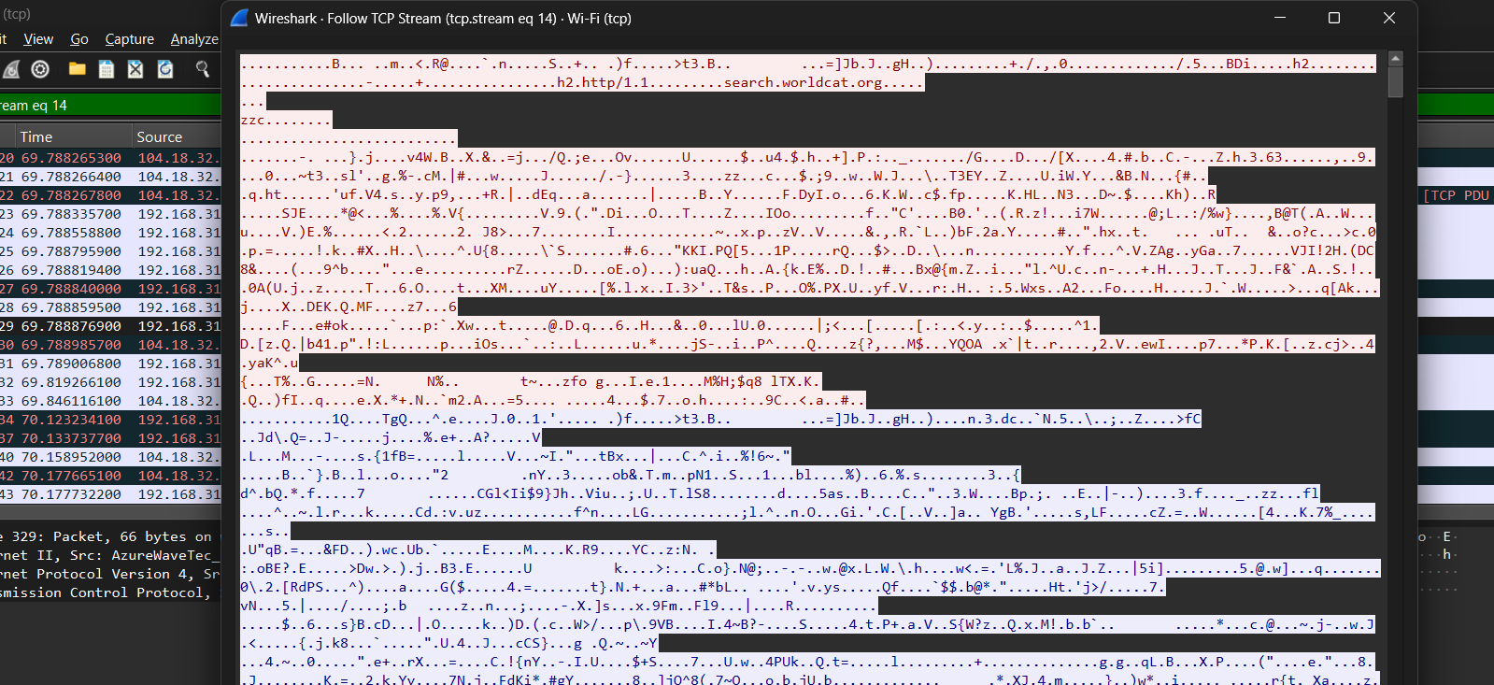
Result:
TCP stream was successfully followed and analyzed using Wireshark.
Conclusion:
Following the TCP stream helps reconstruct end-to-end communication between client and server, which is useful for troubleshooting, forensic analysis, and understanding encrypted traffic behaviour. Advantages (Common for All Tasks):
- Real-Time Traffic Analysis
Wireshark allows monitoring of live network traffic, helping administrators understand what is happening on the network instantly.
- Protocol-Level Visibility
It supports hundreds of protocols (TCP, UDP, DNS, HTTP, HTTPS), making it easy to analyze communication at a deep level.
- Effective Troubleshooting Tool
Helps identify packet loss, latency, retransmissions, and connection failures efficiently.
- Security Monitoring
Enables detection of suspicious traffic, unusual IP addresses, and unauthorized connections.
- Detailed Packet Inspection
Provides complete packet details including headers, payloads, and timestamps for accurate analysis.
- Offline Analysis Support
Captured traffic can be saved and analyzed later using .pcap files.
- Free and Open Source
Wireshark is freely available and widely trusted in the IT and cybersecurity industry.

Disadvantages :
- Requires Technical Knowledge
Understanding packet data and protocols requires networking fundamentals.
- Large Capture Files
Long captures can consume high disk space and system memory.
- Encrypted Traffic Limitation
Encrypted protocols (HTTPS, TLS) cannot be fully read without decryption keys.
- Performance Impact
Running continuous packet capture may slow down system performance.
- Privacy Concerns
Capturing network traffic may expose sensitive information if not handled properly.
- Not an Intrusion Prevention Tool
Wireshark can detect issues but cannot block attacks automatically.

Real-Time Security Usage in IT Companies:
- Network Intrusion Detection
Used to detect unauthorized access, suspicious connections, and abnormal traffic patterns.
- Incident Response and Forensics
Security teams analyze packet captures after cyber incidents to identify attack sources and methods.
- Monitoring Internal Network Traffic
Helps ensure employees and systems follow security policies.
- Malware and Attack Analysis
Used to analyze communication between infected systems and external servers.
- DNS and TCP Analysis
Helps detect DNS spoofing, TCP session hijacking, and man-in-the-middle attacks.
- Compliance and Auditing
Assists in verifying network behavior for audits and regulatory compliance.
- Performance and Security Optimization
Helps IT teams fine-tune firewalls, IDS/IPS, and network configurations.

