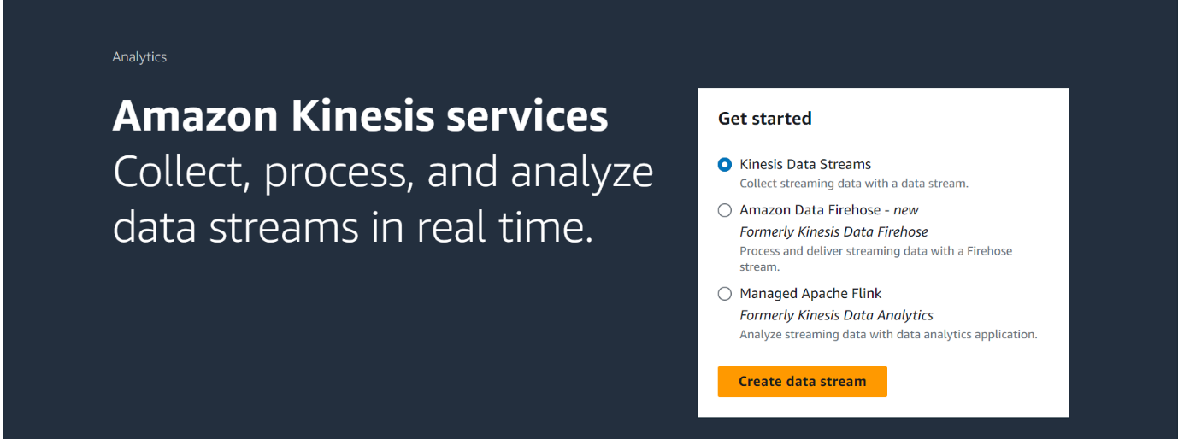

Click on Create data stream

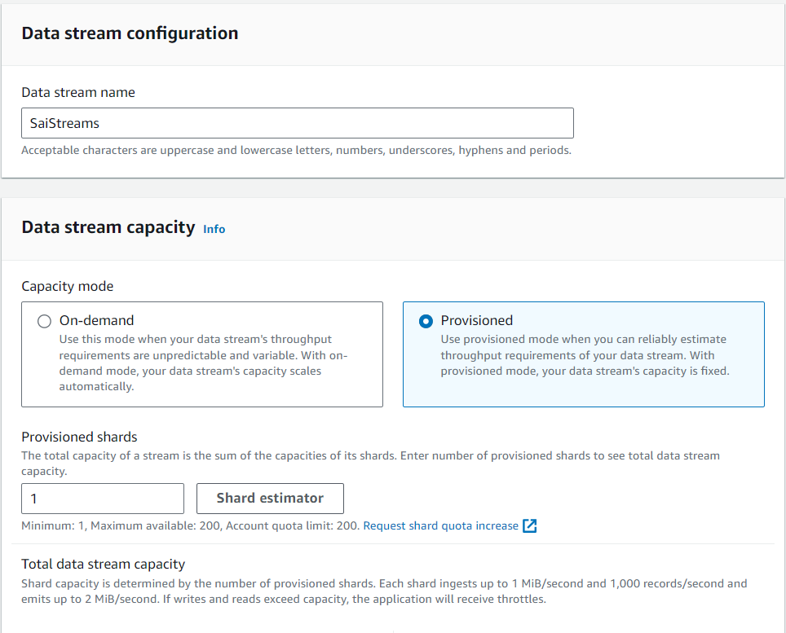

Click on Create Data Streams at the bottom.

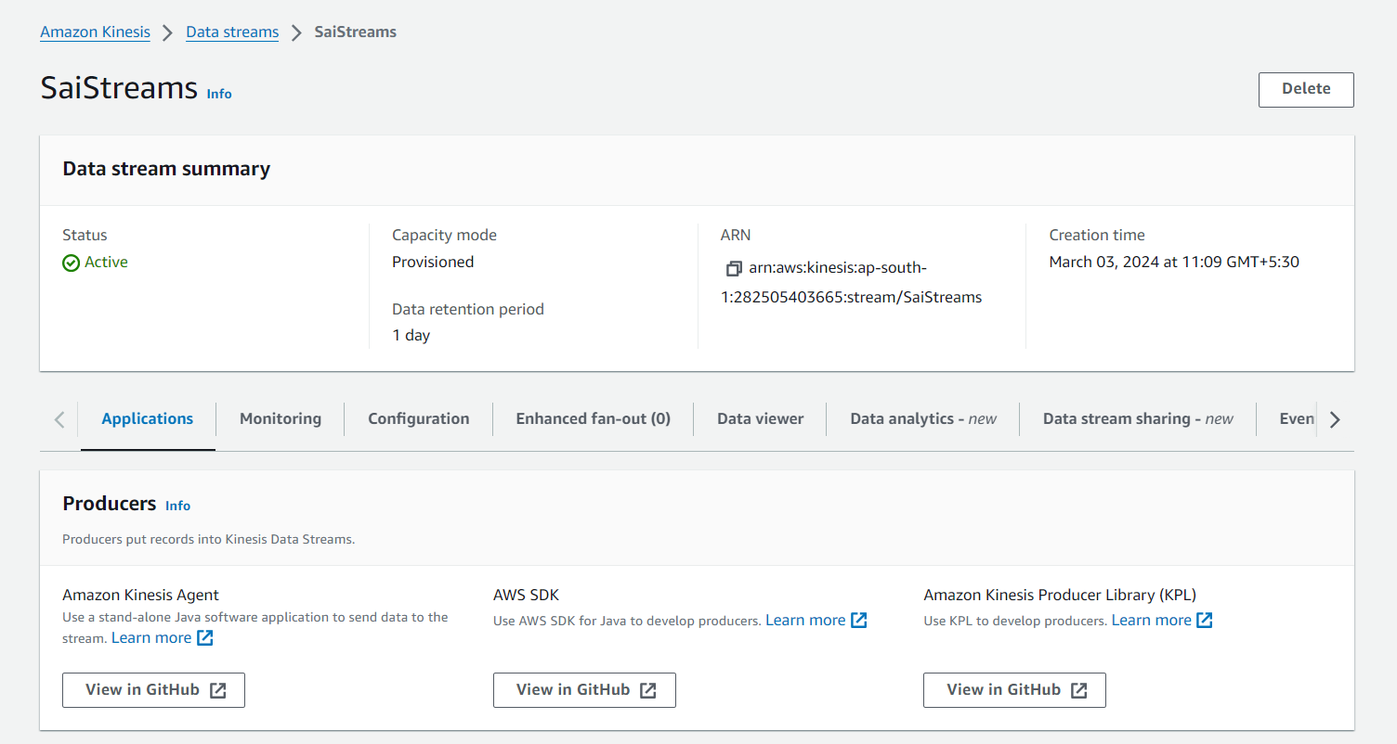

SPARK CODE FOR KENESIS READ

kDF=spark.readStream.format("kinesis").option("StreamName","SaiStreams").option("initialPosition","earliest"). \

option("region",ap-south-1").option("awsAccessKey",xxxxxxx).option("awsSecretKey",xxxxxx).load()

FOR COMPLETE EXAMPLE

<https://spark.apache.org/docs/latest/streaming-kinesis-integration.html>