Working with YARN Commands Commands.

1. Run MapReduce Program and capture the application Id of the job.

hdfs dfs -put Shakespeare

javac -classpath `hadoop classpath` *.java



jar -cvf WordCnish.jar *.class



hadoop jar WordCnish.jar WordCountDriver shakespeare WordOutputnish

hdfs dfs -ls WordOutputnish



hdfs dfs -cat wordOutputnish/part-r-00000

1. Re-run the MapReduce program and kill the application using the yarn command.

yarn application -kill application_1707102216682_0109



1. List all the applications which are RUNNING state

yarn application -list -appStates RUNNING

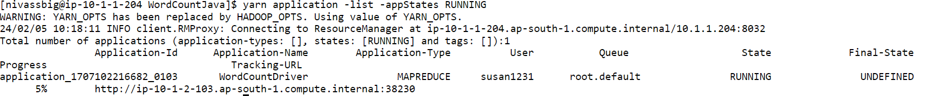

1. View the logs of any of the jobs which are already completed

yarn logs -applicationId application_1707102216682_0108 | head

