mysql> CREATE TABLE weatherdata_ni( statecode VARCHAR(255), countrycode VARCHAR(255), sitenum VARCHAR(255), paramcode VARCHAR(255), poc VARCHAR(255

), latitude VARCHAR(255), longitude VARCHAR(255), datum VARCHAR(255), param VARCHAR(255), datelocal VARCHAR(255), timelocal VARCHAR(255), d

ategmt VARCHAR(255), timegmt VARCHAR(255), degrees DOUBLE, uom VARCHAR(255), mdl VARCHAR(255), uncert VARCHAR(255), qual VARCHAR(255), meth

od VARCHAR(255), methodtype VARCHAR(255), methodname VARCHAR(255), state VARCHAR(255), county VARCHAR(255), dateoflastchange VARCHAR(255) );

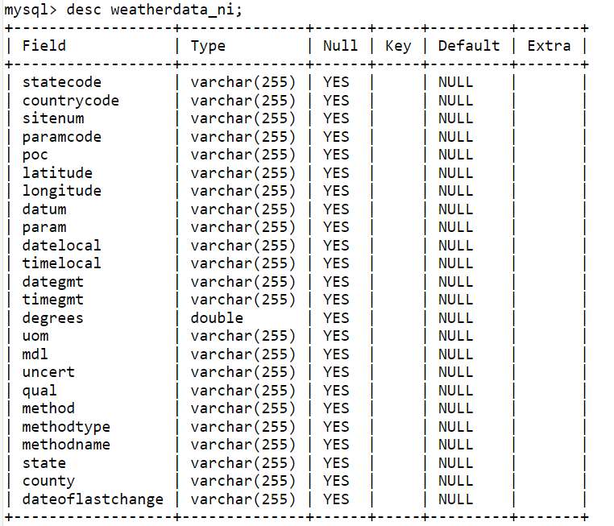

Task 1:

mysql>load data local infile '/home/nivassbig/hourly_TEMP_1990.csv' into table weatherdata_ni fields terminated by ',' enclosed by '"' lines terminated by '\n' ignore 1 rows;

select * from weatherdata_ni limit 10;

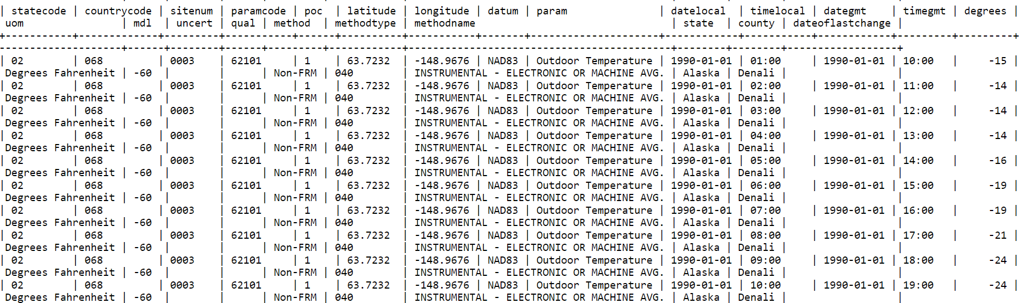

Task 2:

sqoop import --connect jdbc:mysql://ip-10-1-1-204.ap-south-1.compute.internal:3306/nivassbig --username nivassbig --password Bigdatalab123

--table weatherdata_ni --driver com.mysql.jdbc.Driver --target-dir /user/hive/warehouse/nisha.db/weatherdata_txt --fields-terminated-by ',' --lines-terminated-by '\n'

--hive-import --create-hive-table --hive-table nisha.weatherdata_txt -m 1

Task 3:

CREATE TABLE weatherdata_parq

STORED AS PARQUET

AS

SELECT * FROM weatherdata_txt;

**Load the data from text file**

INSERT INTO TABLE weatherdata_parq

SELECT * FROM weatherdata_txt;

Task 4:

SELECT AVG(degrees) AS ave_deg_txt

FROM weatherdata_txt;

SELECT AVG(degrees) AS ave_deg_parq

FROM weatherdata_parq;

Task 5:

Compare the size of data

hdfs dfs -du -h /user/hive/warehouse/weatherdata_txt

hdfs dfs -du -h /user/hive/warehouse/weatherdata_parq