Lineage-Aware Hierarchical Deep Learning for Imbalanced Multi-Class Classification of Peripheral Blood Cells

Final Thesis

In Partial Fulfillment
of the Requirements for the Degree of
Master in Computer Science

Student Name : Arthiga Karthigesu
Student ID : [insert student ID]
Supervisor : [insert supervisor name]

Abstract
Automated classification of peripheral blood cells is a well-studied application of deep learning, yet two properties of the clinical problem are routinely discarded. The eighteen cell types encountered in a differential count are not unrelated labels: they belong to three haematopoietic lineages, and within the myeloid branch they lie on a maturation continuum. The class distribution is also severely long-tailed, so the rare types carrying the greatest diagnostic weight are learned least well. This dissertation investigates whether making a classifier lineage-aware, and training it under an imbalance-robust objective, improves fine-grained classification of rare blood cell types relative to a flat transfer-learning baseline.
Using the MLL23 dataset of 41,621 expert-annotated images across 18 classes at an imbalance ratio of 261:1, a shared pretrained backbone feeds lineage and fine cell-type heads coupled by a class-balanced hierarchical loss combining effective-number reweighting, focal modulation and a consistency term. Four configurations were trained under identical partitions and backbones at three seeds each, and compared by paired testing with reported effect sizes.
The hierarchical model reached a test macro F1 of 0.879 against 0.874 for the flat baseline, and a minority-class macro F1 of 0.840 against 0.823, improving rare classes by more than the overall average. Aggregate differences were not significant at three seeds, but the model significantly reduced cross-lineage error, the clinically severe category (p = 0.020), confirming the predicted mechanism; per-class analysis located the gain almost entirely in the two rarest lymphoid types. Removing the imbalance term cost 0.060 minority macro F1, an order of magnitude more than the hierarchy contributed, identifying the objective as the load-bearing component. Lineage accuracy saturated at 98.9%, explaining the modest architectural effect and indicating that the auxiliary signal should instead target maturation stage.

Keywords: hierarchical classification; class imbalance; peripheral blood cells; class-balanced loss; explainable AI; deep learning

Acknowledgements
I would like to thank my supervisor for their guidance throughout this project, and in particular for the encouragement to treat negative and inconclusive findings as results in their own right, not failures to be tidied away.
I am grateful to the Munich Leukemia Laboratory and the authors of the MLL23 data descriptor for releasing a large, expert-annotated corpus under an open licence. Work of this kind is only possible because practitioners choose to make carefully curated clinical data publicly available.
Finally, I thank my family for their patience and support.

Contents
Abstract ii
Acknowledgements iii
Contents iv
List of Tables v
List of Figures vi
List of Acronyms vii
Chapter 1 Introduction 1
1.1 Background 1
1.2 Problem Statement 2
1.3 Research Question and Objectives 3
1.4 Expected Outcomes 4
Chapter 2 Literature Review 5
2.1 Comprehensive Overview of the Existing Literature 5
2.2 Critical Analysis of Existing Studies 13
Chapter 3 Methodology 17
3.1 Data Collection and Preprocessing 18
3.2 ML/AI Model Development 21
3.3 Evaluation of the Proposed System 24
3.4 Experimental Design and Statistical Protocol 26
Chapter 4 Experimental Results 28
4.1 Experimental Setup 28
4.2 Dataset Description 29
4.3 Results 30
4.4 Comparison with Baseline Methods 36
Chapter 5 Conclusion and Future Work 40
5.1 Conclusion 40
5.2 Future Work 42
References 44
Appendix A. Experimental Configuration Reference 48
Appendix B. Per-Class Results 49

List of Tables
Table 2.1 Critical analysis and summary of the existing studies
Table 3.1 The 18 MLL23 classes, lineage membership and partition sizes
Table 3.2 Class-conditional augmentation parameters
Table 3.3 Candidate backbone architectures
Table 3.4 Ablation switches implemented on the loss object
Table 3.5 The four distinct configurations and five reported experiments
Table 4.1 Training hyperparameters, held identical across all arms
Table 4.2 Test-set performance by experimental arm
Table 4.3 Paired comparisons across three seeds
Table 4.4 Hierarchical decomposition of prediction outcomes
Table 4.5 Per-class test F1 by arm
Table A1 Configuration fields and Phase 2 values
Table A2 Computational cost of the Phase 2 matrix
Table B1 Per-class precision and recall on the test partition

List of Figures
Figure 3.1 Architecture of the proposed system
Figure 3.2 The two-level label hierarchy
Figure 3.3 One representative image per class after preprocessing
Figure 3.4 Class distribution on linear and logarithmic axes
Figure 3.5 The three augmentation policies applied to one image
Figure 3.6 Stain normalisation, one image per lineage
Figure 3.7 UMAP projection of frozen backbone features by lineage
Figure 4.1 Overall and minority-class F1 by experimental arm
Figure 4.2 Cross-lineage error for each seed, baseline against proposed
Figure 4.3 Per-class F1, proposed model against the flat baseline
Figure 4.4 How far along the maturation chain each error lands
Figure 4.5 Grad-CAM saliency for the fine classification head

List of Acronyms
Term | Definition
AML | Acute Myeloid Leukaemia
AMP | Automatic Mixed Precision
bf16 | Brain Floating Point, 16-bit
CB | Class-Balanced loss
CNN | Convolutional Neural Network
cRT | Classifier Re-Training, decoupled training
EMA | Exponential Moving Average
Grad-CAM | Gradient-weighted Class Activation Mapping
KL | Kullback-Leibler divergence
LDAM | Label-Distribution-Aware Margin loss
MLL23 | Munich Leukemia Laboratory 2023 dataset
TTA | Test-Time Augmentation
UMAP | Uniform Manifold Approximation and Projection
ViT | Vision Transformer
XAI | Explainable Artificial Intelligence

Chapter 1 Introduction
This chapter establishes the clinical and technical context of the study, states the problem it addresses, and sets out the research question, objectives and expected outcomes that structure the remainder of the dissertation.

1.1 Background
The microscopic examination of a peripheral blood smear remains a foundational procedure in haematological diagnosis. In a differential count, a trained cytomorphologist inspects individual nucleated cells and assigns each to a cell type on the basis of nuclear shape, chromatin texture, cytoplasmic volume and colour, and the presence and character of granulation. The resulting distribution of cell types informs the diagnosis and monitoring of conditions ranging from reactive infection to acute leukaemia [1], [2].
The procedure has two well-documented weaknesses. It is slow and repetitive, requiring sustained attention across hundreds of cells per slide, and it is subject to appreciable inter-observer variability, since the morphological boundaries between adjacent cell types shade into one another instead of falling into clean categories [3]. Both weaknesses are most pronounced for the rare and immature cell types, which a given observer encounters infrequently and whose appearance overlaps substantially with their neighbours on the maturation continuum.
Deep learning has been applied to this task with considerable success. Convolutional neural networks trained on large annotated corpora have reached expert-level agreement on blast cell recognition [4] and on bone-marrow cell morphology across a wide class vocabulary [2]. The publication of several large, expert-annotated single-cell datasets has accelerated this work by providing common benchmarks [1], [5], [6]. Transfer learning from ImageNet-pretrained backbones is now the standard approach, and reported accuracies on the more balanced benchmarks routinely exceed 95%.
Two properties of the clinical problem are nonetheless discarded by most of these systems. The first is the structure of the label space. The cell types encountered in a differential count are not unrelated categories: they belong to three haematopoietic lineages, and within the myeloid branch they occupy successive stages of a single developmental process. A classifier that treats the eighteen types as a flat vocabulary discards this biology entirely. The second is the shape of the class distribution. Blood cell datasets that reflect genuine clinical prevalence are severely long-tailed, and the rare types are frequently the diagnostically decisive ones.

1.2 Problem Statement
A model trained conventionally on a long-tailed corpus optimises an objective dominated by the majority classes. Where one class contributes 8,606 images and another 33, the gradient contributed by the rare class is negligible, and a classifier that abandons it entirely forfeits less than 0.1% of overall accuracy. The consequence is a system that performs impressively on the headline metric while failing on exactly the cells that motivated its construction. Reporting plain accuracy on such data is worse than uninformative; it actively misleads [7], [8].
The conventional remedy is to resample the training distribution until it is balanced. This is unsatisfactory in the present context for two reasons. Oversampling a class of 33 images cannot manufacture morphological variety that the data does not contain, and risks memorisation of the few available examples; undersampling the majority discards the large volume of data that makes transfer learning effective in the first place. More fundamentally, the imbalance reflects genuine physiological prevalence, and is the phenomenon under study, not a defect to be cleaned up before study begins.
A second limitation concerns the treatment of errors. A flat classifier assigns equal cost to every misclassification, yet the clinical consequences differ sharply. Confusing a myelocyte with a metamyelocyte, two adjacent stages of neutrophil maturation, is a mild error that subsequent human review would likely tolerate. Assigning a lymphocyte to the myeloid lineage is a categorically different failure with direct diagnostic consequences. Standard metrics cannot express this distinction, and standard objectives provide no mechanism to prefer the milder error.
Finally, systems intended for clinical deployment must be interpretable. A model that achieves high accuracy by attending to staining artefacts or to neighbouring red cells instead of the target cell will not generalise to a new laboratory, and cannot be trusted by the practitioner expected to act on its output [9], [10]. Saliency analysis is built into the design, not added at the end as illustration.
These three concerns, the discarded label hierarchy, the long-tailed distribution, and the need for interpretable evidence, have each been addressed in isolation in the literature. They have not been addressed together on a large, genuinely imbalanced peripheral blood corpus, and it is that combination this dissertation examines.

1.3 Research Question and Objectives
This study is guided by the following research question.
Does a lineage-aware hierarchical classifier, combined with an imbalance-robust training objective, improve fine-grained classification of single peripheral blood cell images, especially for rare cell types, compared with a flat transfer-learning classifier on the same data?
The question is addressed through five objectives.
- Acquire, verify and characterise a large, expert-annotated peripheral blood single-cell dataset exhibiting genuine clinical class imbalance, and establish a deterministic partition that preserves rare classes in every split.
- Design and implement a hierarchical classification architecture in which a shared pretrained backbone supports both a lineage head and a fine cell-type head, trained jointly under a single composite objective.
- Formulate an imbalance-robust loss combining effective-number class reweighting, focal modulation and a hierarchical consistency term, with each component independently removable for ablation.
- Evaluate the proposed model against a flat baseline and against ablations removing the hierarchy and the imbalance treatment, under identical partitions and backbones, using macro-averaged and minority-class metrics together with a hierarchical decomposition of errors.
- Assess whether the decisions of the model are grounded in morphologically meaningful image regions using gradient-based saliency analysis.

1.4 Expected Outcomes
The primary expected outcome is quantitative evidence on whether lineage awareness improves rare-class performance. The design anticipates one specific pattern, not a general lift: if the hierarchy contributes as theorised, the gain should be larger on the minority classes than on the corpus as a whole, and errors should shift from cross-lineage to within-lineage even where total error moves little.
The ablation design is expected to apportion credit between the two mechanisms under test. Because the hierarchy and the imbalance objective are removable independently, the study can report not only whether the combined system outperforms the baseline but which component is responsible, which is the more useful finding for subsequent work.
The saliency analysis is expected to establish whether the network attends to nucleus, chromatin and cytoplasm instead of background or neighbouring red cells, providing qualitative support for or against the quantitative results.
Finally, the study is expected to produce a reusable, configuration-driven experimental framework in which every arm is a parameter setting on one implementation instead of a script of its own, so that the comparisons remain valid as further variants are added.
It is worth stating what the study does not expect to deliver. It does not aim to produce a deployable diagnostic system, since a single-centre corpus cannot establish the cross-institution robustness that deployment would require. Nor does it aim to establish which backbone architecture is best suited to the task, which would demand a full-length comparison beyond the available compute budget. The contribution is a controlled test of two specific mechanisms, evaluated under conditions that make the comparison between them interpretable.

1.5 Structure of the Dissertation
Chapter 2 reviews the literature across the four domains the problem draws on, analyses the existing studies against a common set of parameters, and identifies the gap the study addresses. Chapter 3 sets out the methodology: the dataset and its label hierarchy, the partitioning and preprocessing procedure, the two-head architecture, the composite training objective and its ablation switches, the evaluation metrics including the hierarchical decomposition of errors, and the experimental design under which the arms are compared.
Chapter 4 reports the experimental setup and results. It presents the four arms at aggregate level, analyses them per class, examines the saliency evidence, compares the outcome against the flat baseline and against the literature, and records a methodological correction that invalidated an earlier experimental matrix. Chapter 5 draws conclusions against the research question and objectives, and sets out the further work the findings indicate. Appendix A documents the experimental configuration in full, and Appendix B reports per-class precision and recall for every arm.

Chapter 2 Literature Review
The automated classification of single peripheral blood cells draws on four distinct but intersecting research domains: deep learning architectures applied to cytological imagery, hierarchical classification paradigms that exploit known label structure, algorithm-level strategies for learning from severely imbalanced data, and explainable artificial intelligence for clinical viability. Each has developed substantially over the past decade. Their synthesis, particularly within peripheral blood diagnostics, remains underdeveloped, and it is that absence which defines the contribution of the present study.
This review is grounded in primary research published between 2021 and 2026, with preference for Q1-ranked journals in computational medicine, biomedical engineering and computer vision, supplemented by a small number of foundational earlier works whose methods remain in active use. The search strategy used the keywords peripheral blood cell classification, leukaemia deep learning, hierarchical classification medical imaging, class imbalance loss function, explainable AI haematology, and blood smear convolutional neural network, cross-referenced with haematopoiesis taxonomy terms. Candidate papers were retained where they reported quantitative evaluation on cytological image data, or where they introduced a method subsequently adopted in that setting. For each retained study the problem addressed, the methodology, the dataset, the reported results and the stated limitations were recorded, and it is that record which structures the critical analysis in Section 2.2.

2.1 Comprehensive Overview of the Existing Literature

2.1.1 From Handcrafted Features to End-to-End Learning
Early automated blood cell analysis relied on explicit segmentation followed by handcrafted feature extraction. A typical pipeline isolated the nucleus and cytoplasm by colour-space thresholding, computed morphometric descriptors such as area, circularity, nucleus-to-cytoplasm ratio and texture statistics, and passed these to a conventional classifier such as a support vector machine or random forest. The approach is interpretable by construction, since every feature has a stated meaning that a haematologist can evaluate, and it is economical with training data because the feature space is small. Its ceiling, however, is set by the expressiveness of the chosen descriptors, and morphological distinctions that no one thought to encode are simply invisible to the classifier.
Rahimzadeh and colleagues [5] published the Raabin-WBC dataset of approximately 40,000 peripheral white blood cell images acquired with two camera systems and two microscope platforms. Their experiments demonstrated that the generalisation of machine learning models is profoundly affected by acquisition diversity, a challenge handcrafted pipelines cannot address because their descriptors are camera-agnostic by design and so blind to the systematic colour and focus shifts that different hardware introduces. This finding has direct implications for deployment, where imaging hardware is rarely standardised across institutions and where a model validated on one microscope may be applied on another.
Kouzehkanan and colleagues [6] proposed a segmentation-first, feature-extraction-second approach that outperformed several pretrained convolutional networks in cross-dataset generalisation, because it combined principled colour-space segmentation with robust shape features that transfer across acquisition conditions. Their result is a useful corrective to the assumption that end-to-end learning dominates in every respect: where the training corpus is narrow, explicit priors can generalise better than learned ones. It simultaneously illustrated the performance ceiling such pipelines impose, since the same rigidity that confers robustness prevents the model from exploiting subtle texture cues that distinguish adjacent maturation stages. Acevedo and colleagues [26] provided an early demonstration that convolutional networks could exceed this ceiling on peripheral blood images, establishing the transition that the subsequent literature consolidated.

2.1.2 Convolutional Architectures for Blood Cell Classification
Convolutional neural networks changed the pipeline by allowing the model to discover hierarchical feature representations directly from pixels, removing the segmentation step and the descriptor design step simultaneously. Matek and colleagues [2] trained convolutional networks on 171,374 annotated single-cell images from 945 haematologically diverse patients, demonstrating that such networks identify a wide range of diagnostically relevant morphologies, including subtle blast appearances, with precision and recall approaching expert haematologists. The dataset was the largest expert-annotated pool of bone marrow cytology published at the time and remains a reference benchmark. An earlier study by the same group established human-level agreement on blast recognition in acute myeloid leukaemia [4], which is the result most often cited as evidence that the task is tractable at all.
Transfer learning from ImageNet-pretrained backbones subsequently became the dominant paradigm, and for good reason: medical image corpora are typically one to two orders of magnitude smaller than general-purpose vision benchmarks, and pretrained low-level features transfer well because edges, textures and blobs are not domain-specific. Alam and Islam [11] fine-tuned DenseNet-121 on a four-class dataset of 12,444 images, reporting 98.84% accuracy and 99.61% specificity, and showed through systematic ablation that batch size materially affects performance in this regime, with smaller batches acting as an implicit regulariser against overfitting. Their study is a useful illustration of the practical nuance required when standard architectures are transplanted into medical imaging.
Architectural work specific to the domain has also appeared. Erten and colleagues [12] proposed ConcatNeXt, which fuses multi-scale representations from parallel convolutional branches so that fine cytoplasmic texture and coarse nuclear shape are captured simultaneously, surpassing established backbones including ResNet [25] and InceptionV3 across several benchmarks. The design rationale is directly cytological: the features that distinguish leukocyte subtypes exist at different spatial scales, and a single-scale feature stream must trade one against the other. Ghaderzadeh and colleagues [13] fused features from DarkNet-53 and ShuffleNet, selected discriminative components by principal component analysis, and passed them to a support vector machine, reporting 100% accuracy on the ALL-IDB benchmark. A perfect score on a small two-class benchmark raises questions of dataset difficulty and diversity at least as much as it demonstrates method strength, and this pattern recurs throughout the literature.
Subtype-specific work has attracted intense attention, particularly for acute lymphoblastic leukaemia given its paediatric prevalence. Aria and colleagues [14] evaluated ten architectures in a two-channel network for simultaneous detection and subtype classification, with DenseNet201 achieving 99.85% accuracy and 99.52% sensitivity on 3,562 images from 89 patients. Rahman and colleagues [15] demonstrated with a lightweight EfficientNet-B3 using depthwise separable convolutions that heavily parameterised networks are not always necessary, achieving competitive performance at reduced computational cost, which matters for deployment in low-resource settings where the diagnostic need is often greatest. Related contributions include squeeze-and-excitation frameworks for leukaemia detection [29], dedicated feature extractors for acute leukaemia diagnosis from smear images [30], and attention-coupled ResNet and DenseNet hybrids [28]. Lewicki and colleagues [31] extended the approach to acute promyelocytic leukaemia in bone marrow smears, a clinically urgent subtype where rapid identification changes management, and Wang and colleagues [32] reported evaluation of a diagnosis system inside a real clinical workflow instead of on a curated benchmark, which remains uncommon.
Multi-level classification distinguishing both lineage groups and specific types has been explored architecturally. Acevedo, Merino and colleagues [16] proposed a two-stage scheme employing region detection to separate mononuclear from polymorphonuclear types at the first level, then parallel MobileNet subnetworks for fine-grained classification at the second, achieving approximately 98.4% across evaluation metrics under Monte Carlo cross-validation. This sequential coarse-to-fine architecture is an implicit form of hierarchical inference and is the closest antecedent to the present work. Its limitation, developed in Section 2.1.6, is that the two stages are trained independently.

2.1.3 Dataset Benchmarks and Their Limitations
Large annotated datasets have been the critical enabling factor for all of the above. In addition to Raabin-WBC [5] and the segmentation ground truth of Kouzehkanan and colleagues [6], earlier work by Acevedo and colleagues [26] established peripheral blood benchmarks in routine use. The MLL23 collection [1] represents the current state of the art, comprising 41,621 expertly annotated single-cell images across 18 specific classes, and is the dataset employed here. Its class vocabulary is markedly finer than most alternatives, resolving the myeloid maturation sequence into distinct stages instead of collapsing them into one immature category.
A fundamental limitation of most existing datasets, and of models trained on them, is an unnatural class distribution. Raabin-WBC, BCCD and LISC are composed predominantly of mature healthy leukocytes in roughly comparable proportions, because curation for balance makes benchmarking convenient. MLL23 retains the natural long-tailed distribution of physiological blood, with rare pathological types outnumbered in proportions exceeding 260 to one.
The consequence is that reported accuracies on balanced benchmarks are not comparable to performance on clinically representative data, and the difference is not one of degree but of which failure modes are possible at all. On a balanced four-class problem, no class can be abandoned without a visible accuracy penalty. On a corpus where one class holds 0.08% of the images, abandonment is nearly free, and a model may achieve an excellent headline score while never once predicting the class that would matter most clinically. Benchmark curation does not simply make the problem easier; it removes the specific phenomenon that makes deployment difficult, which is why this study treats the imbalance as its subject, not as an obstacle.

2.1.4 Morphological Ambiguity and the Long-Tailed Distribution
Two challenges dominate the domain. The first is extreme morphological similarity between biologically distinct types. A myeloblast and a promyelocyte share nuclear features and cytoplasmic coloration yet represent different diagnostic entities; large lymphocytes and monocytes are confused even by experienced staff. The difficulty is intrinsic, not technological, because haematopoiesis is a continuous developmental process onto which discrete labels have been imposed. Cells genuinely exist between the named stages, and the boundary is a convention agreed among cytologists, not a natural break.
This inter-class overlap is compounded by within-class variability arising from donor status, fixation and staining duration, slide thickness, magnification, exposure and the position of the cell on the slide, where folding or smearing artefacts distort morphology. Modaghegh and colleagues [3] catalogued these factors in a systematic review and found that most classification models are evaluated on curated benchmarks with near-uniform staining, biasing reported accuracy upward relative to multi-institution deployment. Rehman and colleagues [18] reached the same conclusion in an independent review, identifying generalisability across institutions with differing equipment and protocols as a critical unsolved problem in computational haematology.
The second challenge is the severe imbalance of cell type frequencies. In healthy peripheral blood, neutrophils comprise 55 to 70% of leukocytes, lymphocytes 20 to 40%, monocytes 2 to 8%, eosinophils 1 to 4%, and basophils under 1%. Pathological precursors such as blasts and immature granulocytes appear in proportions more dramatically skewed still, and it is their presence, not their abundance, that is diagnostically decisive.
This distribution creates a direct problem for classifiers trained with unweighted cross-entropy. A classifier minimising global expected loss achieves its lowest value by learning majority decision boundaries accurately at the expense of minority features, because the gradient contributed by a class is proportional to its representation in the batch. The result is inflated aggregate metrics alongside near-zero sensitivity for the rarest and most clinically relevant cells. Mushtaq and colleagues [8] identified this bias as a primary failure mode of existing clinical tools and noted that it is almost never surfaced by the accuracy metrics conventionally reported in computer vision studies.
The clinical implication is asymmetric in a way that symmetric loss functions do not encode. Failing to detect a leukaemic blast is not equivalent to an ordinary misclassification; it is a false negative that may delay a life-saving diagnosis, whereas a false positive prompts a review that will correct it. Nor are errors equivalent to one another: confusing two adjacent maturation stages is a mild error that human review would likely tolerate, while assigning a lymphoid cell to the myeloid lineage is a categorically different failure. This asymmetry motivates both the class-balanced objective and the hierarchical error analysis adopted in this study, and its absence from the reviewed literature is one of the gaps identified in Section 2.2.

2.1.5 Handling Class Imbalance in Deep Learning
Two methodological families address imbalance: data-level approaches that rectify the distribution before training, and algorithm-level approaches that modify the objective while leaving the data intact.
Data-level methods include oversampling by SMOTE and ADASYN, undersampling of majority classes, and generative synthesis of minority images. Abbas and colleagues [21] incorporated generative augmentation in a hybrid Inception-XGBoost model reporting 100% accuracy on ALL-IDB, and Ghaderzadeh and colleagues [13] used generative networks to address scarcity in a multi-class pipeline. These approaches carry significant limitations in medical imaging. Interpolation between minority samples in high-dimensional pixel space frequently produces biologically implausible artefacts corresponding to no genuine cellular morphology, since the space of valid cell images is a thin manifold within pixel space and the straight line between two valid points leaves it immediately. Generative training is itself unstable and prone to mode collapse on precisely the small minority sets where it is most needed. And aggressive oversampling of an extremely rare class causes the network to memorise the few source images instead of learning features that generalise.
Khan and colleagues [22] demonstrated this last risk directly, showing that ADASYN-based resampling followed by feature selection achieved 100% cross-validation accuracy while failing to preserve that performance on held-out splits from independent acquisition sites. The result is a caution against the evaluation protocol as much as against the resampling: cross-validation performed after resampling leaks synthetic variants of the same source images across folds, and reports a number that cannot be reproduced on genuinely unseen data.
Algorithm-level approaches modify the optimisation objective instead, leaving the empirical distribution untouched. The foundational mechanism is cost-sensitive learning, reweighting the per-class loss inversely to frequency. Naive inverse-frequency weighting is extremely sensitive to very small class sizes, however, producing enormous weights that destabilise training and cause the model to overfit a handful of examples. Cui and colleagues [7] identified this flaw and proposed a class-balanced loss based on the effective number of samples, reasoning that as a class grows each additional sample provides diminishing marginal information because samples overlap in feature space. The resulting reweighting curve is smooth, bounded and numerically stable, and is directly applicable where class frequencies span three orders of magnitude as they do here.
Lin and colleagues [19] introduced focal loss, which attacks imbalance through difficulty instead of frequency. Easy, confidently correct examples, which are disproportionately drawn from majority classes, are down-weighted by a modulating factor so that gradient concentrates on hard examples. The two mechanisms complement each other; they are not alternatives: class weighting addresses how many samples a class has, focal modulation addresses how hard an individual sample is, and the present study combines them for that reason. Chen and colleagues [20] proposed the progressive class-centre triplet loss, operating on the geometry of the learned feature space instead of on softmax probabilities, repelling class clusters while compacting intra-class distributions so that minority clusters are not subsumed by the gravitational mass of majority centroids. This geometric perspective is a conceptual advance over scalar reweighting, though it introduces additional hyperparameters.
Stronger long-tail treatments have emerged outside the medical domain and have not, to the author's knowledge, been evaluated on this task. Kang and colleagues [36] showed that representation learning and classifier learning have different optimal sampling regimes, and that learning the representation under instance-balanced sampling before retraining only the classifier under class-balanced sampling consistently outperforms end-to-end reweighting. Menon and colleagues [37] derived logit adjustment from the statistical consistency of the balanced error, providing a principled correction applied either during training or post hoc. Both are computationally inexpensive and both represent plausible improvements on the treatment adopted here, a point returned to in Chapter 5.
A limitation is shared by all of these methods. They are designed and validated for flat, one-dimensional label spaces. None has been formulated to operate across a multi-level taxonomy. When a model classifies at two simultaneously optimised levels, it is an open question whether the imbalance-aware loss should be applied at the coarse level, the fine level, or through a weighted combination, and whether the effective number of samples should be computed within or across parent classes. This dissertation investigates that question directly by applying class-balanced weighting at both levels, with the lineage-level counts obtained by summation over each lineage's members.

2.1.6 Hierarchical Classification in Medical Imaging
Hierarchical frameworks represent taxonomic relationships between categories explicitly, typically as a tree or directed acyclic graph, instead of treating every class as equally far from every other. Inference proceeds coarse to fine, mirroring the reasoning of an expert haematologist who identifies lineage before distinguishing subtype.
The theoretical advantages are twofold. Sharing feature representations between related classes at the coarse level is equivalent to increasing the effective sample size for the parent decision boundary, which is particularly valuable for rare classes sharing a lineage with abundant ones. A class with thirty images cannot support a reliable decision boundary on its own, but the lineage to which it belongs may have thousands, and features useful for the lineage are likely useful for its members. Second, hierarchical architectures alter the cost structure of misclassification. A flat model penalises confusing a myeloblast with a lymphocyte identically to confusing it with a promyelocyte, despite the vastly greater clinical severity of the former, whereas a hierarchical model with a coarse-level term has an explicit incentive to keep errors within the correct subtree.
Empirical support exists but is thin in this domain. Acevedo and colleagues [16] provided the clearest instantiation for white blood cells, with mononuclear against polymorphonuclear discrimination at the first stage followed by within-group classification at the second. Their reported 98.4% underlines the practical viability of the approach. The limitation is architectural: the two stages operate independently and are trained with disjoint loss functions, so the gradient signal from fine-grained errors does not propagate to inform the coarse discriminator, and a first-stage error is unrecoverable. The present study differs in coupling the levels through a single differentiable objective for exactly this reason.
An and colleagues [23] demonstrated that enforcing hierarchical structure during training regularises the model to learn generalised coarse features before specialising, consistently reducing overfitting on limited minority samples relative to a flat baseline, in a setting characterised by severe data scarcity. Kowsari and colleagues [24] reported analogous findings with the HMIC framework for medical image classification, and observed that the widest performance gap over flat baselines occurred precisely in the most severely imbalanced experimental conditions. That observation is the most direct published support for the hypothesis this dissertation tests.
Neither of the latter two studies operates in haematology, however, and the hierarchies they employ are constructed from visual similarity metrics or domain-agnostic label graph analysis, not from biological knowledge. A hierarchy inferred from feature clustering is circular in a way a biological one is not: it encodes what the model already finds similar, and so cannot add information the model lacks.
The opportunity this dissertation exploits is that a scientifically rigorous hierarchy already exists and is independent of any model. All blood cells originate from a multipotent haematopoietic stem cell and bifurcate into myeloid and lymphoid lineages, with immature cells progressing through well-defined named intermediate stages from blast through promyelocyte, myelocyte, metamyelocyte and band cell to the mature form. Wang [17] articulates this structure as a fundamental organising principle that deep learning models in haematology should not simply ignore. The present study operationalises it by deriving the taxonomy directly from the haematopoietic tree, so that the structural prior supplied to the model is genuine outside knowledge, not a restatement of what the model already encodes.

2.1.7 Explainable Artificial Intelligence in Medical Diagnostics
Clinical adoption requires that predictions be auditable. A model achieving high accuracy by attending to staining artefacts, slide position or neighbouring erythrocytes will not transfer to a new laboratory, and cannot reasonably be trusted by the practitioner expected to act on it. Explainability here is not an ethical supplement but a component of validation: it is the means by which a shortcut-learning failure is caught before deployment instead of after.
Gradient-based saliency methods are the dominant approach. Grad-CAM [9] produces class-discriminative localisation maps by weighting convolutional activation maps by the spatially pooled gradient of the target logit and rectifying the result, requiring no architectural modification and no retraining, which is why it has been adopted so widely. Islam and colleagues [10] applied explainable analysis to an optimised convolutional network for blood cell classification, confirming that saliency settled on the cell instead of the background and thereby providing evidence that the reported accuracy was not an artefact of spurious correlation. Al-Dulaimi and colleagues [28] incorporated attention mechanisms directly into the architecture, which yields interpretability as a by-product of the forward pass instead of a separate gradient analysis afterwards.
Wenderoth and colleagues [27] addressed the related problem of data limitation through self-supervised pretraining, demonstrating transferable representations across haematological classification tasks without requiring expert annotation at scale. Their work is relevant here because the representations learned without labels are, by construction, not shaped by the label distribution, and may for that reason be less biased toward majority classes than supervised features.
Saliency for hierarchical models remains an open frontier. Where a model emits predictions at two taxonomic levels, the natural questions are whether the coarse and fine decisions attend to the same evidence, whether disagreement between the levels is visible in the saliency, and whether a cross-lineage error is preceded by a shift in attention away from the discriminative region. The reviewed literature does not address these questions, and the present study treats multi-level saliency as a deliverable, not an illustration, although a full analysis remains beyond its scope.

2.2 Critical Analysis of Existing Studies
The studies reviewed above differ along four parameters material to the present work: the dataset used and whether it preserves clinical prevalence, the number of classes discriminated, the treatment applied to imbalance, and whether label structure is exploited. Table 2.1 summarises the comparison and positions the proposed system against it.
Table 2.1 Critical analysis and summary of the existing studies
Study | Dataset (classes) | Method | Imbalance treatment | Hierarchy | Reported accuracy
Matek et al. [2] | Bone marrow (21) | CNN, ResNeXt | None | No | Expert-level
Alam & Islam [11] | WBC (4) | DenseNet-121 | None | No | 98.84%
Erten et al. [12] | Multiple (4-8) | ConcatNeXt | None | No | >98%
Ghaderzadeh et al. [13] | ALL-IDB (2) | DarkNet + ShuffleNet + SVM | GAN synthesis | No | 100%
Aria et al. [14] | B-ALL (4) | DenseNet201, two-channel | None | No | 99.85%
Rahman et al. [15] | Leukaemia (4) | EfficientNet-B3 | None | No | ~98%
Acevedo et al. [16] | WBC (8) | Faster R-CNN + MobileNet | None | Two-stage, disjoint | 98.4%
Al-Dulaimi et al. [28] | WBC (5) | ResNet + DenseNet + SCAM | None | No | >98%
Abbas et al. [21] | ALL-IDB (2) | Inception-v3 + XGBoost | GAN synthesis | No | 100%
Khan et al. [22] | Microarray (2) | Hybrid logistic vector trees | ADASYN | No | 100% (CV only)
An et al. [23] | Medical (varies) | Hierarchical transfer learning | None | Yes, non-biological | Improved vs flat
Kowsari et al. [24] | Histology (varies) | HMIC | None | Yes, non-biological | Improved vs flat
Wenderoth et al. [27] | Haematology (varies) | Self-supervised pretraining | None | No | Competitive
Cui et al. [7] | Long-tailed vision | Class-balanced loss | Effective number | No | Method paper
Lin et al. [19] | Object detection | Focal loss | Difficulty reweighting | No | Method paper
Chen et al. [20] | Medical (varies) | PCCT triplet loss | Feature-space margins | No | Method paper
This study | MLL23 (18), IR 261:1 | Shared backbone, two heads | Class-balanced + focal | Yes, biological | See Chapter 4

Four observations follow from the table. First, reported accuracies cluster tightly above 98%, but almost all are obtained on datasets with few classes and approximately balanced distributions. The apparent maturity of the field is partly an artefact of benchmark selection: an accuracy of 98% on a four-class balanced problem is not evidence about eighteen-class performance under a 261 to one imbalance, and the two numbers are not comparable even in principle. Two studies report 100% accuracy, which is more plausibly read as evidence that the benchmark is saturated than that the problem is solved.
Second, where imbalance is addressed at all, it is addressed at the data level by resampling or generative synthesis, despite the documented tendency of these methods to overfit the rare classes they are meant to protect [22]. The algorithm-level methods that avoid this failure mode [7], [19], [20] originate outside the haematology literature and have not been systematically applied within it, which represents a straightforward transfer opportunity.
Third, and most importantly, the studies that exploit label structure and the studies that address imbalance are largely disjoint sets. Acevedo and colleagues [16] use a hierarchy but train the levels independently and do not treat imbalance; An and colleagues [23] and Kowsari and colleagues [24] use hierarchies but non-biological ones and outside haematology; Cui and colleagues [7] and Lin and colleagues [19] treat imbalance but assume a flat label space. No reviewed study occupies the intersection, which is where this dissertation is positioned.
Fourth, a methodological observation concerns evaluation, not method. The majority of the reviewed studies report accuracy as the headline metric, with macro-averaged measures given secondarily or not at all. On a balanced benchmark this is unobjectionable, since accuracy and macro F1 nearly coincide. On a clinically representative corpus it conceals the very behaviour of interest, since a model may abandon the rarest class entirely at negligible cost to accuracy. Chapter 4 demonstrates this concretely within a single controlled experiment. Furthermore, none of the reviewed studies decomposes errors by taxonomic distance, so the clinically important distinction between a mild within-lineage confusion and a severe cross-lineage one is not measured anywhere in this literature, and any effect on that distinction in existing systems would have been invisible to their authors.
Five conclusions follow from the review. Deep convolutional and transformer models can recognise blood cells at expert level. Generalising across different microscopes and laboratories remains a known weakness that nobody has solved. Class imbalance is widely acknowledged, but the usual remedies carry a documented risk of overfitting the very classes they are meant to protect. Hierarchical classification helps in medical imaging, yet no one has applied it to peripheral blood using a taxonomy taken from biology. And evaluation practice across the field fits the benchmarks better than it fits the clinical problem those benchmarks stand in for.
Research gap. No existing methodology simultaneously combines a biologically faithful haematopoiesis-derived hierarchy, an algorithm-level class-balanced objective operating across multiple taxonomic levels, and saliency analysis, evaluated on a large peripheral blood single-cell dataset that preserves genuine clinical imbalance.
This gap defines the contribution of the present study. The following chapter describes the methodology adopted to address it, and Chapter 4 reports the resulting evidence, including the respects in which the hypothesis was not supported.

Chapter 3 Methodology
This chapter describes the architecture of the proposed system, the collection and preprocessing of data, the model and its training objective, the metrics used to evaluate it, and the experimental design under which the comparisons are made.
The design is comparative and ablative. A single implementation trains every variant, and the variants differ only in the values of a configuration object, never in code path. This matters because the effects under investigation are small. Any incidental divergence between a baseline and a proposed model would be large enough to manufacture or destroy the result, so holding everything constant except the factor under test is a precondition for the comparison being interpretable.
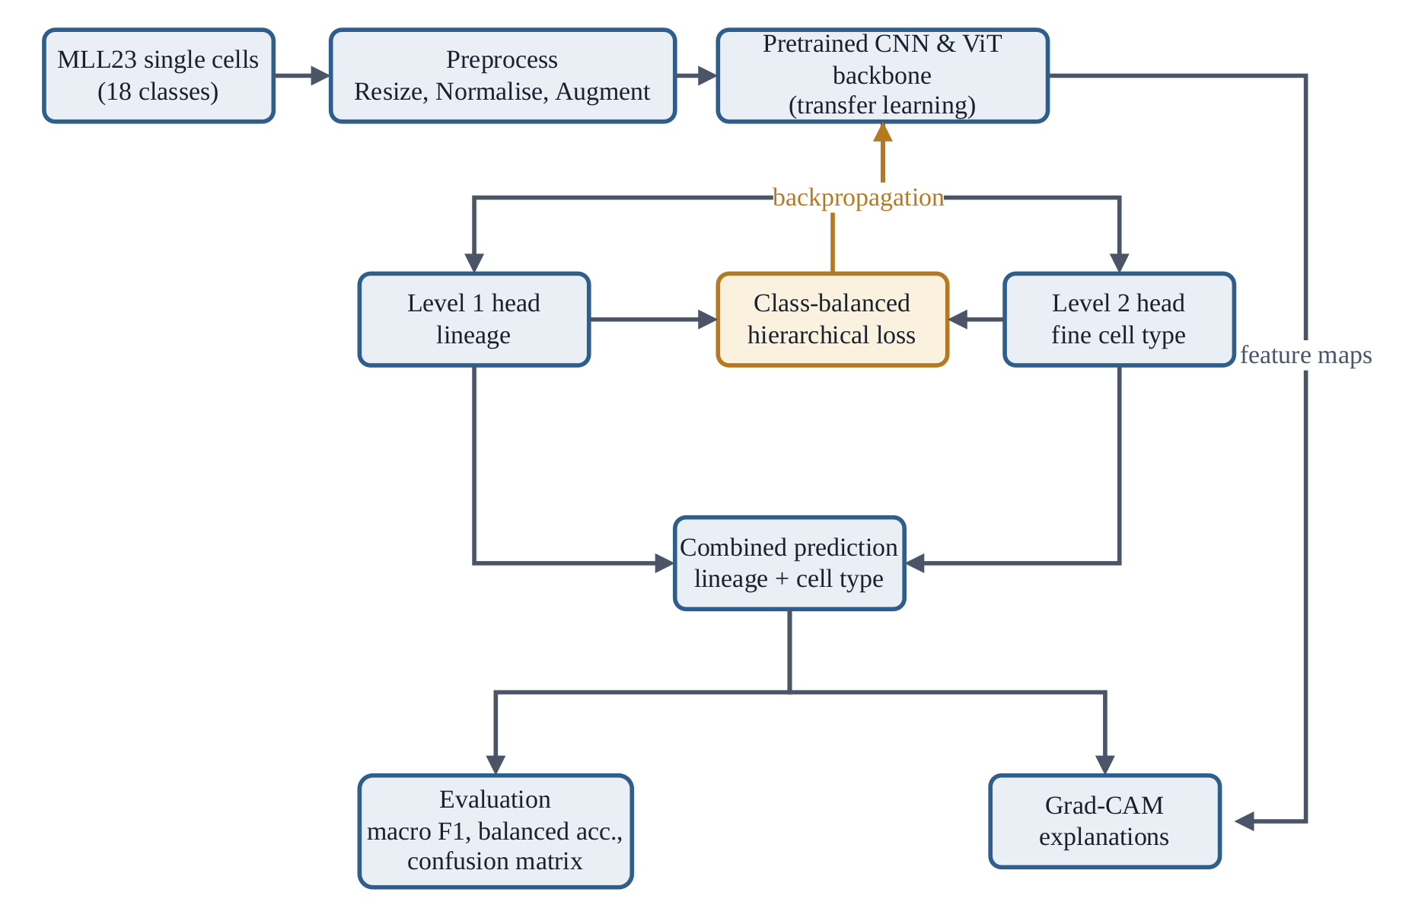
Figure 3.1 Architecture of the proposed system
Figure 3.1 shows the pipeline end to end. Images pass through a deterministic preprocessing stage into a pretrained backbone shared by two classification heads. A single composite loss backpropagates through both heads into the backbone. The trained model emits a combined lineage and cell-type prediction, and is evaluated with hierarchical error analysis and gradient-based saliency.

3.1 Data Collection and Preprocessing

3.1.1 Dataset and label hierarchy
The study uses the MLL23 peripheral blood single-cell dataset [1], distributed through Zenodo under DOI 10.5281/zenodo.14277609. It contains 41,621 Pappenheim-stained single nucleated-cell images at 288 by 288 pixels, each annotated by expert cytomorphologists into one of 18 classes. Archives are MD5-verified on download and realised per-class counts asserted against the data descriptor, since a truncated download or mis-mapped class directory would corrupt every downstream result while leaving a pipeline that still runs.
Each image carries a joint target consisting of a lineage label y1 in {0,1,2} and a fine cell-type label y2 in {0,...,17}. Because every fine class belongs to exactly one lineage, the levels are related by a fixed, non-learned surjection.
y1 = π(y2), π : {0,...,17} → {0,1,2} (3.1)
Equation (3.1) is the structural prior the study exploits. It is known biology, not something the model must discover. Fine-class indices are assigned lineage by lineage, and within the myeloid branch they follow the maturation continuum from myeloblast through promyelocyte, myelocyte, metamyelocyte and band neutrophil to segmented neutrophil. This ordering is preserved in the class indices and in every confusion-matrix axis, so biologically adjacent stages appear adjacent to the diagonal. Adjacent-stage confusion is the clinically expected error mode, and an alphabetical or frequency-sorted axis would scatter it across the plot.
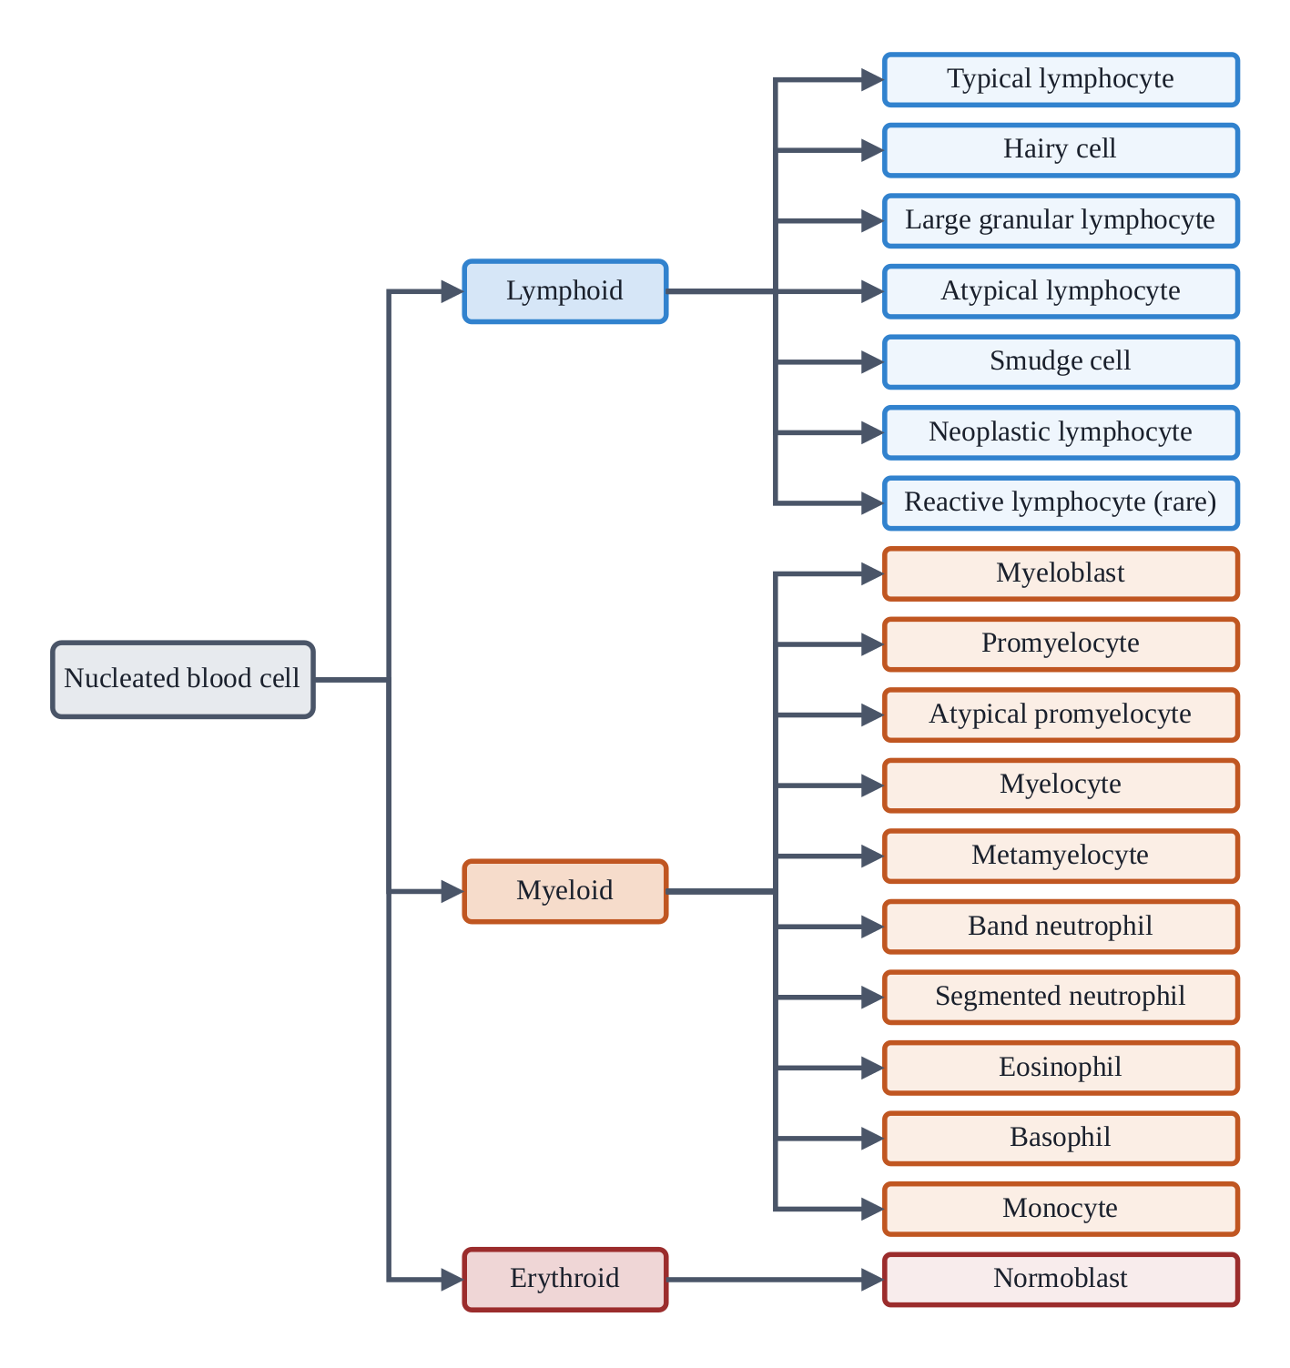
Figure 3.2 The two-level label hierarchy
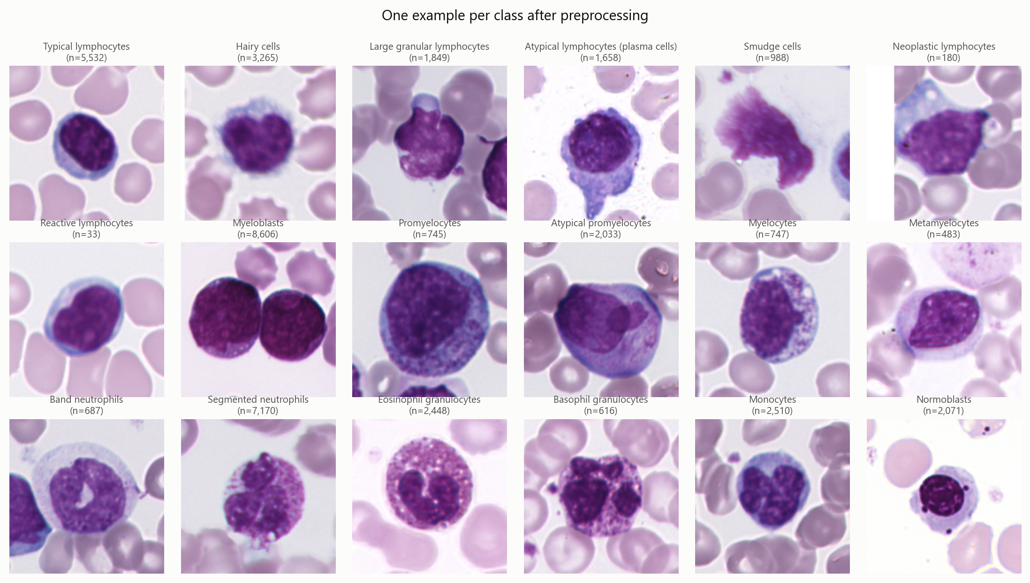
Figure 3.3 One representative image per class after preprocessing, with corpus counts
Figure 3.3 makes the difficulty visible directly: the myeloid maturation stages differ by gradual changes in nuclear shape, chromatin condensation and cytoplasmic granularity, and by no single categorical feature.

3.1.2 Class imbalance
Writing n_c for the number of images in class c, the imbalance ratio is the quotient of the largest and smallest class counts.
IR = max(n_c) / min(n_c) = 8,606 / 33 ≈ 261 (3.2)
Eight classes fall at or below a threshold of 1,000 images and are designated minority classes throughout. The threshold sits in a natural gap in the distribution, the next class above it holding 1,658 images, so it separates a real cluster instead of cutting one in half. This imbalance is the subject matter of the study, not an obstacle to be removed, and it is never resampled away. The training distribution is left intact and the imbalance is addressed in the objective function. Resampling would change the question being asked.
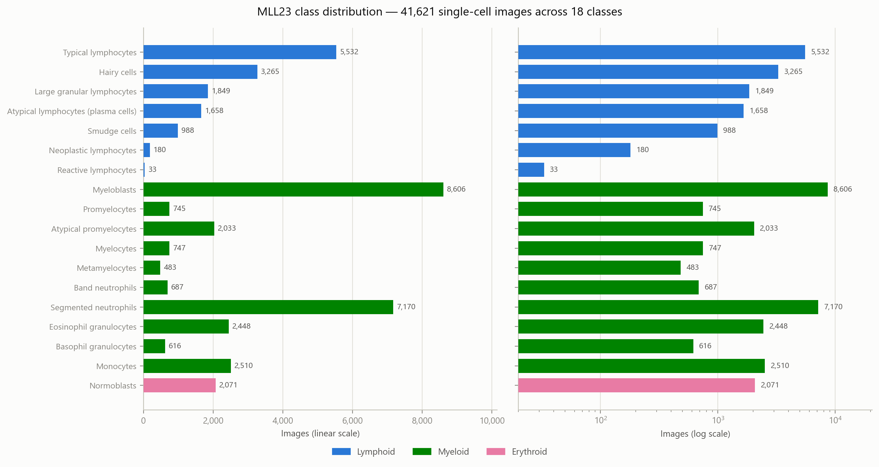
Figure 3.4 Class distribution on linear and logarithmic axes, coloured by lineage

3.1.3 Deterministic stratified partitioning
The corpus is partitioned once into training, validation and test sets in 70/15/15 proportion, stratified on the fine label. Stratifying on the fine label stratifies the lineage automatically by Equation (3.1). The partition is produced by two successive stratified draws under a fixed seed and then persisted to disk, so every arm, seed and backbone reads the same file and the split is identical by construction, not by convention. Table 3.1 gives the realised counts.
Three conditions are checked in code, not assumed: that no class is absent from any partition, that no image path occurs in more than one, and that realised fractions deviate from requested ones by less than one percentage point. The first matters because the rarest class holds only 33 images, leaving 23, 5 and 5 under a 70/15/15 split. An empty validation or test cell would make its recall undefined and silently distort the macro average.
Table 3.1 The 18 MLL23 classes, lineage membership and partition sizes. Minority classes (n ≤ 1,000) are marked †
y2 | Cell type | Lineage | Total | Train | Val | Test
0 | Typical lymphocytes | Lymphoid | 5,532 | 3,872 | 830 | 830
1 | Hairy cells | Lymphoid | 3,265 | 2,285 | 490 | 490
2 | Large granular lymphocytes | Lymphoid | 1,849 | 1,294 | 277 | 278
3 | Atypical lymphocytes (plasma cells) | Lymphoid | 1,658 | 1,161 | 249 | 248
4 | Smudge cells † | Lymphoid | 988 | 692 | 148 | 148
5 | Neoplastic lymphocytes † | Lymphoid | 180 | 126 | 27 | 27
6 | Reactive lymphocytes † | Lymphoid | 33 | 23 | 5 | 5
7 | Myeloblasts | Myeloid | 8,606 | 6,024 | 1,291 | 1,291
8 | Promyelocytes † | Myeloid | 745 | 521 | 112 | 112
9 | Atypical promyelocytes | Myeloid | 2,033 | 1,423 | 305 | 305
10 | Myelocytes † | Myeloid | 747 | 523 | 112 | 112
11 | Metamyelocytes † | Myeloid | 483 | 338 | 73 | 72
12 | Band neutrophils † | Myeloid | 687 | 481 | 103 | 103
13 | Segmented neutrophils | Myeloid | 7,170 | 5,019 | 1,075 | 1,076
14 | Eosinophil granulocytes | Myeloid | 2,448 | 1,714 | 367 | 367
15 | Basophil granulocytes † | Myeloid | 616 | 431 | 93 | 92
16 | Monocytes | Myeloid | 2,510 | 1,757 | 376 | 377
17 | Normoblasts | Erythroid | 2,071 | 1,450 | 310 | 311
 | Total |  | 41,621 | 29,134 | 6,243 | 6,244

3.1.4 Preprocessing and augmentation
Evaluation preprocessing is deterministic. An image is bilinearly resampled from 288 to 224 pixels, scaled to the unit interval, and standardised channel-wise using ImageNet statistics.
x̂ = (x/255 − μ) / σ, μ = (0.485, 0.456, 0.406), σ = (0.229, 0.224, 0.225) (3.3)
Two choices deserve comment. The input resolution is 224 by 224 for every backbone including the Vision Transformer, since holding resolution constant is what keeps the backbone comparison controlled. And ImageNet statistics are retained even though the corpus channel means are brighter in every channel, so the standardised data centres away from zero. This is intentional: pretrained backbones expect inputs standardised the way they were trained, and dataset-specific statistics would trade away part of the transfer benefit.
Training applies online augmentation before this deterministic pipeline. It is class-conditional, so the eight rarest types are presented in greater apparent variety without altering the sampling distribution: a strength multiplier of 2.0 applies to rotation range and jitter for minority classes and 1.0 otherwise, capped as in Table 3.2.
Table 3.2 Class-conditional augmentation parameters
Transform | Majority classes | Minority classes
Horizontal flip | p = 0.5 | p = 0.5
Vertical flip | p = 0.5 | p = 0.5
Random rotation | ±90° | ±180°
Brightness / contrast jitter | 0.1 | 0.2
RandAugment | 2 ops, magnitude 9 | 3 ops, magnitude 9

Rotation is label-preserving here in a way it is not for natural images, since a blood cell has no canonical orientation. It is performed at native resolution before the downsample, so the image is resampled once instead of twice, and the corners are filled with white to match the smear background. Figure 3.5 exposes a caveat: that fill applies to the explicit rotation only, whereas the automated policies perform their own geometric operations defaulting to black and can invert the stain palette outright. This is a recognised property of such policies, not a defect, since their regularising value derives from the severity of the perturbation, but it qualifies the justification above.
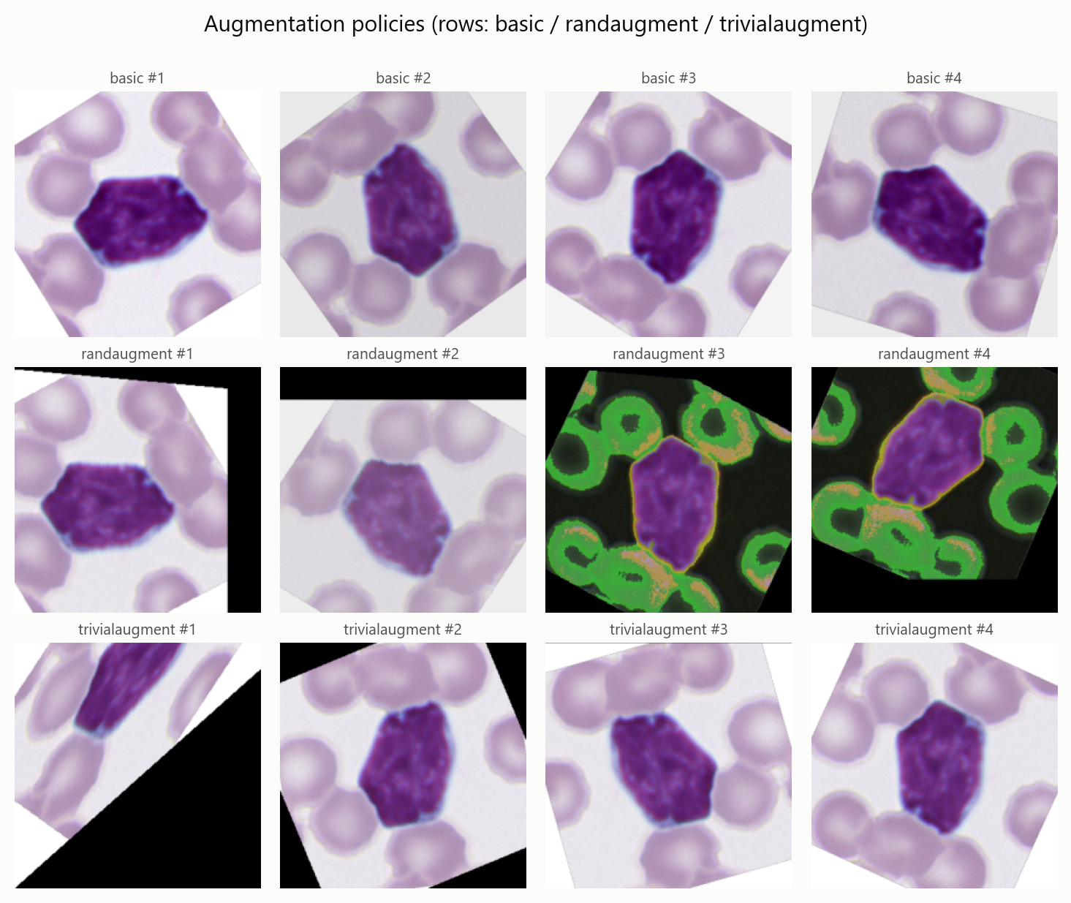
Figure 3.5 The three augmentation policies applied to one image, four draws each

3.1.5 Stain normalisation
Slide preparation and imaging introduce colour variation unrelated to cell identity. One experimental arm evaluates stain normalisation as an additional preprocessing stage using the method of Reinhard [33], in which the image is converted to the decorrelated Lab colour space and each channel matched to a reference by mean and standard deviation.
L′ = (L − mean(L)) × (σ_ref / σ) + mean(L_ref) (3.4)
Reinhard is preferred to Macenko [34] on cost grounds, being roughly twenty times cheaper; per-image stain-basis estimation would starve the accelerator and make that arm slower for reasons unrelated to the science. Critically, the reference statistics are fitted on the training split alone, since fitting on the full corpus would leak validation and test colour statistics into training.
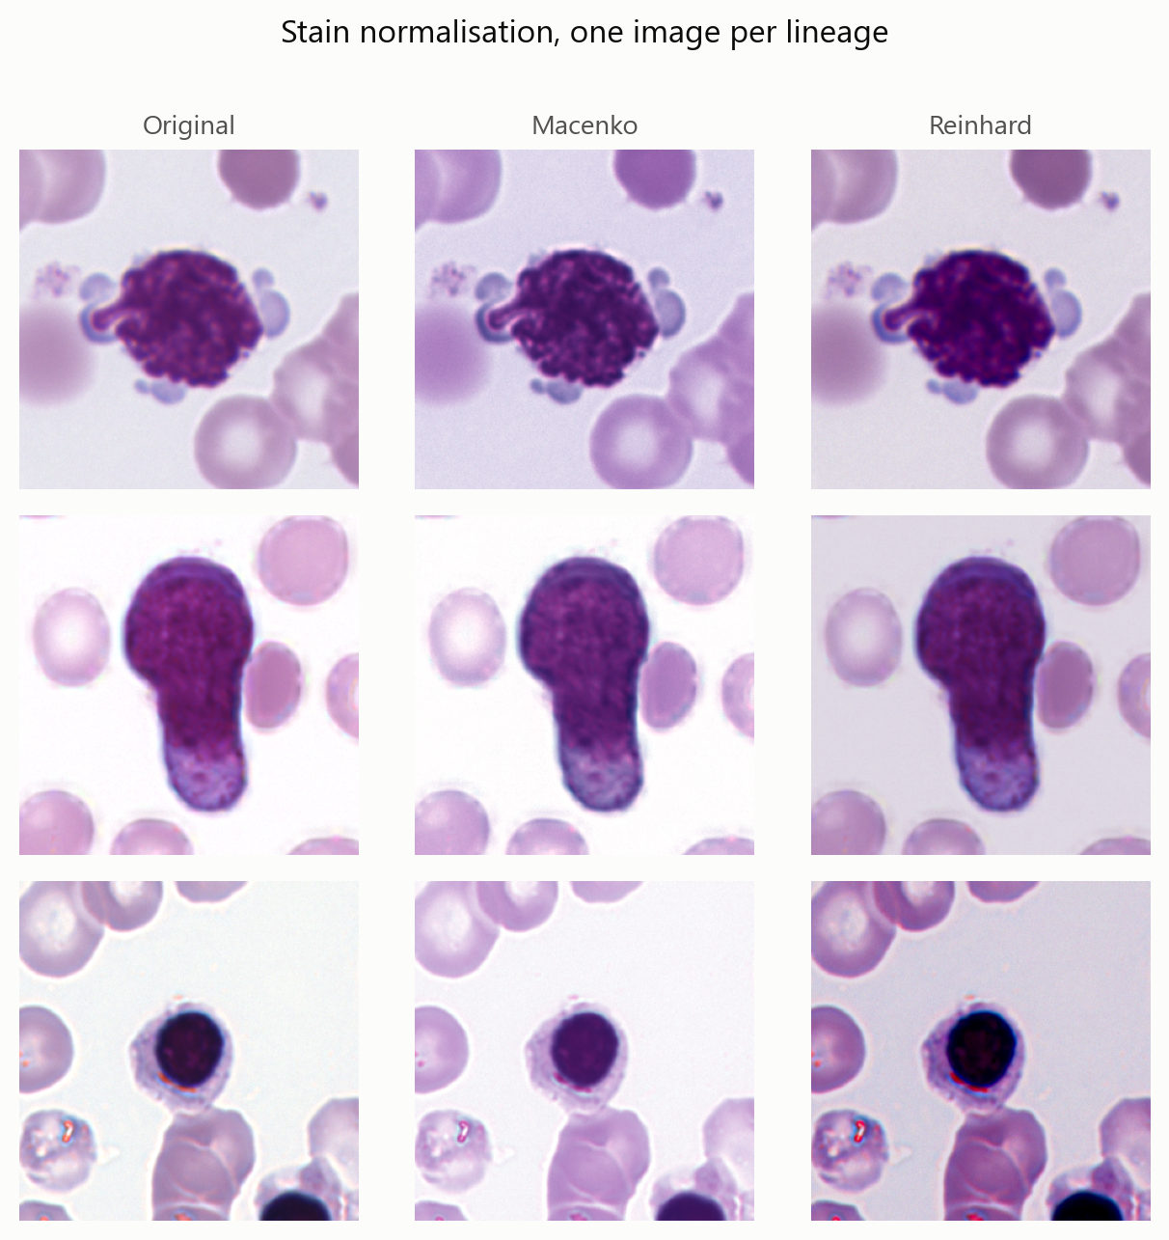
Figure 3.6 Stain normalisation, one image per lineage: original, Macenko, Reinhard

3.2 ML/AI Model Development

3.2.1 Shared backbone with two heads
The model is a pretrained backbone producing a pooled D-dimensional representation, followed by two linear heads emitting lineage logits u and fine logits v respectively.
z = Dropout(fθ(x̂)); u = W₁z + b₁ ∈ ℝ³; v = W₂z + b₂ ∈ ℝ¹⁸ (3.5)
The heads are trained jointly on the shared trunk, so the coarse decision regularises the fine one and rare types borrow representational strength from their lineage neighbours. A single class implements every arm: in flat mode the lineage head is never constructed, so it contributes neither parameters nor weight decay, an unused head having made the claim of an identical backbone quietly false. At inference the flat model's lineage prediction is derived from its fine prediction through Equation (3.1), which makes the hierarchical error decomposition computable for the baseline and hence comparable across arms.
An obvious alternative is a hard gate that predicts lineage first and routes the sample to one of three per-lineage subclassifiers. It was rejected on evidence. Exploratory analysis on frozen ImageNet features measured a lineage silhouette coefficient of approximately zero, so the lineages form no separable global clusters, while k-nearest-neighbour lineage agreement was 0.78 against a chance baseline of 0.45. The structure is real but local. A hard gate assumes global separability, which the data rejects, and every misfire would produce an unrecoverable cross-lineage error. The soft coupling adopted instead exploits the local structure without asserting the global one.
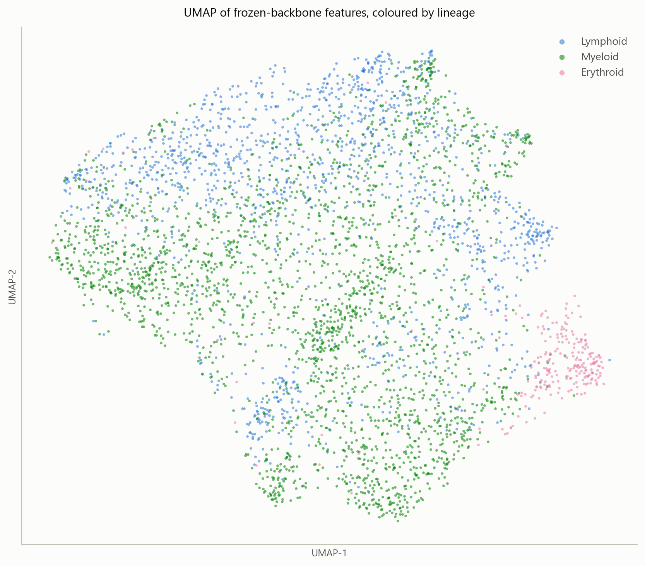
Figure 3.7 UMAP projection of frozen backbone features, coloured by lineage
Figure 3.7 is a two-dimensional projection computed on frozen features before fine-tuning, so it motivates the architectural choice without bounding what the trained model can represent.
Table 3.3 Candidate backbone architectures, all fine-tuned end to end at 224 by 224
Key | Architecture | Family
mobilenet | MobileNetV3-Large | Lightweight CNN
resnet | ResNet-50 | Residual CNN
convnext | ConvNeXt-Tiny | Modernised CNN
vit | ViT-Small/16 | Vision Transformer

3.2.2 The imbalance-robust hierarchical objective
The objective has three components. Two address imbalance and the third couples the label levels. Following Cui and colleagues [7], samples of the same class overlap in feature space, so the n-th sample contributes less new information than the first. The effective number of samples of a class is used to derive its weight, which is then normalised to unit mean.
w_c = (1 − β) / (1 − β^n_c), β = 0.9999 (3.6)
The normalisation to unit mean is essential to the ablation design: without it the weighted arm would train at a different effective learning rate, confounding reweighting with step size. The same construction is applied at the lineage level, which is itself imbalanced with myeloid accounting for roughly 63% of the corpus.
Class weighting addresses how many samples a class has, not how hard an individual sample is. The focal loss of Lin and colleagues [19] supplies the second factor, down-weighting confidently correct examples so the gradient is not dominated by the 8,606 myeloblasts.
L_focal(v, y) = (1 − p_y)^γ · CE(v, y; w), γ = 2 (3.7)
The modulating factor is computed from the unweighted posterior, since it should reflect how hard the sample is, not how rare its class is; the class weight already carries rarity and folding it into both factors would double-count it.
The term that makes the objective hierarchical instead of merely multi-task couples the two heads. Let M be the one-hot matrix of the map in Equation (3.1). Right-multiplying a fine posterior by M marginalises it into lineage space, since each fine class belongs to exactly one lineage. The consistency penalty is the Kullback-Leibler divergence between that marginalised belief and the lineage head's own posterior.
L_cons = KL( softmax(v)ᵀ M ‖ softmax(u) ) (3.8)
Without Equation (3.8) the heads are free to contradict each other, and the claim that the coarse decision regularises the fine one would have no mechanism behind it. Gradients flow into both heads, pulling them toward agreement instead of forcing one to chase the other. The three components combine into the total objective.
L = λ_lin · L_focal(u, y1) + λ_fine · L_focal(v, y2) + λ_cons · L_cons (3.9)
with weights 0.3, 1.0 and 0.1 respectively. The fine term is held at unity because it is the task being evaluated. The consistency weight is deliberately small: the empirical support is for local lineage structure, so consistency is applied as a nudge, not a constraint, and forcing it hard would impose a global structure the data does not exhibit. The two ablations are field values on one object instead of separate loss classes, which is what keeps the arms honest.
Table 3.4 Ablation switches implemented on the loss object
Switch | Effect | Purpose
use_hierarchy = False | λ_lin = λ_cons = 0 | Fine-level loss only; removes the hierarchy
use_imbalance = False | w ≡ 1, γ = 0, no smoothing | Plain cross-entropy; removes the imbalance treatment

Batch mixing is applied as a further regulariser. Because the dataset carries two label levels, the same mixing coefficient applies to both targets, so the coarse and fine losses see the same blend; independent mixes per level would let the objective disagree with itself about how much of each example is targets, which keeps the class-balanced weighting well defined.

3.3 Evaluation of the Proposed System
Plain accuracy is explicitly rejected as a headline number. At an imbalance ratio of 261 it cannot see the behaviour under study, since a classifier abandoning the rarest class entirely forfeits under 0.1% of accuracy. The headline metrics are macro F1 and balanced accuracy, which weight every class equally regardless of frequency.
macro-F1 = (1/C) Σ 2 P_c R_c / (P_c + R_c); balanced accuracy = (1/C) Σ R_c (3.10)
Accuracy, macro precision, macro recall and the full confusion matrix are also reported. Where a rare class receives no predictions its score is recorded as zero, not left undefined, since a missing value would propagate into the macro average. A minority-class view reports the same quantities restricted to samples whose true class is one of the eight minority classes; it is recall-oriented by construction and is labelled as such instead of being presented as an overall score.
Beyond these, every prediction is assigned to exactly one of three outcomes, using Equation (3.1) to derive lineages from fine labels: correct; a within-lineage error, where the fine class is wrong but the lineage right; or a cross-lineage error. The diagnostic of interest is the share of errors that remained inside the correct lineage.
within-error share = #{within-lineage errors} / #{errors} (3.11)
Equation (3.11) is the direct test of this study's thesis. A lineage-aware model should shift errors from cross-lineage to within-lineage even where total error is unchanged, and the two are not clinically equivalent. No scalar accuracy measure expresses this distinction, and no reviewed study reports it.
Saliency is assessed with Grad-CAM [9], which weights the activation maps of a chosen layer by the spatially pooled gradient of the target logit and rectifies the result. Applying this to a Vision Transformer requires care, since the classifier reads only the class token and patch gradients at the final block are exactly zero. Saliency is computed instead at the input to the final block's attention, where patch tokens still route into the class token.

3.4 Experimental Design and Statistical Protocol
Five experiments are required under identical partitions and backbones. They reduce to four distinct configurations, because the hierarchy ablation applied to the proposed model is the flat baseline: removing the lineage head and its loss terms leaves a single-head classifier. That configuration is trained once and reported twice, since training it under two names would consume a fifth of the compute budget to produce two draws from the same distribution and invite the reader to mistake them for independent evidence.
Table 3.5 The four distinct configurations and the five reported experiments
Arm | Mode | Hierarchy | Imbalance | Stain | Reported as
flat_baseline | flat | — | yes | — | 1. Flat baseline; 4. Hierarchy ablation
hierarchical | hier | yes | yes | — | 2. Full hierarchical model (proposed)
no_imbalance | hier | yes | — | — | 3. Imbalance ablation
stain_norm | hier | yes | yes | yes | 5. Stain-normalised input

The work proceeds in two phases. Phase 1 screens the four backbones of Table 3.3 under the hierarchical configuration for a short fixed budget at one seed, selecting the backbone carried into Phase 2 on validation macro F1. This is a selection run and not the backbone comparison result, since a short budget need not rank backbones the way a full run would. Phase 2 trains the four configurations at three seeds each on the selected backbone, giving twelve runs.
Because the design uses one fixed partition instead of k folds, paired samples are obtained by retraining each arm at three seeds on that fixed partition and pairing arms by seed. This keeps the split identical across arms, which the ablation design depends on, at the cost of measuring variation between training runs, not between datasets.
t = mean(d) / (s_d / √n); Cohen's d_z = mean(d) / s_d (3.12)
Effect sizes are reported alongside p-values throughout. With three seeds the test carries two degrees of freedom, which is thin, and reporting the effect size and the per-seed values prevents the reader from being asked to lean on the p-value alone.
Determinism is enforced at three points: the partition is seeded and persisted, each run seeds Python, NumPy and Torch from its configuration, and every configuration is written to the results file alongside its metrics so a recorded run can be reconstructed exactly. Correctness is enforced by assertion instead of inspection, with the class hierarchy validating its own invariants at import and the partition checked for empty cells, duplicates and proportion drift.

Chapter 4 Experimental Results
This chapter reports the experimental setup, restates the properties of the dataset relevant to interpreting the results, presents the quantitative findings of the four experimental arms, analyses them at the level of individual classes, and compares the proposed system against the flat baseline and against reported results from the literature. Findings that did not support the hypothesis are reported alongside those that did.

4.1 Experimental Setup
All experiments were conducted on a single workstation with an NVIDIA RTX 4070 Laptop GPU providing 8 GB of video memory, running Windows 11. The implementation uses PyTorch with the timm library supplying ImageNet-pretrained backbones, scikit-learn for metrics and partitioning, and NumPy and pandas for data handling. The complete Phase 2 matrix of twelve runs consumed approximately 24.2 GPU-hours.
Two implementation decisions materially affected the results and are recorded here instead of in the methodology, because both were found by experiment, not chosen in advance. First, mixed-precision training uses bfloat16 in place of float16. An initial float16 run reached a validation macro F1 of 0.80 and then diverged to a non-finite loss at the third epoch, wasting the remainder of the run since such weights never recover. The bfloat16 format retains the exponent range of float32 and cannot overflow in the same way. Gradient scaling is correspondingly disabled, and the loss is computed in float32 regardless of autocast context, because the class-balanced weights span a wide range and the focal term exponentiates a log-probability.
Second, profiling established that the pipeline was limited by data loading, not by computation. Decoding source images sustained 178 images per second at four dataloader workers and fell to 119 at eight through worker contention, against a full training step of 82 images per second. Caching decoded images at native resolution raised throughput to approximately 850 images per second, without which the twelve-run matrix would not have been feasible. The observation is recorded because it inverts the usual assumption that backbone choice dominates training cost; here it barely moved wall-clock time at all.
The backbone screen of Phase 1 evaluated MobileNetV3-Large, ResNet-50, ConvNeXt-Tiny and ViT-Small/16 under the hierarchical configuration for a short fixed budget at a single seed. ViT-Small/16 achieved the highest validation macro F1 at 0.849 and was carried into Phase 2. As stated in Chapter 3, this is a selection result and not a backbone comparison: the budget was too short to rank architectures reliably, and the margin over ConvNeXt-Tiny was narrow.
Table 4.1 Training hyperparameters, held identical across all arms
Parameter | Value
Backbone | ViT-Small/16, ImageNet-pretrained, fully fine-tuned
Input resolution | 224 x 224 for every backbone
Optimiser | AdamW
Learning rate | 3 x 10^-4
Weight decay | 0.05
Batch size | 64
Epochs | 30, fixed; no early stopping
Warmup | 1 epoch, linear
Schedule | Cosine annealing
Label smoothing | 0.05
Focal gamma | 2.0
Class-balanced beta | 0.9999
Loss weights | lambda_lin 0.3, lambda_fine 1.0, lambda_cons 0.1
Augmentation | RandAugment, class-conditional
Batch mixing | CutMix, p = 0.5, alpha = 1.0
Weight EMA decay | 0.999
Test-time augmentation | 4 flip views
Mixed precision | bfloat16
Model selection | Validation macro F1
Seeds | 0, 1, 2

4.2 Dataset Description
The MLL23 corpus [1] provides 41,621 Pappenheim-stained single nucleated-cell images at 288 by 288 pixels, annotated by expert cytomorphologists into 18 classes across three haematopoietic lineages. The full class listing with partition sizes is given in Table 3.1. Four properties govern the interpretation of every result that follows.
The distribution is severely long-tailed, with an imbalance ratio of 261 between myeloblasts at 8,606 images and reactive lymphocytes at 33. After the 70/15/15 partition the rarest class contributes 23 training images, 5 validation images and 5 test images. Per-class metrics for that class are consequently unstable across seeds, and this is reported openly instead of being buried in the macro average.
The lineages are unequal in size, myeloid accounting for approximately 63% of the corpus, lymphoid for 32% and erythroid for 5%. The lineage task is both imbalanced and, as the results show, easy, which turns out to be central to interpreting the hierarchical result.
The rare classes are not distributed evenly across lineages. Of the eight minority classes, five are myeloid maturation stages and two are rare lymphoid types. This asymmetry matters because the two groups stand in different relations to their lineage neighbours, and Section 4.3.5 shows that the proposed architecture treats them very differently.
The test partition contains 6,244 images, of which 671 belong to the eight minority classes. All minority-class aggregates reported below are computed over those 671 samples, which is a small enough basis that differences of less than approximately 0.01 in minority macro F1 should not be over-interpreted.

4.3 Results
Table 4.2 reports test-set performance for the four distinct configurations, each averaged over three seeds with the standard deviation across seeds. The proposed hierarchical model achieves the highest macro F1, minority macro F1, minority recall and balanced accuracy of the four.
Table 4.2 Test-set performance by experimental arm, mean ± standard deviation across three seeds
Arm | Accuracy | Macro F1 | Balanced acc. | Minority F1 | Minority recall
Hierarchical (proposed) | 0.9567 | 0.8792 ± 0.0028 | 0.8936 | 0.8400 ± 0.0073 | 0.7987
Flat baseline | 0.9565 | 0.8742 ± 0.0060 | 0.8832 | 0.8233 ± 0.0140 | 0.7761
No imbalance term | 0.9602 | 0.8733 ± 0.0093 | 0.8620 | 0.7799 ± 0.0271 | 0.7226
Stain-normalised | 0.9546 | 0.8714 ± 0.0031 | 0.8832 | 0.8206 ± 0.0189 | 0.7753

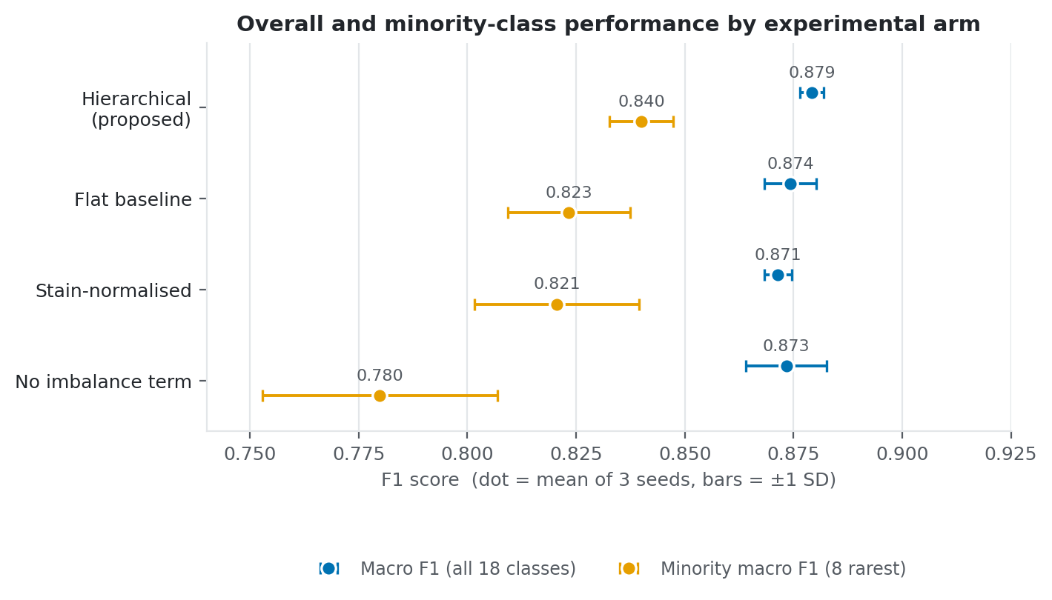
Figure 4.1 Overall and minority-class F1 by arm. Each dot is the mean of three seeds and the bars span one standard deviation. The four arms sit almost on top of one another on overall macro F1 but spread widely on the rare classes.
Figure 4.1 shows why the two columns must be read together. On overall macro F1 the four arms are separated by 0.008 in total, a spread so narrow that the error bars overlap everywhere. On the minority classes the same four arms spread across 0.060, and the ordering changes. Whatever these experiments are measuring, it is not visible in the aggregate number.

4.3.1 Accuracy is the wrong metric, demonstrated directly
The single most instructive row of Table 4.2 is the imbalance ablation. Removing the class-balanced and focal terms produced the highest overall accuracy of any arm, at 0.9602, while simultaneously producing the lowest minority macro F1 at 0.7799 and the lowest minority recall at 0.7226. The arm that looks best on the conventional headline metric is the worst on the classes the study exists to examine.
This is not a coincidence but the predicted arithmetic consequence of the imbalance. An objective that is not class-balanced allocates capacity in proportion to class frequency, which maximises the probability of a correct prediction on a randomly drawn test image. Since approximately 89% of the test partition belongs to the ten majority classes, improving those at the expense of the tail is the accuracy-optimal strategy, and an optimiser given a symmetric objective will find it.
The finding provides direct empirical support for the methodological argument of Chapter 2, that reporting accuracy on clinically representative data conceals the behaviour of interest, and it does so from within one controlled experiment instead of an appeal to principle. Two models differing only in their loss function are separated by 0.0035 in accuracy, in favour of the weaker one, and by 0.060 in minority macro F1, in favour of the stronger. A reader given only the accuracy column would draw precisely the wrong conclusion about which system to deploy. Since accuracy remains the dominant reported metric in the literature reviewed in Chapter 2, this is not a hypothetical concern.

4.3.2 The imbalance objective is the load-bearing component
Comparing the proposed model against the imbalance ablation isolates the contribution of the class-balanced and focal terms, since the two arms are identical in every other respect including the hierarchy. The differences are large and, unusually for a three-seed design, statistically supported.
Table 4.3 Paired comparisons across three seeds. Differences are stated for the first-named arm relative to the second
Comparison | Metric | Difference | t | p | Cohen's d_z
Hier. vs no-imbalance | Minority recall | +0.0760 | 6.36 | 0.024 | 3.67
Hier. vs no-imbalance | Balanced accuracy | +0.0316 | 5.84 | 0.028 | 3.37
Hier. vs no-imbalance | Minority macro F1 | +0.0601 | 4.21 | 0.052 | 2.43
Hier. vs no-imbalance | Macro F1 | +0.0059 | 0.97 | 0.436 | 0.56
Hier. vs flat | Cross-lineage error | -0.0004 | -7.00 | 0.020 | -4.04
Hier. vs flat | Balanced accuracy | +0.0103 | 1.87 | 0.202 | 1.08
Hier. vs flat | Minority recall | +0.0226 | 1.80 | 0.214 | 1.04
Hier. vs flat | Minority macro F1 | +0.0167 | 1.45 | 0.285 | 0.84
Hier. vs flat | Macro F1 | +0.0050 | 1.00 | 0.424 | 0.57
Stain vs hier. | Macro F1 | -0.0078 | -2.29 | 0.149 | -1.32
Stain vs hier. | Minority macro F1 | -0.0194 | -1.71 | 0.229 | -0.99
Stain vs hier. | Cross-lineage error | +0.0012 | 3.62 | 0.069 | 2.09

Removing the imbalance treatment costs 0.076 in minority recall (p = 0.024) and 0.032 in balanced accuracy (p = 0.028), with effect sizes above three standard deviations of the paired difference. Minority macro F1 falls by 0.060 at p = 0.052, marginally outside conventional significance but with a very large effect size of 2.43. Macro F1 over all eighteen classes, by contrast, moves by only 0.006 and is not significant, because the ten non-minority classes dominate that average and are largely unaffected.
The pattern is coherent. The class-balanced and focal terms operate almost exclusively on the tail, leaving the head of the distribution unchanged, which is exactly what they are designed to do. Their contribution to the rare classes is an order of magnitude larger than the contribution of the hierarchy discussed below. On the evidence of this experiment, the imbalance-robust objective is the load-bearing component of the proposed design, and a practitioner forced to adopt only one of the two mechanisms should adopt this one.

4.3.3 The hierarchy operates through the predicted mechanism
The proposed model outperforms the flat baseline on every metric in Table 4.2, and by more on the rare classes, at +0.017 minority macro F1, than on the corpus as a whole, at +0.005 macro F1. That ordering is the pattern the design predicted, and it should be stressed that the prediction was directional and specific, not a general hope of improvement. None of these aggregate differences, however, reaches statistical significance at three seeds. Minority recall improves by 0.023 with p = 0.214, and balanced accuracy by 0.010 with p = 0.202. The effect sizes, at d_z above 1.0, are large; the sample of runs is too small to resolve them.
One comparison does reach significance, and it is the one the theoretical argument identified in advance as the direct test. The hierarchical model reduces cross-lineage error, the clinically severe category, from 0.0119 to 0.0115, a difference of only 0.0004 in absolute terms but one that held in the same direction across all three seeds, giving t = -7.00, p = 0.020 and d_z = -4.04. Correspondingly, the share of errors that remained within the correct lineage rose from 0.726 to 0.733.
Table 4.4 Hierarchical decomposition of prediction outcomes on the test partition
Arm | Correct | Within-lineage error | Cross-lineage error | Within-error share | Lineage accuracy
Hierarchical | 0.9567 | 0.0318 | 0.0115 | 0.7333 | 0.9885
Flat baseline | 0.9565 | 0.0316 | 0.0119 | 0.7261 | 0.9881
No imbalance term | 0.9602 | 0.0294 | 0.0104 | 0.7396 | 0.9896
Stain-normalised | 0.9546 | 0.0327 | 0.0127 | 0.7200 | 0.9873

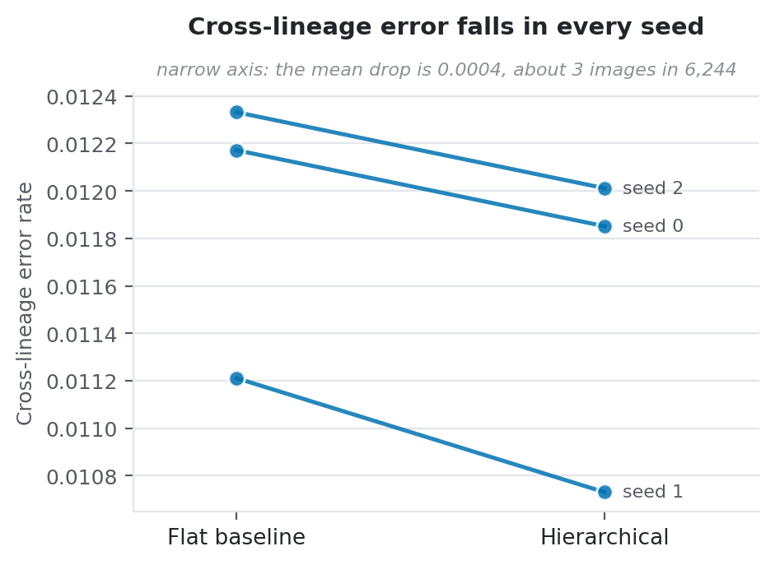
Figure 4.2 Cross-lineage error for each seed, flat baseline against the proposed model. All three seeds move the same way, which is what produces a low p-value from a very small difference.
The interpretation requires care in both directions. The consistent sign across seeds indicates a real effect and supports the mechanism the architecture was built to exploit: coupling the fine head to a lineage posterior does shift errors toward the clinically milder kind. But the magnitude is very small. A reduction of 0.0004 in cross-lineage error corresponds to approximately two or three images in a test partition of 6,244. A statistically significant result of this size should be described as a reliably detected small effect, not as a clinically important improvement, and the low p-value reflects the consistency of the difference across seeds, not its size. Reporting it otherwise would be a misuse of the significance test.
The comparison also illustrates why the hierarchical decomposition of Equation (3.11) was worth computing. Total accuracy for the two arms is identical to three decimal places, at 0.9567 against 0.9565, and total error is likewise unchanged. Judged on accuracy alone the hierarchy would appear to do nothing whatsoever. The decomposition shows that it redistributes errors between categories of differing clinical severity while leaving their total count essentially unchanged, which is exactly the behaviour a scalar metric cannot express. As noted in Chapter 2, no reviewed study reports this decomposition, which means that comparable effects in existing systems would have been invisible to their authors.
An apparent anomaly in Table 4.4 deserves comment. The imbalance ablation records both the lowest cross-lineage error, at 0.0104, and the highest lineage accuracy, at 0.9896, despite being the weakest arm on every minority metric. This is not a contradiction. Cross-lineage error is computed over all test samples, so it is dominated by the majority classes, on which that arm concentrates its capacity. A model that serves the head of the distribution well and abandons the tail will produce few lineage-level errors in aggregate because the abandoned classes are rare. The measure is most informative when comparing arms of similar minority performance, as with the hierarchical and flat pair, but should not be read across arms with very different tail behaviour.

4.3.4 Why the hierarchical effect is small
Diagnostic logging supplies a direct explanation for the modest size of the hierarchical contribution. Lineage accuracy reaches 98.9% (Table 4.4), and by the end of training both auxiliary loss terms have collapsed to approximately 0.0007. The lineage task is essentially solved early in training, after which the auxiliary head contributes almost no gradient to the shared trunk.
This is a finding about the design, not a tuning problem, and the distinction matters for what follows from it. Adjusting the loss weight would not help: multiplying a gradient of approximately zero by a larger coefficient yields a gradient of approximately zero. The auxiliary task regularises an axis the model has already mastered, so it cannot continue to shape the representation during the period when the hard discriminations are being learned.
The hard problem is discrimination within a lineage, between myeloid maturation stages and among the rare lymphoid types, and lineage supervision provides no signal whatever about those distinctions by construction, since every confusable pair shares a lineage label. A myelocyte and a metamyelocyte are both myeloid; the auxiliary head is indifferent between them, and correctly so. The architecture supplies extra supervision on the one axis that needed it least.
The result is consistent with the exploratory analysis reported in Chapter 3. Frozen-feature analysis found k-nearest-neighbour agreement of 0.78 for lineage against 0.42 for fine cell type: the coarse level was already substantially recoverable from a generic ImageNet representation before any fine-tuning, whereas the fine level was not. An auxiliary task defined on the coarse level had limited headroom from the outset, and in hindsight the exploratory measurement predicted the size of the effect that was subsequently observed. The implication for future work, developed in Chapter 5, is that the auxiliary signal should target maturation stage within the myeloid branch, where the residual confusion demonstrably resides.

4.3.5 Per-class analysis: where the hierarchy actually helps
The aggregate metrics of Table 4.2 average over eighteen classes of widely differing frequency and difficulty, and in doing so they conceal the structure of the effect. Table 4.5 reports per-class test F1 for each arm, averaged over the three seeds, together with the difference between the proposed model and each of its two comparators.
Table 4.5 Per-class test F1 by arm, averaged over three seeds. Minority classes marked †. Rows follow class-index order, so adjacent myeloid rows are adjacent maturation stages
Cell type | Test n | Hier. | Flat | No imb. | Stain | Hier. − Flat | Hier. − No imb.
Typical lymphocytes | 830 | 0.937 | 0.934 | 0.942 | 0.934 | +0.003 | -0.005
Hairy cells | 490 | 0.982 | 0.984 | 0.986 | 0.984 | -0.002 | -0.005
Large granular lymphocytes | 278 | 0.919 | 0.918 | 0.927 | 0.920 | +0.000 | -0.008
Atypical lymphocytes (plasma) | 248 | 0.995 | 0.995 | 0.996 | 0.994 | +0.000 | -0.001
Smudge cells † | 148 | 0.960 | 0.964 | 0.962 | 0.959 | -0.004 | -0.002
Neoplastic lymphocytes † | 27 | 0.739 | 0.689 | 0.604 | 0.680 | +0.050 | +0.136
Reactive lymphocytes † | 5 | 0.430 | 0.360 | 0.370 | 0.407 | +0.070 | +0.060
Myeloblasts | 1291 | 0.986 | 0.985 | 0.989 | 0.983 | +0.001 | -0.003
Promyelocytes † | 112 | 0.840 | 0.853 | 0.856 | 0.849 | -0.013 | -0.016
Atypical promyelocytes | 305 | 0.988 | 0.988 | 0.990 | 0.985 | +0.000 | -0.002
Myelocytes † | 112 | 0.740 | 0.755 | 0.760 | 0.711 | -0.015 | -0.021
Metamyelocytes † | 72 | 0.677 | 0.676 | 0.705 | 0.661 | +0.001 | -0.028
Band neutrophils † | 103 | 0.754 | 0.760 | 0.747 | 0.744 | -0.006 | +0.007
Segmented neutrophils | 1076 | 0.984 | 0.984 | 0.984 | 0.984 | -0.000 | +0.000
Eosinophil granulocytes | 367 | 0.991 | 0.990 | 0.993 | 0.990 | +0.000 | -0.002
Basophil granulocytes † | 92 | 0.982 | 0.982 | 0.983 | 0.976 | +0.000 | -0.002
Monocytes | 377 | 0.940 | 0.939 | 0.938 | 0.936 | +0.000 | +0.001
Normoblasts | 311 | 0.983 | 0.981 | 0.986 | 0.987 | +0.002 | -0.004

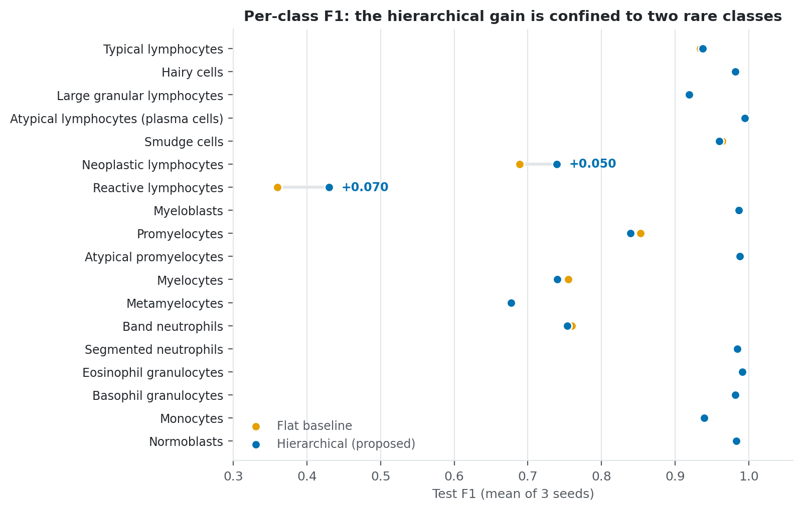
Figure 4.3 Per-class F1 for the proposed model against the flat baseline. Where the two dots sit on top of each other the arms agree; only two classes show a visible gap.
The first observation is that the hierarchical advantage is not diffuse. Of eighteen classes, fifteen show a difference against the flat baseline of 0.006 or less in absolute terms, which is within seed-to-seed noise. The aggregate improvement is carried almost entirely by two classes: reactive lymphocytes, which gain 0.070, and neoplastic lymphocytes, which gain 0.050. These are the two rarest lymphoid types in the corpus, with 33 and 180 images respectively.
This is the pattern the theoretical argument predicts, and it is a considerably more specific confirmation than the aggregate metrics provide. The mechanism claimed for hierarchical coupling is that rare classes borrow representational strength from abundant neighbours sharing their lineage. Reactive and neoplastic lymphocytes sit in a lineage that also contains typical lymphocytes at 5,532 images and hairy cells at 3,265. There is a great deal of same-lineage evidence for them to borrow from, and the coupling lets them do so. The effect appears exactly where the mechanism says it should, and is absent where the mechanism offers no reason to expect it.
The second observation is the mirror image of the first. The hierarchy confers no measurable benefit on the myeloid maturation stages: across the six classes of the neutrophil chain the mean difference against the flat baseline is -0.005, against a typical seed-to-seed standard deviation of 0.011, so the chain as a whole is unchanged within noise. The largest individual movements, myelocytes at -0.015 and promyelocytes at -0.013, are of the same order as their own seed variation and no claim of harm is made on that evidence. What can be said is that the gain observed on the rare lymphoid types is entirely absent here, and the reason is structural: these are classes whose confusable neighbours share their lineage label, so lineage supervision cannot discriminate among them even in principle.
The net effect is positive, which is why the aggregate favours the proposed model, but describing it as a uniform improvement would misrepresent the evidence. It is a redistribution, and the redistribution follows the structure of the taxonomy in a way that is predictable in advance, not accidental.
The third observation concerns the imbalance ablation, whose per-class profile is a still starker trade. Neoplastic lymphocytes lose 0.136 and reactive lymphocytes 0.060 when the class-balanced and focal terms are removed, which is the expected direction and a very large effect. But several mid-frequency classes improve without those terms: metamyelocytes gain 0.028, myelocytes 0.021 and promyelocytes 0.016. Class-balanced weighting redistributes capacity toward the extreme tail, and it takes that capacity from classes that are themselves uncommon but not rare enough to be protected. Three of the classes that lose ground are formally minority classes under the threshold adopted here, which shows the threshold is a simplification of a continuum, not a natural boundary.
The fourth observation concerns absolute difficulty, and it is independent of arm. The five worst classes under every configuration are reactive lymphocytes at 0.43, metamyelocytes at 0.68, neoplastic lymphocytes at 0.74, myelocytes at 0.74 and band neutrophils at 0.75. Two of these are rare lymphoid types; three are consecutive stages of neutrophil maturation. Rarity alone does not explain the pattern, since basophil granulocytes at 92 test images reach 0.982 and smudge cells at 148 reach 0.960, both comparable in frequency to the failing myeloid stages. What distinguishes the failing classes is that they have close morphological neighbours, whereas basophils are visually distinctive. Difficulty here is driven by morphological adjacency at least as much as by sample count, which is consistent with the argument advanced in Chapter 2 and is the strongest available justification for targeting the maturation axis in future work.
Reactive lymphocytes warrant separate comment. At an F1 of approximately 0.43 across arms, the class is not usefully classified by any configuration tested. With 5 test images, a single prediction changes its recall by 0.2, so the seed-to-seed variance is necessarily large and no conclusion about the relative merits of the arms on that class alone would be safe. It is reported because omitting it would flatter the results, and because it establishes a floor: for a class with 23 training examples, neither the hierarchy nor the class-balanced objective as implemented here is sufficient.

4.3.6 Errors follow the maturation continuum
The per-class results raise a question they cannot answer. Three of the five weakest classes are consecutive stages of neutrophil maturation, so it is worth asking what those classes are actually being confused with. Pooling the predictions of all three hierarchical seeds gives 18,732 test predictions and 811 errors, of which 305 fall between two classes that both belong to the maturation chain. Each of those errors can be scored by how many developmental stages separate the true class from the predicted one.
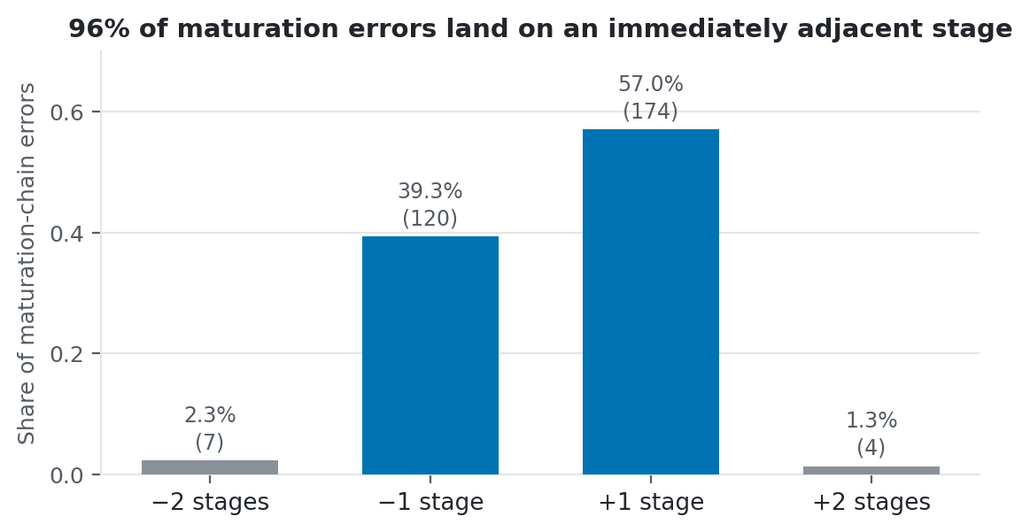
Figure 4.4 How far along the maturation chain each error lands. Almost every mistake is a single stage in one direction or the other, and none is more than two.
Figure 4.4 gives an unusually clean answer. Of the 305 errors inside the chain, 294, or 96.4%, are off by exactly one stage. Not one is off by more than two. The individual classes behave the same way: promyelocytes are called myelocytes in 88% of their errors, metamyelocytes go to band neutrophils or myelocytes in 100% of theirs, and segmented neutrophils are called band neutrophils in 81%. These are neighbours on the developmental path, and the model is landing next door, not guessing at random.
Counted against every error the model makes, adjacent-stage confusions come to 294 of 811, or 36%. Over a third of all mistakes are the mildest kind available, and the training objective treats each of them as exactly as costly as calling a lymphocyte a myeloblast. Nothing in the loss, and nothing in macro F1, knows that these six classes lie in an order. Chapter 5 returns to this, because it is the clearest opening the results leave for further work.
Myeloblasts are the exception that confirms the reading. Their errors do not travel along the chain at all: 47% go to typical lymphocytes and 22% to monocytes, both outside the myeloid lineage. A blast is not visually adjacent to a promyelocyte in the way a metamyelocyte is adjacent to a band neutrophil, and distinguishing blasts from lymphocytes is a different and clinically graver problem that ordinal reasoning would not touch.

4.3.7 Stain normalisation did not help
The stain-normalised arm underperformed the proposed model on every metric in Table 4.2, with macro F1 lower by 0.008 and minority macro F1 lower by 0.019. Neither difference is significant at three seeds, at p = 0.149 and p = 0.229, but the direction was consistent across seeds and cross-lineage error was higher at p = 0.069. The per-class view in Table 4.5 shows the loss concentrated on myelocytes, which fall from 0.740 to 0.711, and on neoplastic lymphocytes. The hypothesis that removing colour variation would aid classification is not supported here, and the balance of evidence mildly favours the opposite.
Two explanations are plausible and the experiment does not distinguish them. Colour may carry genuine diagnostic signal in Pappenheim-stained material, since stain uptake reflects nucleic acid and protein content, so normalising it away would throw away information, not noise. This would explain why the loss falls on classes distinguished partly by cytoplasmic staining character. Alternatively, MLL23 originates from a single laboratory with consistent preparation protocols, so there may be little inter-site variation for normalisation to correct, leaving only its cost in discarded signal.
The second explanation implies the arm might behave quite differently on multi-site data, where the variation stain normalisation exists to remove is actually present. The finding should not be generalised beyond the single-source setting tested, and it constitutes an argument for the cross-site evaluation proposed in Chapter 5, not a verdict on the technique.

4.3.8 Saliency
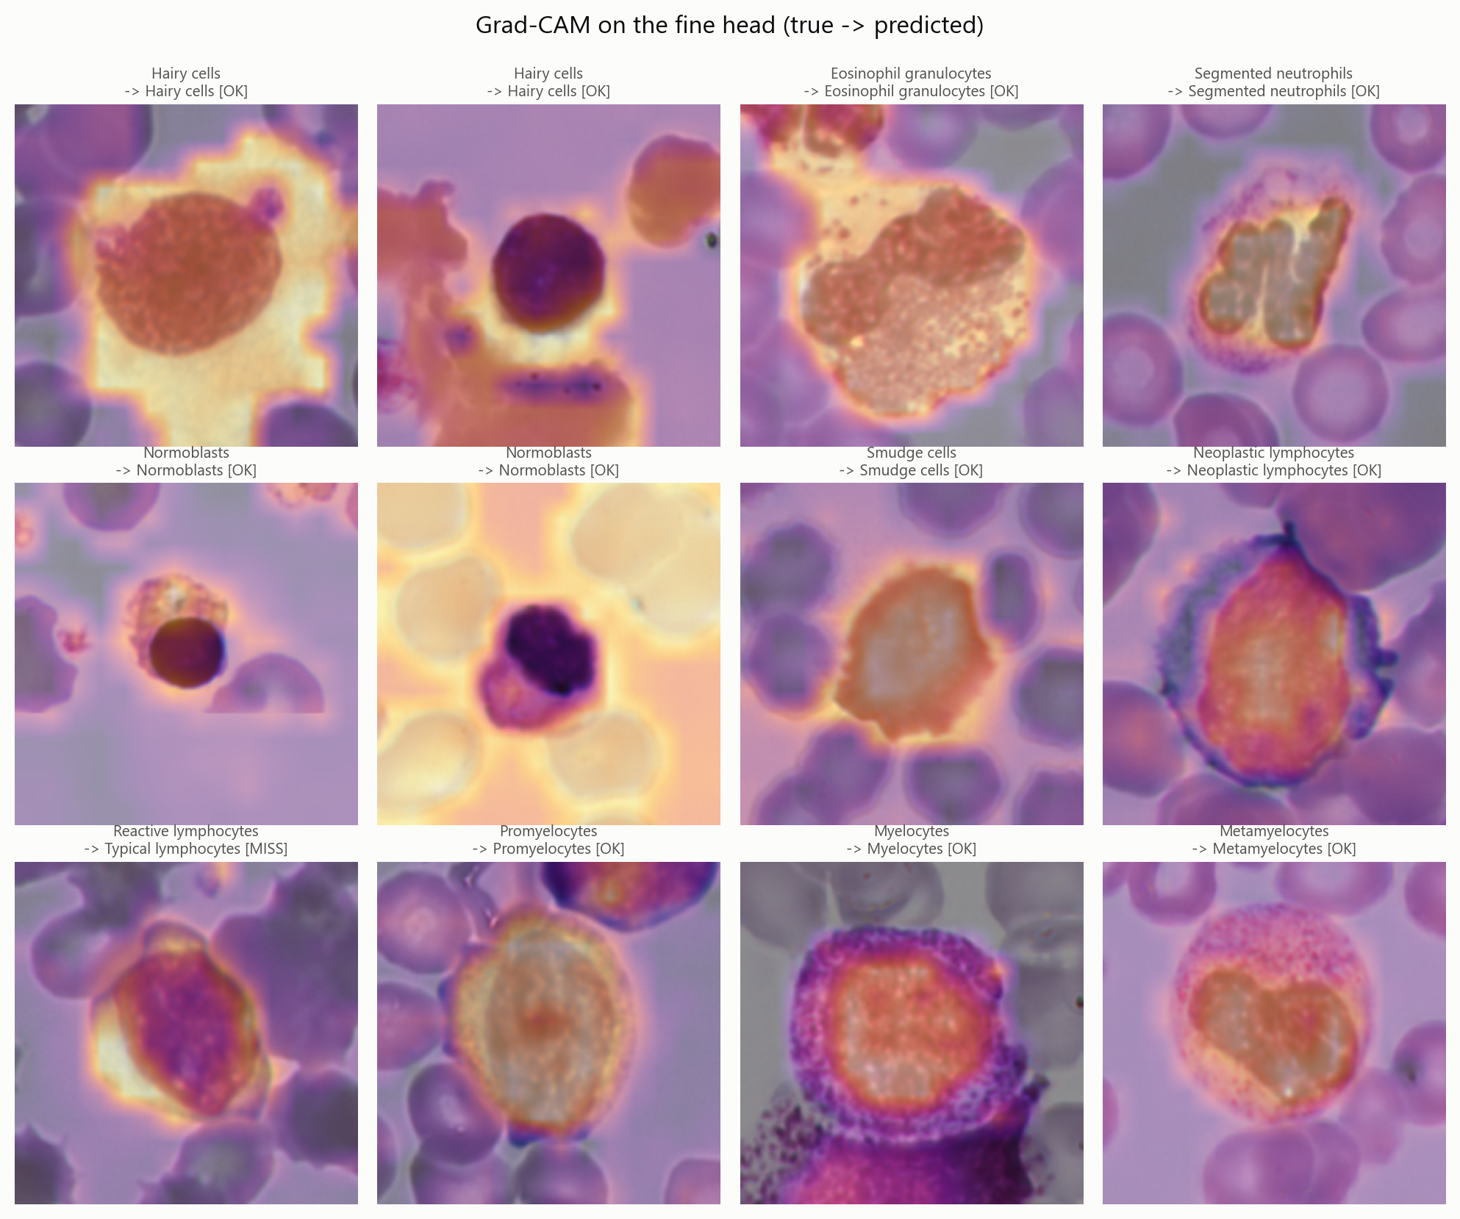
Figure 4.5 Grad-CAM saliency for the fine classification head, with true and predicted labels
Figure 4.5 shows Grad-CAM maps for the fine head across a range of classes. Attention concentrates on the cell body, covering the nucleus, chromatin texture and cytoplasmic boundary, and not on the red cells around it or on empty background. This is the qualitative check the method was included to perform, and it passes: the network is not exploiting background staining artefacts or field position as a shortcut, which is the failure mode that would most obviously prevent transfer to another laboratory.
The reactive lymphocyte panel, which the model misclassified as a typical lymphocyte, is the most instructive. Saliency remains correctly localised on the cell, so the failure is not one of attention but of discrimination: the model examined the right evidence and drew the wrong conclusion from it. For a class with 23 training examples this is the expected failure mode, and it carries a practical implication. Further gains on that class will come from the training objective or from additional data, not from architectural changes that improve localisation, since localisation is already correct.
A methodological caveat attaches to producing these maps on a Vision Transformer. Because the classifier reads only the class token, patch tokens at the final block have exactly zero gradient, and hooking that layer yields a uniformly blank map that min-max normalisation renders as a plausible-looking figure. The measured gradient magnitude was 0.0 at the final block against 6.6 x 10^-2 at the input to its attention sublayer, which is the layer used here. This is worth recording because the failure is silent: the resulting figure looks like a result, and would pass visual inspection.

4.4 Comparison with Baseline Methods
The primary baseline is the flat single-head classifier trained under identical conditions, reported throughout Section 4.3. That comparison is internally controlled: identical partition, identical backbone, identical schedule, identical augmentation, differing only in the presence of the lineage head and its loss terms. It is the comparison on which the conclusions of this study rest, and it is the only one in which the confounds are fully accounted for.
It is tempting to place these numbers beside the accuracies quoted in Chapter 2, several of which reach 99% or 100%. No such table appears here, and the reason is that the comparison would be meaningless. Those figures come from problems with two to eight classes; this one has eighteen. They come from datasets that were balanced before training began; this one has 261 times more myeloblasts than reactive lymphocytes. They report accuracy; this study reports macro F1 because Section 4.3.1 showed accuracy to be actively misleading on data of this shape. Three separate things differ at once, so any ranking drawn from such a table would say more about which benchmark each author chose than about which method works.
The size of the distortion can be measured inside this study's own results. The proposed model scores 0.957 on accuracy and 0.879 on macro F1 from the very same predictions. Nearly eight points separate the two numbers, and the only difference is whether rare classes are allowed to count as much as common ones. Quoting the higher figure alongside a published 99% would suggest this work falls short, when in truth the two numbers are measuring different things.
The per-class results make the same point more concretely. This study's models pass 0.98 F1 on eight of the eighteen classes, which matches anything in the published literature, and fall below 0.76 on five others. A system evaluated only on the easy eight would look excellent and would never meet the hard five at all. That is the shape of the problem, and it is why a like-for-like table cannot be built from the sources available.
One published system can be compared in a qualitative sense. Acevedo and colleagues [16] built the closest antecedent to this architecture, a two-stage design that decides the coarse group first and the fine type second. Their two stages learn from separate objectives, so a mistake at the fine level never teaches the coarse stage anything. The model here joins the levels through one differentiable loss, and Section 4.3.3 shows that this does move errors from the severe category to the mild one, if only by a little. Which design would win on the same data is unknown, because no dataset has been used by both.

4.4.1 A methodological correction affecting these results
An earlier complete experimental matrix was run and subsequently discarded. It is reported here because the reason for discarding it bears directly on the reliability of the results above, and because the failure mode is one the reviewed literature does not discuss.
That first matrix enabled early stopping against a cosine schedule defined over a 50-epoch budget. Runs halted between epochs 12 and 37, which truncated the anneal and left models at up to 86% of peak learning rate, mid-training and not converged. The number of epochs a run survived then correlated with its final score at r = +0.87, so the ranking of arms substantially measured the stopping rule, not the method under test. A striking symptom was that the six-epoch screening runs, whose schedules completed, scored higher on test than any fifty-epoch run: training for longer made results worse, purely through this interaction.
Compounding this, epoch-to-epoch validation macro F1 varied with a standard deviation of 0.021, larger than the between-arm differences of 0.008 to 0.028 the study set out to detect. Selecting a checkpoint on such a signal approximates a lottery, and patience-based stopping on it approximates a random stopping rule.
The consequence was not merely imprecision but inversion. That first matrix ranked the flat baseline above the hierarchical model on minority macro F1, at 0.819 against 0.791, the reverse of the ordering reported in Table 4.2. Had it been reported, this dissertation would have concluded that lineage awareness harms rare-class performance. No number of additional seeds could have rescued it, because the measurement noise exceeded the effect being measured.
The protocol was rebuilt around four changes. Early stopping was switched off and the budget fixed at 30 epochs, so every arm now receives the same anneal. Weight averaging was added, and the averaged weights are evaluated in place of the live ones. Predictions are averaged over four flip views at test time. Augmentation was strengthened to counter the memorisation visible when training loss fell to 0.005 while validation sat on a plateau. A fifth problem surfaced during the rebuild: the configuration field controlling augmentation policy never reached the dataset, so every run in the first matrix had trained under the basic policy no matter what its recorded settings claimed.
These changes reduced epoch-to-epoch validation variation from 0.0211 to 0.0097, a reduction of 54%, measured on a matched configuration with identical data and seed. The accompanying accuracy gain was modest, approximately 0.011 in macro F1, and is not the point. Halving the measurement noise is what makes an effect of 0.005 to 0.017 detectable at all, and is the reason the cross-lineage comparison could reach significance on three seeds. The episode is reported because a study whose effects are of the same order as its measurement noise cannot be evaluated by its readers unless that noise is stated.

4.4.2 Limitations
Five limitations qualify these results. First, three seeds provide two degrees of freedom, which is a thin basis for a paired t-test. Effect sizes and per-seed values are reported throughout so that conclusions do not rest on p-values alone, but several comparisons showing large effect sizes remain formally unresolved. The honest summary is that the hierarchical improvement in aggregate metrics is suggested, not demonstrated, and only the cross-lineage effect and the imbalance ablation are statistically supported.
Second, the rarest class contributes 23 training and 5 test images. Its per-class scores are correspondingly unstable, and minority-class aggregates computed over 671 test samples carry meaningful sampling uncertainty. The per-class differences discussed in Section 4.3.5 for individual rare classes should be read as indicative of the pattern, not as precise estimates.
Third, the backbone screen used a short budget and picked a backbone instead of comparing them, so this study licenses no claim about the relative merits of the four architectures. A full-length comparison remains outstanding, and the choice of Vision Transformer rests on weaker evidence than the rest of the design.
Fourth, MLL23 originates from a single laboratory. The generalisation problem identified in Chapter 2 as a central unsolved issue in this field is left untouched by this study, and the stain normalisation result in particular may not transfer to a multi-site setting.
Fifth, the minority threshold of 1,000 images is a simplification. Section 4.3.5 shows that classes on either side of it behave along a continuum instead of splitting into two groups, and that the class-balanced objective redistributes capacity between classes that are both nominally minority. Aggregate minority statistics average over a mixed set, which the per-class table is included to make visible.

Chapter 5 Conclusion and Future Work

5.1 Conclusion
This study asked whether a lineage-aware hierarchical classifier, combined with an imbalance-robust training objective, improves fine-grained classification of single peripheral blood cell images, especially for rare cell types, relative to a flat transfer-learning classifier on the same data. Four configurations were trained on the MLL23 corpus of 41,621 expert-annotated images across 18 classes at an imbalance ratio of 261:1, under identical partitions, backbones and schedules, at three seeds each.
The answer is a qualified yes, with the qualification carrying as much information as the affirmation.
The proposed hierarchical model outperformed the flat baseline on every metric measured, achieving a test macro F1 of 0.879 against 0.874, a minority-class macro F1 of 0.840 against 0.823, a minority recall of 0.799 against 0.776, and a balanced accuracy of 0.894 against 0.883. Critically, the improvement was larger on the rare classes than on the corpus as a whole, which is the pattern the design predicted, not a uniform lift. None of these aggregate differences reached statistical significance at three seeds, although the effect sizes were large, with Cohen's d_z above 1.0 for minority recall and balanced accuracy. On the aggregate metrics the hierarchical advantage is suggested but not demonstrated.
One comparison did reach significance, and it was the one identified in advance as the direct test of the mechanism. The hierarchical model reduced cross-lineage error, the clinically severe category, from 0.0119 to 0.0115, consistently across all three seeds, at p = 0.020 with d_z = -4.04, and correspondingly raised the share of errors remaining within the correct lineage from 0.726 to 0.733. Total accuracy for the two arms was identical to three decimal places. The hierarchy does what it was designed to do, redistributing errors from the severe category toward the mild one, but the magnitude is small: the absolute reduction corresponds to two or three images in a test partition of 6,244. This is a reliably detected small effect, not a clinically decisive one, and it is reported as such.
The ablation design produced the study's clearest finding, and it concerns the other component. Removing the class-balanced and focal terms cost 0.076 in minority recall (p = 0.024), 0.032 in balanced accuracy (p = 0.028) and 0.060 in minority macro F1 (p = 0.052), with effect sizes above two standard deviations throughout. The imbalance objective contributes roughly an order of magnitude more to rare-class performance than the hierarchy does. Where credit for the combined system is apportioned, it belongs predominantly to the loss function, not to the architecture.
Diagnostic analysis explains why the architectural contribution was modest, and this is arguably the most useful outcome of the work. Lineage accuracy saturates at 98.9% and both auxiliary loss terms collapse to approximately 0.0007 by the end of training. The auxiliary task regularises an axis the model has already solved, and so supplies almost no gradient during the period when the hard discriminations, between myeloid maturation stages and among the rare lymphoid types, are actually being learned. Lineage supervision cannot help with those distinctions by construction, since the confusable classes share a lineage label. This is a design finding, not a tuning deficiency, and it points directly at the remedy set out below.
Per-class analysis sharpened the picture considerably, and produced the most specific confirmation of the mechanism the study obtained. The hierarchical advantage is not diffuse: of eighteen classes, fifteen differ from the flat baseline by 0.006 or less in F1, and the aggregate improvement is carried almost entirely by reactive lymphocytes, which gain 0.070, and neoplastic lymphocytes, which gain 0.050. These are the two rarest lymphoid types, and they sit in a lineage containing typical lymphocytes and hairy cells in abundance. The effect appears exactly where the theory says rare classes should be able to borrow strength from populous same-lineage neighbours, and is absent where the theory offers no reason to expect it. Correspondingly, the myeloid maturation stages show no measurable benefit, the mean difference across the six chain classes being -0.005 against a seed standard deviation of 0.011. Their confusable neighbours share their lineage label, so lineage supervision cannot discriminate among them even in principle. The architecture helps along one axis of the taxonomy and is inert along another, and describing it as a general improvement would misrepresent the evidence.
A fourth finding was negative. Stain normalisation, evaluated as an additional preprocessing stage, underperformed the proposed model on every metric, though not significantly. Either colour carries genuine diagnostic signal in Pappenheim-stained material, or the single-source corpus offers little inter-site variation for normalisation to correct. The experiment does not distinguish these, and the result should not be generalised to multi-site data.
A fifth observation concerns difficulty, not method, and holds across every configuration tested. The five hardest classes are reactive lymphocytes, metamyelocytes, neoplastic lymphocytes, myelocytes and band neutrophils. Rarity alone does not explain this grouping: basophil granulocytes, with 92 test images, reach an F1 of 0.982, while metamyelocytes with 72 reach 0.677. What separates them is that basophils are visually distinctive whereas metamyelocytes sit between two adjacent stages of a continuous developmental process. Difficulty here is driven as much by morphological adjacency as by sample count. That reframes the problem in a useful way. The tail is hard partly because it is small, and more data would help. The maturation continuum is hard for a different reason: the labels draw sharp lines across a process that has none, and no quantity of extra images would change that.
Two methodological contributions accompany the empirical ones. The study demonstrates, from within a single controlled experiment, that accuracy is the wrong headline metric for this problem: the arm scoring highest on accuracy at 0.9602 scored lowest on minority macro F1 at 0.7799. And it establishes the hierarchical decomposition of errors as a measurement that scalar metrics cannot replace, since it detected a consistent, significant effect between two arms whose overall accuracy was indistinguishable. The study also records the invalidation of an initial experimental matrix in which measurement noise exceeded the effects under study, and the protocol changes that reduced that noise by 54%, without which none of the comparisons reported here would have been resolvable.

5.2 Future Work
Four directions follow from these findings, ordered by the strength of the evidence supporting them.

Retarget the auxiliary task. The saturation of the lineage head at 98.9% is the clearest diagnosed cause of the small hierarchical effect, and the most direct remedy is to define the auxiliary task on an axis that remains unresolved late in training. Maturation stage within the myeloid branch is the natural candidate, since that is where the residual confusion demonstrably resides. An alternative is to factor inference conditionally, so that the coarse decision genuinely constrains the fine one, instead of two heads sitting side by side on a shared trunk and being nudged toward agreement. Both preserve the biological grounding that motivated the design while directing the supervisory signal at a harder problem.
Adopt stronger long-tail methods. Since the imbalance objective proved load-bearing, improving it is the highest-value direction. Class-balanced reweighting combined with focal modulation is a comparatively mild treatment. Decoupled training, in which the representation is learned under instance-balanced sampling and only the classifier subsequently retrained under class-balanced sampling [36], is consistently among the strongest reported long-tail methods and is inexpensive here because it reuses backbones already trained. Logit adjustment [37] and margin-based objectives enforcing larger decision margins for rare classes are drop-in alternatives within the existing loss implementation. The target is to move minority recall off the 0.80 plateau observed across every arm in this study.
Raise statistical power. Three seeds give two degrees of freedom, and several comparisons in this study showed large effect sizes while remaining formally unresolved. Five seeds, combined with the halved measurement noise already achieved, would convert the paired tests from indicative to informative. A full-length backbone comparison is also outstanding: the screen conducted here selected an architecture but was too short to compare them, so the choice of Vision Transformer rests on weaker evidence than the rest of the design.
Address cross-site generalisation. The most significant limitation of this study is that MLL23 originates from a single laboratory, so the generalisation problem repeatedly identified in the literature as the field's central unsolved issue [3], [18] is untested here. Evaluating the trained model on an independently acquired corpus such as Raabin-WBC [5] would establish whether the hierarchical coupling confers robustness to acquisition shift, and would also resolve the ambiguity in the stain normalisation result, which may behave quite differently where genuine inter-site colour variation exists. Self-supervised pretraining on unlabelled smear images [27] is a complementary route to the same objective.
Beyond these, two smaller refinements were identified during implementation. The automated augmentation policies fill geometric transformations with black and can invert the stain palette, producing images far outside the distribution of any real smear; constraining them to a white fill consistent with the smear background is a single-parameter change worth evaluating. And multi-level saliency, comparing where the coarse and fine heads attend and whether their disagreement is visible, remains an open question that the present analysis raises without answering.

References
References follow IEEE style.
[1] S. Shetab Boushehri, S. Kazeminia, A. Gruber et al., “A large expert-annotated single-cell peripheral blood dataset for hematological disease diagnostics,” Scientific Data, vol. 12, 1773, 2025.
[2] C. Matek, S. Krappe, C. Münzenmayer, T. Haferlach and C. Marr, “Highly accurate differentiation of bone marrow cell morphologies using deep neural networks on a large image data set,” Blood, vol. 138, no. 20, pp. 1917–1927, 2021.
[3] M. H. S. Modaghegh et al., “Machine learning in detection and classification of leukemia using smear blood images: a systematic review,” Scientific Programming, vol. 2021, 9933481, 2021.
[4] C. Matek, S. Schwarz, K. Spiekermann and C. Marr, “Human-level recognition of blast cells in acute myeloid leukaemia with convolutional neural networks,” Nature Machine Intelligence, vol. 1, pp. 538–544, 2019.
[5] Z. M. Kouzehkanan, S. Saghari, S. Tavakoli et al., “A large dataset of white blood cells containing cell locations and types, along with segmented nuclei and cytoplasm,” Scientific Reports, vol. 12, 1123, 2022.
[6] S. M. Z. Kouzehkanan et al., “New segmentation and feature extraction algorithm for classification of white blood cells in peripheral smear images,” Scientific Reports, vol. 11, 19428, 2021.
[7] Y. Cui, M. Jia, T.-Y. Lin, Y. Song and S. Belongie, “Class-balanced loss based on effective number of samples,” in Proc. IEEE/CVF Conf. Computer Vision and Pattern Recognition, 2019, pp. 9268–9277.
[8] Z. Mushtaq et al., “A systematic review on recent advancements in deep and machine learning based detection and classification of acute lymphoblastic leukemia,” IEEE Access, vol. 10, pp. 90755–90776, 2022.
[9] R. R. Selvaraju, M. Cogswell, A. Das, R. Vedantam, D. Parikh and D. Batra, “Grad-CAM: visual explanations from deep networks via gradient-based localization,” in Proc. IEEE Int. Conf. Computer Vision, 2017, pp. 618–626.
[10] O. Islam, M. Assaduzzaman and M. Z. Hasan, “An explainable AI-based blood cell classification using optimized convolutional neural network,” Journal of Pathology Informatics, vol. 15, 100389, 2024.
[11] M. M. Alam and M. T. Islam, “Deep learning model for the automatic classification of white blood cells,” Computational Intelligence and Neuroscience, vol. 2022, 7384131, 2022.
[12] M. Erten, P. D. Barua, S. Dogan, T. Tuncer, R.-S. Tan and U. R. Acharya, “ConcatNeXt: an automated blood cell classification with a new deep convolutional neural network,” Multimedia Tools and Applications, vol. 84, pp. 22231–22249, 2025.
[13] M. Ghaderzadeh, F. Asadi, A. Hosseini et al., “A deep network designed for segmentation and classification of leukemia using fusion of the transfer learning models,” Complex & Intelligent Systems, vol. 7, pp. 2197–2220, 2021.
[14] M. Aria, S. Meskinimood, A. Dateki, B. Nouri and A. Mohammadi, “A fast and efficient CNN model for B-ALL diagnosis and its subtypes classification using peripheral blood smear images,” International Journal of Intelligent Systems, vol. 37, no. 8, pp. 5113–5133, 2021.
[15] A. U. Rahman, S. Abbas, M. Gollapalli et al., “Lightweight EfficientNetB3 model based on depthwise separable convolutions for enhancing classification of leukemia white blood cell images,” IEEE Access, vol. 11, pp. 36490–36502, 2023.
[16] A. Acevedo, A. Merino, I. Ruiz et al., “An efficient multi-level convolutional neural network approach for white blood cells classification,” Diagnostics, vol. 12, no. 2, 248, 2022.
[17] J. Wang, “Deep learning in hematology: from molecules to patients,” Clinical Hematology International, vol. 6, no. 4, pp. 38–61, 2024.
[18] A. Rehman et al., “Automated diagnosis of leukemia: a comprehensive review,” IEEE Access, vol. 9, pp. 116156–116175, 2021.
[19] T.-Y. Lin, P. Goyal, R. Girshick, K. He and P. Dollár, “Focal loss for dense object detection,” in Proc. IEEE Int. Conf. Computer Vision, 2017, pp. 2980–2988.
[20] K. Chen, W. Lei, S. Zhao et al., “PCCT: progressive class-center triplet loss for imbalanced medical image classification,” IEEE Journal of Biomedical and Health Informatics, vol. 27, no. 4, pp. 2026–2036, 2023.
[21] N. Abbas et al., “Hybrid Inception v3 XGBoost model for acute lymphoblastic leukemia classification,” Computational and Mathematical Methods in Medicine, vol. 2021, 2577375, 2021.
[22] S. I. Khan et al., “Blood cancer prediction using leukemia microarray gene data and hybrid logistic vector trees model,” Scientific Reports, vol. 12, 1882, 2022.
[23] G. An, M. Akiba, K. Omodaka, T. Nakazawa and H. Yokota, “Hierarchical deep learning models using transfer learning for disease detection and classification based on small number of medical images,” Scientific Reports, vol. 11, 4250, 2021.
[24] K. Kowsari, R. Sali, L. Ehsan et al., “HMIC: hierarchical medical image classification, a deep learning approach,” Information, vol. 11, no. 6, 318, 2020.
[25] K. He, X. Zhang, S. Ren and J. Sun, “Deep residual learning for image recognition,” in Proc. IEEE Conf. Computer Vision and Pattern Recognition, 2016, pp. 770–778.
[26] A. Acevedo, S. Alférez, A. Merino, L. Puigví and J. Rodellar, “Recognition of peripheral blood cell images using convolutional neural networks,” Computer Methods and Programs in Biomedicine, vol. 180, 105020, 2019.
[27] L. Wenderoth et al., “Transferable automatic hematological cell classification: overcoming data limitations with self-supervised learning,” Computer Methods and Programs in Biomedicine, vol. 260, 108560, 2025.
[28] K. A. K. Al-Dulaimi et al., “Accurate classification of white blood cells by coupling pre-trained ResNet and DenseNet with SCAM mechanism,” BMC Bioinformatics, vol. 23, 329, 2022.
[29] H. Rezatofighi et al., “A deep learning framework for leukemia cancer detection in microscopic blood samples using squeeze and excitation learning,” Mathematical Problems in Engineering, vol. 2022, 2801227, 2022.
[30] S. H. Park et al., “LeuFeatx: deep learning-based feature extractor for the diagnosis of acute leukemia from microscopic images of peripheral blood smear,” Computers in Biology and Medicine, vol. 142, 105236, 2022.
[31] P. Lewicki et al., “Deep learning identifies acute promyelocytic leukemia in bone marrow smears,” BMC Cancer, vol. 22, 332, 2022.
[32] W. Wang et al., “Development and evaluation of a leukemia diagnosis system using deep learning in real clinical scenarios,” Frontiers in Pediatrics, vol. 9, 693676, 2021.
[33] E. Reinhard, M. Ashikhmin, B. Gooch and P. Shirley, “Color transfer between images,” IEEE Computer Graphics and Applications, vol. 21, no. 5, pp. 34–41, 2001.
[34] M. Macenko et al., “A method for normalizing histology slides for quantitative analysis,” in Proc. IEEE Int. Symp. Biomedical Imaging, 2009, pp. 1107–1110.
[35] A. Dosovitskiy et al., “An image is worth 16x16 words: transformers for image recognition at scale,” in Proc. Int. Conf. Learning Representations, 2021.
[36] B. Kang et al., “Decoupling representation and classifier for long-tailed recognition,” in Proc. Int. Conf. Learning Representations, 2020.
[37] A. K. Menon, S. Jayasumana, A. S. Rawat, H. Jain, A. Veit and S. Kumar, “Long-tail learning via logit adjustment,” in Proc. Int. Conf. Learning Representations, 2021.

Appendix A. Experimental Configuration Reference
Every run is fully specified by a frozen configuration object, and the configuration is written to the results file alongside the metrics so that any recorded run can be reconstructed exactly. Table A1 lists the fields and the values used in Phase 2. Only the four fields marked vary between arms; every other field is held constant, which is what makes the comparison between arms attributable to the factor under test.
Table A1 Configuration fields and Phase 2 values
Field | Phase 2 value | Varies by arm?
arm | flat_baseline / hierarchical / no_imbalance / stain_norm | Yes
backbone | vit (ViT-Small/16) | No
mode | flat or hier | Yes
use_hierarchy | True or False | Yes
use_imbalance | True or False | Yes
stain_norm | True or False | Yes
seed | 0, 1, 2 | No (all arms use all three)
epochs | 30 | No
batch_size | 64 | No
lr | 0.0003 | No
weight_decay | 0.05 | No
warmup_epochs | 1 | No
label_smoothing | 0.05 | No
aug_policy | randaugment | No
mix_kind | cutmix | No
mix_prob | 0.5 | No
mix_alpha | 1.0 | No
use_ema | True | No
ema_decay | 0.999 | No
tta | True (4 flip views) | No
use_early_stopping | False | No

Table A2 records the wall-clock cost of the complete matrix. Times vary between runs of the same arm because the workstation was in intermittent use for other tasks; they are reported for completeness rather than as a controlled measurement of computational cost.
Table A2 Computational cost of the Phase 2 matrix
Arm | Runs | Mean minutes per run
flat_baseline | 3 | 55.7
hierarchical | 3 | 75.2
no_imbalance | 3 | 239.4
stain_norm | 3 | 114.3
Total | 12 | 1,453.8 minutes (24.2 hours)

Appendix B. Per-Class Precision and Recall
Table 4.5 in the main text reports per-class F1. This appendix decomposes that figure into its precision and recall components for the proposed model and the flat baseline, since the two behave differently and the distinction matters clinically: recall determines how many cells of a given type are found, while precision determines how many of the cells so labelled genuinely belong to it. For screening applications recall is generally the more important of the two.
All figures are averaged over the three seeds and computed on the test partition with four-view test-time augmentation. Rows follow class-index order, so within the myeloid block adjacent rows are adjacent maturation stages. Minority classes are marked with a dagger.
Table B1 Per-class precision and recall on the test partition, averaged over three seeds. Minority classes marked †
Cell type | Test n | Hier. precision | Hier. recall | Flat precision | Flat recall
Typical lymphocytes | 830 | 0.942 | 0.932 | 0.938 | 0.930
Hairy cells | 490 | 0.970 | 0.994 | 0.972 | 0.995
Large granular lymphocytes | 278 | 0.908 | 0.930 | 0.906 | 0.932
Atypical lymphocytes (plasma cells) | 248 | 0.993 | 0.996 | 0.993 | 0.996
Smudge cells † | 148 | 0.972 | 0.948 | 0.970 | 0.957
Neoplastic lymphocytes † | 27 | 0.660 | 0.840 | 0.635 | 0.753
Reactive lymphocytes † | 5 | 0.336 | 0.600 | 0.294 | 0.467
Myeloblasts | 1291 | 0.988 | 0.985 | 0.988 | 0.983
Promyelocytes † | 112 | 0.872 | 0.809 | 0.870 | 0.836
Atypical promyelocytes | 305 | 0.984 | 0.992 | 0.983 | 0.992
Myelocytes † | 112 | 0.727 | 0.753 | 0.737 | 0.774
Metamyelocytes † | 72 | 0.674 | 0.681 | 0.686 | 0.667
Band neutrophils † | 103 | 0.732 | 0.777 | 0.744 | 0.777
Segmented neutrophils | 1076 | 0.982 | 0.987 | 0.981 | 0.988
Eosinophil granulocytes | 367 | 0.997 | 0.985 | 0.996 | 0.985
Basophil granulocytes † | 92 | 0.982 | 0.982 | 0.986 | 0.978
Monocytes | 377 | 0.960 | 0.920 | 0.959 | 0.920
Normoblasts | 311 | 0.992 | 0.973 | 0.995 | 0.968

The decomposition clarifies the nature of the residual failures. For the rare lymphoid classes, recall is substantially below precision, meaning the model is conservative: when it does assign the label it is usually right, but it frequently fails to assign it at all. That is the signature of an under-represented class whose decision boundary has been drawn too tightly, and it is the behaviour the class-balanced objective is intended to counteract.
For the intermediate myeloid stages the two quantities are closer together, indicating symmetric confusion with neighbouring stages rather than systematic under-prediction. This supports the argument in Section 4.3.5 that the two groups of difficult classes fail for different reasons, and that a single remedy is unlikely to address both.
Aggregate minority-class statistics quoted throughout Chapter 4 are computed over the 671 test images whose true class is one of the eight daggered classes above. Note that the minority macro F1 reported in Table 4.2 is computed on that restricted subset rather than as the mean of the full-data per-class F1 values in Table 4.5, so the two are related but not arithmetically identical.

