**DEPARTMENT OF INFORMATION SCIENCE AND ENGINEERING**

**Mini Project on Internet and Web Programming**

|  |  |  |
| --- | --- | --- |
| **Title of the Mini Project** | DishDazzle | |
| **Team Member Details** | **Name** | **USN** |
| Nishan H | NNM23IS511 |
| Adarsha | NNM23IS501 |
| Jithesh | NNM23IS507 |
| Akash | NNM23IS502 |
| **Sem & Section** | **IV Sem D** | |
| **Academic Year** | **2023-24** | |
| **Faculty In-Charge** | **Ms. Anusha N.** | |

**Description about the project**

DishDazzle is an innovative web application designed to serve as a hub for cooking enthusiasts, providing a platform for users to share, discover, and organize recipes. The project aims to create a vibrant online community centred around culinary exploration and creativity.

The core functionalities of DishDazzle include user authentication, profile management, recipe posting, category exploration, and database integration. These features collectively contribute to building a seamless and engaging user experience, fostering interaction and collaboration among users.

**Different Modules**

**1. User Authentication:**

* **Objective:** User authentication ensures that only registered users can access the platform's features, maintaining the security and integrity of user data.
* **Implementation:** DishDazzle employs a secure user authentication system that allows users to log in using their username and password. New users can sign up for an account to gain access to the platform. Session management is utilized to maintain user authentication across different pages of the application.
* **Benefits:** By implementing user authentication, DishDazzle protects user accounts from unauthorized access, safeguarding sensitive information such as personal profiles and posted recipes.

**2. Profile Management:**

* **Objective:** Profile management enables users to create and personalize their profiles, providing a platform for users to share information about themselves and their culinary preferences.
* **Implementation:** DishDazzle allows users to create profiles by providing details such as username, password, and bio. Users can customize their profiles with personal information and preferences, enhancing their engagement with the community. Profile pages display user bios, as well as a list of recipes posted by the user.
* **Benefits:** Profile management facilitates user engagement and interaction within the DishDazzle community. By allowing users to share information about their culinary background and interests, DishDazzle creates a sense of belonging and connection among users.

**3. Recipe Posting:**

* **Objective:** Recipe posting empowers users to share their favourite recipes with the DishDazzle community, contributing to a diverse and dynamic collection of culinary creations.
* **Implementation:** DishDazzle provides users with a platform to post new recipes, including details such as recipe name, category, ingredients, and cooking instructions. Users can share their culinary expertise and creativity by showcasing their favourite dishes and cooking techniques.
* **Benefits:** Recipe posting enriches the DishDazzle platform with a wide range of recipes, catering to different tastes and preferences. By encouraging users to share their culinary creations, DishDazzle fosters collaboration and inspiration among users.

**4. Category Exploration:**

* **Objective:** Category exploration enables users to discover new recipes and culinary inspiration by browsing recipes organized into different categories and cuisines.
* **Implementation:** DishDazzle categorizes recipes into various categories such as appetizers, main courses, desserts, and more. Users can explore recipes by browsing through different categories, making it easy to discover new dishes and cooking ideas.
* **Benefits:** Category exploration enhances the user experience by providing a structured way to navigate the DishDazzle platform. By organizing recipes into categories, DishDazzle simplifies the process of finding recipes that match users' interests and preferences.

**5. Database Integration:**

* **Objective:** Database integration enables DishDazzle to store and retrieve user data, recipes, and other relevant information, ensuring the scalability and reliability of the platform.
* **Implementation:** DishDazzle integrates with an SQLite database to store user information, posted recipes, and category data. The database is used to persistently store user accounts, profile details, recipe information, and other essential data.
* **Benefits:** Database integration provides a robust and scalable solution for managing user data and content within the DishDazzle platform. By leveraging database technology, DishDazzle ensures the efficient storage and retrieval of information, supporting the growth and expansion of the platform over time.

**Results**

* 1. **Login page**

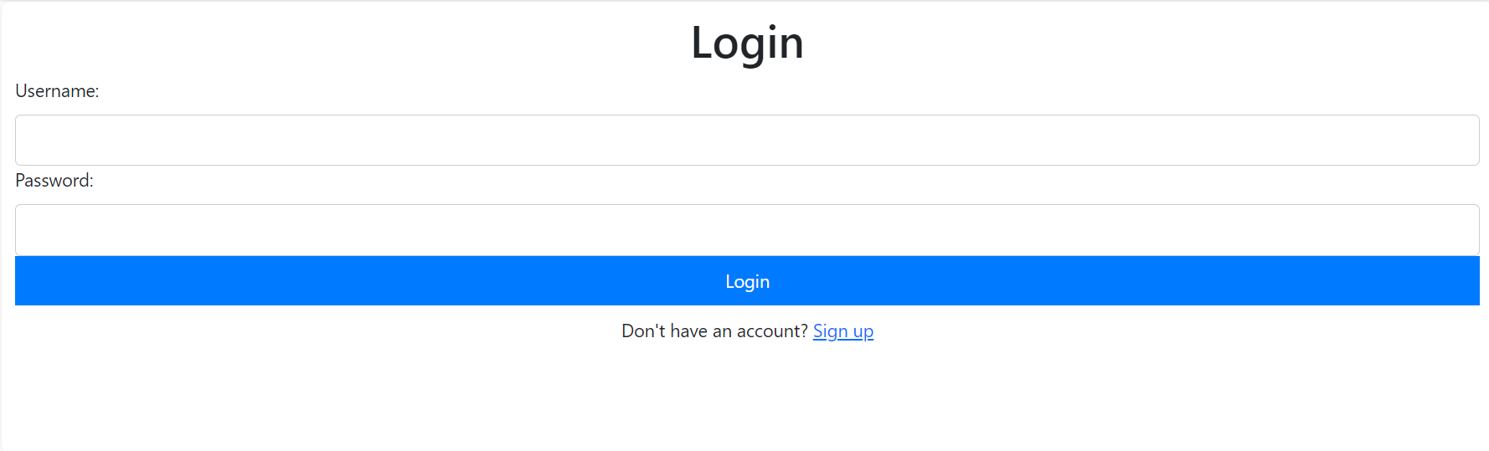

* 1. **Signup page**

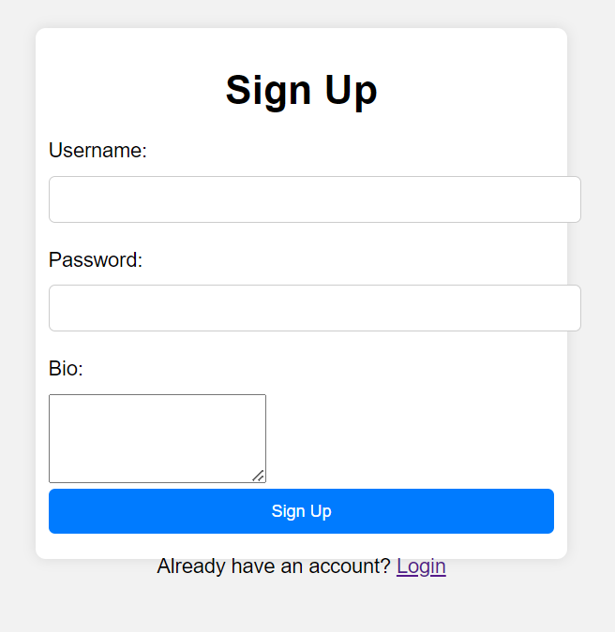

* 1. **Homepage**

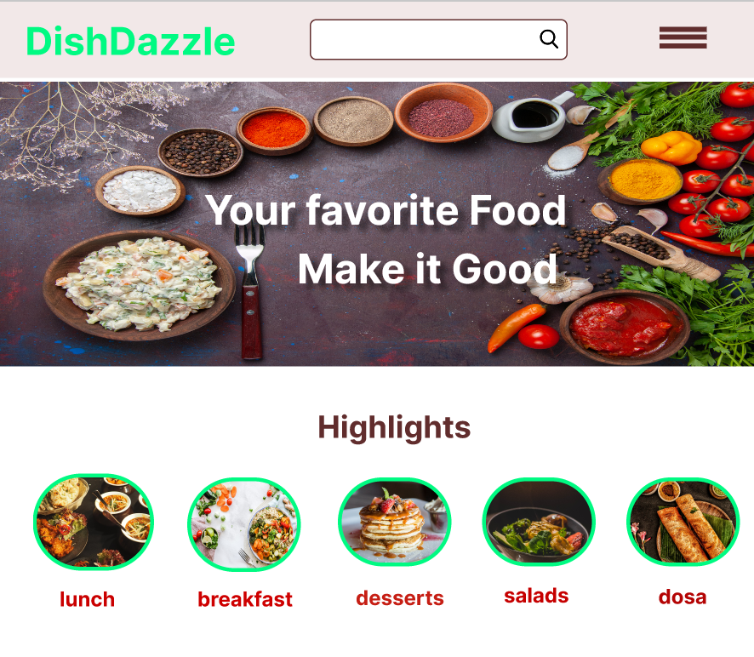

* 1. **User dashboard**

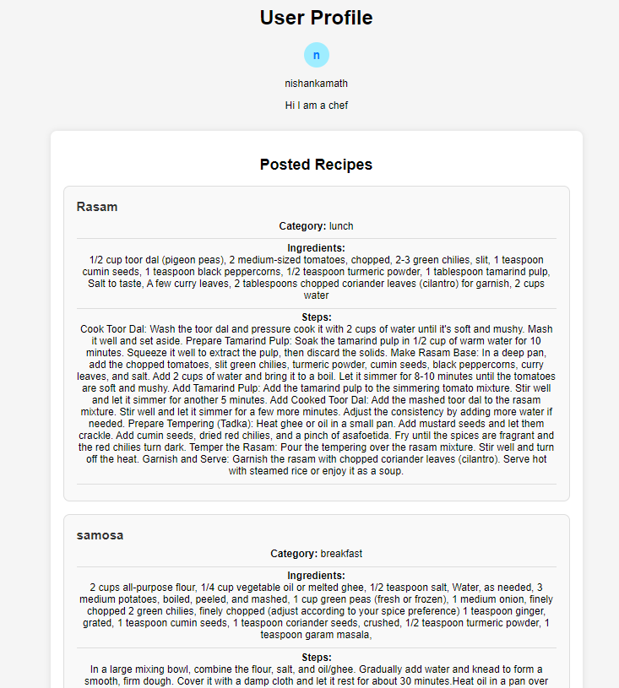

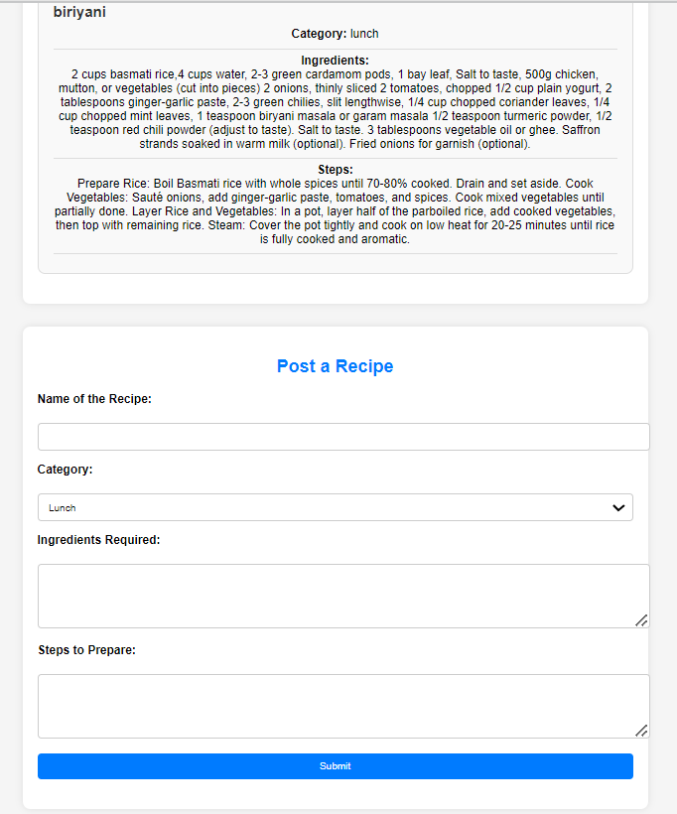

* 1. **Php page output of all users along with their recipes**

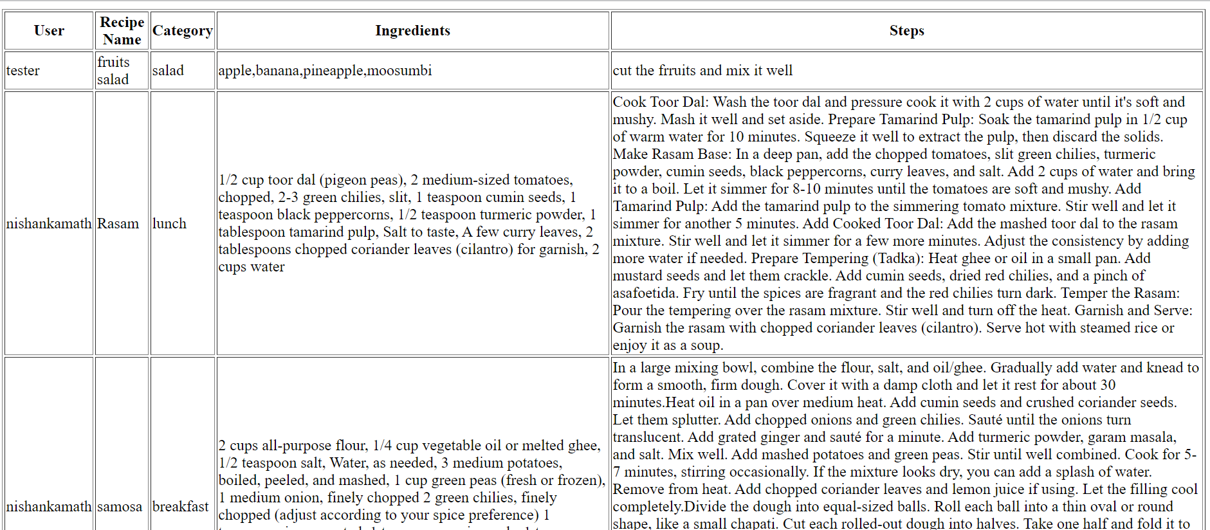

**Conclusion**

Overall, DishDazzle represents a comprehensive and innovative solution for building a vibrant online community centered around cooking and culinary exploration. By combining user authentication, profile management, recipe posting, category exploration, and database integration, DishDazzle creates a dynamic and engaging platform for cooking enthusiasts to connect, share, and discover new culinary experiences.