**Acknowledgement**

I'd like to express my heartfelt gratitude to everyone who has helped and motivated me, directly or indirectly, to finish this report.

I'd like to take this opportunity to thank Itahari Namuna College for providing me with the invaluable opportunity to attend the week-long training program. I am also grateful to Tritech Web Solutions for conducting the training with such professionalism and expertise. Their dedication and support were critical in assisting me in acquiring new knowledge and skills.

Furthermore, I would like to express my heartfelt gratitude to Nabin Shrestha (Head of Department), Manish Rathi, Saroj Ojha, and our principal, Dharma Prasad Neupane, for providing us with the opportunity to participate in the training program. Their advice and assistance throughout the training were invaluable in assisting us in learning and developing new skills.

Finally, I want to express my gratitude to my parents for their unwavering support and encouragement throughout my academic career. Their love and support have been a constant source of inspiration for me, and I am grateful for their sacrifices and efforts in assisting me in reaching my objectives.

Finally, I'd like to express my heartfelt gratitude to everyone who contributed to the successful completion of this lab report.

**Table of Content**

Day 1:

Lab Work…………………………………………………………………3

* WordPress Introduction
* Registration of .com.np Domain

Day 2:

Lab Work………………………………………………………………4,5

* Installation of XAMPP
* Installation of WordPress

Day 3:

Lab Work………………………………………………………………6,7

* Introduction to dashboard

Day 4,5:

Lab Work……………………………………………………………….7,8

* Creating a design for website on hosipital.securitygau.com
* Working on Styling and functioning

Day 6, 7:

Lab Work…………………………………………………………………9

* Developing own Website

Outcomes of Training………………………………………………………….10

**Introduction**

The purpose of this report is to document my experience and learning outcomes from the WordPress training that I participated in this training was aimed at providing me with the necessary knowledge and skills to build, manage, and customize websites using WordPress, a popular content management system.

**Day 1**

**Introduction of WordPress**

WordPress is an open-source platform designed for web developers who want to build websites quickly without having to know too much about HTML or CSS. The software was created by Matt Mullenweg in 2003 as a blogging tool for non-coders that uses PHP as its coding language. Over time it has become quite popular because of its ease of use and flexibility in building websites from scratch with just a few clicks on your computer screen.

**Registration of .com.np domain**

On the first day, we learn how to create our own domain. The following are the steps for registering a domain:

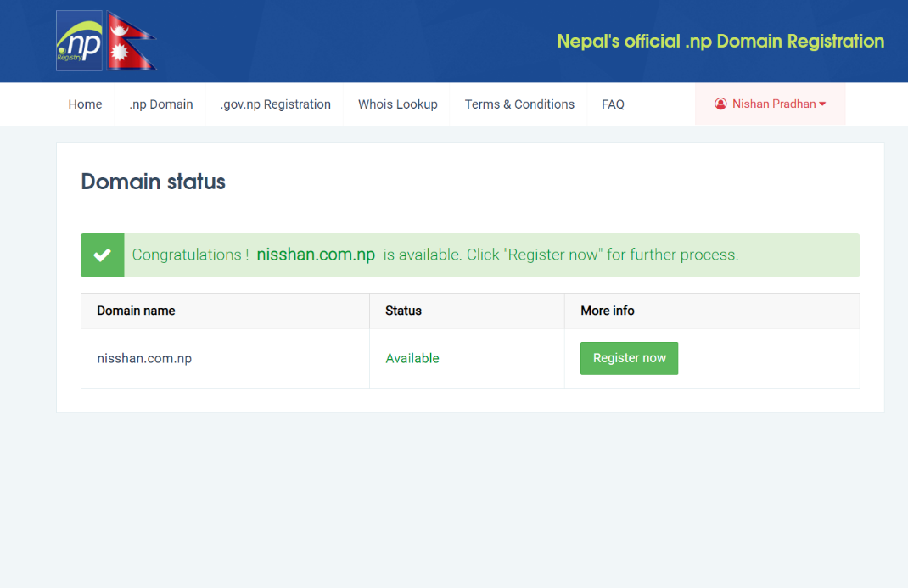To register a domain name, the user must select a name that is not already registered by someone else. The domain registrar then confirms the availability of the desired name and registers it on the user's behalf. During the registration process, the user must provide accurate information such as their name, email address, phone number, and mailing address.

**Day 2**

**Introduction of XAMPP**

XAMPP is a free and open-source web server solution that allows you to create a local web server environment on your computer. It consists of several software components, including Apache, MySQL, PHP, and Perl, which are commonly used in web development.

**Installation of XAMPP**

Download XAMPP for local hosting. We also get XAMPP for the local host.

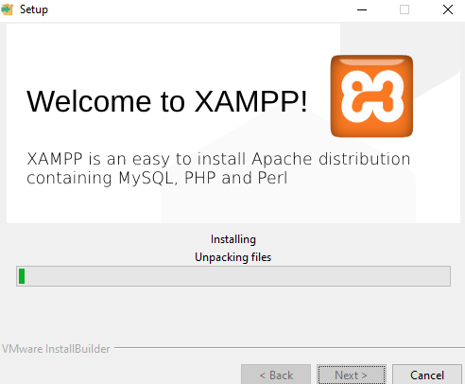From [www.apachefriends.org](http://www.apachefriends.org)

Step 1: Installing XAMMP

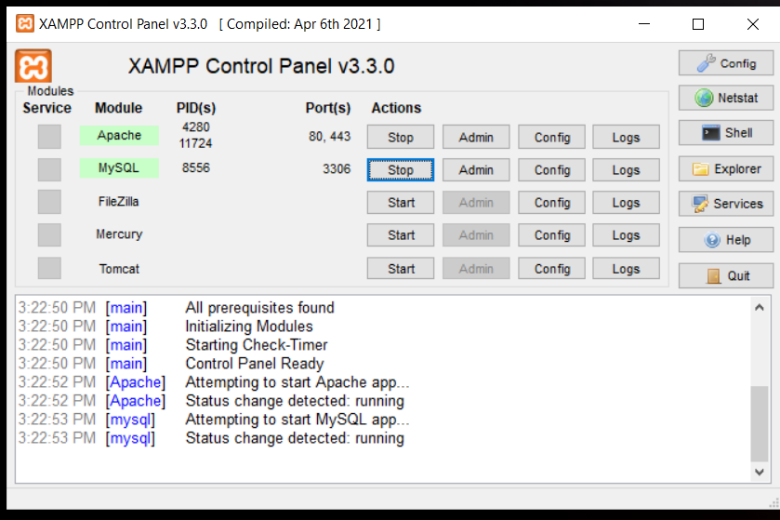Step 2: Run the XAMPP and start Apache, MySQL

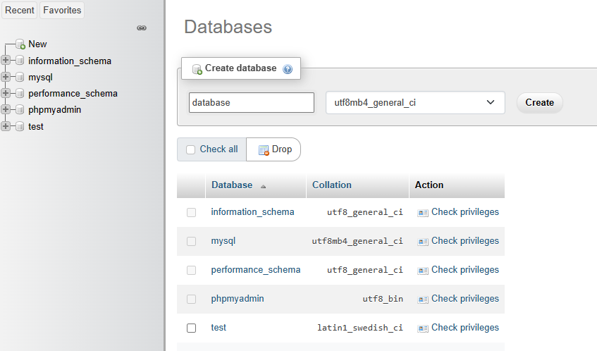

Step 3: Select Admin from MySQL

Step 4: Create a database

**Installing WordPress**

We launch WordPress on the second day. There are several steps involved in setting up a WordPress website. Here's a step-by-step guide to getting started:

**Select a Domain Name:** Select a distinct domain name for your website. As mentioned in the previous question, you can register a domain name with a domain registrar.

**Choose a Hosting Provider**: Select a XAMPP a web hosting provider that provides WordPress hosting services for the local host.

**Install WordPress**: Most hosting providers provide one-click WordPress installation, making it simple to get your website up and running. Install WordPress on your hosting account by following the instructions.

Step 1: Download the latest version of WordPress from the official website

Step 2: Move WordPress files to XAMPP htdocs directory:

* After downloading and extracting WordPress, locate the folder where the files were extracted.
* Open the XAMPP installation directory on your computer (e.g., C:\xampp).
* Open the "htdocs" folder within the XAMPP directory.
* Copy the entire WordPress folder and paste it into the "htdocs" folder.

Step 3: Configure WordPress:

* Locate the "wp-config-sample" file and duplicate the file and rename the new created copy file to "wp-config.php".
* Open the "wp-config.php" file in a text editor, such as Notepad or Visual Studio Code.
* Replace 'database_name_here' with the name of the database you created in phpMyAdmin in step 4.
* Replace 'username here' with the username you created for the database in step 4, If you didn’t create username in step4 or you were not asked to use “root” which is default username.
* Replace 'password_here' with the password you created for the database in step 4, blank is default password so remove “password_here” and make it blank.
* Save the changes you made to the "wp-config.php" file.

Step 4: Install WordPress:

* Open a web browser (e.g., Chrome, Firefox) and go (http://localhost/ wordpress_folder_name)
* Follow the on-screen instructions to complete the WordPress installation process.
* 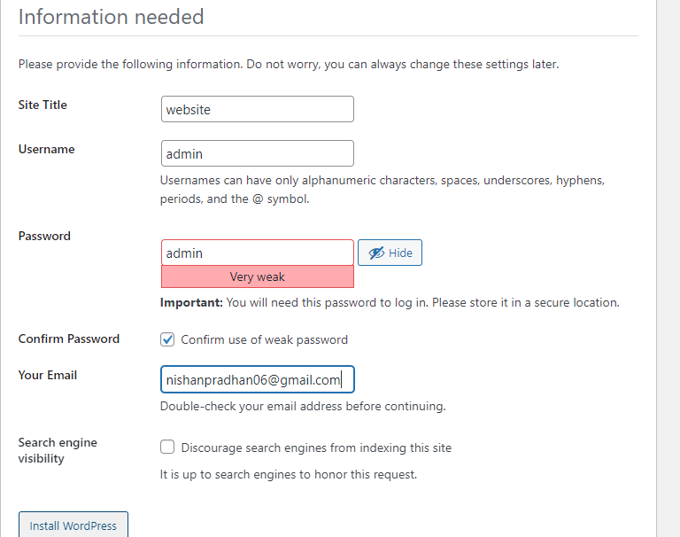Enter your site title, username, and password and keep them safely as they are required later to log in.
* Click the “Install WordPress”
* Enter your username and password and then login.

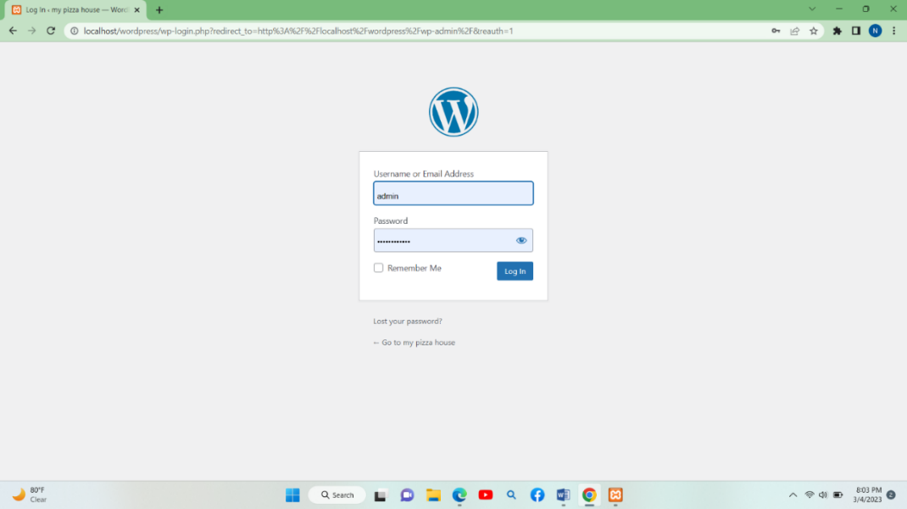

**Day 3**

On the third day, we continued our WordPress training. We were shown how to use the dashboard and various themes and plugins to create a sample site. In addition, we learned the distinctions between posts and pages in WordPress.

**Dashboard Introduction**

1) **Dashboard:** After logging in to your WordPress account, the dashboard is the first page you see. It shows a summary of your website's activity, such as recent posts, comments, and statistics.

2) **Posts:** You can create, edit, and manage your blog posts in the Posts section. You can create new posts, categorize existing ones, and edit existing ones.

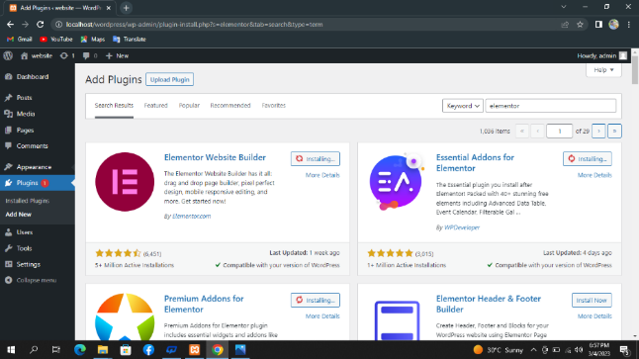3) **Plugins:** Plugins, such as contact forms, social media sharing buttons, and search engine optimization tools, add functionality to your website. We download various plugins for our website design. For instance, elementor header and footer, elements lite, formator, and so on.

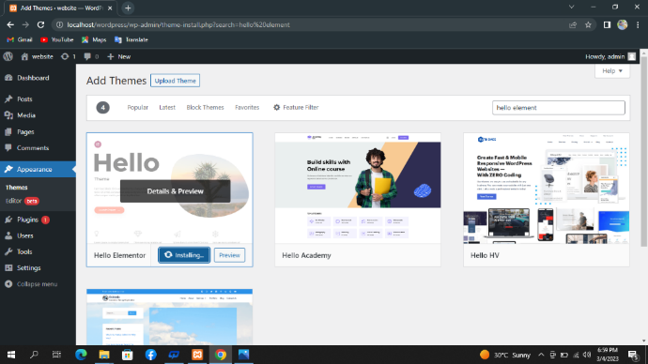4) **Choose a Theme:** We install hello elements for the purpose and design of our website. WordPress provides a plethora of free and premium themes that you can use to customize the look and feel of your website.

5) **Website Personalization:** Personalize our website by adding pages, posts, and media such as images and videos. WordPress has a user-friendly interface that makes it simple to create and manage content on our website.

**Day 4,5**

**Creating website**

On the Fourth day, our WordPress training instructor divided us into groups of three or four students to create our own website, news, blog, or other. He provides live hosting to each group under a different sub-domain name. such as digital.securitygau.com, hospital.securitygau.com, café.securitygau.com, and many others. I was placed in a group of “hospital Service” subdomain “hospital.securitygau.com” with my friends Pratik Rana, Utsav Satyal, Ripesh Limbu, and Nishan Pradhan. We begin our project by gathering our ideas. Our team developed a service of hospital with the hospital.securitygau.com subdomain. However, there are numerous issues with our website but our instructor, from Tritech Web Solutions, provides the guidance to solve the error.

During this day, we were introduced to several useful themes such as Elementor, Header and Footer, Scroll to Top, among others. The instructor provided us with a demonstration on how to integrate these plugins into our news website, enhancing its functionality and improving user experience.

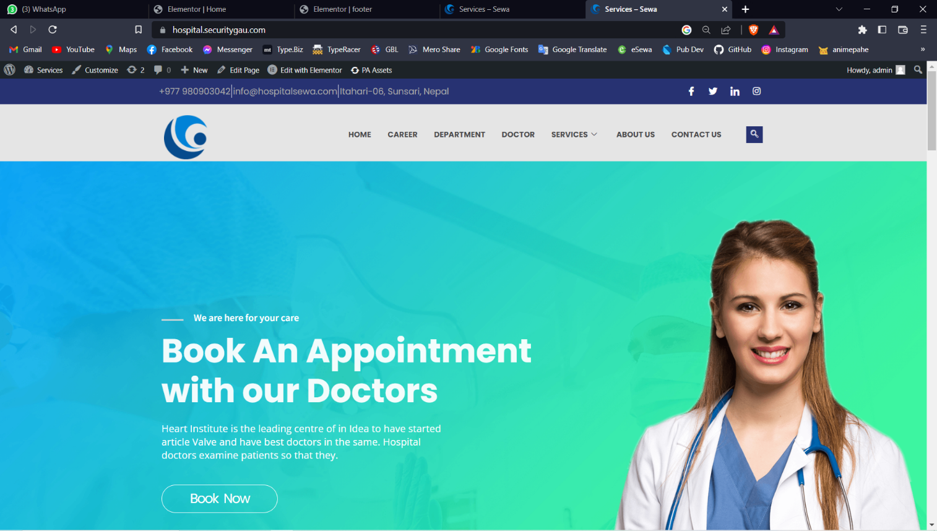

**Day 5, 6**

**Day 6,7**

**Working on Own Websites Projects**

On the sixth and seventh day, we decided to create our own website on a local host. As a result, we must present our work on last day of training so I made a website within two days.

I continued working on my individual’s website relating to the notes and solution of BCA course affiliated to TU. I have tried to make simple and clean UI. This website can provide the notes related to the BCA all semester.

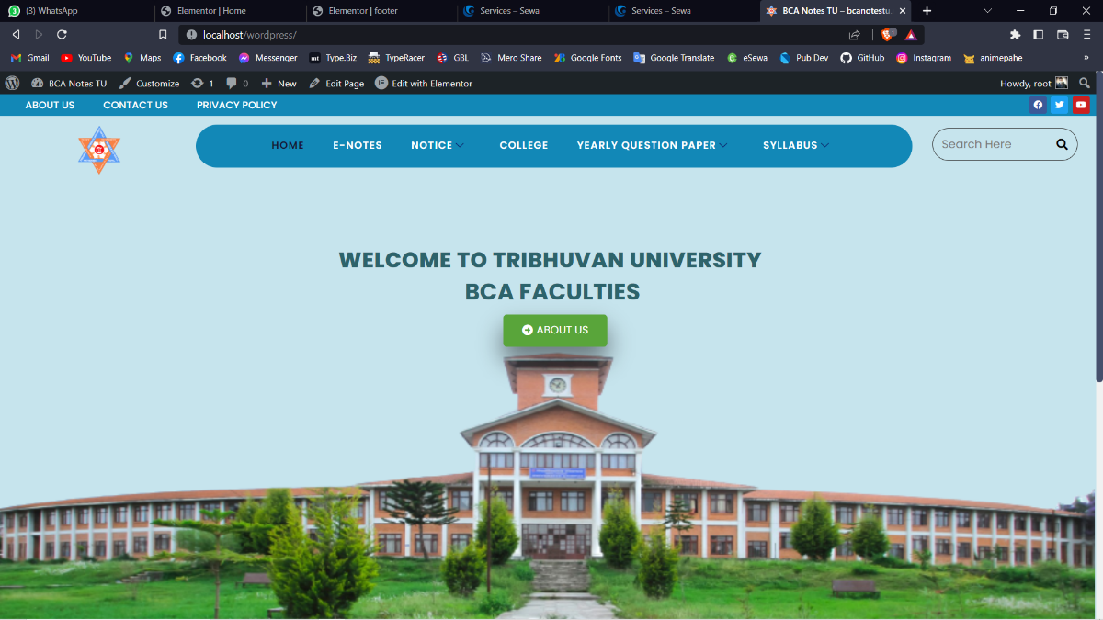

**Conclusion**

During this seven day of WordPress training I had learned to developed websites using WordPress using theme and template as well as to implement CSS and JavaScript and I made website successfully as individual and in groups with my friends. I am thankful to my friend for working with me as a team to overcome success.

Finally, I want to sincerely thank Nabin Shrestha (HOD), Manish Rathi, Saroj Ojha, and our principal, Dharma Prasad Neupane, for enabling us to take part in the training program. Their guidance and support were incredibly helpful in our acquisition of new skills. Additionally, I appreciate the professionalism and expertise displayed by Tritech Web Solutions' WordPress trainers, Bibas Bajgain and Pukar Dhungana.

**Outcomes of Training**

I had learned many useful features such as implement CSS and JavaScript. I have made custom scrollbar using CSS and smooth scrolling using JS as well as I have made the heading navbar sticky when the page is scroll down the user. Other feature such as 404 page not found error also I have successfully implemented on this website with the help of our instructor, from Tritech Web Solutions.