

Tribhuvan University
Faculty of Humanities and Social Science

“SkillSwap”

A PROJECT REPORT

Submitted to
Department of Computer Application
Itahari Namuna College

In partial fulfillment of the requirements for the degree of Bachelor in Computer Application
.
Submitted By
Name: Nishan Pradhan
Regd No: 6-2-1152-34-2022

Under the Supervision of
Er. Chandra Prasad Acharya



Tribhuvan University
Faculty of Humanities and Social Sciences
Itahari Namuna College

SUPERVISOR’S RECOMMENDATION

I hereby recommend that this project prepared under my supervision by NISHAN PRADHAN entitled “Skillswap” in partial fulfillment of the requirements for the degree of bachelor’s in computer Application is recommended for the final evaluation.

Chandra Parshad Acharya
Project Supervisor
Itahari Namuna College
Itahari-8, Sunsari



Tribhuvan University
Faculty of Humanities and Social Sciences
Itahari Namuna Collage

LETTER OF APPROVAL

………………………….  Chandra Parshad Aacharya  Supervisor  Itahari Namuna College | …………………………… Nabin Shrestha HOD/Coordinator  Itahari Namuna College
……………………………… Internal Examiner  Itahari Namuna College | ……………………………… External Examiner  Tribhuvan University
This is to certify that this project prepared by NISHAN PRADHAN entitled “SkillSwap” in partial fulfillment of the requirements for the degree of Bachelor’s in Computer Application has been evaluated. In our opinion it is satisfactory in the scope and quality as a project for the required degree.

ACKNOWLEDGEMENT
The success and final outcomes of this project requires a lot of guidance and assistance from many people and are very fortunate to have this all along the completion of this project. We would like to express our gratitude and appreciation to all those who gave us the possibility to complete this project. We are very glad to express our deepest sense of gratitude and sincere thanks to our supervisor Er. Chandra Prasad Acharya and project teacher Mr. Saroj Ojha whose contribution in stimulating suggestion and encouragement helped us in completing project.
We are also thankful to Mr. Nabin Shrestha, HOD, Itahari Namuna Collage and Mr. Dharma Neupane, principle, Itahari Namuna College for encouraging and guiding us throughout the completion of this project. All useful suggestions for this whole work and co-operative behaviour are sincerely acknowledged.
Last but not the least many thanks go to our teachers, friends, guardians who directly or indirectly helped us in achieving the goal. We would like to appreciate all the guidance and support, which helped in completion of this project. Special thanks to their comment and advices.
ABSTRACT
The Skill Exchange System is a digital platform designed to transform traditional learning into a collaborative and point-based skill-sharing environment. This platform enables users to connect as mentors and learners, allowing them to exchange skills efficiently through scheduled sessions. Users can browse skills, book available time slots, earn and spend points, and participate in structured learning sessions. The system provides secure point transactions, session tracking, and push notifications to ensure transparency and reliability. Mentors benefit from organized slot management and fair reward distribution, while learners gain access to flexible and affordable learning opportunities.
This user-friendly system enhances time management, ensures accountability through session confirmation and embraces modern technology to create a structured and transparent learning ecosystem. The platform is developed using a modern backend framework and RESTful APIs, ensuring scalability and security. A systematic development approach is followed to carefully design and implement each module, including user management, skill posting, booking flow, point wallet management.
Overall, this project envisions upgrading informal skill sharing into a structured, secure, and efficient online platform that promotes collaborative learning, transparency, and equal opportunities for knowledge exchange.
Keywords:
- Skill Exchange Platform
- Point-Based Learning System
- Slot-Based Session Booking
- Mentor-Learner Role Switching
- Time Management in Learning

TABLE OF CONTENTS

LIST OF FIGURES

LIST OF TABLES

LIST OF ABBREVIATIONS
API : Application Programming Interface
DB : Database
DFD : Data Flow Diagram
ERD : Entity Relationship Diagram
JWT : JSON Web Token
REST : Representational State Transfer
IDE : Integrated Development Environment
UI : User Interface
UX : User Experience
OTP : One Time Password
FCM : Firebase Cloud Messaging
CRUD : Create, Read, Update, Delete
TCID : Test Case ID
UML : Unified Modeling Language
SQL : Structured Query Language

INTRODUCTION

Introduction
Our transformative concept for the BCA 3rd year college project is a Skill Exchange Platform designed to modernize the traditional way of learning and teaching skills. This system replaces informal, unstructured skill sharing with a well-organized online platform where learners and mentors can connect efficiently. The platform allows mentors to post the skills they can teach, define available time slots, and specify the total duration of the course (e.g., 4 days of training). Learners can browse skills, book available slots, and exchange points securely within the system.
Our innovation extends to a structured slot-based learning mechanism, where mentors define weekly availability (full week or selected days) and specific hourly time slots (e.g., 7–9 PM, 1-hour sessions). Learners can only request or book available slots, ensuring no scheduling conflicts. The system also introduces a secure point-based exchange model where learner points are temporarily held during booking and released to the mentor only after successful course completion.
Focusing on transparency, accountability, and fairness, our system includes completion tracking, attendance confirmation from both mentor and learner, notifications, and role flexibility (a user can act as both mentor and learner at different times). This project envisions a modern, user-friendly, and secure digital environment for collaborative learning and knowledge exchange.
The facilities provided by our platform are mentioned below:
- Slot-Based Skill Booking: Mentors define available teaching days and hourly slots, and learners can only book from those predefined available slots, preventing time conflicts.
- Point-Based Exchange System: Instead of money, learners use platform points to book sessions. Points are deducted and held securely until the course is completed, then released to the mentor.
- Course Duration Management: Mentors can define the total number of learning days required for skill completion (e.g., 4-day training program).
- Role Flexibility: A user can act as both a mentor and a learner and switch roles at any time without creating separate accounts.
- Completion and Attendance Tracking: Both mentor and learner must confirm session completion, ensuring fairness and preventing misuse of the system.
- Notification System: The platform provides in-app and push notifications for booking confirmations, reminders, approvals, and course completion updates.
- Profile and Skill Management: Users can create detailed profiles including skills offered, skills wanted, certifications, experience, and portfolio details.
- Secure Authentication System: The system uses JWT-based authentication and optional Google login integration for secure and seamless access.
- Reward and Daily Points System: Users earn reward points for registration, daily login, and profile completion, encouraging active participation.
- Transparent Learning Environment: By tracking sessions, points, and confirmations, the system ensures trust, accountability, and structured skill development.
Overall, this project visualizes upgrading traditional informal skill sharing into a structured, efficient, transparent, and secure online Skill Exchange Platform that promotes collaborative learning and digital empowerment.

Problem Statement
The problem statement for the Skill Exchange Platform focuses on identifying the major challenges faced in traditional and informal skill-sharing systems. Currently, skill exchange often happens through unstructured communication, social media, or personal networks, which lack proper scheduling, accountability, transparency, and trust. These limitations create inefficiencies for both mentors and learners.
Some of the major problems are:
- Unstructured Skill Sharing Process: Traditional skill exchange methods do not provide a formal system for posting skills, defining availability, or managing learning duration. Mentors and learners often struggle with coordination, resulting in confusion, missed sessions, and ineffective learning experiences.
- Lack of Proper Scheduling and Slot Management: Without a structured slot-based system, learners may request sessions at unavailable times, leading to scheduling conflicts. The absence of predefined time slots and course duration management makes it difficult to ensure organized and consistent learning progress.
- No Secure Point or Reward Handling System: In informal skill exchange, there is no secure mechanism to manage value exchange. Without a proper point holding and release system, mentors may not feel assured about receiving rewards, and learners may hesitate due to trust issues. A transparent point deduction and release mechanism is necessary to maintain fairness.
- Absence of Completion and Attendance Tracking: There is no reliable way to verify whether a mentor conducted the session or whether a learner attended it. This lack of confirmation can result in disputes, misunderstandings, or unfair reward distribution.
- Limited Role Flexibility: In many systems, users are restricted to a single role. However, in real-life learning environments, an individual can be both a mentor and a learner at different times. The absence of dynamic role switching limits user participation and collaboration.
- Lack of Transparency and User Trust: Without structured profiles, skill listings, certifications, and experience tracking, users may hesitate to engage in skill exchange due to uncertainty about credibility and reliability.
- Technical and System Challenges: Developing a slot-based booking system with real-time availability tracking, point holding logic, notifications, and secure authentication may introduce technical complexities. Poor implementation can lead to booking conflicts, incorrect point deductions, or system performance issues, negatively affecting user experience.
Therefore, there is a strong need for a secure, structured, and transparent digital Skill Exchange Platform that addresses these challenges by implementing slot management, role flexibility, secure point handling, attendance tracking, and a user-friendly system architecture.

Objectives
The primary objective of this project is to develop a Skill Exchange platform that enables users to learn and teach skills through a structured, point-based system. The project aims to create a streamlined online platform that ensures secure transactions and organized session management, focusing on the below points: -
- To implement a structured skill-based session booking system
- To develop a secure point-based learning and reward

Scope and Limitations:

Scope
This Skill Exchange platform will provide a structured online system where users can teach and learn skills through a secure point-based session model. The system will manage role-based access, session booking, wallet transactions, and notifications efficiently.
Roles:
Admin
- Login
- Manage users (Mentor / Learner roles)
- Manage skills and categories
- Monitor sessions
- Manage point transactions
- Send manual notifications (All)
- Handle disputes and no-show cases
- View reports and platform analytics
Mentor
- Register / Login
- Create and manage skill offerings
- Set availability (weekly schedule and time slots)
- Define course duration (e.g., 4 days)
- Set session point cost
- Accept or reject session requests
- Conduct sessions (add meeting link)
- Mark session as completed
- View earnings and transaction history
Learner
- Register / Login
- Search and browse skills
- View mentor profiles
- Book available time slots
- Pay points (held in escrow)
- Join sessions
- View wallet and transaction history
Advantages of Proposed System
- Secure point-based transaction system (withhold & release mechanism)
- Structured session scheduling with slot management
- Role switching flexibility (Mentor / Learner)
- Automated notifications and tracking
- Efficient database management
- Scalable and user-friendly platform

Limitations:
- The system depends on internet connectivity, which may not be available during severe disasters.
- Advanced GIS and real-time location tracking are not fully implemented.
- The system does not provide automated rescue dispatching based on proximity.

Report Organization
This report is structured as follows:
Chapter 1: Introduction: Overview of the project, problem statement, objectives, scope, and report structure.
Chapter 2: Background Study and Literature Review: Discussion on theories, concepts, and related projects.
Chapter 3: System Analysis and Design: Detailed analysis of requirements, feasibility, and system design.
Chapter 4: Implementation and Testing: Explanation of tools, modules, and testing processes.
Chapter 5: Conclusion and Future Recommendations: Summary of outcomes, lessons learned, and proposed enhancements.

Literature Review

Background Study
In the contemporary landscape of digital learning, the efficiency and accessibility of skill development have been significantly enhanced by the emergence of online learning and collaboration platforms. The Skill Exchange Platform represents a structured approach to modernizing informal skill-sharing practices by leveraging a secure backend system and RESTful technologies to deliver an organized, transparent, and user-centric experience. By incorporating features such as slot-based booking, a secure point-based exchange mechanism, session tracking, and role flexibility, the platform establishes a reliable environment for collaborative learning and knowledge sharing.
The purpose of the Skill Exchange project is to build a platform where users can effortlessly explore available skills, connect with mentors, and book structured learning sessions according to predefined availability. The system also enables users to estimate the required points for completing a course, helping them manage their learning resources effectively. The technologies used to build this platform include modern backend frameworks and API-based architecture to ensure scalability, security, and performance.
Moreover, the platform provides clear guidelines regarding session duration, booking policies, and point transactions to ensure transparency between mentors and learners. Additionally, through automated notifications and session tracking mechanisms, users can monitor their booking status, session confirmations, and course progress. The system also facilitates users to provide feedback and ratings after session completion, promoting accountability and continuous improvement within the learning community.

Literature review
Online skill exchange and digital learning systems focus on facilitating peer‑to‑peer interactions, secure transactions, transparent scheduling, and user satisfaction. These platforms enable users to connect, manage availability, book sessions, and handle transactions in a structured environment that supports both learners and mentors. The literature highlights key characteristics such as matching mechanisms, scheduling efficiency, secure value exchange, and user trust in platform environments, which are crucial for seamless online service delivery.

Kaplan et al. explore design principles of peer‑to‑peer learning ecosystems, emphasizing the integration of structured scheduling, personalized interaction, and feedback systems to support scalable educational communities. They argue that well‑designed interaction models and scheduling mechanisms enhance user engagement and learning outcomes in digital environments [1].
A study in the International Journal of Computer Engineering and Intelligent Systems investigates decentralized peer‑to‑peer transaction models, showing how eliminating centralized intermediaries can improve transaction security and user trust. The research underlines the importance of secure transaction handling and cancellation logic, ensuring that transfers occur only after verification or are safely reverted if verification fails — a principle that aligns with the escrow point settlement mechanism applied in skill exchange platforms [2].
Additionally, research on peer‑to‑peer and decentralized learning infrastructures demonstrates that combining dynamic role interchange with structured scheduling and collaborative features can support content sharing and session coordination effectively. These works propose that flexible role management and collaborative interaction patterns are essential for modern online learning communities [3].
In conclusion, the literature on digital peer‑to‑peer learning and exchange systems emphasizes features that are directly relevant to this project - secure transaction mechanisms, structured scheduling, role flexibility, and trust‑enhancing feedback systems. These elements collectively contribute to improving user experience, platform reliability, and the overall effectiveness of online skill‑sharing environments.

System Analysis and Design

System Analysis
System analysis focuses on designing, developing, and testing high-quality software that meets users’ expectations and is delivered on time. For this project, we have chosen the Waterfall model to guide the software development lifecycle (SDLC).
The Waterfall model is one of the earliest SDLC approaches, where each phase must be completed before the next begins, with no overlapping between phases. We selected this model because the project requirements are clear, stable, and unlikely to change significantly. This makes the Waterfall model suitable, as it assumes that requirements are fixed at the beginning and provides a structured approach for projects with minimal anticipated changes.
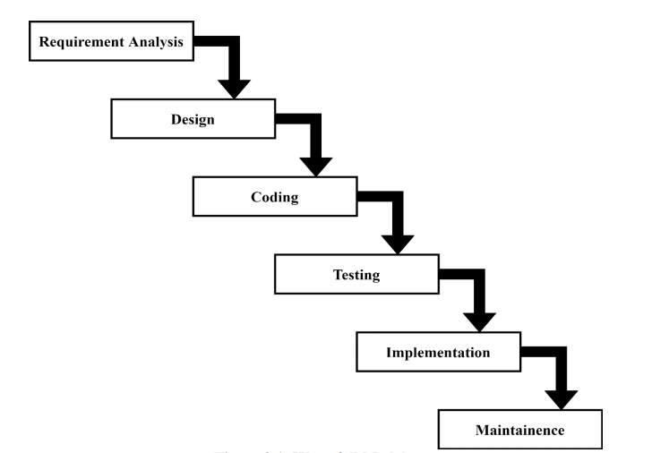
Figure 3.1: Waterfall Model

Requirement Analysis
For any system, both functional and non-functional requirements must be considered when determining system needs. Functional requirements describe the specific features or functions that developers must implement to allow users to accomplish their tasks. Non-functional requirements (NFRs) define system attributes such as security, reliability, performance, maintainability, scalability, and usability.

Functional Requirements
Only authenticated users should have access to the system.
Admin:
The Admin must be authenticated before accessing the system. The Super Admin will be able to:
- Manage users (add/update/delete mentors and learners)
- Approve or reject skill session requests
- View transaction and point history
- Monitor overall system activity
- Manage notifications
- Track skill exchanges and schedules
Mentor:
Mentors must be authenticated before accessing the system. Mentors will be able to:
- Post skills they can teach
- Define available slots (days and times) for sessions
- Set point cost for sessions
- Accept or reject learning requests
- Provide meeting links for sessions (Google Meet/Zoom)
- Mark sessions as completed
- View earned points and transaction history
Learner:
Learners must be authenticated before accessing the system. Learners will be able to:
- Search for skills and mentors
- View mentor profiles and ratings
- Request learning sessions based on available slots
- Book sessions using points
- Join scheduled sessions
- Track point balance and transaction history
System Features for Both Mentors and Learners:
- Notifications for session requests, confirmations, and completions
- Points management (deduction on booking, release on completion)

Non-Functional Requirements
Security: Only authenticated users can access the system. Users (mentors and learners) must log in with valid credentials. Session data and point transactions are securely managed to prevent unauthorized access.
Usability: The system will have a user-friendly interface. The UI should be simple and intuitive, enabling both mentors and learners to navigate easily, book sessions, and manage skills without confusion.
Accuracy: Data stored about users, skills, sessions, and points must be correct, consistent, and reliable. Session schedules, point balances, and mentor availability must reflect real-time updates.
Availability: The system should be available 24/7 to allow learners to request sessions and mentors to manage availability. It must respond promptly to user actions such as booking requests, session confirmations, and notifications.
Maintainability: The software should be easily maintainable. Adding new features (e.g., new skill categories, session types) or updating existing functionality should be straightforward and require minimal downtime.
Portability: The system should function properly on multiple devices and platforms, including web browsers on desktops, tablets, and mobile devices.
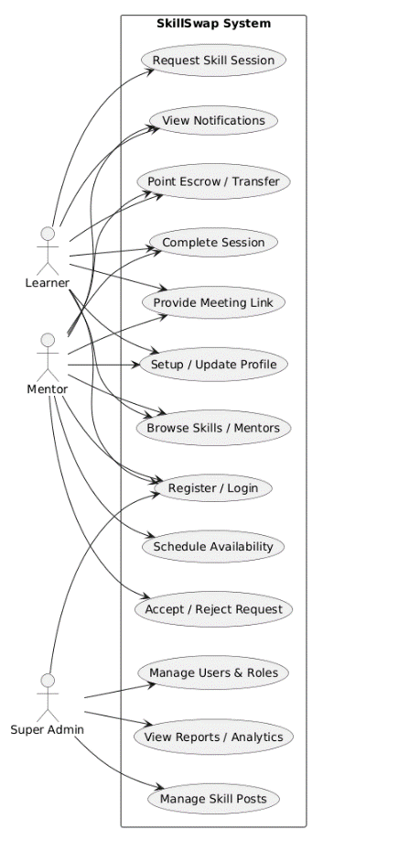
Performance: The system must handle multiple concurrent users without significant delays, ensuring smooth session booking, point management, and notifications.
Figure 3.1: Use case diagram

Feasibility analysis
A feasibility study is conducted to evaluate whether the proposed SkillSwap system is practical and achievable. It examines different factors such as technical capability, operational practicality, economic benefits, and time constraints to determine whether the system can be successfully developed and implemented.
The following feasibility analyses are carried out for the SkillSwap platform:
- Technical Feasibility
- Market Analysis
- Security and Point Transaction Processing
- Scalability
- User Experience and Interface Design
- Operational Feasibility
- Economic Feasibility

Technical Feasibility
The technical feasibility of the SkillSwap system evaluates whether the required technologies, tools, and technical resources are available to successfully develop and maintain the platform.
SkillSwap is developed using modern and reliable technologies:
Mobile Application: Flutter
Backend Framework: Django
Admin Web Panel: Django Web Framework
Database: Relational database (MySQL/PostgreSQL)
Authentication System: Secure login with encrypted passwords and role-based access
Session Scheduling System: Date and time-based mentor availability management
Escrow Point Mechanism: Secure point holding and transfer after successful session completion

Operational Feasibility
The SkillSwap system is easy to operate with basic knowledge of mobile applications and internet usage. The Flutter-based mobile app provides a simple and user-friendly interface, allowing learners and mentors to use the system without technical difficulty.
Users can easily register, book sessions, manage availability, and viewpoints. The admin can manage the system through the Django web panel efficiently. Therefore, no special training is required, and the system is operationally feasible.

Economic Feasibility
Development of the SkillSwap application is economically feasible. The system is built using open-source technologies such as Flutter and Django, which do not require any licensing cost. Therefore, the development cost is minimal.
The main expenses include basic infrastructure such as a development environment, internet access, and hosting services for deployment. No expensive hardware or specialized tools are required. Since the platform is digital and service-based, operational costs are also low. Hence, the project is economically viable and cost-effective.

Schedule Feasibility
The schedule feasibility explains the estimated time required to complete the SkillSwap project. The development includes requirement analysis, design, implementation, testing, and deployment phases.
Since the requirements were clearly defined and Flutter with Django provides structured development support, the project was completed within the planned timeline. A Gantt chart was used to track tasks and monitor overall progress. Therefore, the SkillSwap system is schedule feasible.
Figure 3.2: Gantt chart

Data modeling (ER-Diagram)

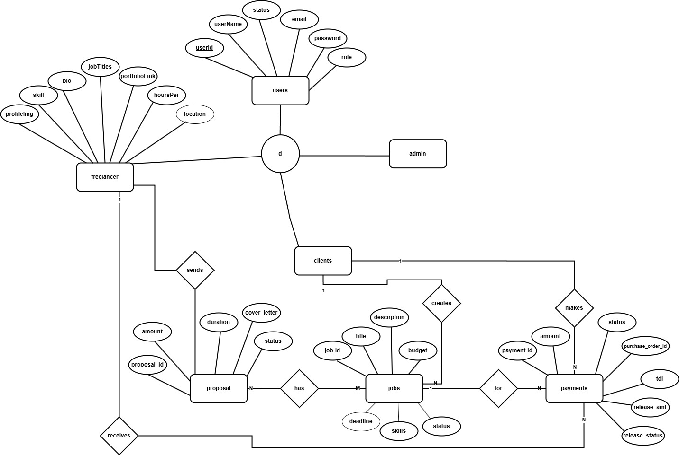

Figure 3.3: E-R Diagram

Process Modeling (DFD)
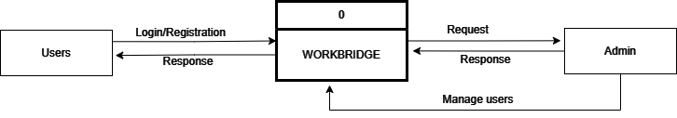
Figure 3.4: Context level DFD

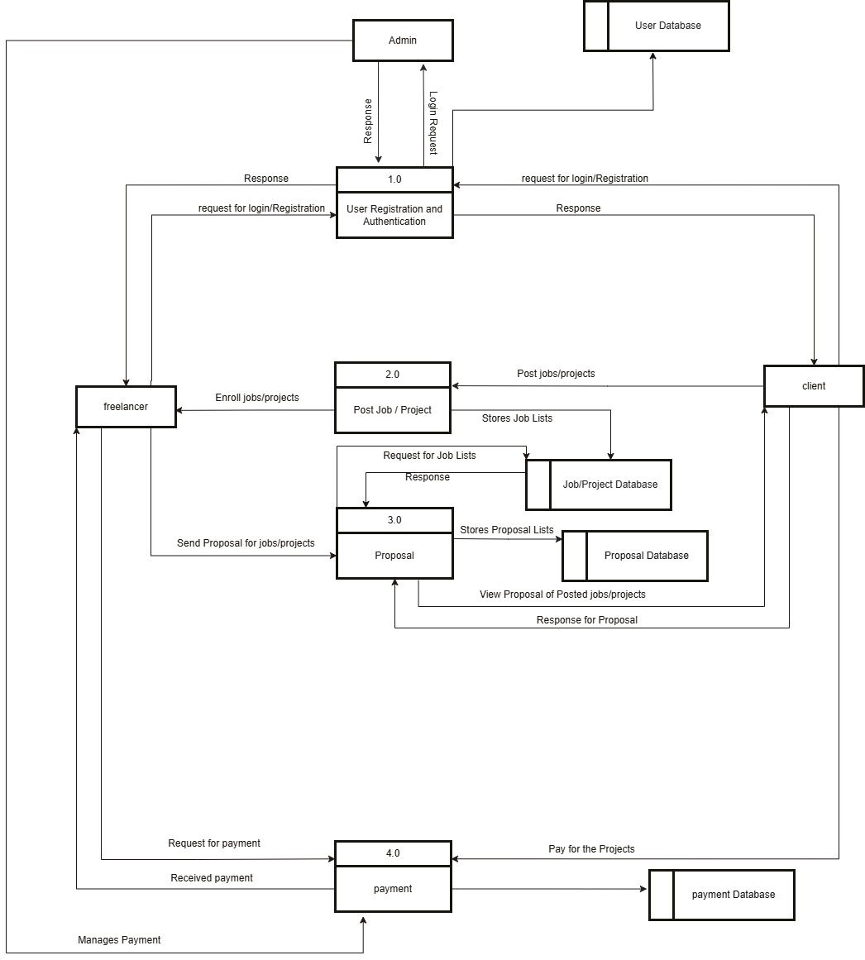
Figure 3.5: Level 1 DFD
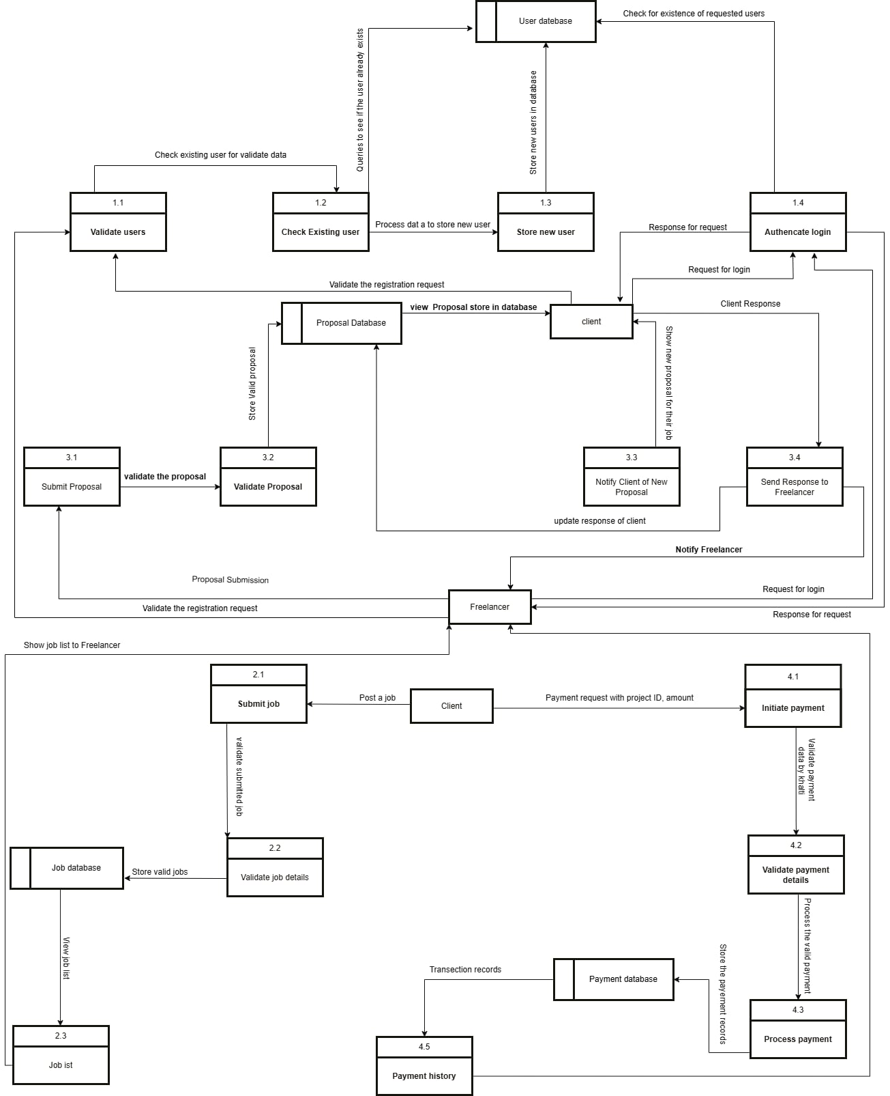Figure 3.6: Level 2 DFD

System Design
System Design is the process of defining the elements of a system such as its architecture, modules, components, the interfaces between components, and the flow of data through the system. For the SkillSwap application, system design helps in understanding the requirements and planning the software to meet the needs of users [4].
The goal of the design is to create a coherent and efficient system that allows users to exchange skills easily. In this chapter, we will discuss the modules, database design, user interface design, and program design of SkillSwap.

Architectural Design
An architectural diagram is a visual representation of a system's structure, showing how its components interact with each other. It typically illustrates the relationships between the user interface, backend logic, database, and external services, often based on a chosen design pattern. It helps stakeholders understand the overall system architecture and design.
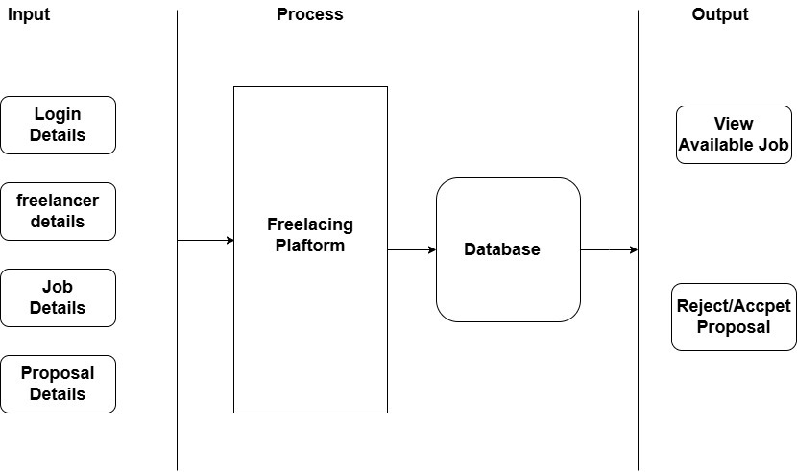
Figure 3.7 : Architectural Design.

Database Schema Design
The design of database is called a schema. This tells us about the structural view of the
database. A database schema represents the logical configuration of all or part of a
relational database. A database schema indicates show the entities that make up the
database relate to one another, including tables, views, stored procedures, and more.
Typically, a database designer creates a database schema to help programmers whose
software will interact with the database.
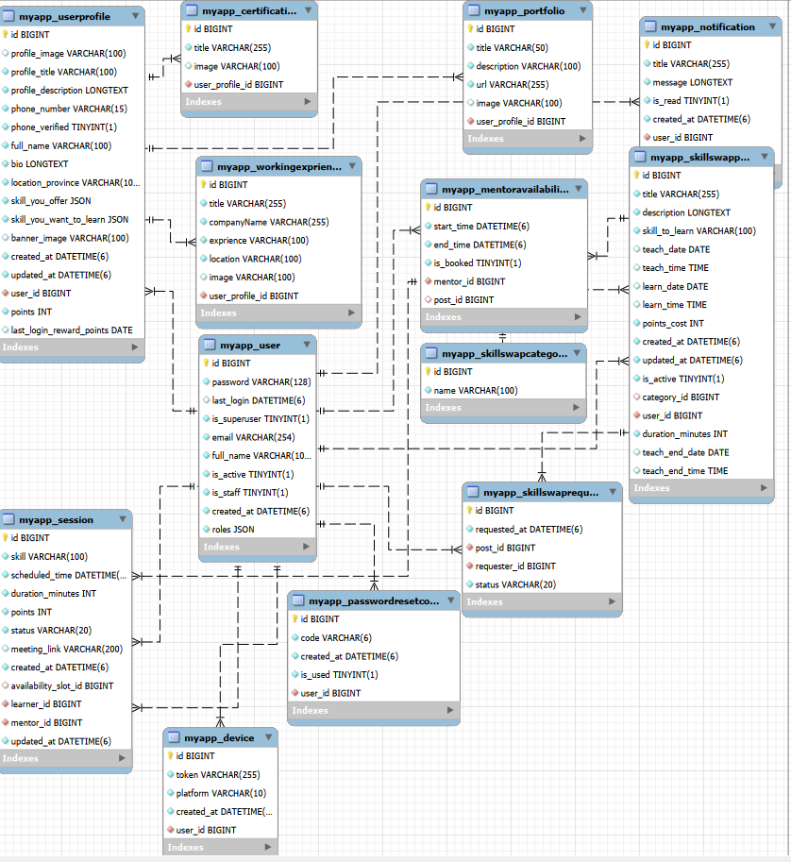

Figure 3.8: Database Schema Design

Interface Design (UI Interface / Interface Structure Diagrams)
Interface design is an important part of software development. User interface is the front-end application view to which user interacts in order to use the software. User can manipulate and control the software as well as hardware by means of user interface. UI should be as simple as possible.
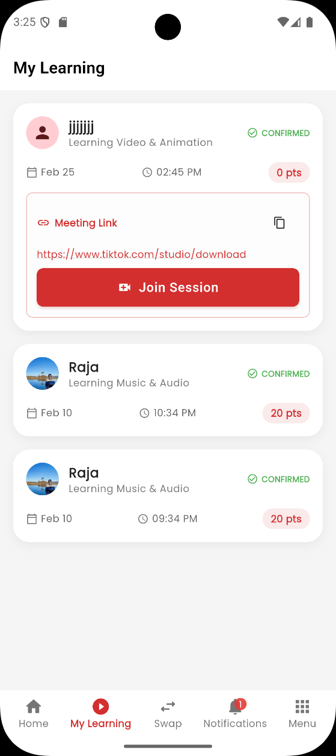
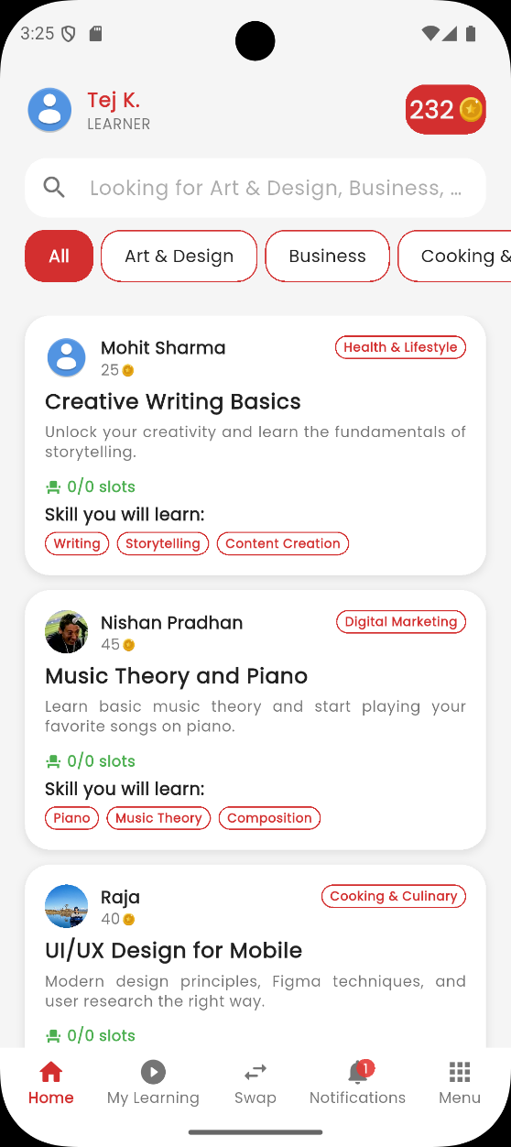
LEARNER PAGE

Figure 3.9: Home page design of learner

MENTOR DASHBOARD
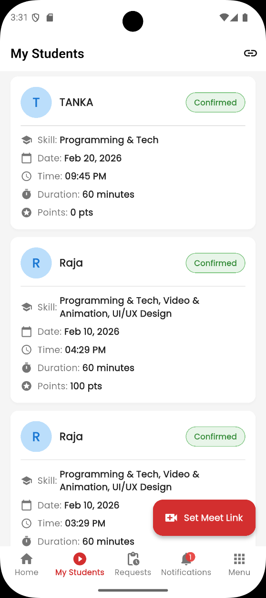
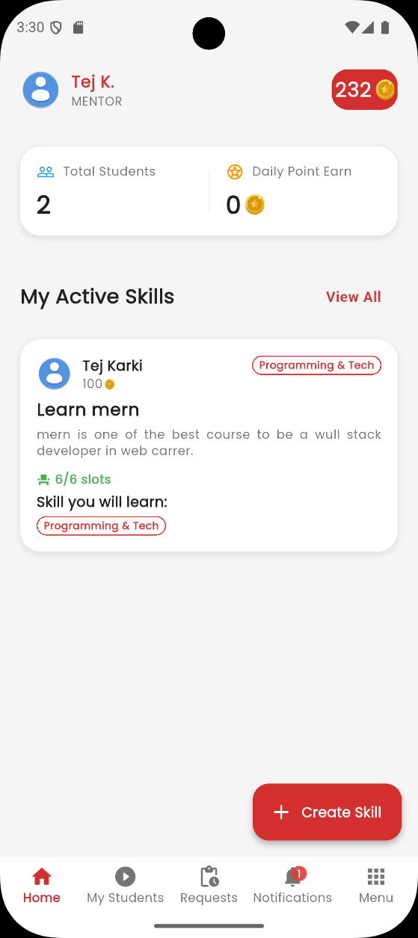

Figure 3.10: Home page design of mentor

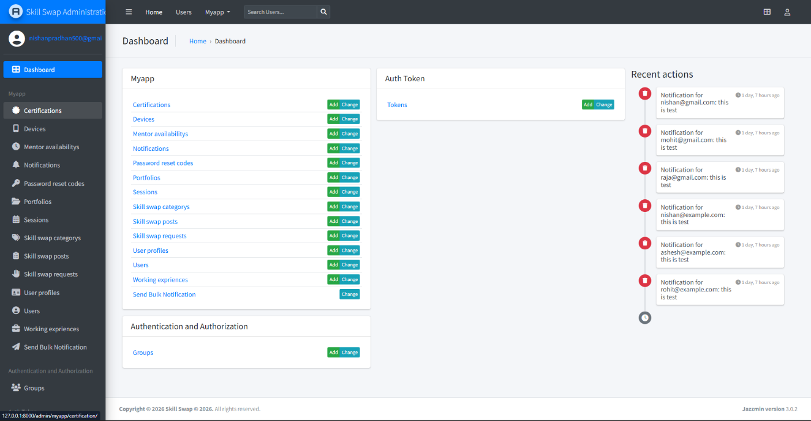
ADMIN DASHBOARD

Figure 3.10: Home page design of admin

Implementation and Testing

Implementation

Tools Used
The various system tools used in developing both the frontend and backend of the SkillSwap application are discussed in this chapter.
i. Frontend
Flutter
Flutter is an open-source UI software development toolkit developed by Google. It is used to build cross-platform applications for Android, iOS, web, and desktop from a single codebase. Flutter uses the Dart programming language and provides a rich set of pre-designed widgets to create attractive and responsive user interfaces.
Flutter allows fast development through features like hot reload, which helps developers see changes instantly during development. It ensures smooth performance and consistent design across platforms.
BLoC (Business Logic Component)
BLoC is used for state management in the SkillSwap application. It helps in separating business logic from the user interface.
Using BLoC architecture makes the application more structured, maintainable, and scalable. It ensures that the UI reacts properly to changes in data, such as updating skill listings, handling user authentication, and managing notifications.
Firebase (Push Notifications)
Firebase is used to implement push notifications in SkillSwap. Firebase Cloud Messaging (FCM) allows the system to send real-time notifications to users regarding:
- Skill match requests
- Session confirmations
- Updates and alerts

ii. Backend and Database:
Django REST Framework (DRF) is used to implement the backend of SkillSwap.
Django REST Framework
Django REST Framework is a powerful and flexible toolkit for building Web APIs using the Django framework in Python.
It is used in SkillSwap to:
- Handle user authentication and authorization
- Manage skill listings and requests
- Process skill exchange interactions
- Store and retrieve user data
- Provide secure API endpoints for the Flutter frontend
DRF supports token-based authentication, serializers for data conversion, and built-in security features, making it suitable for scalable applications.
Database
Django’s ORM (Object Relational Mapping) is used to manage the database. It allows interaction with the database using Python objects instead of writing raw SQL queries.
The database stores:
- User information
- Skills offered and requested
- Notifications
iii. Admin Panel:
Jazzmin is used to enhance the Django admin interface. Jazzmin provides a modern and user-friendly interface for administrators to manage the system.
Through the admin panel, administrators can:
- Manage users
- Approve or monitor skill listings
- View reports
- Monitor system activities
Jazzmin improves usability and makes backend management more efficient.as users and jobs, were managed using foreign keys, ensuring data consistency and integrity.

Implementation Details of Modules
Learner Module:
- Registration & Login: Learners can register and log in securely using authentication provided by Django REST Framework. Token-based authentication ensures secure access.
- Search Skills: Learners can browse and search for skills offered by mentors based on categories, keywords, or availability.
- Send Skill Request: Learners can send skill exchange or learning requests to mentors.
- View Request Status: Learners can check whether their request is accepted, rejected, or pending.
- Receive Notifications: Learners receive push notifications via Firebase for request updates, and session confirmations.
Mentor Module:
- Registration & Profile Creation: Mentors can create profiles including their expertise, skill description, and availability.
- Add and Manage Skills: Mentors can add, update, or delete skills they are willing to teach.
- View Skill Requests: Mentors can view learning requests sent by learners.
- Accept or Reject Requests: Mentors can approve or decline requests based on their availability.
- Notifications: Mentors receive real-time notifications for new requests and messages using Firebase Cloud Messaging.
Admin Module:
Manage Users: Admin can monitor, activate, deactivate, or remove learner and mentor accounts using the Django Admin panel enhanced with Jazzmin.
Manage Skills: Admin can review and manage skill listings to ensure appropriate and relevant content.
Monitor System Activity: Admin oversees user activities, skill exchanges, and overall platform performance.
Handle Reports: Admin can review reported users or inappropriate content and take necessary actions.
Database Management: Admin manages backend data through Django REST Framework and ensures system security and reliability.

Testing
Testing is the process of making sure that the software we create works properly and does
what it's supposed to do.

Test Cases for Unit Testing
Unit testing is a software development process in which the smallest testable parts of the SkillSwap application, called units, are individually and independently examined to ensure proper functionality. In this project, units include Flutter widgets, BLoC state management logic, Django REST Framework APIs, serializers, and database models.
This testing process is carried out during the development phase by developers to verify that each component performs as expected. The primary objective of unit testing in SkillSwap is to isolate individual pieces of code and validate their correctness without depending on other system components.

Table 1 : Test case for Unit Testing
Test case/ module | Test Scenario | Expected Result | Actual Result | Pass/Fail
Authentication  /Registration | Verify user valid credentials | Registration successful | User Registered successfully | pass
Authentication | Verify login with valid credentials | User login successful. | Login Successfully | pass
Freelancer Profile | Check profile creation | Move to freelancer profile if exist. | Profile created successfully | pass
Client Profile | Check profile update | Profile updates successfully | Profile updates successfully | pass
Job Posting | Create a job post | job post is created | Job is posted successfully | pass
Proposal Submitting | Submit a job proposal | Proposal is submitted | Proposal is submitted successfully | pass
Payment System | Process a payment | Payment is processed successfully | Payment successful | pass

Test Cases for System Testing
System testing evaluates the complete and integrated WorkBridge platform to ensure all modules function correctly together. It involves testing the overall workflow, including authentication, job posting, freelancer-client interactions, contract management, messaging, and payment processing. This testing phase ensures that the system behaves as expected under real-world conditions, including different user roles, load handling, and security aspects.
Table 2 :Test cases for System Testing
Test scenario | Test steps | Expected Result | Actual Result | Status(pass/fail)
User experience | Interface navigation | User navigates  accurately | User experience satisfactory | pass
Ensure job post is visible to relevant freelancer | Client posts a job, and freelancers check their dashboard | Job display in freelancers | Job post is displayed correctly to freelancers | pass
Validate the freelancer proposal/application process | A freelancer applies for a job, and the client receives the proposal or application | Proposal appears in client dashboard | Proposal is visible in client dashboard | pass
Validate proposal or accepting proposal | If a proposal is selected or approved other disappears or rejection. | Proposal is accepted | Only Single proposal can be approved and other disperse after a proposal is approved | pass

4.2.3. Bug Fixes and Iterations
- Several issues were identified during testing and resolved:
- Fixed bugs in the job posting form where invalid inputs caused crashes.
- Resolved issues with session handling during prolonged inactivity.
- Improved the efficiency of database queries to optimize load times.

Conclusion and Future works

Lessons Learned / Outcome
The development of the Work Bridge project provided significant insights and practical experience in software engineering. Key takeaways include:
- Understanding the complete software development lifecycle, from requirement gathering to deployment.
- Enhanced skills in using Laravel for backend development and integrating it seamlessly with MySQL for data management.
- Improved proficiency in frontend technologies such as HTML, CSS, JavaScript, and Bootstrap to create a responsive and user-friendly interface.
- Practical experience with version control systems like GitHub, fostering collaborative development among team members.
- Gained expertise in designing system architectures and implementing secure, scalable web applications.

Conclusion
The Work Bridge project successfully achieved its objectives by providing a platform that connects clients and freelancers efficiently. The system allows clients to post jobs, review proposals, and manage payments seamlessly. Freelancers benefit from the ability to apply for jobs, manage contracts, and receive payments securely. The admin module ensures smooth platform management, fostering trust and compliance among users. The project stands as a comprehensive solution for freelance job management.
Key accomplishments include:
- Development of a robust, user-centric platform with a clear separation of concerns for clients, freelancers, and administrators.
- Implementation of a secure payment system, ensuring financial transactions are reliable and transparent.
- Creation of a responsive and intuitive interface that enhances user experience across devices.

Future Recommendations
To further enhance the Work Bridge platform, the following recommendations are proposed:
- Advanced Search and Filtering: Implement advanced filters for job searches, such as filtering by budget, location, and skill requirements.
- Analytics Dashboard: Provide clients and freelancers with analytics dashboards to track job performance, earnings, and other metrics.
- Enhanced Security Measures: Implement additional security features, such as two-factor authentication, to ensure data protection and user privacy.
- Feedback and Rating System: Introduce a robust feedback mechanism to promote transparency and trust within the platform.

References

[1] | Y. Kotturi, "Community-Based Approaches to Building Peer Support Systems for Work.," Community-Based Approaches to Building Peer Support Systems for Work., 2022.
[2] | A. Ali, "Decentralised Escrow Protocol that Facilitates Secure Transactions between Trustless Parties," in Proceedings of the International Conference on Innovative Computing & Communication (ICICC), 2022.
[3] | R. a. K. M. Hasan, "implementation of WebRTC (Web based Real Time Communication) solution for On Premise Video Conferencing System.," implementation of WebRTC (Web based Real Time Communication) solution for On Premise Video Conferencing System., 2021.
[4] | "Determinants of client satisfaction in web development projects from freelance marketplaces," International Journal of Managing Projects in Business , vol. 11.3, pp. 583-607., 2018 May 17.
[5] | P. D. M. Celestin, "Exploring the growth of freelance and gig workforces: Impacts on employment models and business risks," in University of Rwanda, 2024.
[6] | P. R. Stahl, "Building Resilient Digital Labor Platforms: Strategic Approaches to Retain and Empower Online Freelancers.," 15th of May 2023.
[7] | A. F. H. a. G. S. Mahomodally, "bidding system freelancing," An Enhanced Freelancer Management System with Machine Learning-based Hiring, vol. 9.3, pp. 34-41., 2022.
[8] | upwork, "upwork," Upwork. (n.d.). How Upwork Works. Retrieved from , [Online]. Available: https://www.upwork.com/.
[9] | "Freelancer. (n.d.).," About Freelancer: Connecting Employers and Freelancers. Retrieved from, [Online]. Available: www.freelancer.com.
[10] | "Fiverr. (n.d.).," How Fiverr Works: An Overview. Retrieved from , [Online]. Available: www.fiverr.com.
[11] | C. Shubham, "The Gig Economy: Navigating Complexities in Human Resource Management.," The Gig Economy: Navigating Complexities in Human Resource Management..
[12] | S. Chitte, "The Gig Economy: Navigating Complexities in Human Resource Management."," The Gig Economy: Navigating Complexities in Human Resource Management.".

APPENDIX 1: UI SCREENSHOTS

APPENDIX 2: SOURCE CODE
<!doctype html>
<html lang="en">
<head>
<meta charset="utf-8">
<meta name="viewport" content="width=device-width, initial-scale=1, shrink-to-fit=no">
<link rel="stylesheet" href="https://cdn.jsdelivr.net/npm/bootstrap@4.4.1/dist/css/bootstrap.min.css" integrity="sha38Vkoo8x4CGsO3+Hhxv8T/Q5PaXtkKtu6ug5TOeNV6gBiFeWPGFN9MuhOf23Q9Ifjh" crossorigin="anonymous">
<link rel="icon" href="favicon.png" type="image/png">
<title>WorkBridge - Freelancing</title>
<link rel="stylesheet" href="{{ asset('css/style.css') }}">
</head>
<body>
<!-- navbar component -->
@include('components.navigation_bar')
<div class="hero-sections bg-light ">
<div class="detail">
<div class="col-lg-10 ">
<h1 class="display-5 font-weight-bold text-dark">Are you Looking for Freelancers?</h1>
<p class="mt-3 lead text-muted"> Hire Great Freelancers, Fast. Spacelance helps you hire elite freelancers at a moment's notice.
</p>
</div>
<div class="text-left">
<a href="/get-started" class="btn btn-primary btn-lg active " role="button" aria-pressed="true">Hire Freelacner</a>
</div>
</div>
<div class="banner">
<lottie-player
src="https://lottie.host/7a77e23a-99ef-48cf-93a7-bacc2358c156/DPjzPgiwZn.json"
background="transparent"
speed="1"
style="width: 500px; height: 500px"
loop
autoplay
direction="1"
mode="normal">
</lottie-player>
</div>
</div>
<div class="ways">
<div class="ways-image">
<img src="landingGirl.png" alt="">
</div>
<div class="ways-text">
<h1>Find The Best <br><span style="color:blue;">Freelancers</span> Here</h1>
<p>Lorem ipsum dolor sit, amet consectetur adipisicing elit. Corporis veniam perferendis animi voluptatum dolorum hic, porro et vitae. </p>
</div>
</div>
<!-- portfolios card -->
<div class="portfolio-container">
<div class="portfolio-head">
<p id="p-top">Logos,websites,book & mores!</p>
<p id="p-down">Checkout The Best <span style="color:#00A4EF;">Portfolios </span>Here</p>
</div>
<div class="portfolios">
<div class="portfolio">
<div class="image-box">
<img src="bunny.webp" alt="">
</div>
<div class="text">
<p id="name">Bunny.desin</p>
<p id="job">UI/UX Designer</p>
</div>
</div>
<div class="portfolio">
<div class="image-box">
<img src="nishan.jpg" alt="">
</div>
</div>
<div class="portfolio">
<div class="image-box">
<img src="teaser.jpg" alt="">
</div>
<div class="text">
<p id="name">Teaser</p>
<p id="job">Graphic Desiner</p>
</div>
</div>
</div>
</div>
<div class="subscription-container">
<p id="s-top">Newsletter Subscription</p>
<p id="s-down">Susribe to our newsletter to get new freelencer work and project</p>
<input id="email" type="email" placeholder="Enter your address"></br>
<button id="subscribe">subscribe</button>
</div>
<h2 class="text-center my-4">Our Platform's Achievements</h2>
<div class="container-fluid stats-section">
<div class="container">
<div class="row text-center">
<div class="col-md-3 stats-divider">
<div class="stats-number">1200</div>
<div class="stats-label">PROJECTS COMPLETED</div>
</div>
<div class="col-md-3 stats-divider">
<div class="stats-number">500+</div>
<div class="stats-label">REGISTERED FREELANCERS</div>
</div>
<div class="col-md-3 stats-divider">
<div class="stats-number">900</div>
<div class="stats-label">SATISFIED CLIENTS</div>
</div>
<div class="col-md-3">
<div class="stats-number">10</div>
<div class="stats-label">YEARS IN OPERATION</div>
</div>
</div>
</div>
</div>
<script src="https://unpkg.com/@lottiefiles/lottie-player@2.0.8/dist/lottie-player.js"></script>
<!-- footer components -->
@include('components.footer')
</body>
</html>

