**SQL_ASSIGNMENT:**

**Worker Table:**

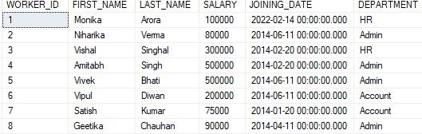

**Bonus Table:**

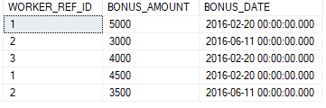

**Title Table:**

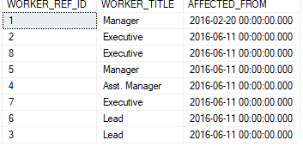

**Q-1. Write an SQL query to fetch “FIRST_NAME” from Worker table using the alias name as <WORKER_NAME>.**

Query: select FIRST_NAME as WORKER_NAME from Worker;

OUTPUT:

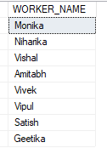

**Q-2. Write an SQL query to fetch “FIRST_NAME” from Worker table in upper case.**

QUERY: select UPPER(FIRST_NAME) as WORKER_NAME from Worker;

OUTPUT:

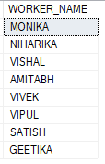

**Q-3. Write an SQL query to fetch unique values of DEPARTMENT from Worker table.**

QUERY: select distinct DEPARTMENT from Worker;

OUTPUT:

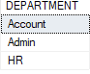

**Q-4. Write an SQL query to find the position of the alphabet (‘a’) in the first name column ‘Amitabh’ from Worker table.**

QUERY: select charindex('a',(select FIRST_NAME from Worker where FIRST_NAME='Amitabh')) as INDEXOF;

OUTPUT:



**Q-5. Write an SQL query that fetches the unique values of DEPARTMENT from Worker table and prints its length.**

QUERY: select DEPARTMENT,COUNT(DEPARTMENT) as DCOUNT,LEN(DEPARTMENT) as DLENGTH from Worker Group by DEPARTMENT;

OUTPUT:

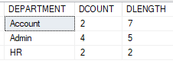

**Q-6. Write an SQL query to print details of the Workers whose FIRST_NAME ends with ‘a’.**

QUERY: select * from Worker where FIRST_NAME like '%a';

OUTPUT:

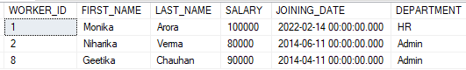

**Q-7. Write an SQL query to print details of the Workers whose SALARY lies between 100000 and 500000.**

QUERY: select * from Worker where SALARY between 100000 and 500000;

OUTPUT:

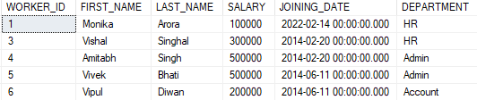

**Q-8. Write an SQL query to print details of the Workers who have joined in Feb’2014.**

QUERY: select * from Worker where year(JOINING_DATE)=2014 and MONTH(JOINING_DATE)=02;

OUTPUT:

