# Writeup

<https://github.com/N4NU/Reversing-Challenges-List/blob/master/Baby/Sharif_University_CTF_2016_dMd/README.md>

Takes user input and md5 probably:

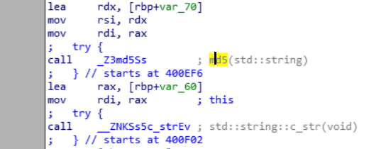

And checking section

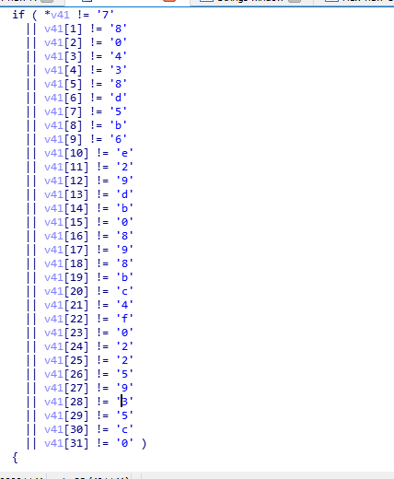

Checked it online and found this

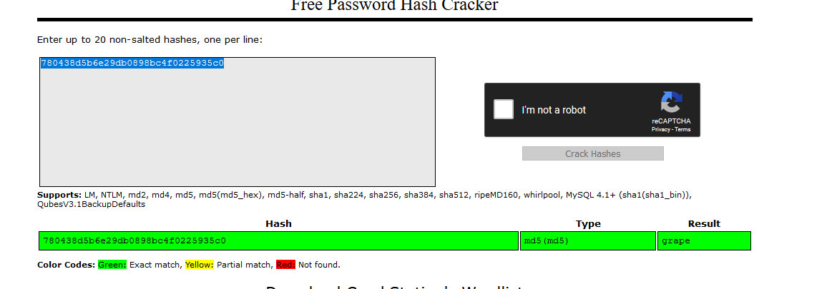

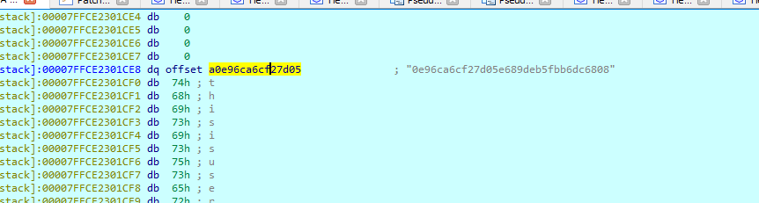

IT seems hash collision grape has md5 b781cbb29054db12f88f08c6e161c199, but when bruteforcing 780438d5b6e29db0898bc4f0225935c0 also is grape LOL!!!.

WOOH HOOH, it seems the cracstation had the problem, when bruteforcing with it the passwoed was grape, but when using <https://md5decrypt.net/en/> the password was b781cbb29054db12f88f08c6e161c199.