Now lets go to the client.

A function that we did not add.

Similar, net.Dial = net_Dial(“tcp”,3,” localhost:8080”,14), Also return value error in rsp+0x30. Compared with zero, if zero jump (no error)

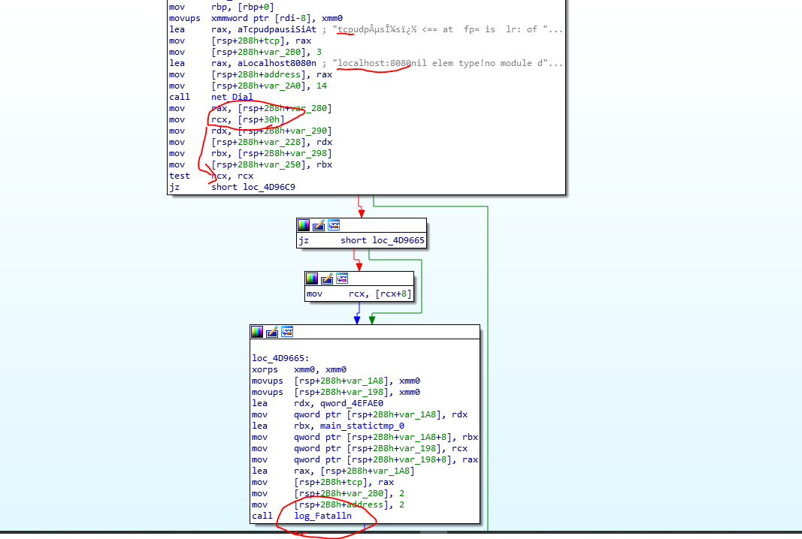

Similar defer in code.

While we made many call to get input about the user environment, but in the compiled form a single function called everything. The official documentation explains that the function returns a pointer to structure which holds pointer to three strings

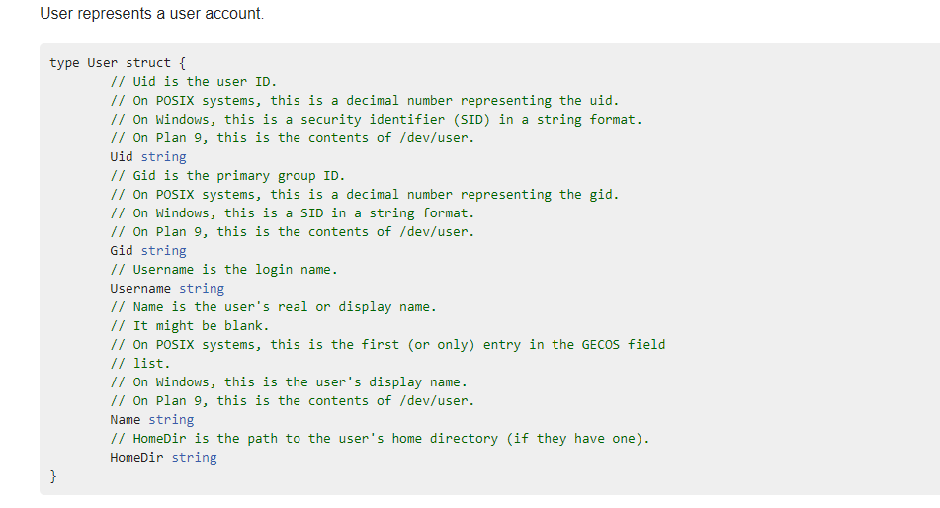

<https://golang.org/pkg/os/user/#User>

The return value is in top of stack.

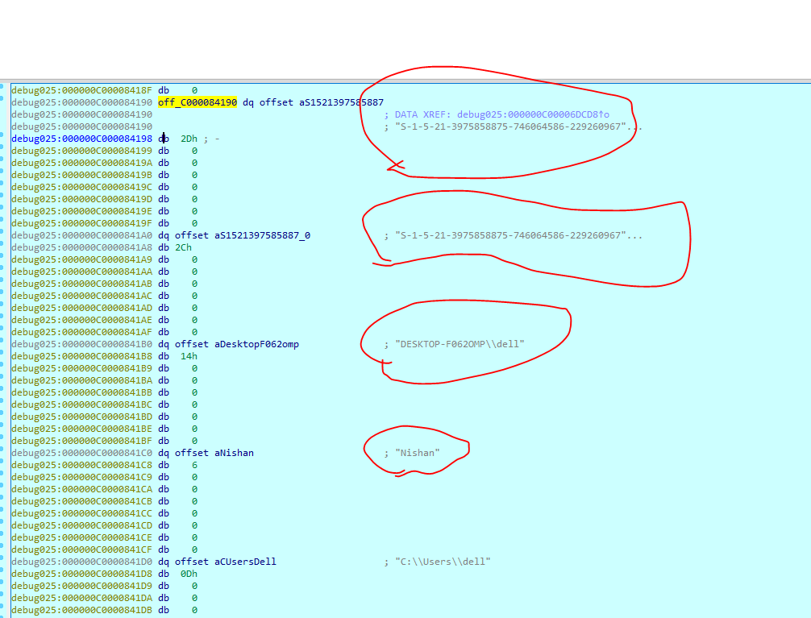

To concat strings runtime_concatstrings, judging by the arguments

runtime_concatstrings(pointer to dest, pointer to source)

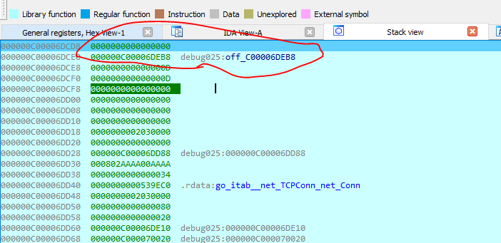

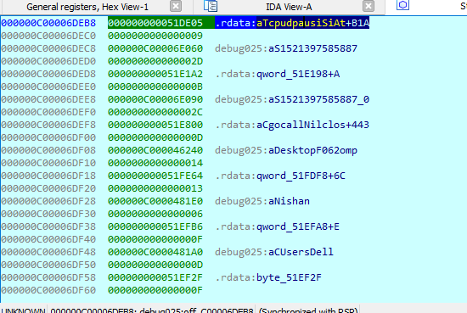

Then we see a call to runtime_convI2I, passed , main_statictmp_5 (points to )

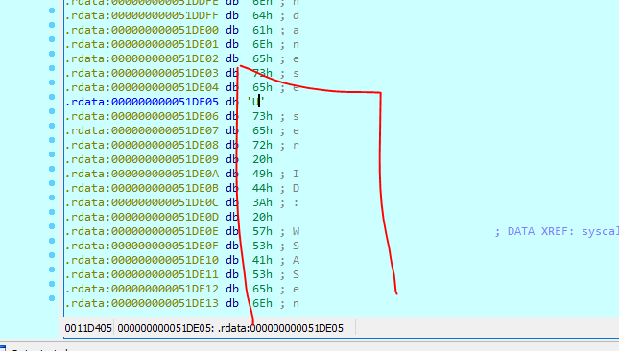

which then used in io_writestring()

After that this is similar to server.exe ,except for something different where the servers input is executed .

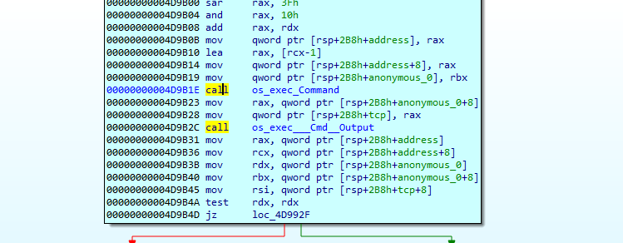

Os_exec_command, returns the command structure,

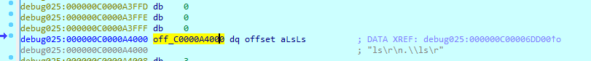

The os_exec___Cmd__Output() which returns output and sends to server, similar to server.exe. First args holds the buffer.



<https://golang.org/pkg/os/exec/#Cmd.Output>

<https://golang.org/pkg/os/exec/>