DFD

Level 1 Context Diagram for e-Panchayat

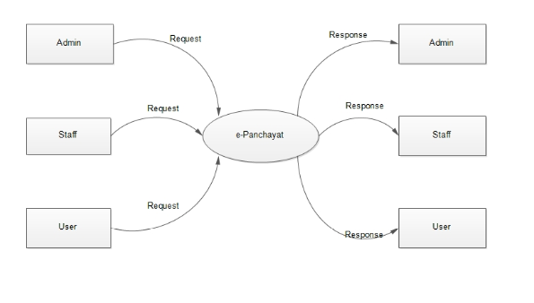

Level1 DFD for e-Panchayat Admin

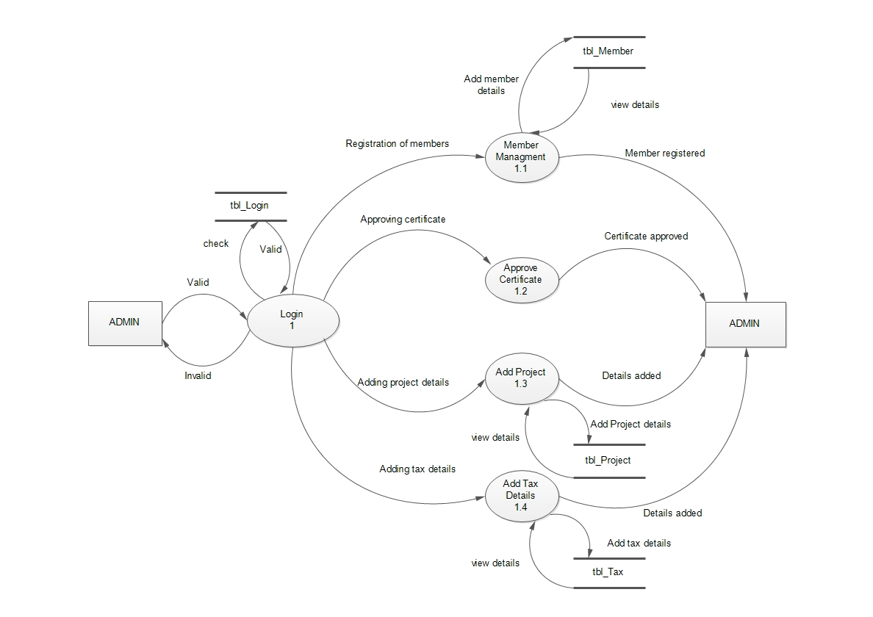

Level 1 DFD for e-Panchayat Staff

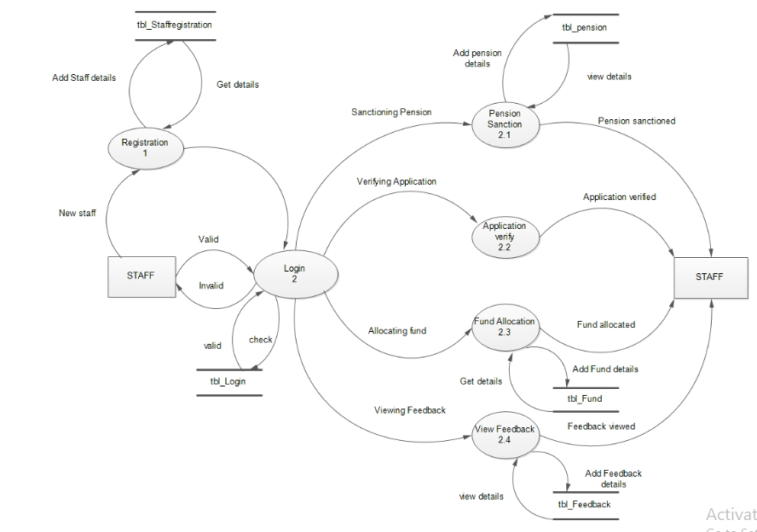

Level 1 DFD for User

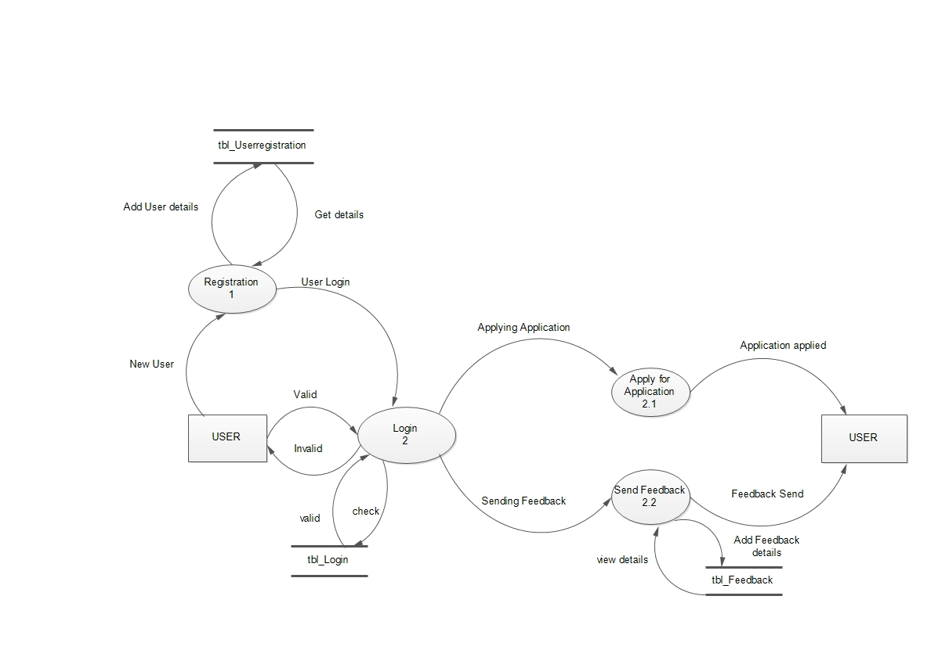

Level 2 DFD for Admin

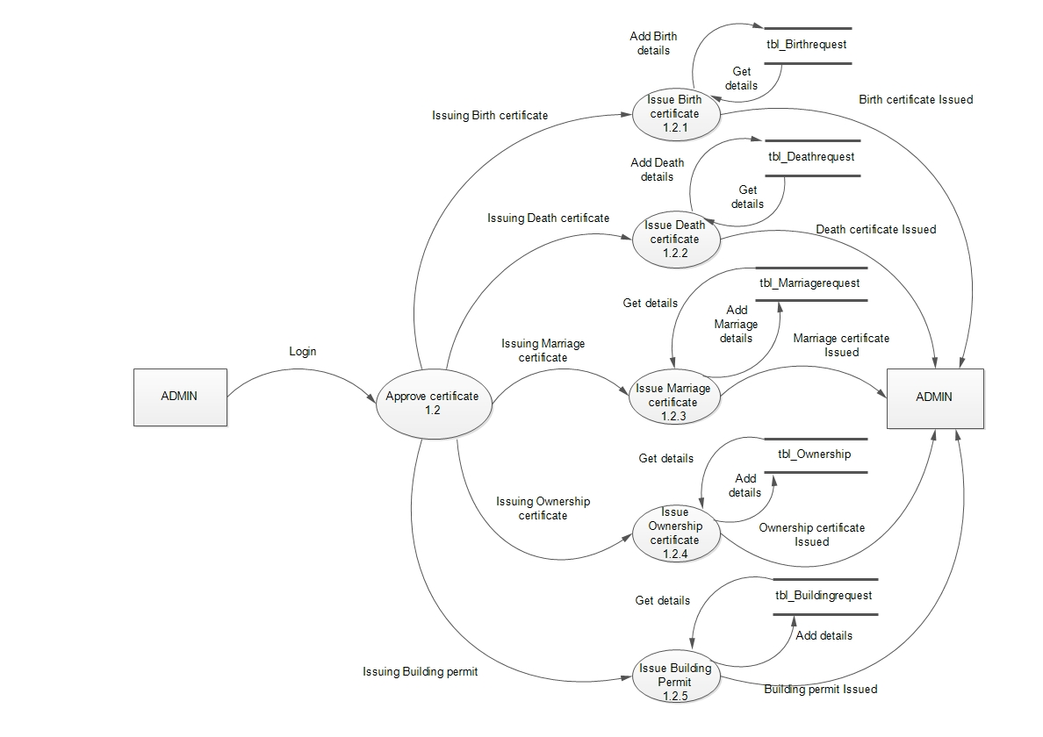

Level 2 DFD for Staff

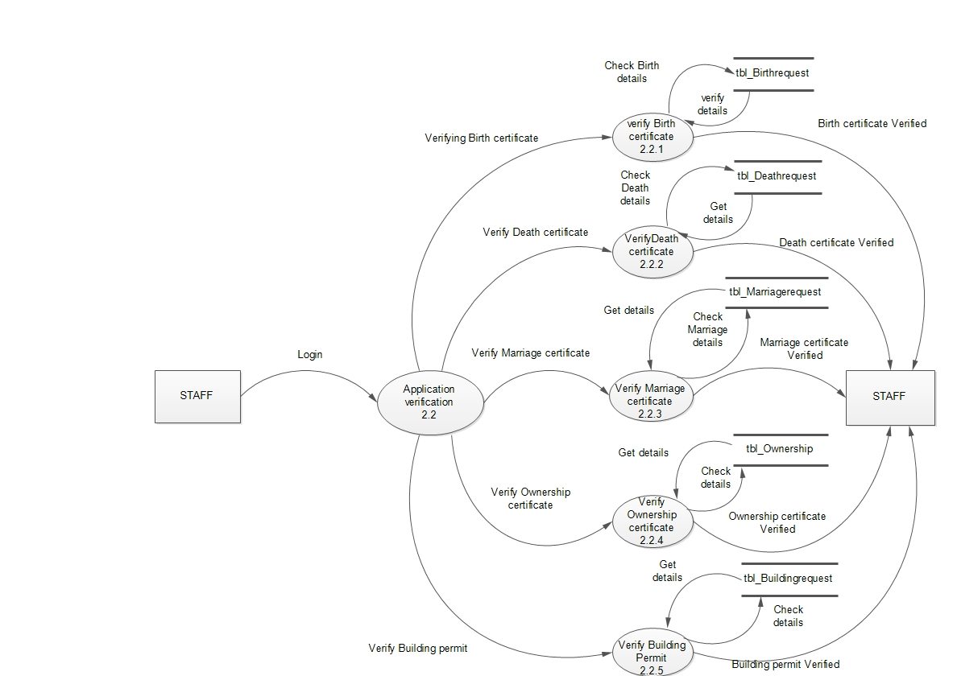

Level 2 DFD for User

