# REQUIREMENTS

**Language Used:**

* Web Application
* Front-End: HTML, CSS, Bootstrap, JavaScript, JQuery
* Backend:
  + Node.js, 🡺 <https://nodejs.org/en/>
  + Express (framework), 🡺 <https://expressjs.com/>
  + Socket.io (library) 🡺 <https://socket.io/>

**Editor and system installation:**

* The app was worked on using Sublime Text so no special IDE is required.
* The app should be viewed on a web browser, any web browser would do.
* The app needs to be started on the terminal for that:
  + Install Node JS (see above link)
  + Navigate to my project folder and just do *npm install* as my application contains package.json file which indicates all the libraries used.
  + Then just type **npm start** in the terminal

**Screenshots and Working:**

1. Step one initiate the server from the terminal

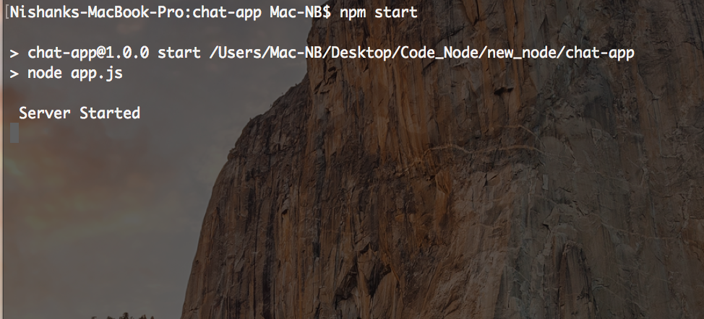

1. Step two open two web browser side by side and enter localhost:3000 as the url then enter the username and join in.

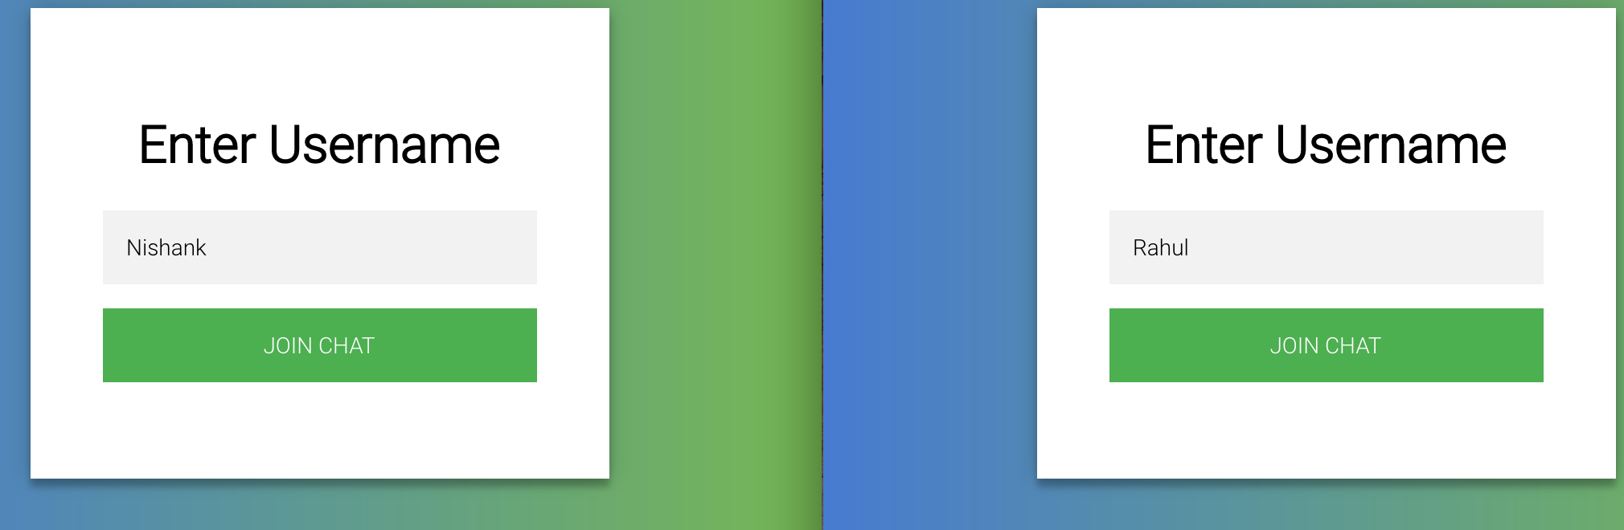

1. Step 3 on the right side is the user login detail. You can see the people that are logged in the system. Enter the name to chat with, to start the chat initiation.

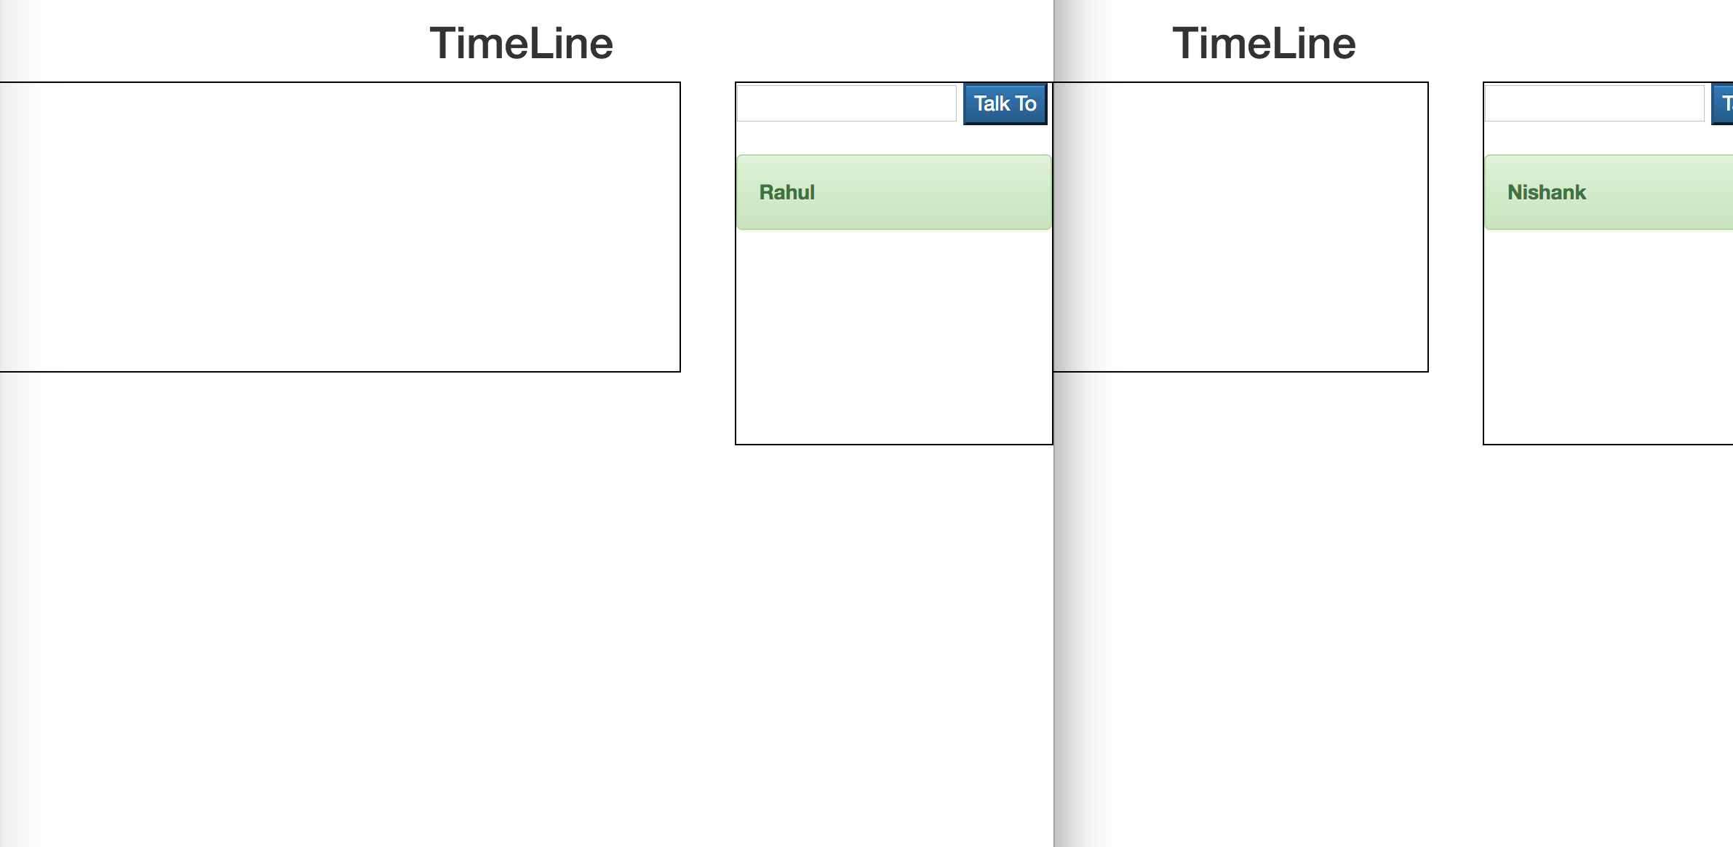

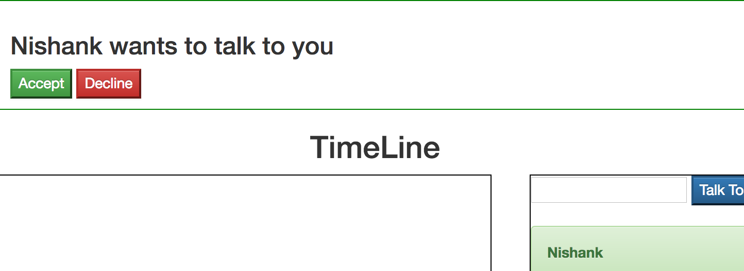

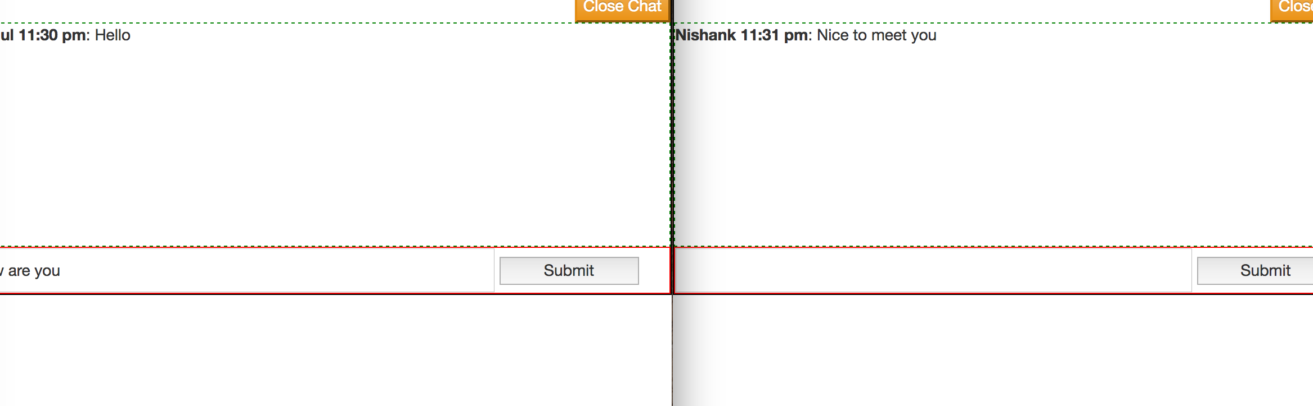

* As you can see above the user has to accept the invitation to start chatting.

1. Now open a new tab/window and enter a new user.

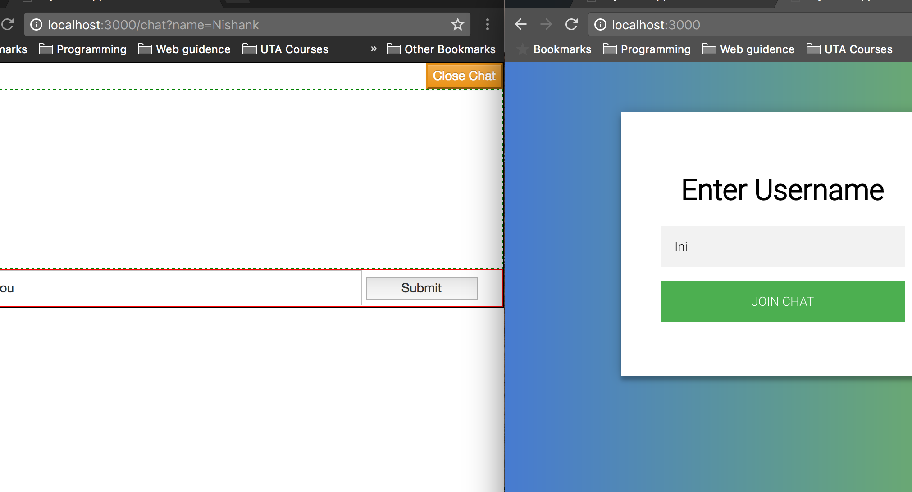

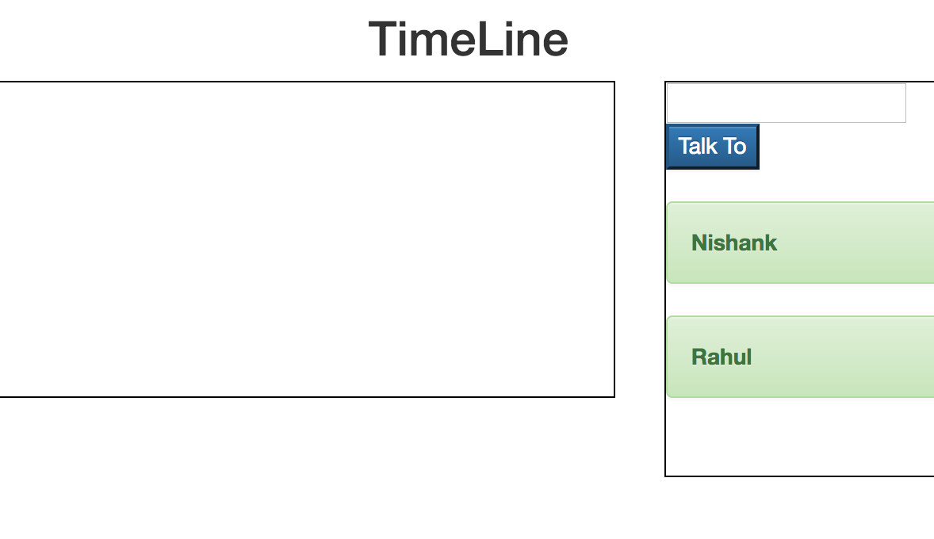

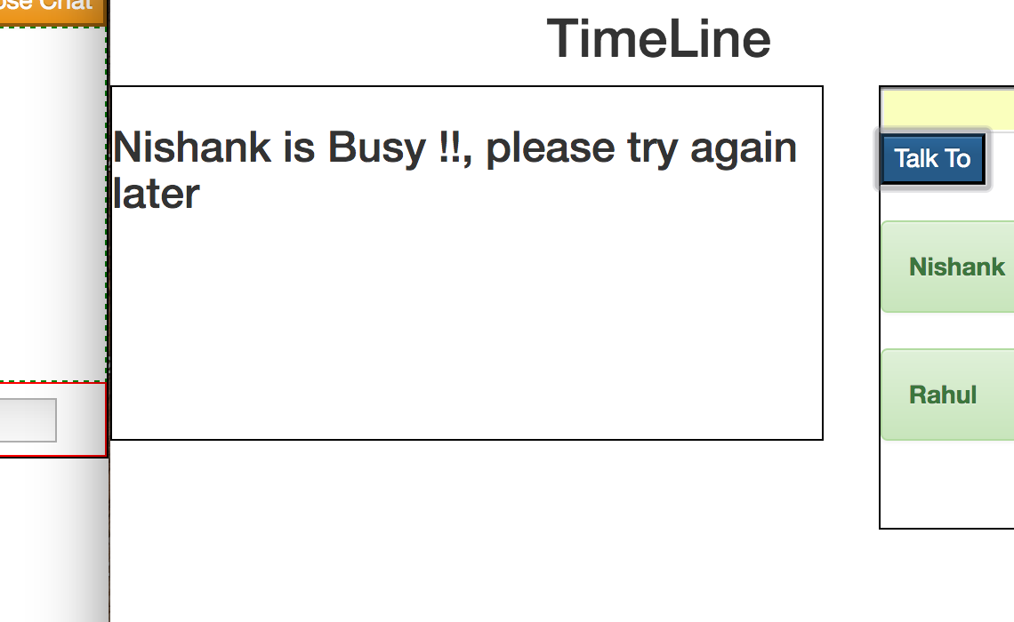

* If the client tries to talk to a client who is engaged the client will get an error message.

1. Close the window to leave the system.

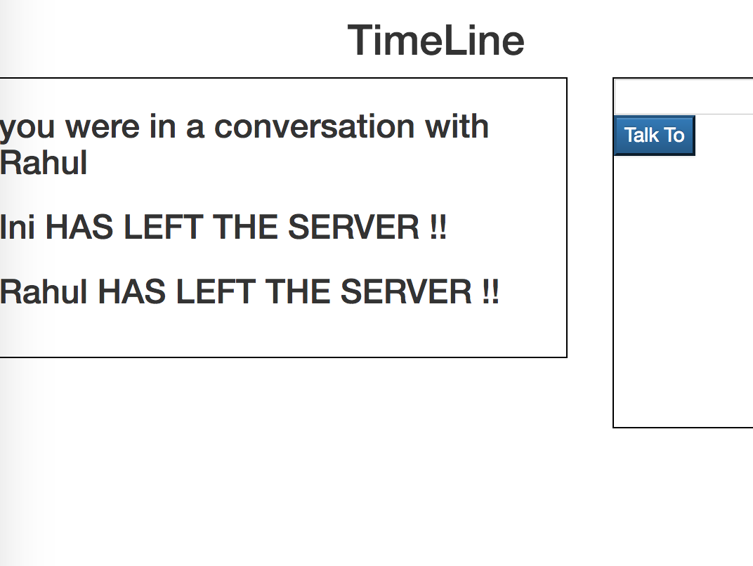

# **Citation**

* The login page was taken from : <http://codepen.io/colorlib/pen/rxddKy>
* The whole application was build from ground up by me.
* There is a lot of scope for improvement and if time persist it can be a full production level chat application.

Thank You and Regards