# **DOCUMENTATION**

**Project Done By: Nishank Bhatnagar**

**Student ID: 1001397098**

**Description:**

This Project is about Ring Election Algorithm taught in Distributed Systems class.

This was implemented as a Web Application with complete GUI. The complete project was done by me from scratch and no code was taken from online. The frameworks and libraries that I used is mentioned below.

**Technologies Used:**

* Web Application
* Front-End:
  + HTML, CSS, JavaScript,
  + Bootstrap <http://getbootstrap.com/>
  + JQuery <https://jquery.com/>
* Backend:
  + Node.js <https://nodejs.org/en/>
  + Express <https://expressjs.com/>
  + Socket.io <https://socket.io/>

**Editor and system installation:**

* The app was worked on using Atom so no special IDE is required.
* The app should be viewed on a web browser, any web browser would do.
* The app needs to be started on the terminal for that:
  + Install Node JS (see above link)
  + Navigate to my project folder and just do npm install as my application contains package.json file which indicates all the libraries used.
  + Then type **“npm start”** in the terminal

**Screenshot**

* Start the server by typing npm start after you navigate to the folder

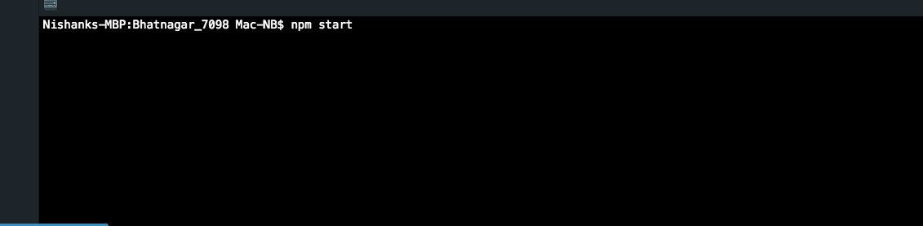

* Type localhot:3000 on a web browser to open the application

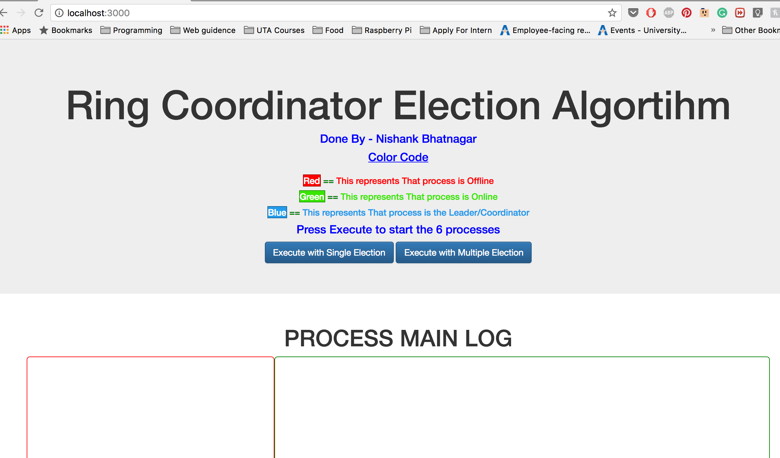

* Press Execute with single Process or Multiple process to check either of those
* The Process will initiate timely and until the last process is connected will conduct the election

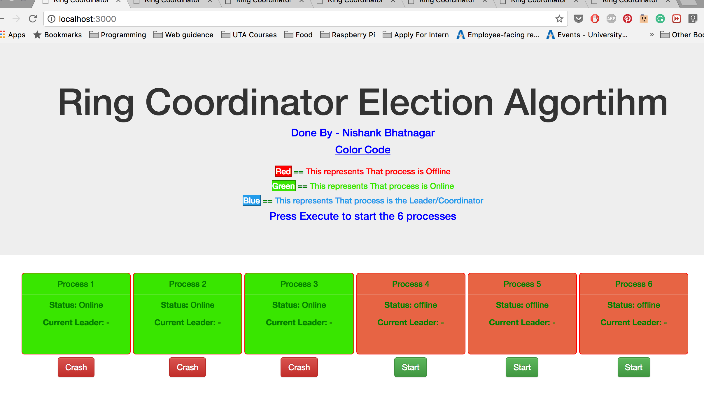

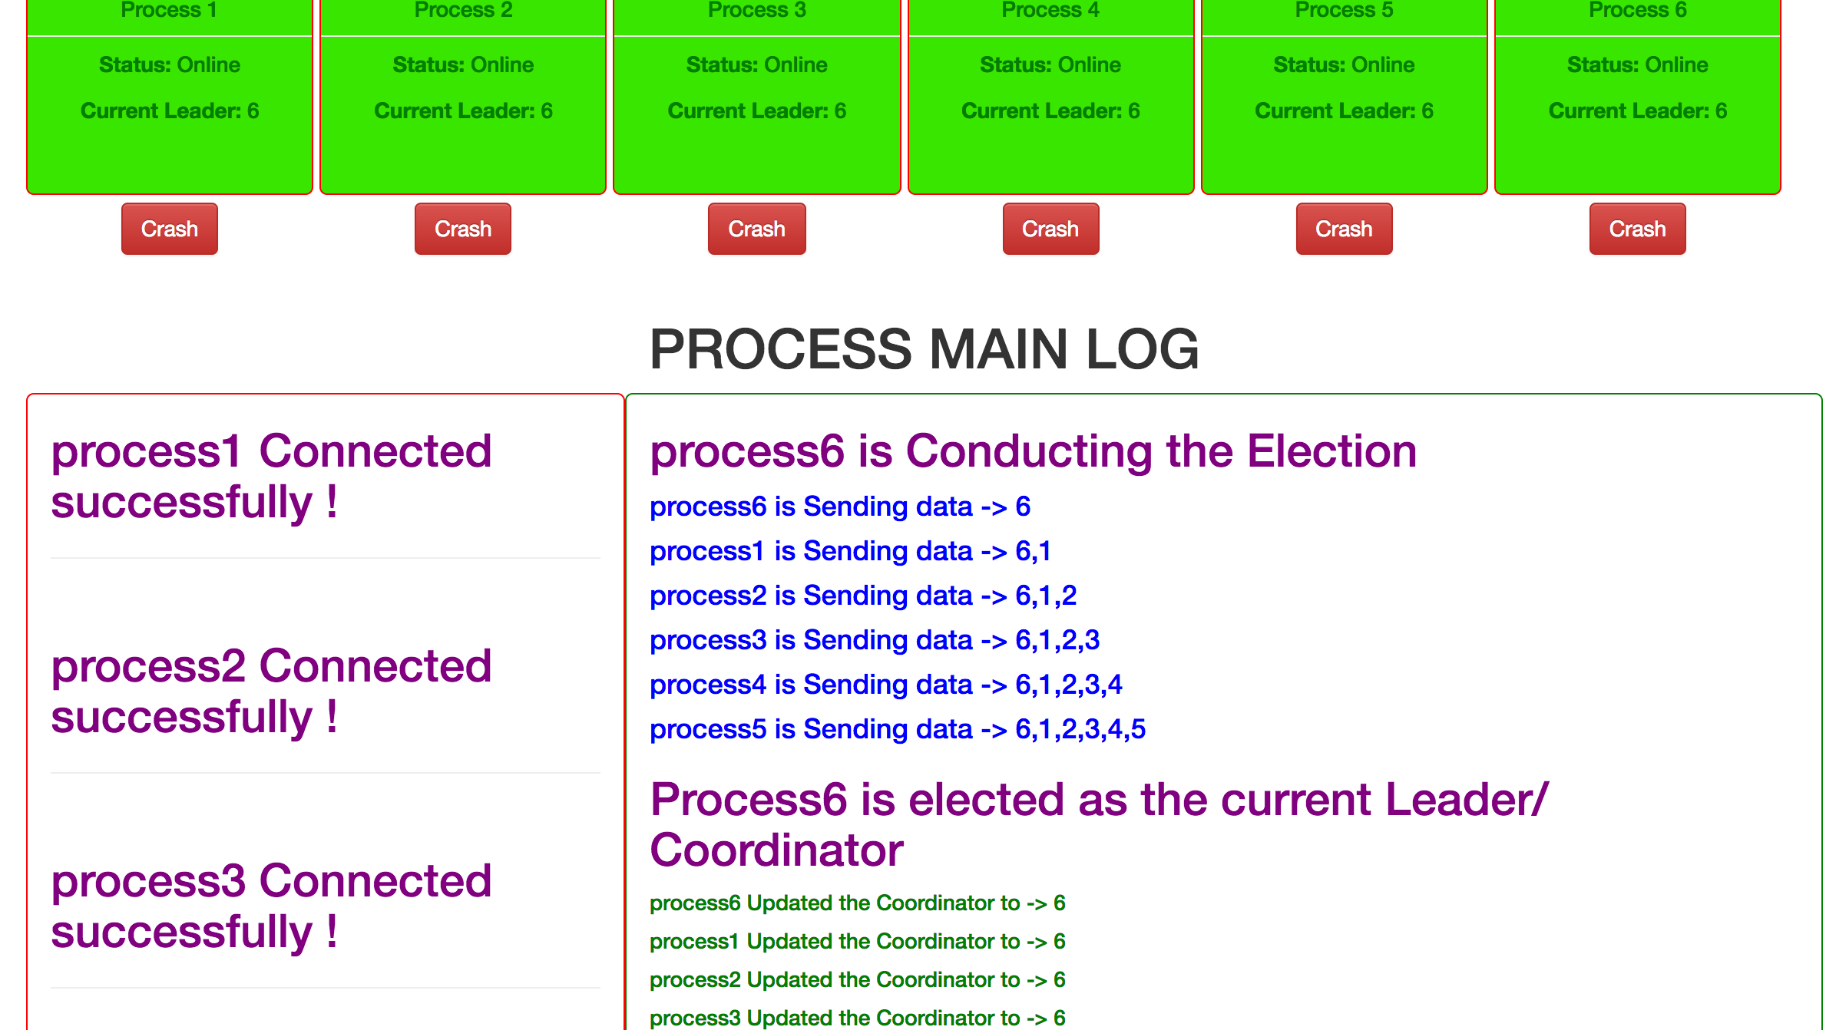

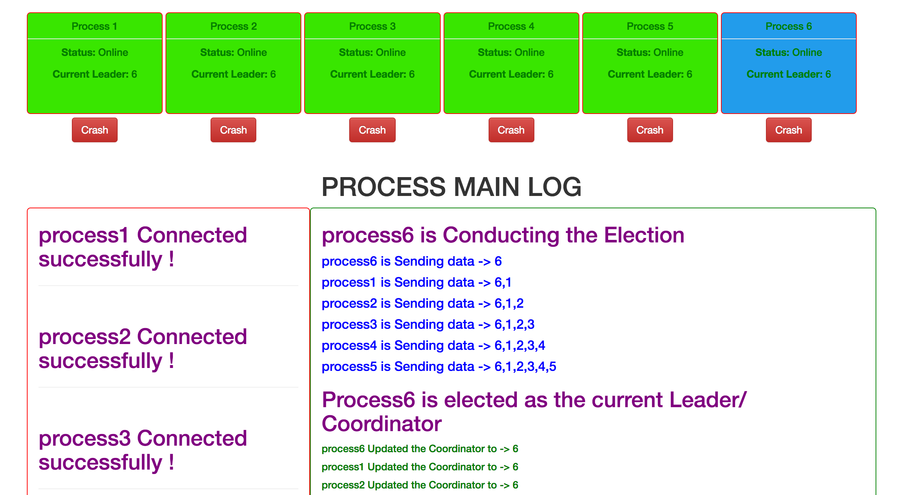

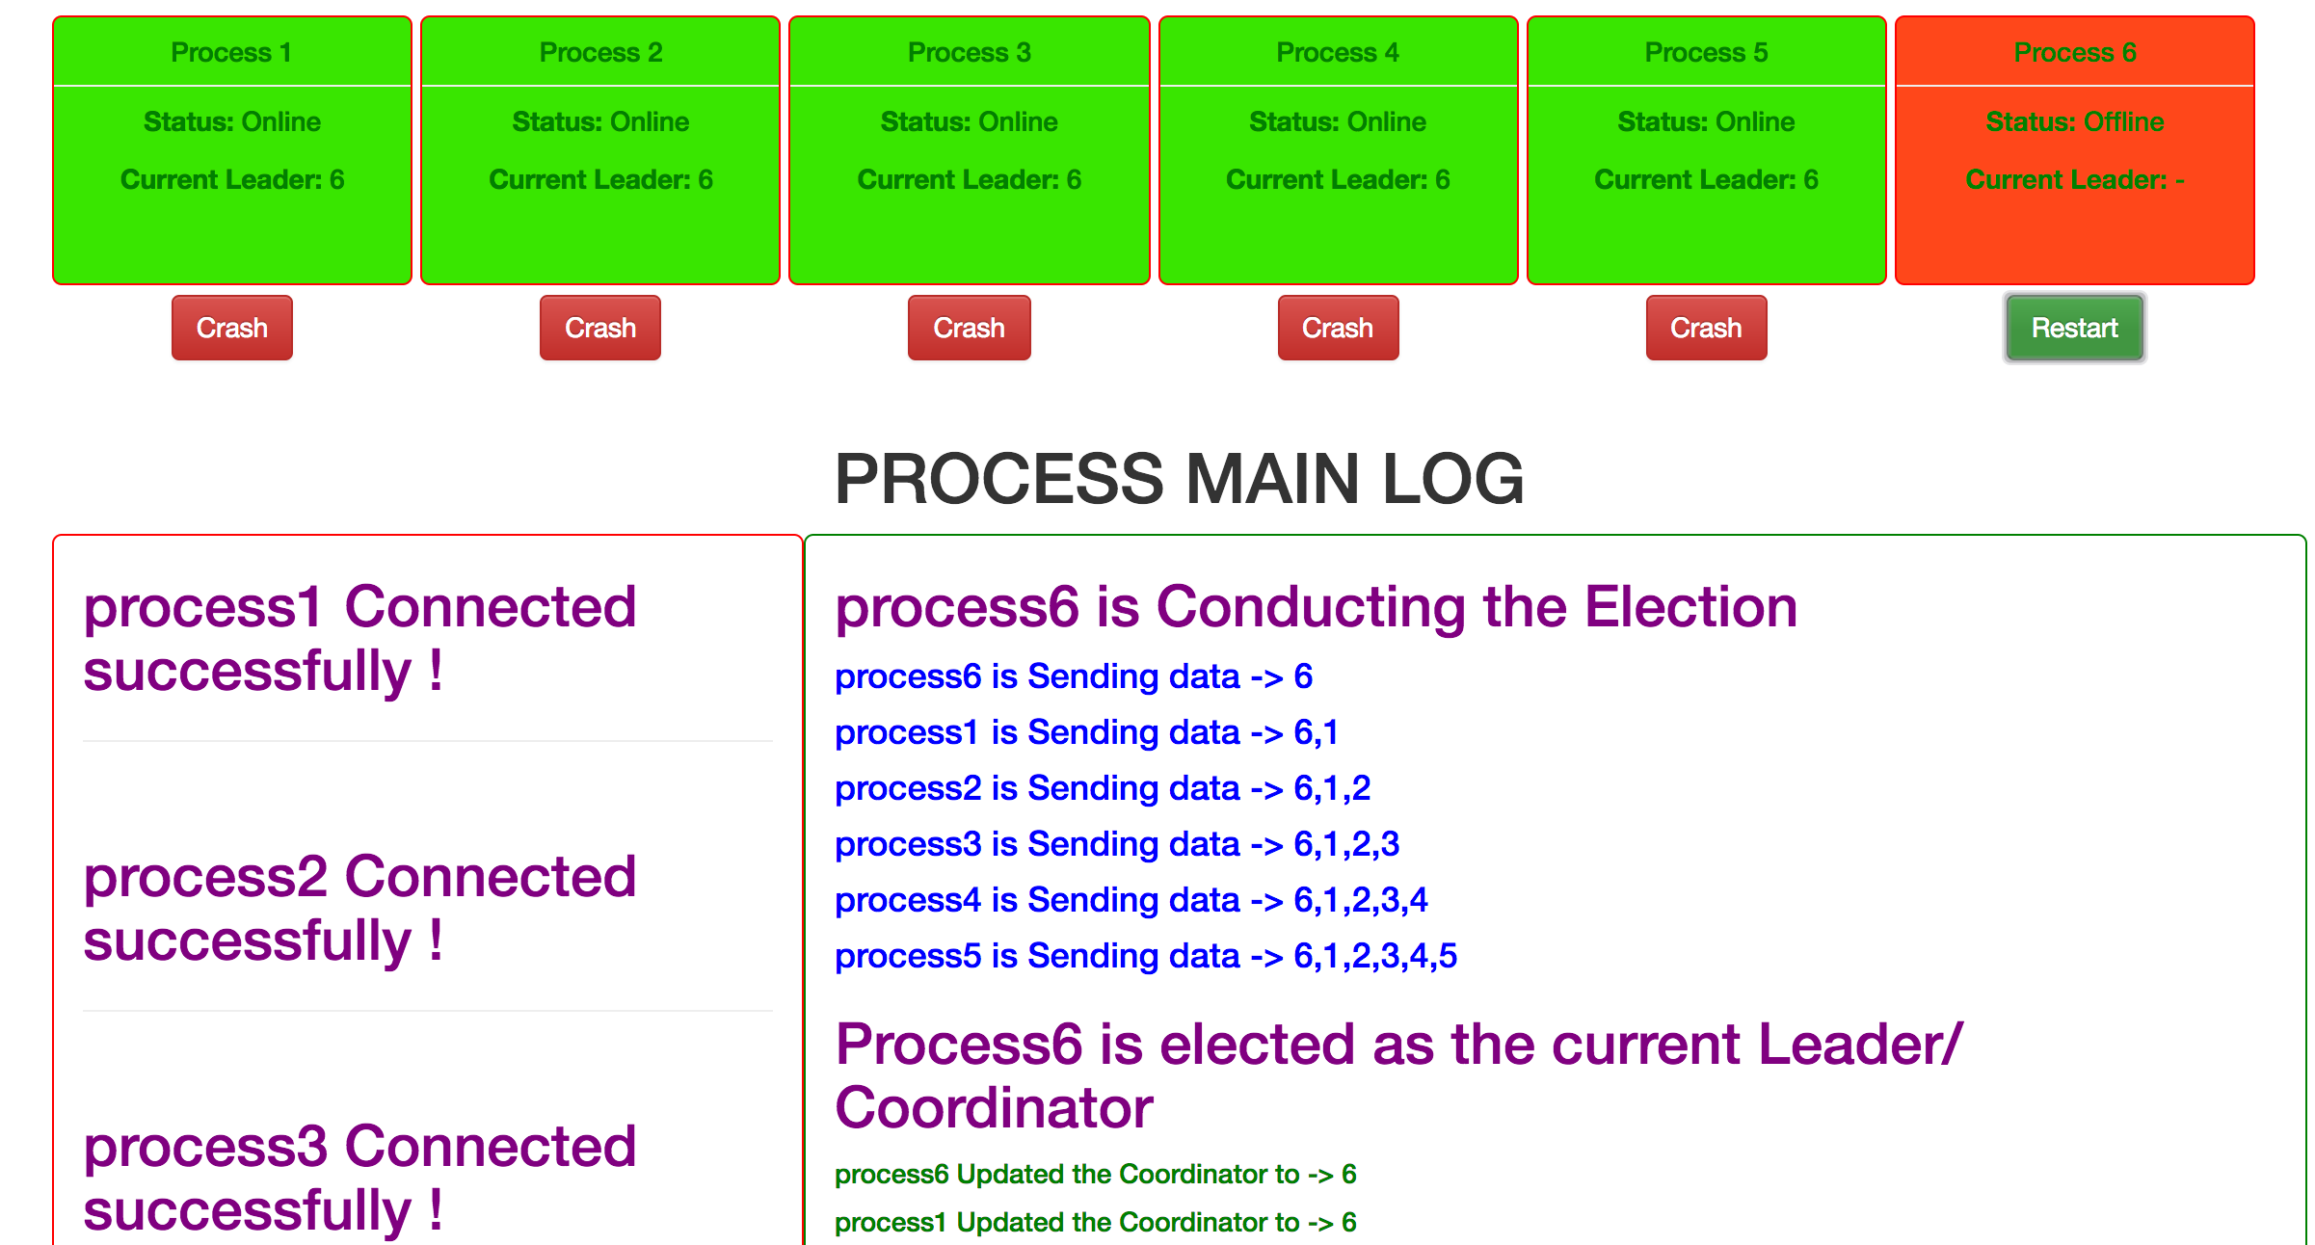

* You can crash a process by clicking on the crash button, if the Process that is crashed is the Coordinator then the process which detects will conduct the Election

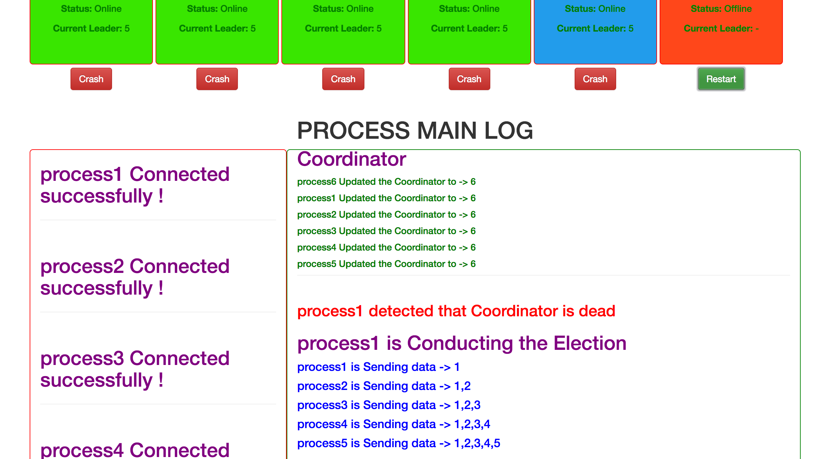

* You can crash as many process as you want, Unless the Coordinator dies no election will be held or if a process is brought back up.

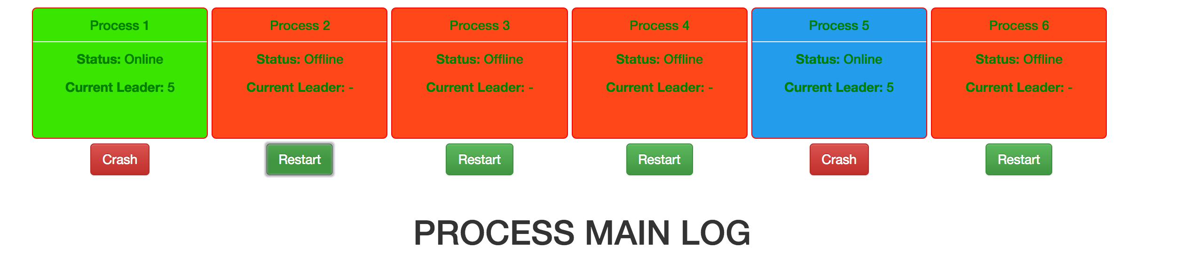

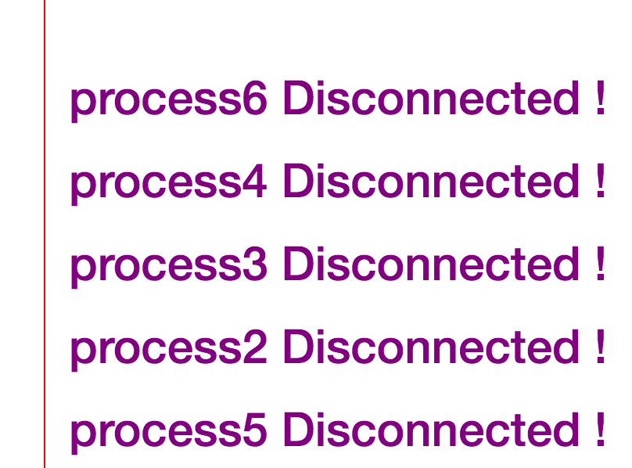

**Citation:**

* Referred to Distributed Systems Textbook Third Edition Chapter 6: page 332 The Ring Algorithm for the algorithm and technique
* <http://www.cs.colostate.edu/~cs551/CourseNotes/Synchronization/RingElectExample.html>
* <http://www2.cs.uregina.ca/~hamilton/courses/330/notes/distributed/distributed.html>

**THANK YOU**