# **DOCUMENTATION**

**Project Done By: Nishank Bhatnagar**

**Student ID: 1001397098**

**Description:**

This Project is about making SOAP request to National Weather Service Station to get the Weather Data and other necessary parameters to support the weather information.

**Technologies Used:**

* Web Application
* Front-End:
  + HTML, CSS, JavaScript,
  + Xml to json <https://github.com/abdmob/x2js>
  + Bootstrap <http://getbootstrap.com/>
  + JQuery <https://jquery.com/>
* Backend:
  + Node.js <https://nodejs.org/en/>
  + Express <https://expressjs.com/>
  + Socket.io <https://socket.io/>
  + Soap-strong (npm library to render SOAP request) <https://www.npmjs.com/package/strong-soap>

**Editor and system installation:**

* The app was worked on using Atom so no special IDE is required.
* The app should be viewed on a web browser, any web browser would do.
* The app needs to be started on the terminal for that:
  + Install Node JS (see above link)
  + Navigate to my project folder and just do npm install as my application contains package.json file which indicates all the libraries used.
  + Then type **“npm start”** in the terminal

**Screenshot**

* Start the application with “npm start” in the terminal and open a browser and type “localhost:3000”

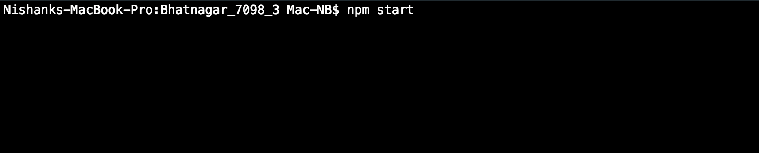

* You will get an initial page with Latitude and Longitude on the top. Click on “Get Weather Data” to get the data.

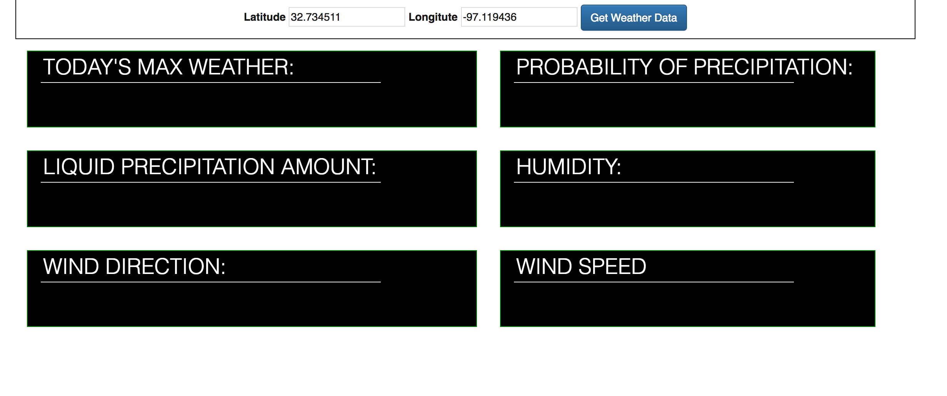

* On clicking the button the data will be filled in the weather cards accordingly.

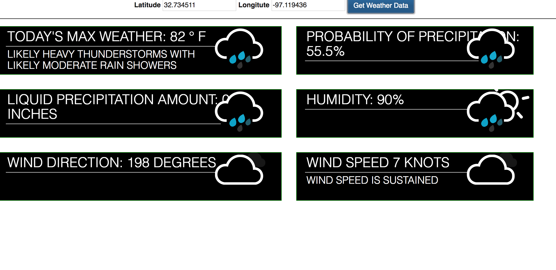

**Citation:**

* <https://graphical.weather.gov/xml/mdl/XML/Design/MDL_XML_Design.pdf>
* <https://codepen.io/joshbader/pen/EjXgqr>
* https://graphical.weather.gov/xml/

**THANK YOU**