Market Size Analysis on Electric Vehicle Industries

Introduction
This project analyzes the market size and growth trends of the electric vehicle industry using Python data analysis and visualization techniques. The study focuses on EV registrations, manufacturers, models, electric range, and future market trends.

Objectives
- Analyze EV registrations by model year.
- Identify top EV manufacturers and models.
- Study EV type distribution.
- Analyze electric range and pricing.
- Perform correlation analysis.
- Study geographical distribution of EVs.

Libraries Used
- Pandas
- NumPy
- Matplotlib
- Seaborn
- Scikit-learn

Dataset Information
The dataset contains electric vehicle registration records including manufacturer, model year, electric range, MSRP, county, city, and EV type.

Data Cleaning and Preprocessing
- Checked missing values.
- Removed rows containing missing data.
- Removed duplicate records.
- Prepared clean dataset for analysis.

Generated Graphs and Analysis
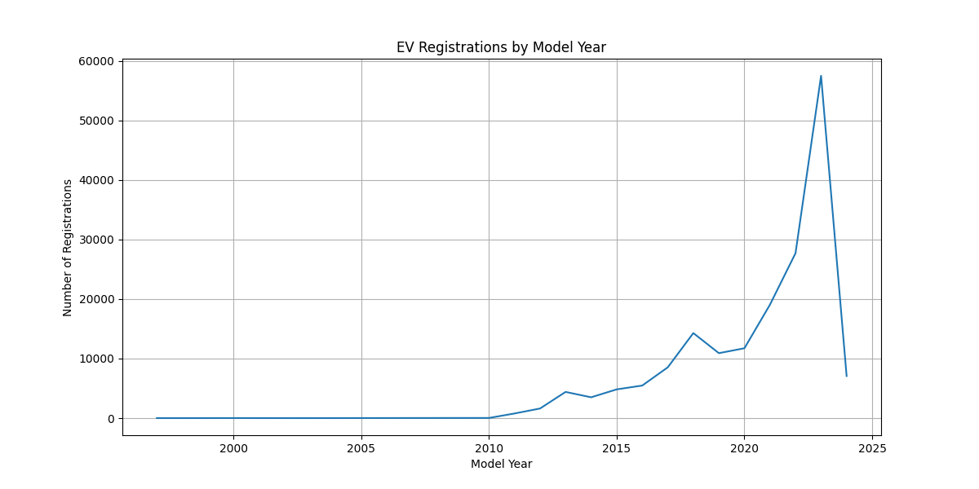
Figure 1: EV Registrations by Model Year
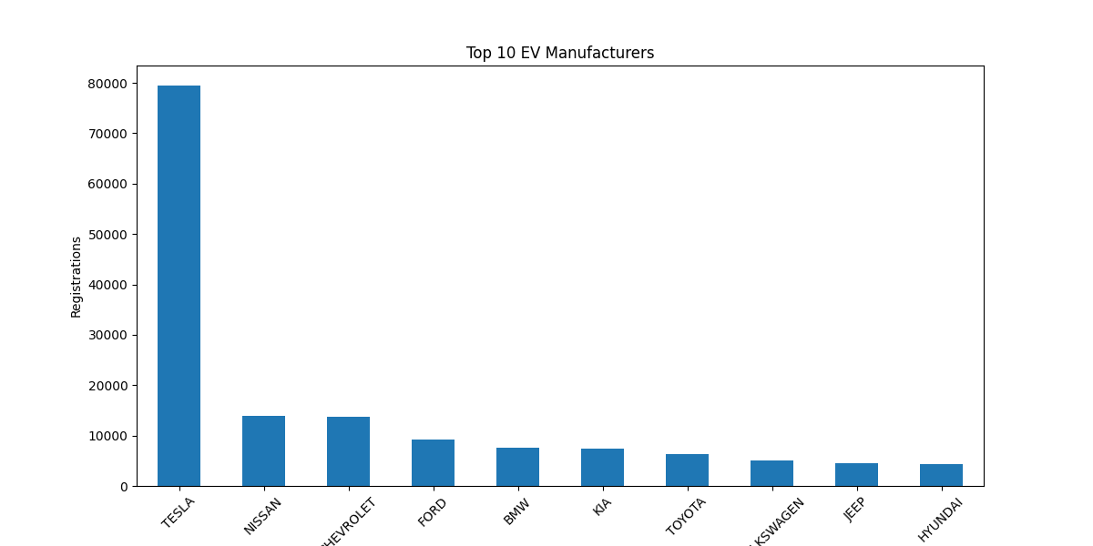
Figure 2: Top 10 EV Manufacturers
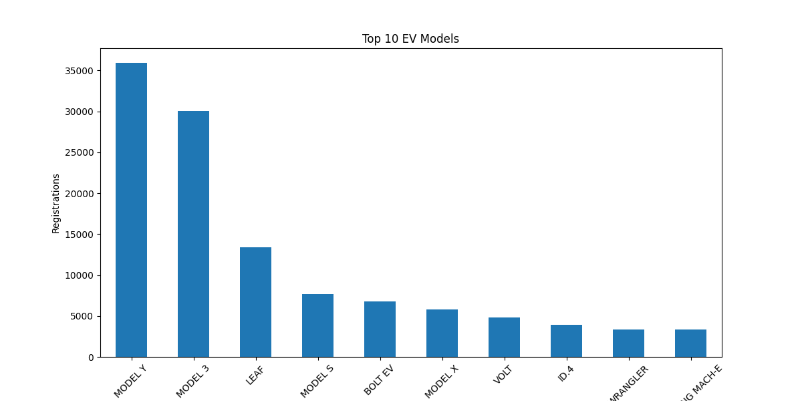
Figure 3: Top 10 EV Models
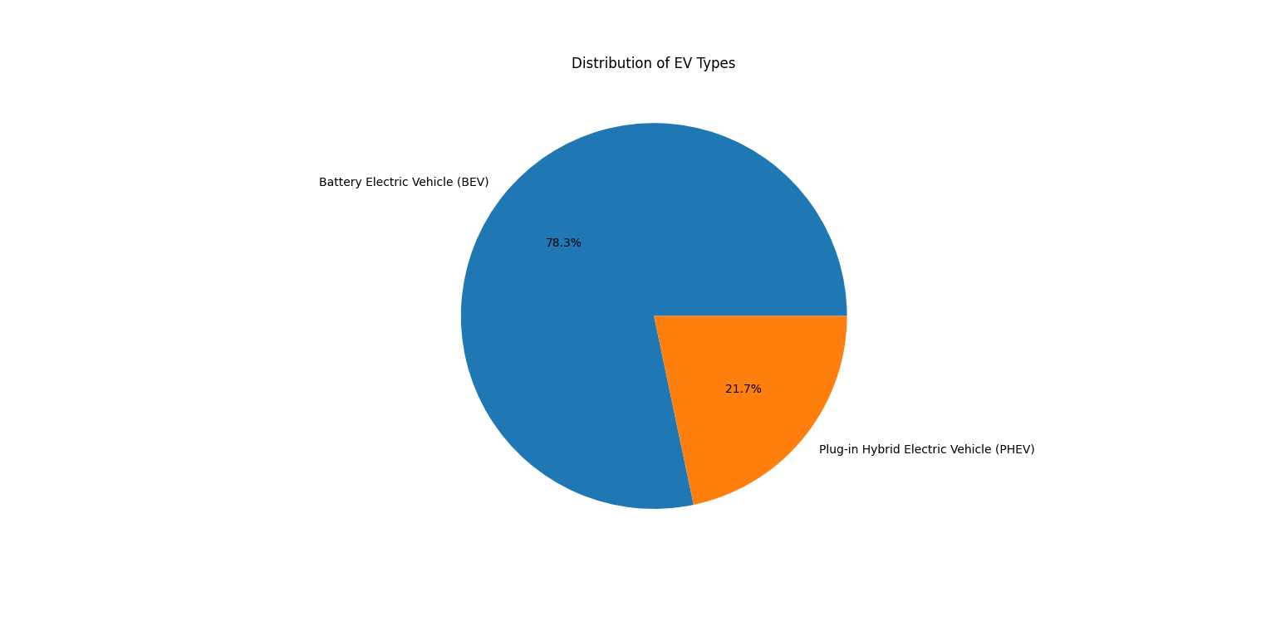
Figure 4: Distribution of EV Types
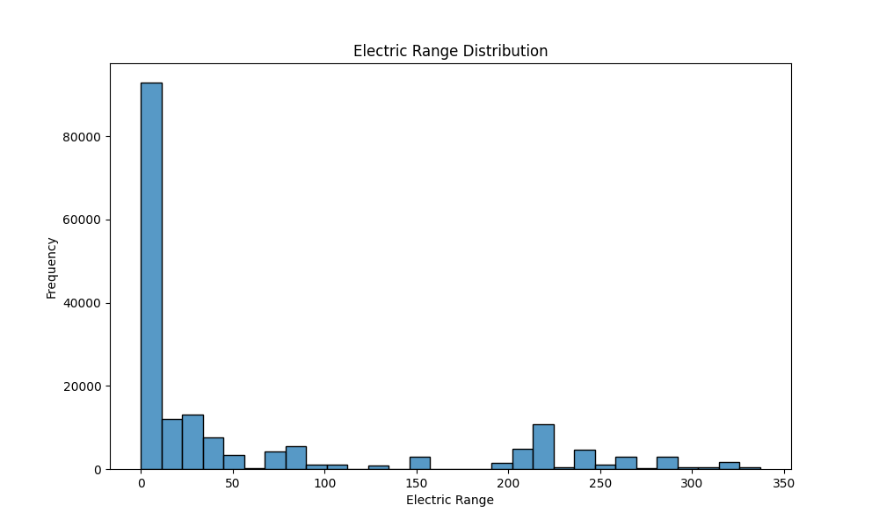
Figure 5: Electric Range Distribution
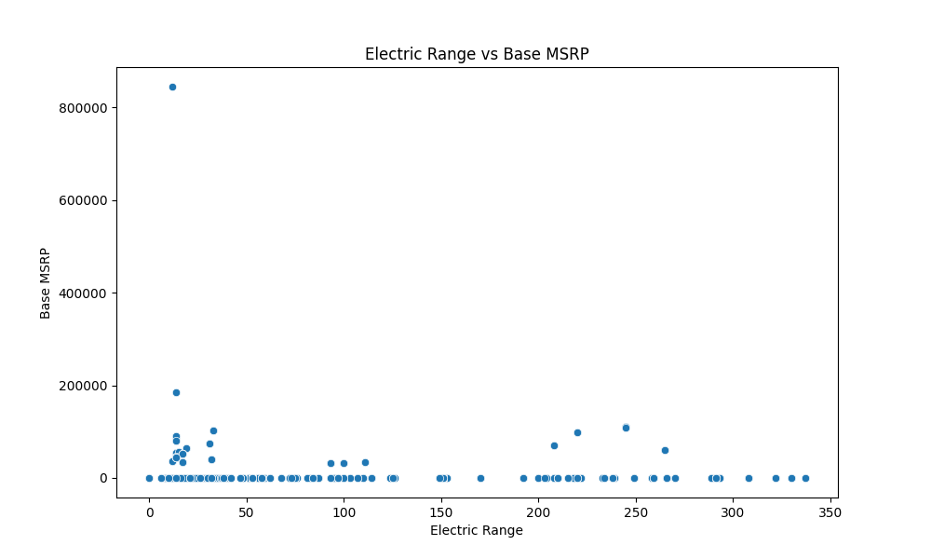
Figure 6: Electric Range vs Base MSRP
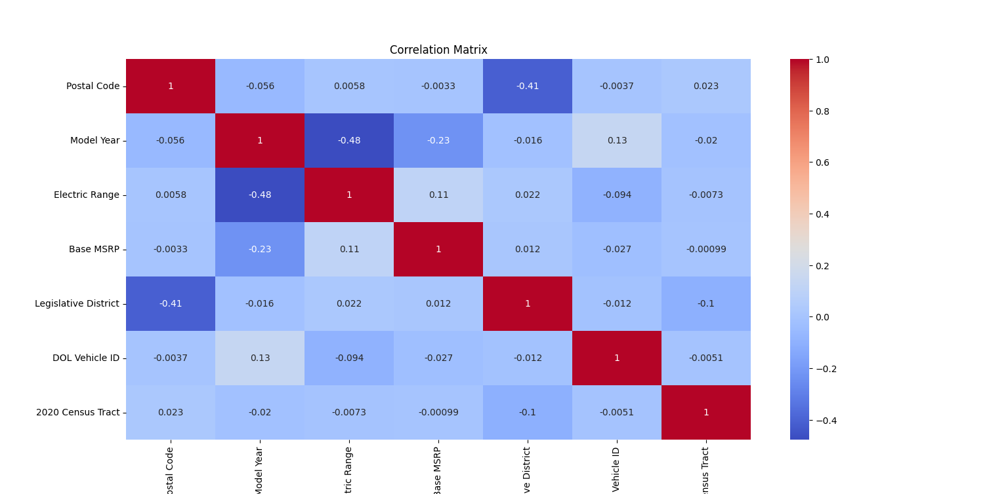
Figure 7: Correlation Matrix
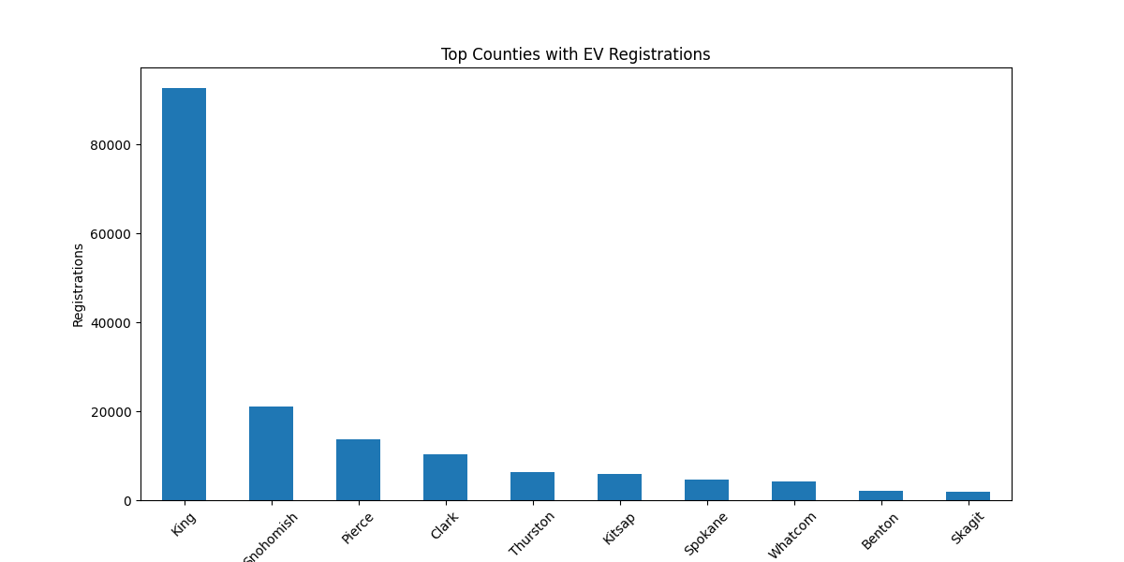
Figure 8: Top Counties with EV Registrations
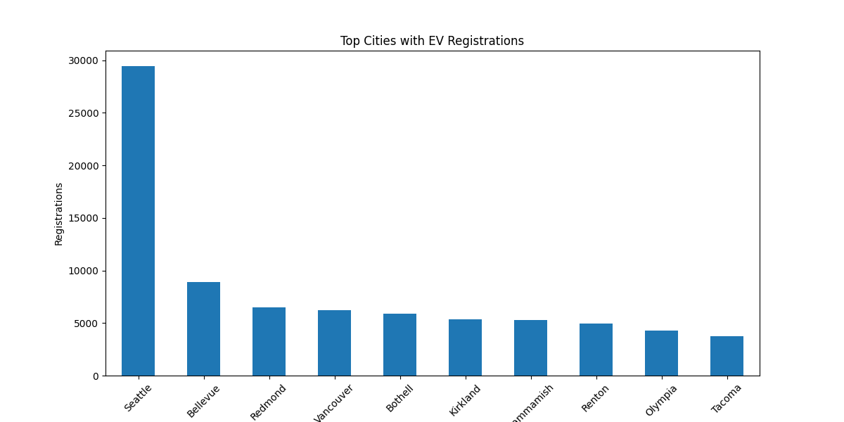
Figure 9: Top Cities with EV Registrations

Key Observations
- EV registrations have increased rapidly after 2015.
- Tesla dominates the EV market.
- Battery Electric Vehicles contribute the highest share.
- King County has the highest EV registrations.
- Electric range and MSRP show moderate relationship.

Conclusion
The project successfully analyzed the electric vehicle market using Python. The analysis showed rapid market growth, increasing adoption of EVs, and strong dominance of Tesla in the industry. Data visualization techniques helped identify important trends and relationships.

References
- https://pandas.pydata.org/
- https://matplotlib.org/
- https://seaborn.pydata.org/
- https://scikit-learn.org/

