House Price Prediction using Python
This project focuses on exploratory data analysis and machine learning techniques for predicting house prices using Python.

Objective
The objective of this assignment is to analyze the housing dataset, perform data preprocessing, visualize important relationships, and build a predictive model for house price estimation.

Software and Libraries Used
- Python
- Pandas
- NumPy
- Matplotlib
- Seaborn
- Scikit-learn

Dataset Description
The dataset contains information about residential properties such as Lot Area, Basement Area, Building Type, Zoning Type, Year Built, Year Remodeled, and Sale Price.

Data Cleaning and Preprocessing
- Removed records with missing SalePrice values.
- Checked all columns for missing values.
- Analyzed numerical and categorical features.
- Applied log transformation to skewed variables.
- Performed feature engineering for better analysis.

Generated Graphs and Analysis
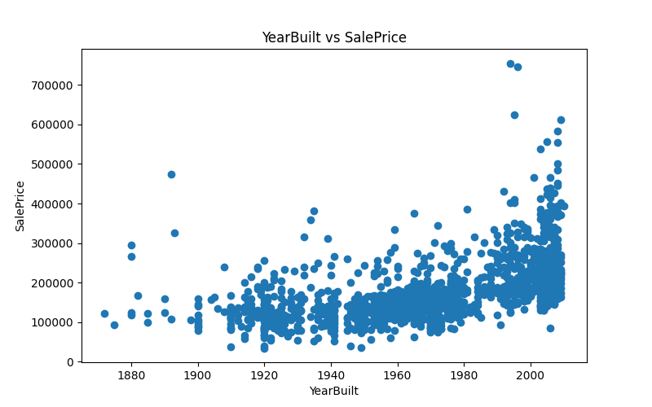
Figure 1: YearBuilt vs SalePrice
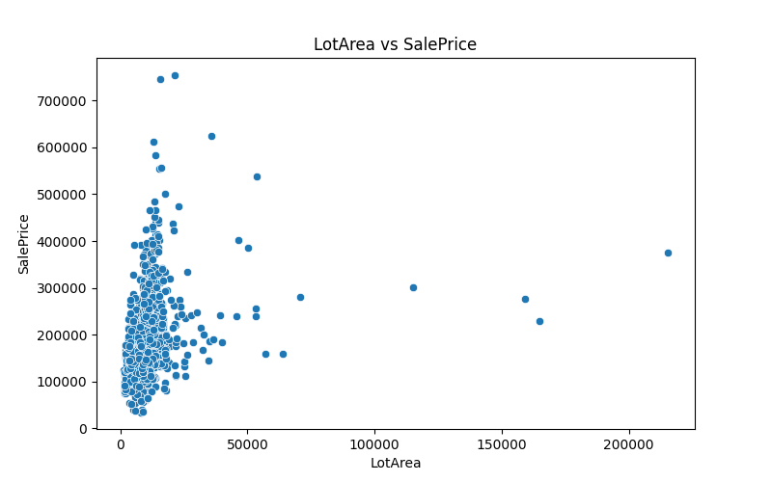
Figure 2: YearRemodAdd vs SalePrice
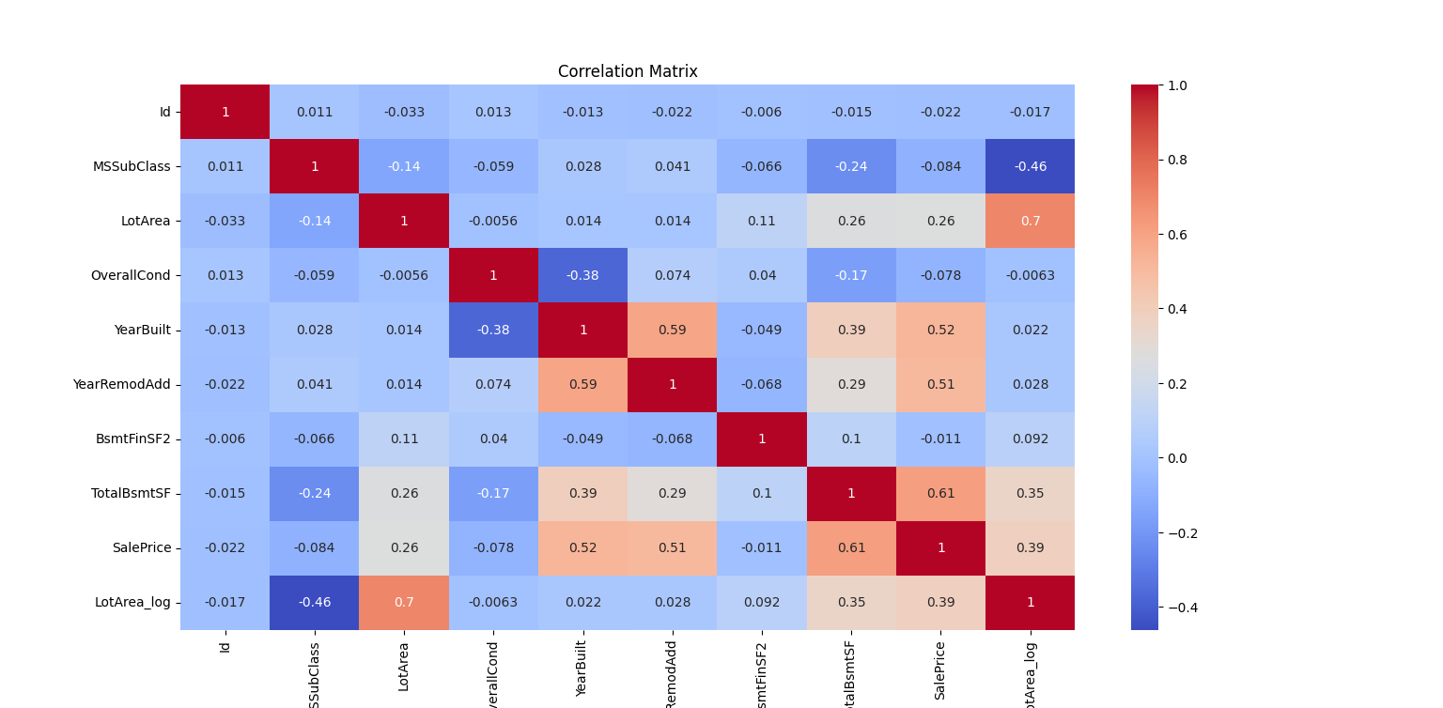
Figure 3: OverallCond vs SalePrice
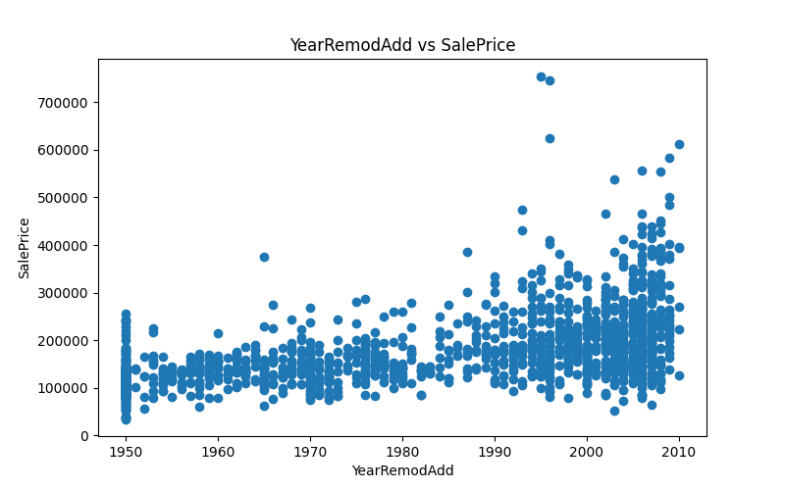
Figure 4: Histogram of LotArea
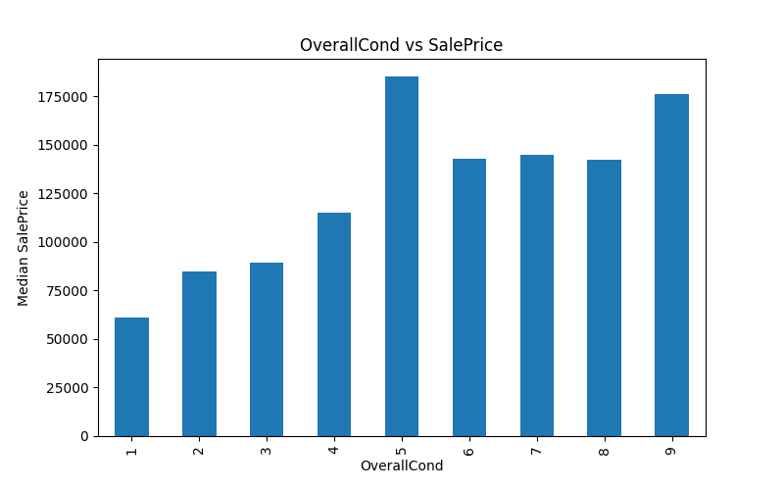
Figure 5: Histogram of TotalBsmtSF
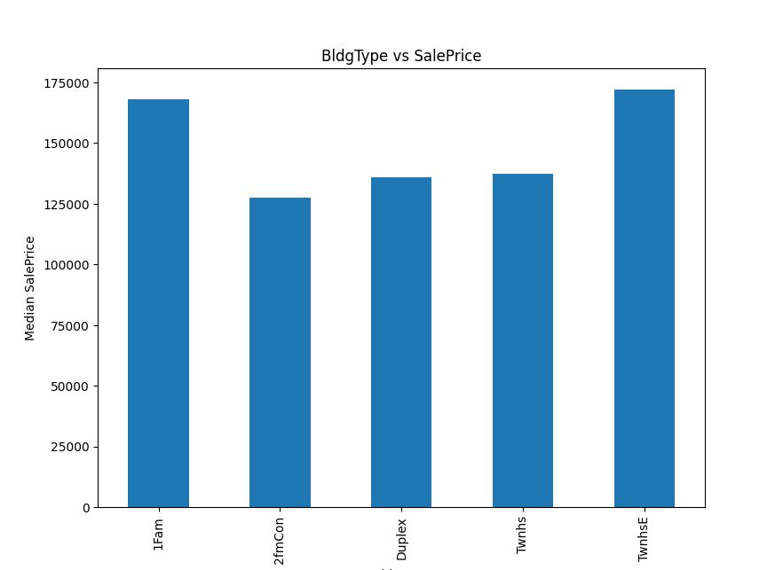
Figure 6: Log Transformed LotArea
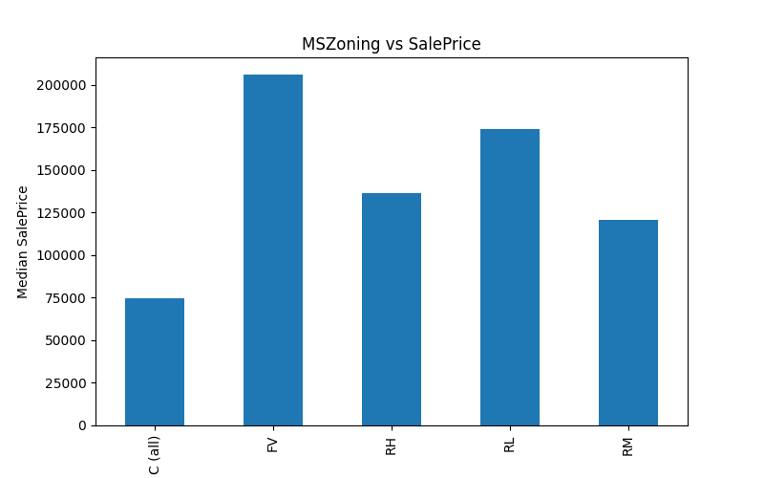
Figure 7: Boxplot of LotArea
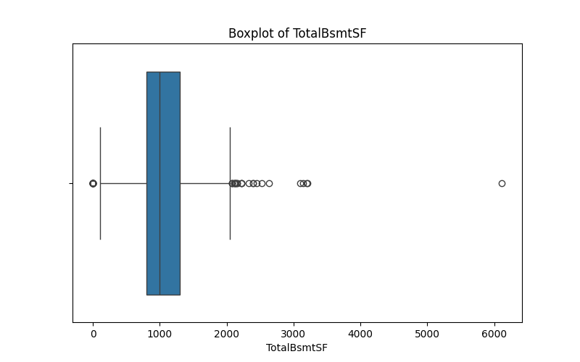
Figure 8: Boxplot of TotalBsmtSF
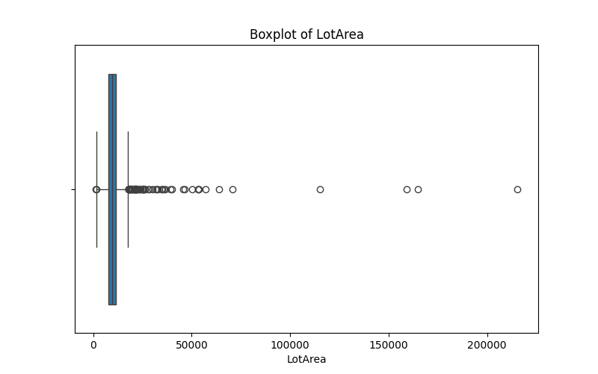
Figure 9: MSZoning vs SalePrice
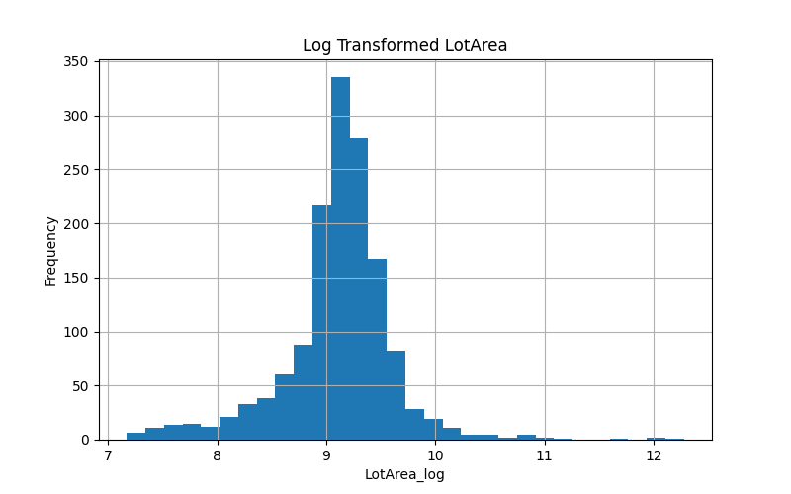
Figure 10: BldgType vs SalePrice
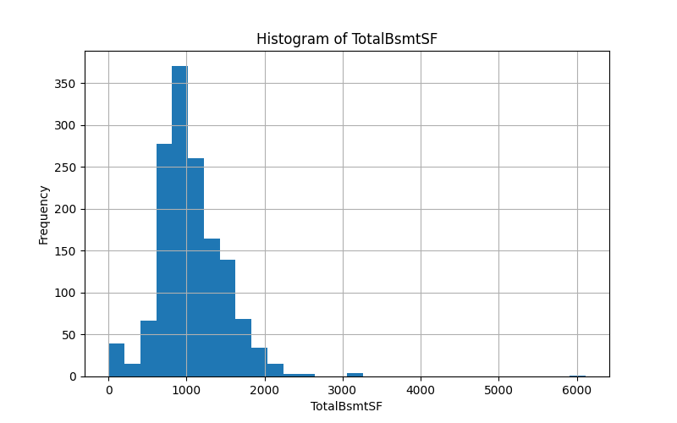
Figure 11: Correlation Matrix

Key Observations
- Newer houses generally had higher sale prices.
- Larger basement areas positively influenced sale price.
- LotArea contained several outliers.
- Correlation analysis showed that TotalBsmtSF and YearBuilt strongly affected SalePrice.
- Log transformation improved the distribution of skewed features.

Model Performance
A Linear Regression model was trained using the processed dataset.
- Mean Absolute Error (MAE): 32767.66
- R² Score: 0.6505

Conclusion
The project successfully analyzed housing data and identified major factors affecting house prices. Data visualization techniques helped in understanding relationships between variables and detecting outliers. The Linear Regression model produced satisfactory prediction performance.

References
- https://pandas.pydata.org/
- https://matplotlib.org/
- https://seaborn.pydata.org/
- https://scikit-learn.org/

