Module: - Frontend – CSS and CSS3

CSS Selectors & Styling

Question 1: What is a CSS selector? Provide examples of element, class, and ID selectors.
A CSS selector is a pattern used to select the HTML elements on a web page that we want to style with CSS rules. Selectors allow for fine-grained control over which elements get a specific style applied to them, targeting elements based on their tag name, attributes, state, or relationship to other elements.
We can divide CSS selectors into five categories:
- Simple selectors (select elements based on name, id, class)
- Combinator selectors (select elements based on a specific relationship between them)
- Pseudo-class selectors (select elements based on a certain state)
- Pseudo-elements selectors (select and style a part of an element)
- Attribute selectors (select elements based on an attribute or attribute value)
Here are the examples of element, class, and ID selectors:
- Element Selector:
An element selector selects all HTML elements of a specific type. It is written using the HTML tag name.
Example:
<html>
<head>
<style>
p {
font-size: 16px;
}
</style>
</head>
<body>
<p>This paragraph styled with font size 16px.</p>
</body>
</html>
This selector applies the blue color to all paragraph (<p>) elements.
- Class Selector:
A class selector selects HTML elements that have a specific class attribute. It is written using a dot (.) followed by the class name. A class can be used for multiple elements.
Example:
<html>
<head>
<style>
.button {
background-color: blue;
color: white;
}
</style>
</head>
<body>
<button class="button">Click Me!</button>
</body>
</html>
This style is applied to all elements with class="button".
- ID Selector:
An ID selector selects a unique HTML element with a specific ID. It is written using a hash (#) followed by the ID name. An ID must be unique within a webpage.
Example:
<html>
<head>
<style>
#header {
background-color: gray;
}
</style>
</head>
<body>
<div id="header">This is the header section.</div>
</body>
</html>

Table 1 The following table provides examples of element, class, and ID selectors:
Selector Type | Syntax | Description | Example Code (CSS & HTML)
Element (Type) | elementname | Selects all HTML elements of the given tag name. | CSS: p { color: blue; }  HTML: <p>All paragraphs will be blue.</p>
Class | .classname | Selects all elements with a specific class attribute value. A class can be used on multiple elements. | CSS: .highlight { background-color: yellow; }  HTML: <span class="highlight">This text is highlighted.</span>
ID | #idname | Selects a single, unique element with a specific id attribute value. An ID must be unique within an HTML document. | CSS: #header { border: 1px solid black; }  HTML: <div id="header">This is a unique header.</div>

Question 2: Explain the concept of CSS specificity. How do conflicts between multiple styles get resolved?
Specificity is an advanced algorithm used by HTML browsers to define the CSS declaration which will be the most appropriate to an HTML element. It basically calculates the weights of all the CSS selectors to determine the proper rule. The main goal is when more than one CSS rule is applied to the same element the selector with the highest specificity value will be applied to that element.
Order of CSS Specificity (Lowest to Highest):
- Element selectors (e.g., p, div)
- Class selectors, attributes, and pseudo-classes (e.g., .box, :hover)
- ID selectors (e.g., #header)
- Inline styles (written directly inside HTML elements)
- !important rule (overrides all other rules)

Calculating Specificity:
Specificity is calculated by assigning a point value to each part of a selector and tallying the score. The score is often represented as a four-part value: (inline, IDs, classes, elements).
Table 2 Spacificity conflict calculation
Selector Type | Example | Points (or (a, b, c, d) value)
Inline Styles | <p style="color: red;"> | 1000 (or 1,0,0,0)
IDs | #header | 100 (or 0,1,0,0)
Classes, Attributes, Pseudo-classes | .nav, [type="text"], :hover | 10 (or 0,0,1,0)
Elements and Pseudo-elements | div, ::before | 1 (or 0,0,0,1)
Universal Selector/Combinators | *, +, >, ~ | 0

There is mainly 4 ways CSS solve conflicts between multiple styles:
1. Origin Precedence
When there are two different specified styles for an element, the declaration at the bottom wins. For external stylesheets, consider it to be at the position of the declaration of the stylesheet. Because of this, for example, one should always declare the user stylesheet after the Bootstrap stylesheet so that we can override any bootstrap styles we want.
Example:
<!DOCTYPE html>
<html lang="en">
<head>
<meta charset="UTF-8">
<meta name="viewport" content="width=device-width, initial-scale=1.0">
<title>Document</title>
<style>
.box{
color: green;
background-color: aqua;
}
.box{
color: red;
}
</style>
</head>
<body>
<div class="box">Hello</div>
</body>
</html>
In this code text is printed in RED color. Because, according to the rules, the colour, which is in conflict, is received from the bottom declaration. The non-conflicting ones, like background colour, are received from the upper declaration.
2. Inheritance

A child element always inherits the styles of the parent element, unless declared otherwise separately.
<!DOCTYPE html>
<html lang="en">
<head>
<meta charset="UTF-8">
<meta name="viewport" content="width=device-width, initial-scale=1.0">
<title>Document</title>
<style>
.parent{
color: red;
background-color: bisque;
}
.box{
background-color: green;
}
</style>
</head>
<body>
<div class="parent">
<div class="box">Hello</div>
</div>
</body>
</html>
In this code the text colour is inherited from the parent element. The background colour is received from the styles of the box.
3. Specificity

When two different selectors are used but both select the same element, the precedence is decided by specificity rules. The specificity of an element as a 4-digit number, and the greater number wins.
<!DOCTYPE html>
<html lang="en">
<head>
<meta charset="UTF-8">
<meta name="viewport" content="width=device-width, initial-scale=1.0">
<title>Document</title>
<style>
.parent{
color: blue;
background-color: green;
}
.box4.box{
color: yellow;
font-size: 1em;
}
#b{
color: pink;
}
div > .box{
font-size: 3em;
background-color: red;
border: 1px solid black;
margin: 10px;
}
</style>
</head>
<body>
<div class="parent">
<div class="box" style="color: purple;">Hello box</div>
<div class="box" id="a">Hello box</div>
<div class="box">Hello box</div>
<div class="box box4" id="b">Hello box</div>
</div>
</body>
</html>
First box:
- There are two selectors for the first box. One is using “div >.box”, and the other is the inline style.
- Using the rules above, the selector using inline styles gets a score of 1000.
- The selector using “div > .box” gets a score of 0011.
- So, selector using inline style wins (since 1000>11), and the conflicting style, i.e., font-colour, should be purple. The other styles should simply merge.
Second box:
- Again there are two selectors here, namely “#b” and “div > .box”.
- “#b” gets a score of 0100, and “div > .box” has score of 0011.
- As 100>11, the ID selector wins, although there are no conflicting declarations here.
Third box:
- There is only one selector “div > .box”.
Fourth box:
- The “div > .box” is common for this as well. The other one has two classes, and therefore has a score of 0020.
- Again, as 20>11, “.box4.box” wins.

- !important

When you use !important with a style, it bypasses all the rules and sets the style defined by that selector.
<!DOCTYPE html>
<html lang="en">
<head>
<meta charset="UTF-8">
<meta name="viewport" content="width=device-width, initial-scale=1.0">
<title>Document</title>
<style>
.parent{
color: blue;
background-color: green;
}
.box4.box{
color: yellow;
font-size: 1em;
}
#b{
color: pink;
}
div > .box{
font-size: 3em;
background-color: red;
border: 1px solid black; !important
margin: 10px;
}
</style>
</head>
<body>
<div class="parent">
<div class="box" style="color: purple;">Hello box</div>
<div class="box" id="a">Hello box</div>
<div class="box">Hello box</div>
<div class="box box4" id="b">Hello box</div>
</div>
</body>
</html>

As you can see, even though div > .box had the least specificity, all the divs text are black, due to the !important rule.

Question 3. What is the difference between internal, external, and inline CSS? Discuss the advantages and disadvantages of each approach.
CSS can be applied to HTML documents in three different ways: inline CSS, internal CSS, and external CSS. The main difference between inline, internal, and external CSS is their location and scope: inline affects a single element, internal styles one HTML page, and external styles an entire website via a separate file. External CSS is the industry standard for large projects due to its efficiency and maintainability.
1. Inline CSS:
Inline CSS is written directly inside an HTML element using the style attribute.
Example:
<p style="color: red; font-size: 16px;">Hello World</p>
Advantages:
- Applies styles immediately to a specific element
- Useful for quick fixes, testing, or applying a unique style to a single element.
- Highest specificity, meaning it overrides any other styles for that specific element.
- Does not require creating or uploading separate files, potentially reducing HTTP requests.
Disadvantages:
- Not reusable
- Makes HTML code messy
- Difficult to maintain for large websites
- Difficult to manage and update styles across multiple elements as each must be edited individually.
- Reduces code readability and mixes presentation with content, violating the separation of concerns.
- Not suitable for defining styles for pseudo-elements or pseudo-classes.

2. Internal CSS:
Internal CSS is written inside a <style> tag within the <head> section of an HTML document.
Example:
<style>
p {
color: blue;
}
</style>
Advantages:
- Allows styling of multiple elements on a single page, providing better control than inline styles for that specific page.
- Keeps HTML and CSS within the same file, which can be convenient for single-page projects or prototyping.
- Can override external styles for specific elements on that page.
Disadvantages:
- Styles cannot be reused across multiple HTML documents.
- Increases the HTML file size, which can affect load performance compared to cached external files.
- Requires editing the <head> section of every page individually if a sitewide change is needed.

3. External CSS:
External CSS is contained in a separate .css file and linked to one or more HTML documents using the <link> tag in the <head> section.
Example:
<link rel="stylesheet" href="styles.css">
Advantages:
- Promotes a clear separation of concerns between content (HTML) and presentation (CSS), leading to cleaner, more modular code.
- Styles are reusable across an entire website; changing one file updates all linked pages.
- Easy to maintain and update.
- Improves page load times on subsequent visits because the browser can cache the CSS file.
Disadvantages:
- Requires an additional HTTP request to load the separate CSS file, which can slightly impact the initial page load speed.
- The page may appear unstyled or "flash" with unformatted content if the external file fails to load or is slow.
- Requires an additional file to manage.

Table 3 Differences between Inline, Internal, and External CSS
Feature | Inline CSS | Internal CSS | External CSS
Location | It is used within HTML tag using the style attribute. | It is used within <head> section of HTML document. | It is used in a separate .css file.
Selector Scope | Affects a single element or a group of elements. | Affects multiple elements within the same HTML element. | Affects multiple HTML documents or an entire website.
Reusability | Not reusable. Styles need to be repeated for each element. | Can be reused on multiple elements within the same HTML document. | Can be reused on multiple HTML documents or an entire website.
Priority | Highest priority. Overrides internal and external styles. | Medium priority. Overrides external styles but can be overridden by inline styles. | Lowest priority. Can be overridden by both inline and internal styles.
File Size | Inline styles increase the HTML file size, which can affect the page load time. | Internal styles are part of the HTML file, which increases the file size. | External styles are in a separate file, which reduces the HTML file size and can be cached for faster page loads.
Maintainability | Not easy to maintain. Changes need to be made manually to each element. | Relatively easy to maintain. Changes need to be made in one place in the <head> section. | Easiest to maintain. Changes need to be made in one place in the external .css file.

CSS Box Model

Question 1. Explain the CSS box model and its components (content, padding, border, margin). How does each affect the size of an element?
The CSS box model is a fundamental concept that describes how HTML elements are structured and how their size and spacing are calculated in a web page. Every element is represented as a rectangular box made up of four main components: content, padding, border, and margin.
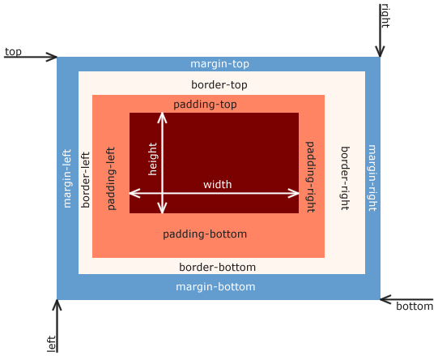
Figure 1 CSS box model and its components

1. Content:
The content area contains the actual text, images, or other elements inside the box. The width and height properties apply to this area by default.
Effect on size:
- Increasing content size increases the overall size of the element.
- The width and height properties set the dimensions of this area. The total size calculation starts here.
2. Padding:
Padding is the space between the content and the border. It creates transparent space surrounding the content, inside the border. It uses the element's background color.
Effect on size:
- Padding increases the total size of the element by adding space inside the border.
- Adds to the element's total width and height. For example, width: 100px and padding: 10px result in a visible width of 120px (100 + 10 + 10).
3. Border:
The border surrounds the padding and content. It can have a defined width, style, and color.
Effect on size:
- Border thickness adds to the overall width and height of the element.
- Adds to the element's total width and height. A 5px border on all sides adds 10px to both the total width and height.
4. Margin:
Margin is the outermost space around the border. It creates distance between elements.
Effect on size:
- Margin does not increase the element’s box size but affects spacing between elements.
- Does not add to the element's actual size (width/height of the box itself), but affects the total space the element occupies on the page and pushes other elements away.
Size Calculation Example:
If an element has:
Width: 200px
Padding: 10px
Border: 5px
Then the total width becomes: 200 + 20 (padding) + 10 (border) = 230px

Question 2. What is the difference between border-box and content-box box-sizing in CSS? Which is the default?
The box-sizing property in CSS defines how the width and height of an element are calculated. The two most commonly used values are content-box and border-box. content-box is the default value.
Content-box (Default):
Calculation: The specified width and height properties apply only to the element's content area. Any added padding and border are then added outside of these dimensions, increasing the total space the element occupies on the page.
Total Size Formula: Total Width = content width + left padding + right padding + left border + right border.
Example:
- If an element has:
- width: 100px;
- padding: 10px;
- border: 2px solid black;
its total rendered width will be 100px + 2*10px (padding) + 2*2px (border) = 124px.

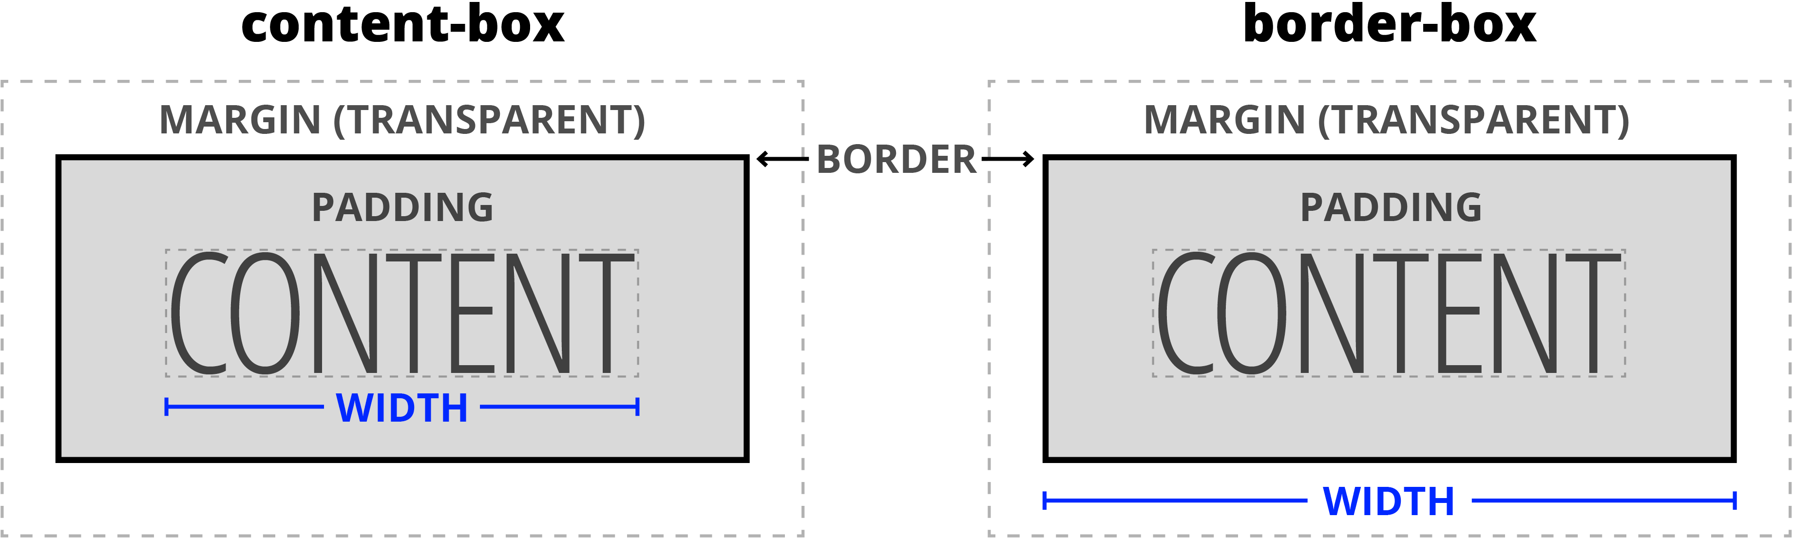
Figure 2 Content-box
Border-box:
Calculation: The specified width and height properties define the element's total outer dimensions, including its padding and border. The content area will shrink as needed to accommodate the padding and border within the set dimensions.
Total Size Formula: Total Width = specified width (which includes content + padding + border).
Example:
- If an element has
- width: 100px;
- padding: 10px;
- border: 2px solid black; with box-sizing: border-box;,
its total rendered width will be exactly 100px. The content area will be 100px - 2*10px (padding) - 2*2px (border) = 76px wide.


Figure 3 Border-box
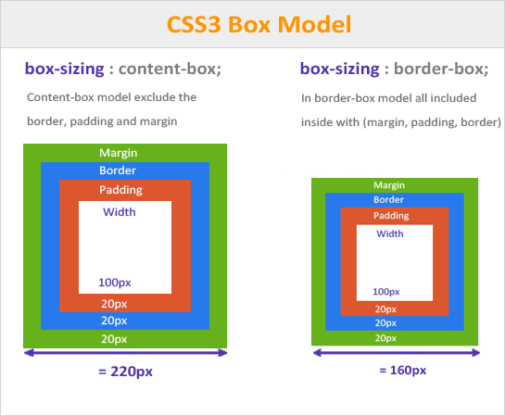
Figure 4 CSS3 Box Model

CSS Flexbox

Question 1. What is CSS Flexbox, and how is it useful for layout design? Explain the terms flex-container and flex-item.
CSS Flexbox (Flexible Box Layout) is a one-dimensional layout model in CSS that allows developers to design flexible and responsive layouts easily. It helps in aligning, spacing, and distributing elements within a container, even when their size is unknown or dynamic. Flexbox is especially useful for creating layouts in a row or column direction.
Key benefits include:
- Easy Alignment: It simplifies the process of aligning items both horizontally and vertically using properties like justify-content and align-items, which was a complex task with older layout methods.
- Flexible Sizing: Items can automatically grow (flex-grow) to fill extra space or shrink (flex-shrink) to avoid overflowing the container, adapting to various screen sizes and orientations.
- Content Reordering: The order property allows the visual order of elements to be changed without altering the underlying HTML source code, which is highly valuable for different screen layouts.
- Eliminates Hacks: Flexbox removes the need for layout "hacks" such as floats and clearfixes, leading to cleaner and more intuitive code.

The Flexbox model revolves around two main components that work in tandem: the flex container and the flex items.
Flex-container:
This is the parent element in which the layout is defined. To create a flex container, you set the CSS display property to flex (for a block-level container) or inline-flex (for an inline-level container). All direct children of this element are then automatically converted into flex items, and the container's properties (like flex-direction, flex-wrap, justify-content, and align-items) control their layout.

Flex-item:
These are the direct child elements inside a flex container. They are the components that are laid out, aligned, and resized according to the rules set by the parent container and their own individual properties (like flex, order, or align-self). An individual flex item can also become a flex container itself if its display property is set to flex, allowing for complex nested layouts.
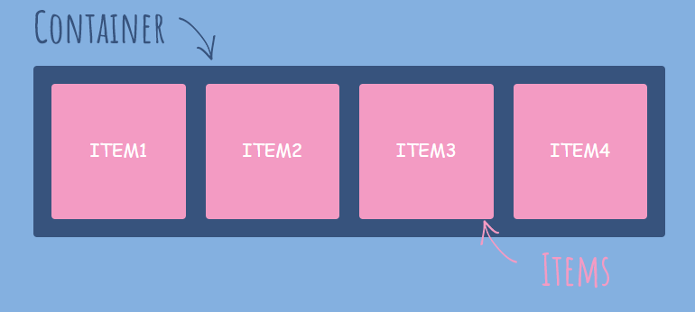
Figure 5 CSS Flexbox

Question 2. Describe the properties justify-content, align-items, and flex-direction used in Flexbox.
In CSS Flexbox, properties such as justify-content, align-items, and flex-direction are used to control the layout, alignment, and direction of flex items inside a flex container.
- justify-content:
The justify-content property aligns flex items along the main axis (defined by flex-direction). It controls spacing between items.
Common values:
- flex-start: items align at the start
- center: items align at the center
- flex-end: items align at the end
- space-between: equal space between items
- space-around: equal space around items

- align-items:
The align-items property aligns flex items along the cross axis (perpendicular to the main axis).
Common values:
- flex-start: align at the start of cross axis
- center: align at the center
- flex-end: align at the end
- stretch (default): stretch items to fill container

- flex-direction:
The flex-direction property defines the main axis direction along which flex items are placed.
Common values:
- row (default): items are placed horizontally from left to right
- row-reverse: items are placed horizontally from right to left
- column: items are placed vertically from top to bottom
- column-reverse: items are placed vertically from bottom to top

CSS Grid

Question 1. Explain CSS Grid and how it differs from Flexbox. When would you use Grid over Flexbox?
CSS Grid is a two-dimensional layout system used for organizing content into both rows and columns simultaneously, offering precise control over the entire page structure. Flexbox, in contrast, is a one-dimensional layout system, excelling at aligning and distributing items along a single axis (either a row or a column).
The fundamental difference lies in the dimensionality of their layout control.
Flexbox (One-Dimensional):
Flexbox works primarily along a single axis (main axis), which can be set to either a row or a column using the flex-direction property. While it supports wrapping items onto multiple lines, each line is treated as an independent flex container, meaning items in one row do not align with items in the next row by default. Flexbox works from the content out, adjusting the size of items based on the available space and their content size.
CSS Grid (Two-Dimensional):
Grid is designed to manage rows and columns at the same time, functioning like a table for layout purposes. It works from the layout in, where you define a strict grid structure with specific column and row sizes using properties like grid-template-columns and grid-template-rows, and then place items into the defined cells or areas. This gives developers full control over both vertical and horizontal alignment and positioning.
You would typically use CSS Grid when you need a complex, structured layout where the alignment across both axes is important.
- Full-page layouts: For defining the main regions of a webpage like headers, footers, sidebars, and main content areas. The grid-template-areas property is particularly useful for this.
- Complex components: For scenarios where items need to span multiple rows and columns, such as in image galleries or dashboards with different sized widgets.
- Consistent row/column alignment: When you need items in different rows to line up precisely underneath each other in columns, regardless of the content size in other rows.
- Overlapping elements: When a design requires elements to overlap or layer on top of one another.
Table 4 Difference Between CSS Grid and Flexbox
Property | Grid | Flexbox
Dimension | Two - Dimensional | One - Dimensional
Features | Can flex combination of items through space-occupying Features | Can push content element to extreme alignment
Support Type | Layout First | Content First
Primary Use Case | Creating complex layouts with rows and columns | Aligning items in a row or column
Performance | Can be less in performance due to very complex grids | Generally faster for simple layouts

Question 2. Describe the grid-template-columns, grid-template-rows, and grid- gap properties. Provide examples of how to use them.
In CSS Grid Layout, the properties grid-template-columns, grid-template-rows, and grid-gap are used to define the structure and spacing of a grid layout. These properties are applied to the grid container.
- grid-template-columns: The grid-template-columns property defines the number and width of columns in a grid.
- Usage: You provide a space-separated list of values on the grid container element. Each value specifies the width of the corresponding column track.
- Values: You can use various units, including fixed lengths (px, em, %), the fr (fractional) unit to distribute remaining space, auto for automatic sizing based on content, or min-content and max-content.
- Example: grid-template-columns: 200px 1fr 2fr; creates three columns: the first has a fixed width of 100 pixels, the second takes up one-third of the remaining space, and the third takes up two-thirds.
  - .container {
display: grid;
grid-template-columns: 200px 1fr 2fr;
}

- grid-template-rows: The grid-template-rows property defines the number and height of rows in a grid.
- Usage: Similar to columns, you provide a space-separated list of values on the grid container. Each value defines the height of the respective row track.
- Values: It accepts the same value types as grid-template-columns: fixed lengths, fr units, auto, min-content, and max-content.
- Example: grid-template-rows: auto 150px; creates two rows: the first row's height adjusts automatically to its content, while the second row has a fixed height of 150 pixels.
  - .container {
display: grid;
grid-template-rows: auto 150px;
}

- grid-gap: The grid-gap property specifies the space between rows and columns in the grid. (It is now commonly written as gap.)
- Usage: This property is applied to the grid container and creates empty space between tracks, not around the outer edges of the container.
- Values:
  - One value: gap: 20px; applies a 20-pixel gap to both rows and columns.
    - .container {
display: grid;
grid-gap: 20px;
}
  - Two values: gap: 10px 30px; sets the row-gap to 10 pixels and the column-gap to 30 pixels.
    - .container {
display: grid;
grid-gap: 10px 30px;
}

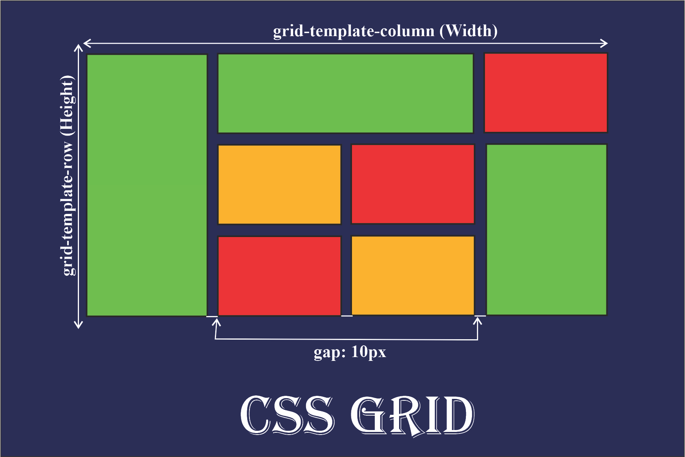
Figure 6 CSS Grid

Responsive Web Design with Media Queries

Question 1. What are media queries in CSS, and why are they important for responsive design?
Media queries in CSS are a technique used to apply styles conditionally based on the characteristics of the user's device or the environment displaying the web page. They are the fundamental technology behind responsive web design, which allows websites to adapt their layout and appearance to various screen sizes and devices, from smartphones to desktop computers.

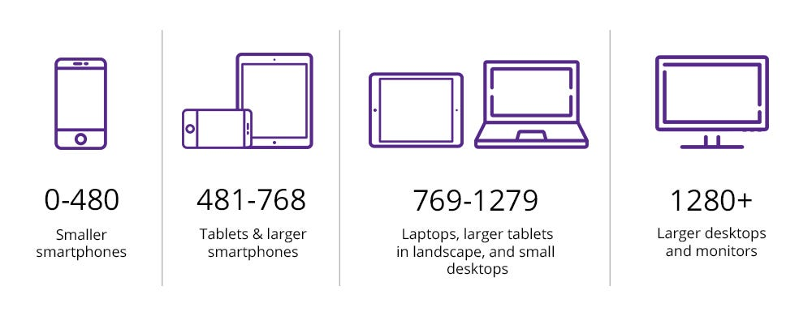
Figure 7 Common screen size of devices

A media query uses the @media rule to check conditions like screen width and then applies CSS styles when those conditions are met.
Example:
@media (max-width: 768px) {
body {
background-color: lightgray;
}
}
This code applies styles only when the screen width is 768px or less.

Key components of a media query include:
- @media rule: Initiates the media query.
- Media type: Specifies the general category of device (e.g., screen, print, speech). If omitted, it defaults to all.
- Media features: Describe specific characteristics or conditions of the device or viewport (e.g., width, height, orientation, resolution, prefers-color-scheme). These are enclosed in parentheses.
- Logical operators: Combine multiple media features (and, or, not) to create complex queries.

Importance for Responsive Design:
- Media queries are crucial because they enable a single website to provide an optimal viewing experience across an increasingly diverse range of devices, offering several key benefits:
- Optimal User Experience: They ensure content is readable, and layouts are easy to navigate, regardless of screen size, preventing the need for users to scroll excessively or zoom in and out.
- Adaptable Layouts: Designers can use "breakpoints" (specific screen widths) to change a multi-column desktop layout into a single-column mobile layout, adjust font sizes, or hide certain elements, using CSS features like Flexbox and Grid.
- Efficiency: Instead of building separate websites for different devices (e.g., a mobile version and a desktop version), media queries allow the same HTML code to be used for all devices, reducing development and maintenance costs.
- Accessibility and User Preferences: Beyond screen dimensions, media queries can detect user preferences, such as the desire for reduced motion (prefers-reduced-motion) or a dark color scheme (prefers-color-scheme), allowing for more inclusive and personalized user interfaces.
- Improved SEO: Search engines like Google favor mobile-friendly and responsive websites, which can lead to better search result rankings.

Question 2. Write a basic media query that adjusts the font size of a webpage for screens smaller than 600px
A media query can be used to change the font size of a webpage when the screen width becomes smaller than a specified value. This helps improve readability on small devices like mobile phones.
Example:
@media (max-width: 600px) {
body {
font-size: 14px;
}
}
Explanation:
- @media (max-width: 600px) checks if the screen width is 600px or less
- When the condition is true, the font size of the entire webpage is set to 14px
- On larger screens, the default font size remains unchanged

Typography and Web Fonts

Question 1. Explain the difference between web-safe fonts and custom web fonts. Why might you use a web-safe font over a custom font?
Fonts used on websites are mainly classified into web-safe fonts and custom web fonts. The choice between them affects website appearance, performance, and compatibility.

Web-Safe Fonts:
Web-safe fonts are fonts that are pre-installed on most operating systems and browsers. These fonts display consistently across different devices without needing to be downloaded.
Examples: Arial, Times New Roman, Verdana
Advantages:
- Load instantly (no download required)
- High compatibility across all devices and browsers
- Better performance and faster page load
Disadvantages:
- Limited design variety
- Less unique visual appearance

Custom Web Fonts
Custom web fonts are fonts that are not pre-installed on devices and are downloaded from external sources or server files using @font-face or services like Google Fonts.
Examples: Roboto, Poppins, Open Sans
Advantages:
- Wide variety of styles and designs
- Improves branding and visual appeal
Disadvantages:
- Slightly slower loading due to font download
- May cause font loading issues if not optimized

Here is the explanation why we prefer web-safe fonts over custom-fonts:
- Universal Consistency: Web-safe fonts guarantee the text appears exactly as intended across all devices, browsers, and operating systems. Custom fonts may fail to load or display differently on older devices.
- Faster Page Load Times & Performance: Because web-safe fonts are stored locally on the user's device, they require no additional server requests, significantly improving loading speeds, which is crucial for SEO.
- Accessibility & Readability: Established web-safe fonts, such as Arial and Verdana, are highly legible and provide a reliable, universally accessible experience for users, including those with visual impairments.
- Email Compatibility: Many email clients do not support custom web fonts, often stripping them or showing a default font. Web-safe fonts are essential for ensuring a consistent experience in email marketing.
- Reliability: Web-safe fonts remove the risk of "Flash of Unstyled Text" (FOUT) or invisible text that can occur while a browser downloads a custom font file.

Question 2. What is the font-family property in CSS? How do you apply a custom Google Font to a webpage?
The font-family property in CSS is used to specify the typeface that should be applied to text on a webpage. It can include one or more font names as a fallback list, ensuring that if one font is not available, the browser uses the next available font.
The property is applied to HTML elements using CSS.
- Family names: Specific names of font families, such as "Times New Roman", Arial, or Verdana. Names containing whitespace must be enclosed in quotation marks.
- Generic family names: Keywords representing general categories of fonts. The browser will use its default font for that category if all other specified fonts are unavailable. The five main generic families are serif, sans-serif, monospace, cursive, and fantasy.
Example:
body {
font-family: Arial, Helvetica, sans-serif;
}
In this example, the browser first tries to use Arial. If it is not available, it uses Helvetica, and finally a generic sans-serif font.

To apply a custom font from the Google Fonts library to a webpage, follow these steps:
- Choose Your Font: Go to the Google Fonts website and select the desired font and specific styles (e.g., regular, bold, italic) you want to use.
- Get the Embed Code: A sidebar will appear with embed options. Google Fonts provides a <link> tag for HTML or an @import rule for CSS.
- Embed the Code:
- HTML Method (Recommended for performance): Copy the provided <link> tag and paste it into the <head> section of your HTML document, before your main stylesheet link.
<html>
<head>
<link rel="preconnect" href="https://fonts.googleapis.com">
<link rel="preconnect" href="https://fonts.gstatic.com" crossorigin>
<link href="https://fonts.googleapis.com" rel="stylesheet">
</head>
</html>
- CSS Method: Copy the @import code and paste it at the very top of your CSS file, before any other CSS rules.
css
@import url('https://fonts.googleapis.com');
- Apply the Font in CSS: Use the font-family property to apply the imported font to specific elements, such as the <body> for a site-wide effect. The required CSS rule is provided by Google Fonts.
css
body {
font-family: 'Roboto', sans-serif;
}
- Save and Test: Save your HTML and CSS files and refresh your website in your browser to see the custom font applied.

