Assignment-12

Q1>Write a query that selects all customers whose ratings are equal to or greater than ANY of Serres.
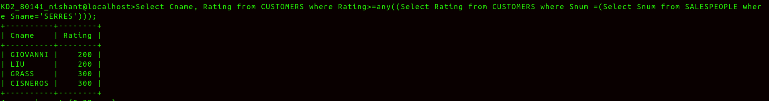
Ans>

Q2> Write a query using ANY or ALL that will find all salespeople who have no customers located in their city.
Ans>
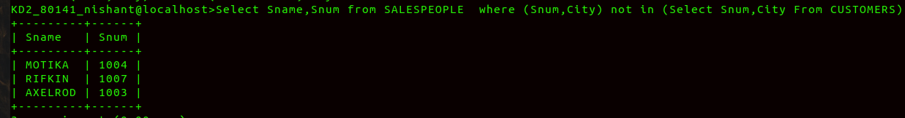
Q3> Write a query that selects all orders for amounts greater than any for the customers in LONDON.
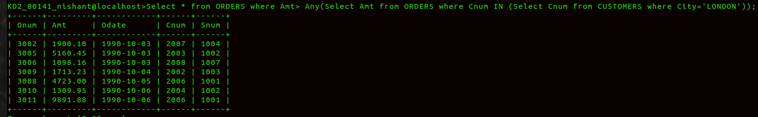
Ans>

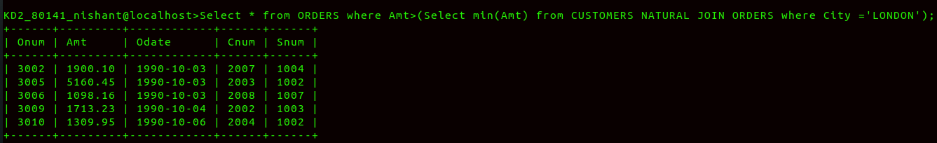
Q4> Write the above query using MIN or MAX.

