Assignment – 5

Q1> Write a query that will give you all orders for more than Rs.1000.
Ans> Select * from ORDERS
-> where Amt>1000;
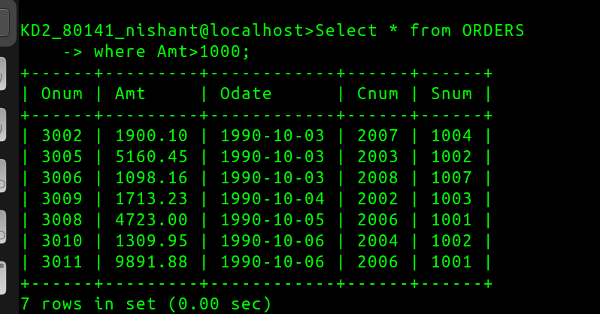
Q2> Write query that will give you the names and cities of all Salespeople in London with a commision above .10
Ans>
select Sname,City from SALESPEOPLE
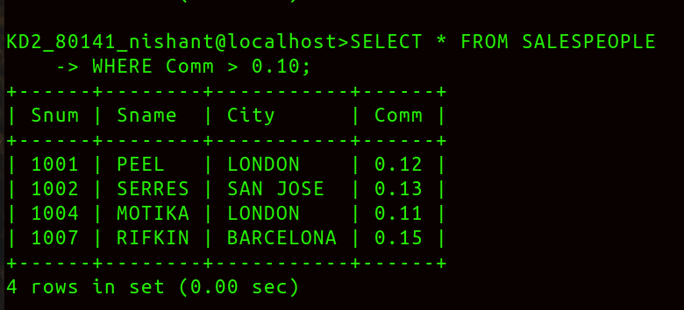
-> where City='LONDON'and Comm>0.10;

Q3> Write a query on the customers table whose output will exclude all customers with a rating <=100,unless they are located in rome.
Ans> Select * from CUSTOMERS
where Rating>100 or City='ROME';
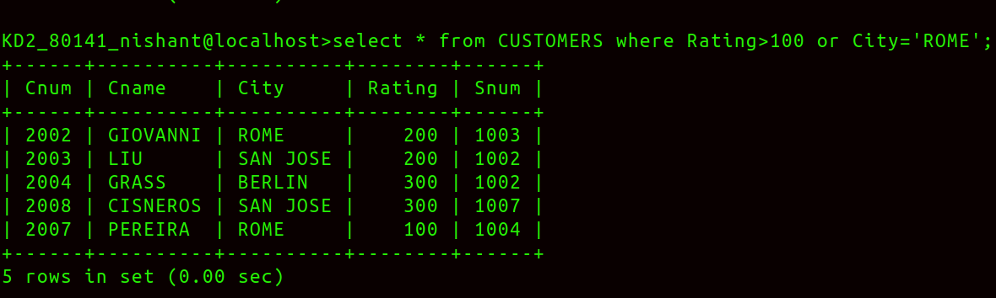
Q4> What will be the output?
Ans> Select * from ORDERS where (Amt<1000 or NOT(Odate ='1990-10-03' And Cnum>2003));
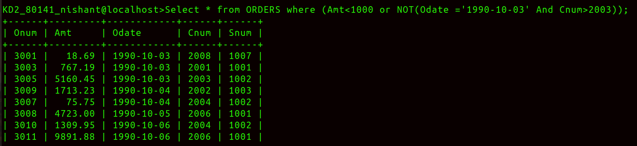

Q5> What will be the output?
Ans> select * from ORDERS
-> where NOT((Odate ='1990-10-03' or Snum>1006) and Amt>=1500);

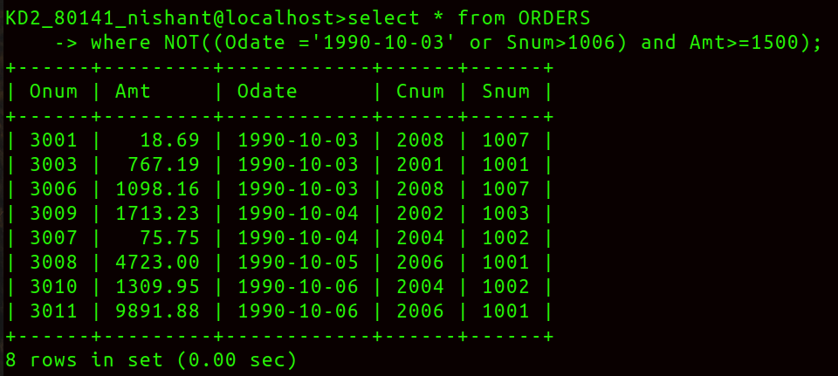

Q6> What is a simpler way to write this query Select snum ,sname,city,comm from Salespeople where (comm > .12 OR comm <.14);

Ans> Select * from SALESPEOPLE;

