Assignment-9

Q1> Write a query that lists each order number followed by the name of the customer who made the order.
Ans>
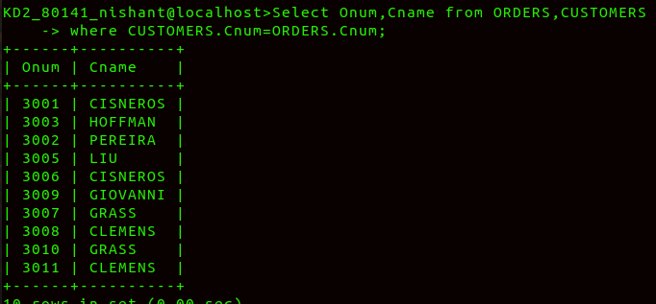
Q2> write a query that gives the names of both the salesperson and the customer for each order along with order number.
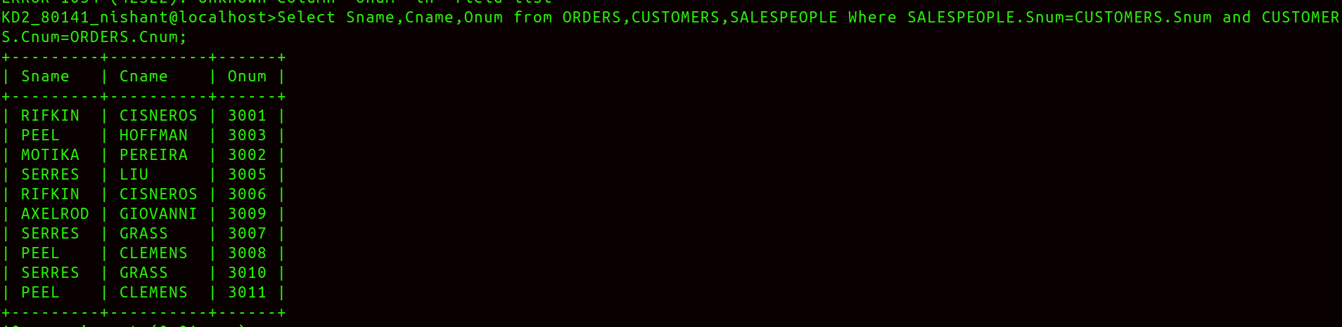
Ans>

Q3>Write a query that produces all customers serviced by salespeople,with a commission above 12% output the customers name the salesperson name and the salesperson rate of commision.
Ans>

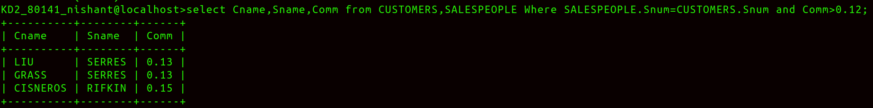
Q4> Write a query that calculates the amount of the salespersons commision on each order by a customer with a rating above 100.
Ans>
