Assignment-15

Q1> Assume there is a table called MULTICUST with all of the same column definations as Salespeople .Write a command that inserts all Salespeople with more than a one customer into this table.
Ans>
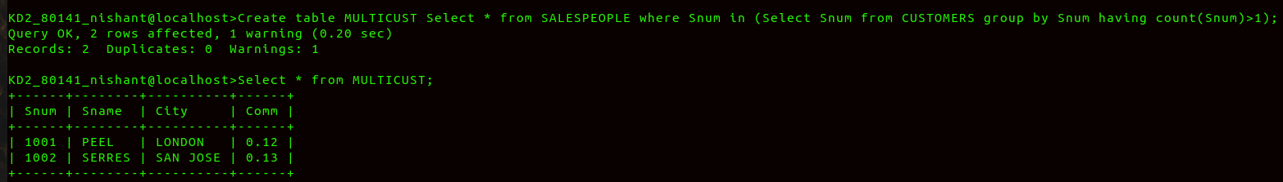
Q2>Write a command that deletes all customers with no current orders.
Ans>
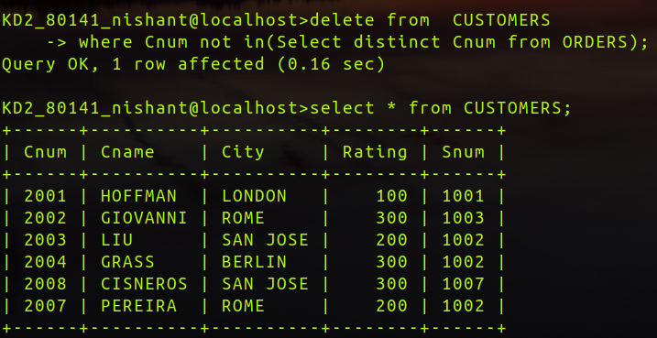

Q3>Write a command that increases by twenty percent the commisiion of all salespeople with total orders above Rs.3000.
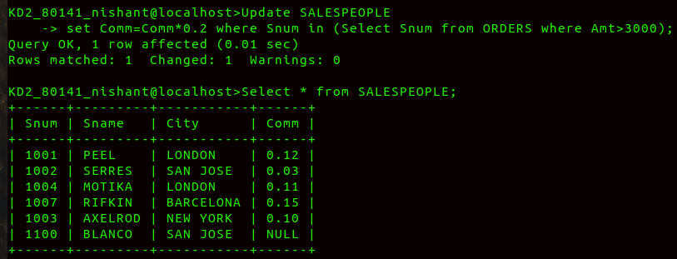
Ans>

