Assignment-10

Q1> Write a query that produces all pairs of salespeople who are living in the same city.Exculde combinations of salespoeple with themselves as well as duplicate rows with the Order reversed.
Ans>
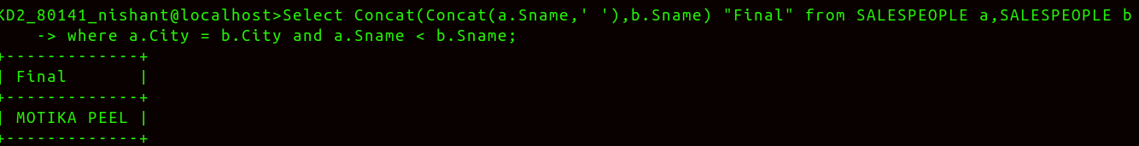

Q2> Write a query that produces the names and cities of all customers with the same rating as Hoffman.
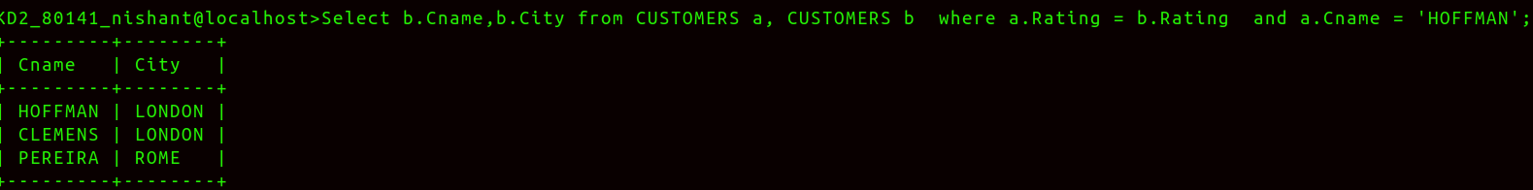
Ans>

