Assignment-11

Q1> Write a query that uses a subquery to obtain all orders for the customer named Cisneros . Assume you do not know his cnum.
Ans>
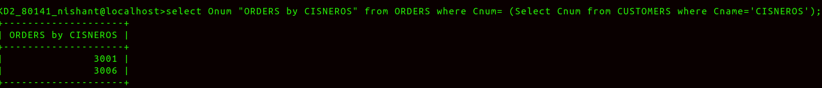

Q2> Write a query that produces the names and ratings of all customers who have above average orders.
Ans>
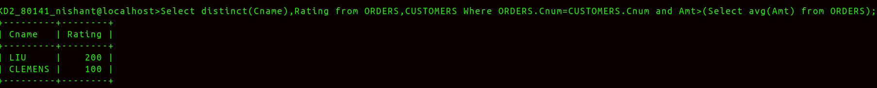
Q3> Write a query that selects the total amount in orders for each salespoeple for whome this total is greater than amount of the largest order in the table.
Ans>
