Assignment – 4

Q1> Write a select command that produces the order number , amount,and date for all rows in the orders table.
Ans> select Onum,Amt,Odate from ORDERS;
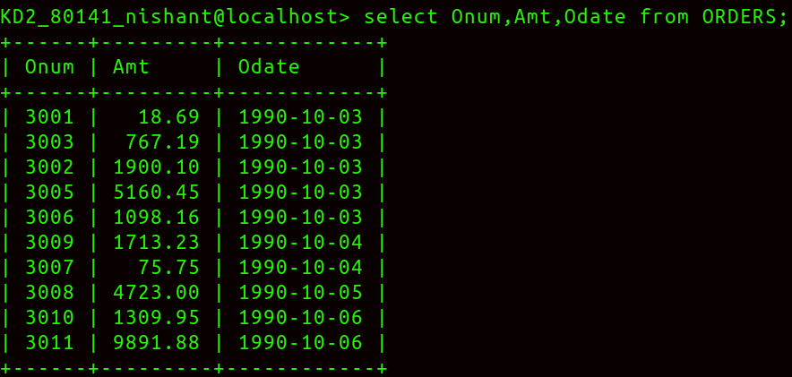
Q2> Write a query that produce all rows from the Customer table for which the salesperson’s number is 1001.
Ans> select * from CUSTOMERS
-> where Snum=1001;
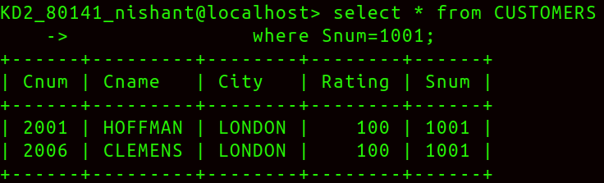

Q3> Write a query that displays the Salespeople table with the column in the folllowing order: city,sname,snum,comm.
Ans>Select City,Sname,Snum,Comm from SALESPEOPLE;
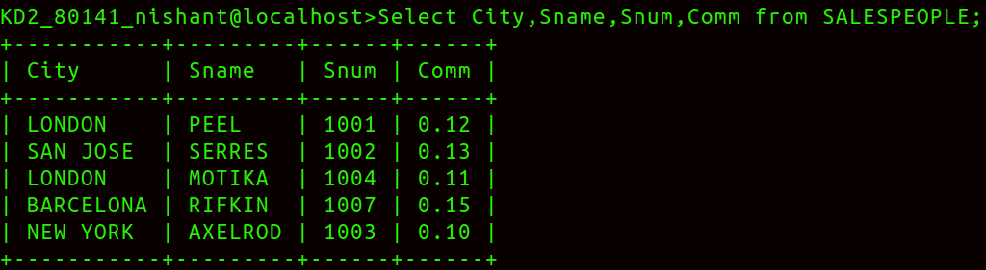

Q4> Write a select command that produces the rating followed by the name of each customer in San Jose.
Ans>select Rating,Cname,City from CUSTOMERS where City = 'SAN JOSE';

